(Continued from page 1)

We need leadership to gather us together in basement rooms to plot our strategy to detonate Satan’s bridgehead and liberate some of his prisoners of war.

We don’t see ourselves as insurgents in the alien’s territory of sin, planting explosives of righteousness and truth to destroy fortified walls.

When Paul reminded us of our conscription into the army of God, he told us plainly to stand and fight if necessary. The battle is God’s to win—and He does win, by the way!

**A Personal Discipleship Story**

A few years ago, I had a friend, Brad, who lived an absolutely despicable lifestyle. He worked away from home on a pipeline crew, and spent many evenings after work hanging around in bars and getting drunk, fighting, and waking up the next morning with a terrible hangover.

His wife had started coming to our church and had finally come to the realization that she needed Jesus in her life. The difference for her was amazing, and she immediately began asking all of us to pray that her husband would come to the same truth that she had found.

It took some time, but Brad began to notice a difference in his wife’s behavior. Curiosity got the best of him and he started coming to church once in a while. After a year or so of prayers for his salvation, Brad finally conceded that he needed Christ in his life as well. He walked forward one Sunday morning and asked Jesus into his heart. It was a wonderful day, to be sure.

Time went on and I would talk to Brad whenever he was back in town and able to come to church. I wanted to keep tabs on his commitment to Christ and help him along if I could. One Sunday morning I asked Brad how his week had gone and he began telling me an excited story about how he had been in a bar that Friday night and had been drinking and got into a fight.

I looked at him in disbelief, until I finally realized that no one had taken him under their wing and explained to him that drinking and bar fighting was not something that a Christian should be doing any more. I kindly explained that to him and the look on his face as the truth sunk in was astonishing. He realized for the first time that he needed to stop visiting bars and getting drunk.

I decided then and there that I would make it a point to try to teach Brad a few basics of what his new Christian life should actually look like. We met together, one on one, for Bible study and prayer each week. We talked and I explained the basic truths of the Bible and he began to learn and grow.

When I think of discipleship, I think of Brad and the difference God made in his life when someone like me stepped up and came along side him and walked through a few basic truths to get him onto the right track.

I tell you that story simply to show what being a disciple maker can look like.

**How *Not* to Find and Carve a Pumpkin Like a Pro**

The first step involves the task of locating and obtaining an appropriate pumpkin. Once a huge one is located, slip it inside your shirt and casually walk out of the store with your prize. If you are caught, consider that being in jail means free food and housing during your stay there. And think of the great story you will have to tell your kids some day!

Next is the cleaning step. Cats are OK, but dogs are the best at licking, so I highly recommend a good licking cleaning. Saint Bernards are the slobberiset dogs that I know of, so try one of them first. You may also use an old pair of dirty socks to dry off the dog slobber. If no socks are available, you will discover that you can lick the dog slobber off yourself.

Now you are ready to carve. Grab the largest, sharpest knife you can find and begin cutting recklessly. Your family will love to watch your flare and gusto as you carve with huge sweeping strokes. There is no need to be concerned if you should accidentally cut yourself carving. There are plenty of doctors available to sew your fingers back on, should you need their expertise.

During the carving process, drop it on the floor a time or two. It adds character to the final product. A few cat or dog hairs are always a nice touch.

When you return from the Emergency Room, have someone help you to set your carved, bloodstained pumpkin up in a grand display, since your fingers are all bandaged up. And enjoy the holiday.

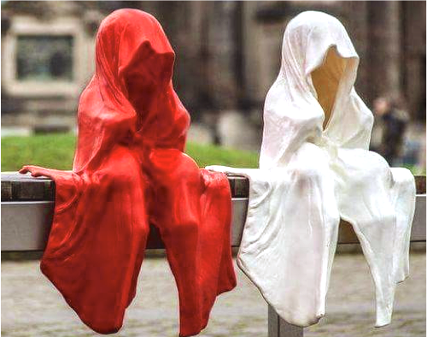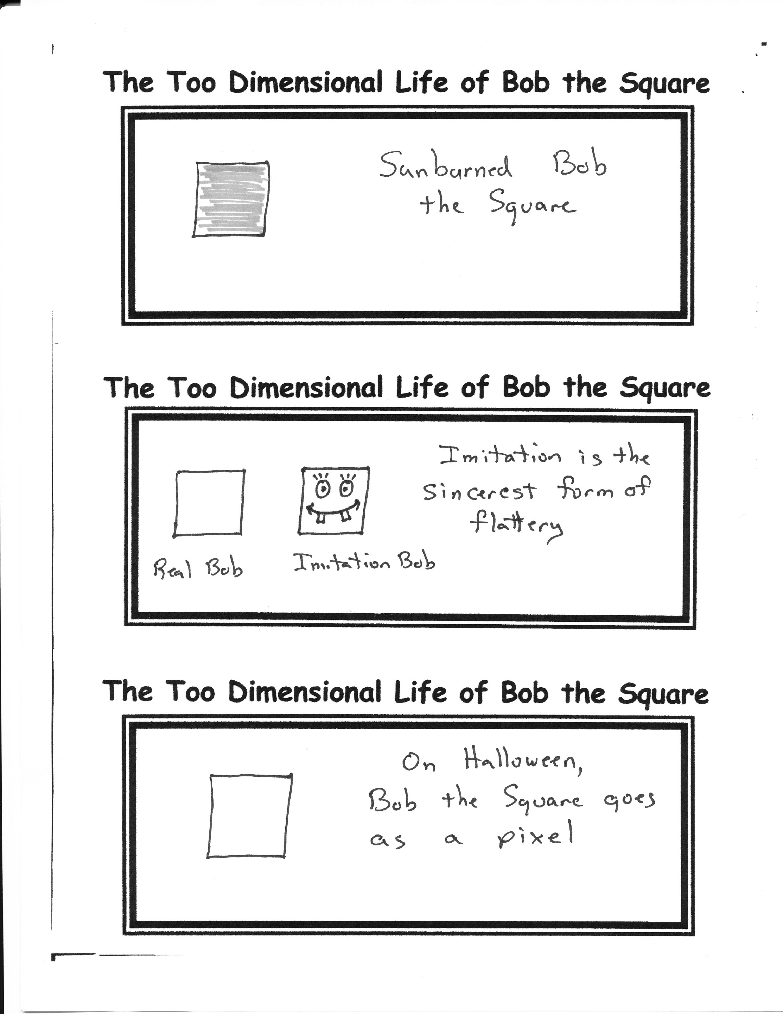

My Two Youngest Daughter Dressed in Their Halloween Costumes A Few Years Ago-Note The Facial Detail!