

**The Interpet**

(Continued from page 1)

One of the other drivers on the crew was returning from the feedlot, having dumped his load, so Mr. Lyle flashed his lights and flagged him down to stop and ask him to look at the road near that old farmhouse and tell him later what was there.

A few minutes later, the CB radio crackled and his buddy told him that on his return trip to the field, he should either take a different route, or for sure to “not stop at the farmhouse driveway—just keep driving—it’s not pretty!”

Mr. Lyle went on to dump his load at the feedlot, all the while wondering what this all meant. Curiosity got the best of him, and he decided to take the same road back to the field, so he could see what had happened at the old farmhouse driveway. He slowed down a bit as he came by. The family was out by the road, loading stuff into some 55 gallon barrels on the back of a pickup truck. They were yelling at him as he drove past and from what he saw, he knew immediately that it was probably not a good time to stop and chat with them.

That evening, as the sun was setting, creating a beautiful western Kansas sunset, 24 little piglets had broken out of their enclosure, their pink little skins blending in with all of the other reddish colored hues in the sky and in the dust clouds generated by all of the passing trucks. Let’s just say that not one of those cute little piglets made it back home to their Momma that evening.

In those days, the harvest crews used CB radios to communicate among themselves during the day, and each person had a CB nickname or “handle” as it was known back then. From that day forward, because of the events of that fateful day, Mr. Lyle became known as “The Butcher”, a name that followed him the entire 5 summers he worked with that crew.

There are other stories to be sure, and if we have time, he might tell a couple of them. There’s one about the world’s largest toad frog, one about a mad serial killer that attacks people driving down country roads, and one about his neighbor, Mrs. Larsen. Oh, and he even tried to outrun the city police one night!

But as you might guess, we are here for a Sunday School lesson. Today’s lesson will be Mr. Lyle’s own personal testimony concerning his walk with the Lord and where he is right now in that process.

Again, welcome.

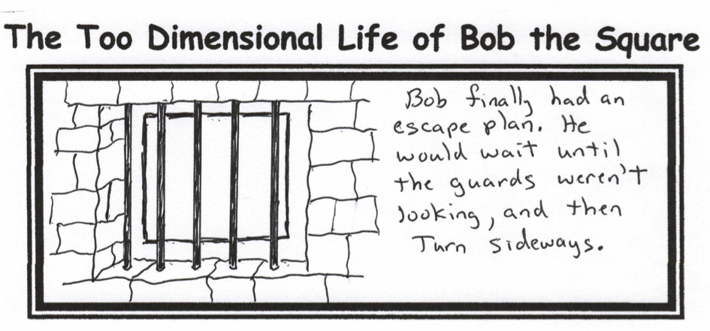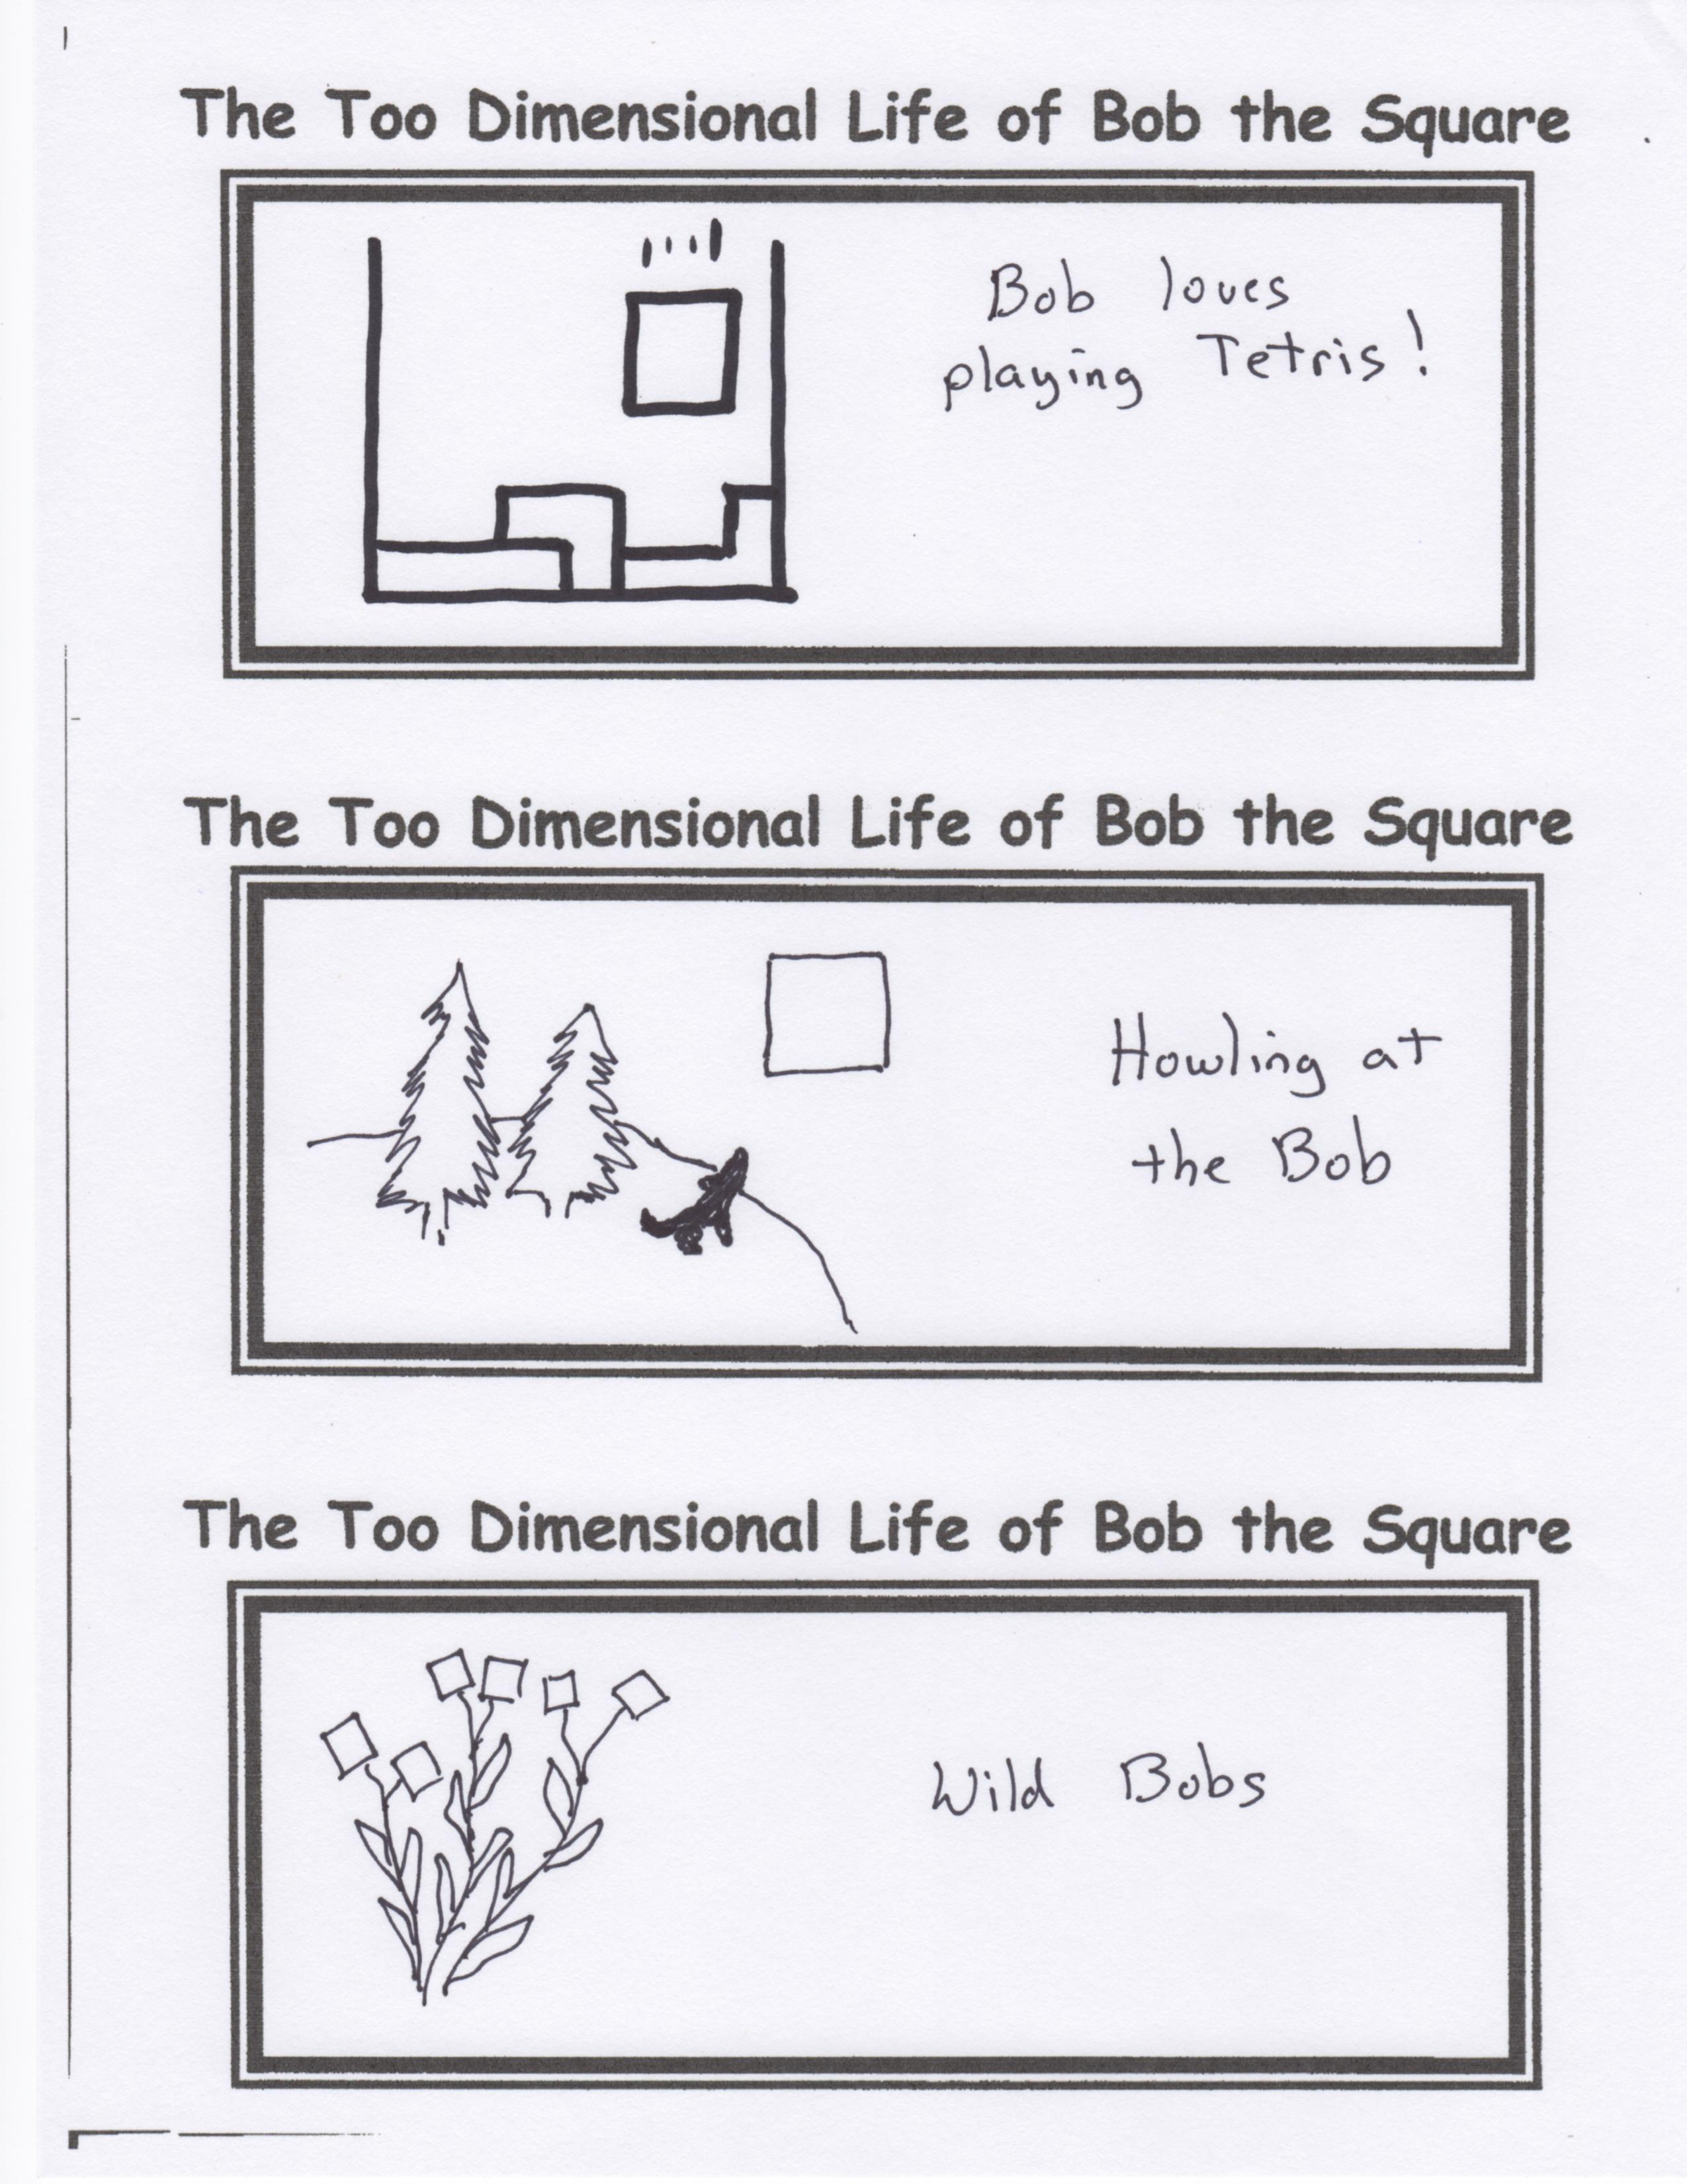

**How Do I Love School?...**

**Let Me Count the Ways…**

**1.**

**2.**

**3.**

**4.**

**5.**

**6.**

**7.**

**8.**

**9. (When I come up with something, I’ll let you know.)**