**December 9, 2018**

**Volume 7, Issue 15**

Sunday School Times

***Stuff For Today***

• Bob the Square

• Top 10 Christmas Truths

• All About Moose

Published almost weekly, but more like…..whenever, so get used to it, OK?

# Are You A Moose?

**By Mr. Lyle (mrlyle1@gmail.com**

***Let love and faithfulness never leave you; bind them round your neck, write them on the tablet of your heart. Proverbs 3:3***

I would like to ask you a question that you probably have never been asked before. “Are you a moose?” Before you answer, allow me to tell you a little story.

I stepped out of the back door of my business one day and caught a glimpse of a stray dog running away from the building and disappearing into the tall grass. Another stray, I thought. The creek nearby seems to be a magnet for those unscrupulous people who no longer want to care for an animal and mistakenly think that the poor animals will fare well there by the water. They don’t. In short order, they find their way back to the first civilization they see, my business, and park themselves close by, looking for a friend or a handout. Thinking little about it, I went back inside.

A full month later, I again had occasion to go out the back door to take care of something and saw that same dog running off into the grass. I now knew I had a vagrant living near me, so I kept an eye open for her appearance again. Two days later, I again walked out the back door, this time stealthily and in search of the elusive animal. What I was greeted with was a most awful stench! Now my thoughts changed. I was sure that I had a dead animal on my hands, and I also knew that if it was the dog I had been seeing, she was large enough that it would just not do to ignore the smell. It would have to be buried. So I began searching. My nose led me to a flat bed trailer surrounded by tall grass. The smell was most certainly coming from underneath that trailer, so I bent down, pushed the grass aside, and was shocked to see a live animal looking back at me with weak, pleading eyes.

I quickly found a bit of my leftover afternoon snack, and coaxed her out from under the bed of the trailer. What I saw and smelled was burned into my memory forever. She was a walking death. Nearly all of her fur had fallen off and in its place was raw, oozing skin covered in scabs. Worms and maggots were crawling in the open sores on her body. She smelled terrible. She smelled dead! I will admit, my first thought was to put her out of her misery and bury her. But it was the middle of dry season here and the shale ground is almost impossible to dig through without a pickaxe. To top it off, I really didn’t want to get out there in the hot summer sun and dig, so I did what I thought would be the humane thing to do. I took her to my veterinarian to have her put down and buried.

Once there, I put on a long sleeve shirt and gloves and carried this bleeding, oozing, dying animal through the back door of the hospital. I didn’t want to take her through the lobby with all of the people there. The vet met me, looked her over for a minute or two and surprised me by saying that he could fix this. Shocked and unprepared for this turn of events, I blurted out my decision to pay the money to heal her. $350 later, I had a new pet dog. Much to my family’s chagrin, I named her Moose.

It took several months, but in due time she was a normal dog again. She was MY dog, and no one else’s! Moose worshipped me! I supposed that she identified me as the one who had saved her from a horrible existence. She was right beside me always, never disobeying my commands, placing herself within inches of my feet. If I moved a foot or two to the right, she dutifully got up and moved to the right the appropriate amount and would then lie back down. She was the living, breathing definition of loyalty.

(Continued on Page 2)

**How To Decorate Your Moose For the Holidays**

By Mr. Lyle (mrlyle1@gmail.com)

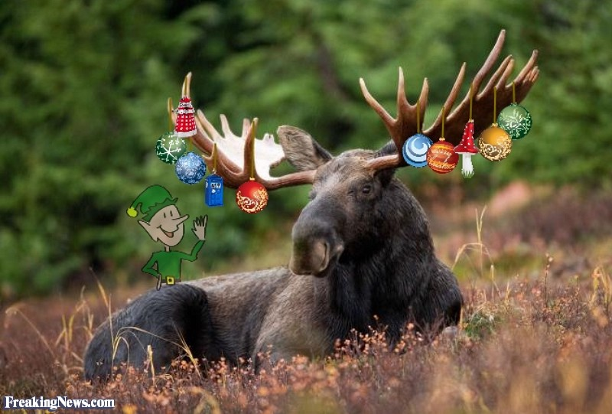

Decorating a moose is actually much easier than one might expect. A wild moose has a unique desire for interaction with people. Humans learned centuries ago that applying Christmas ornaments to a moose’s antlers, while singing or humming Christmas carols, was a festive way to add to holiday cheer. The moose seem to know that the season is joyful and always sit quietly during the decorating process. Then they will casually stroll off and show their antlers to the other moose nearby. DO NOT try to un-decorate a moose however! They become very attached to their adornments and will fight to keep them.