**November 12, 2017**

**Volume 6, Issue 9**

Sunday School Times

***Stuff For Today***

• Wait, Wait, Let Me Guess

• Rscheearch

* Man’s survival
* 10%

Published almost weekly, but more like…..whenever, so get used to it, OK?

# A Verdict Based Upon The Evidence

**By Mr. Lyle (mrlyle1@gmail.com)**

***10%=Tithe***

So, how do you figure out how much to give God?

**Money**—that one is easy,. Divide the total by ten. But does a God who owns everything really need our money? Or does He want us to be less absorbed by it? What about our…

**Time**—with a limited amount of time at our disposal, it may well be the most valuable thing that God gives us. With 24 hours a day, ten percent would be 2.4 hours? Imagine what God could do with our willingness to give Him our time. And then there is…

**Talent**—that’s even harder to figure! God has given every Christian at least one spiritual gift. He wishes for us to learn to use our gift for His purposes. Also, don’t forget all of the …

**Many things beside money that God gives us.** Through our life, we receive many gifts from a very generous God. Can we ever calculate a true tithe?

***Romans 1:20***

***For since the creation of the world God’s invisible qualities – his eternal power and divine nature – have been clearly seen, being understood from what has been made, so that people are without excuse.***

I once had the opportunity to witness our judicial system at work. I sat in a courtroom for nearly two weeks and watched a homicide trial from beginning to end,

After all of the testimony was completed and all of the pieces of evidence had been accepted by the court, the judge turned to the jury and instructed them that they must decide the guilt or innocence of the accused based solely on the evidence presented in court.

It was a complex case involving nearly 30 witnesses and 230 individual pieces of evidence. And no one single piece of evidence, if considered by itself and only itself, could bring a jury to a fair conclusion. They had to look at all of the evidence and put everything together to come to a verdict.

Proving the existence of God is much the same. We do not have a living eyewitness who we can call on to give us firsthand testimony that He is indeed real. Rather we must make a decision based upon the evidence available to determine if He exists or is simply a figment of someone’s vivid imagination.

God gives us a hint where to start our search for evidence—creation. Look at the universe around us and know it could not happen by chance.

Science and technology are showing us some amazing things about the universe we live in. We now know the universe is expanding, and at an accelerating rate. There is no reasonable explanation for this other than it is the fingerprint of God.

Then go to the small end of the spectrum. The advancements in the understanding of genetics and DNA have serious scientists leaving the thoughts of evolution to be an impossible idea to consider anymore. Again, we can see the fingerprint of God.

These arguments come from the Bible. Can we believe the Bible to be true? God left us little doubt in that category also. Consider this list:

A. The ancient original works of Plato—7, the earliest written 1200 years after his death.

B. The works of Aristotle—49, the earliest written 1400 years after his death.

C. Homer’s Illiad—the most copied book in antiquity, 643, the earliest written 500 years after his death.

D. The Bible—24,000 copies, and all written from 30 to 100 years after Jesus was buried and rose again! God left little question as to the validity of His Word.

All of us must admit that we have had doubts as to God’s existence. It is natural. But just as the trial juror must deliberate, so we too must sift through the evidence before us. We cannot expect to find that one special piece of evidence that proves everything in and by itself. Rather, it takes an effort on our part to honestly look around us and put it all together.

You must reach a verdict based solely on the evidence.

**Rscheearch**

Aoccdrnig to a rscheearch at Cmabrigde Uinervtisy, it deosn’t mttaer in waht oredr the ltteers in a wrod are, the olny iprmoetnt tinhg is taht the frist and lsat ltteer be at the rghit pclae. The rset can be a taotl mses and you can siltl raed it wouthit a porbelm. Tihs is bcuseae the hamun mnid deos not raed ervey lteter by istlef, but the wrod as a wlohe. Amzanig, huh?

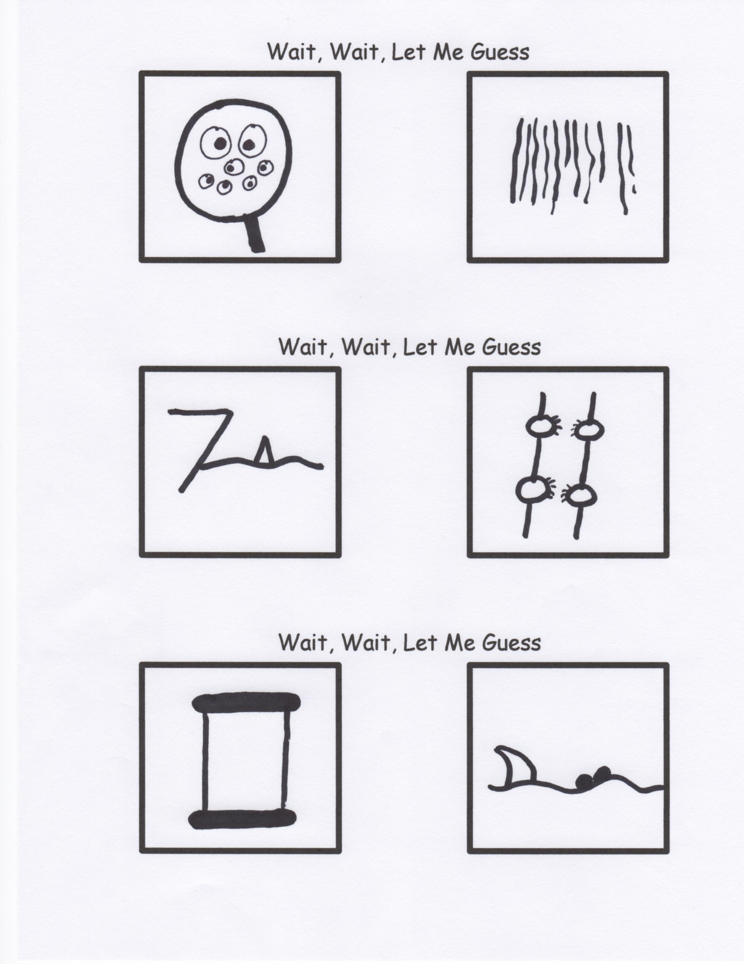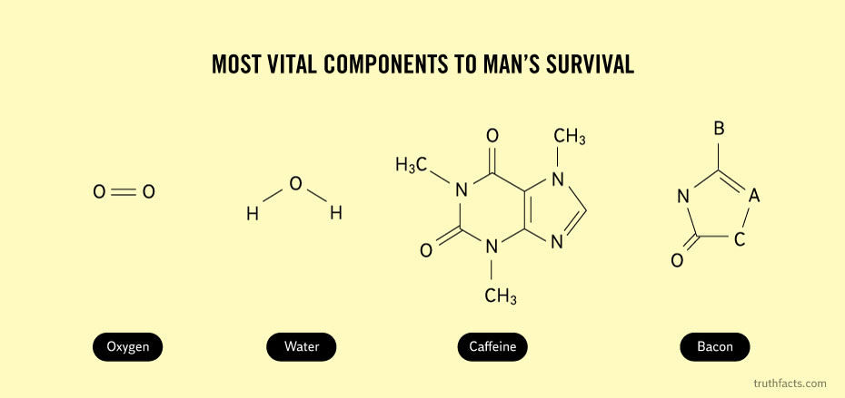

BACON

Oxygen

**Jesus is coming back someday.**

**RUE ?**

**Your Greatest Treasure**

Remember, friendship is the greatest treasure of all…that is, of course, unless you have a magic pony! Then, by all means, it is the magic pony.

Caffeine

Water