**August 5, 2018**

**Volume 6, Issue 39**

Sunday School Times

# The End

***Stuff For Today***

• Remembering

• Graduation

* Goodbye!

Published almost weekly, but more like…..whenever, so get used to it, OK?

**By Mr. Lyle (mrlyle1@gmail.com**

**How many of these lessons do you remember?**

1. Finding a watch under a cup
2. George Wilson Pardon
3. Prince Charmin
4. 4 Way Victor rat trap
5. Hu Waru
6. COTSA
7. Funeral for Glassey
8. Jesus’ first sermon
9. Verdict in a court case
10. Story of Ruth
11. Kroger Christmas
12. The great bear hunt
13. Oil in clay jars
14. Creation
15. Gospel in the Gates
16. Mr Lyle Bowl XVIII
17. Bob and Darla’s wedding
18. The famous artist Ly Lé
19. Creatures with 4 faces
20. Toilet paper canon
21. Gravity Corner
22. Picking the Lamb
23. Ultimate recycling
24. 6 mpossible things
25. Nd
26. Daniel 11
27. Crux
28. To tell the truth
29. Prison le Devil
30. KLEW
31. Moses makes a mistake
32. Divine wood cutters
33. William Tell
34. Gender dysphoria

**Today’s Graduation Ceremony**

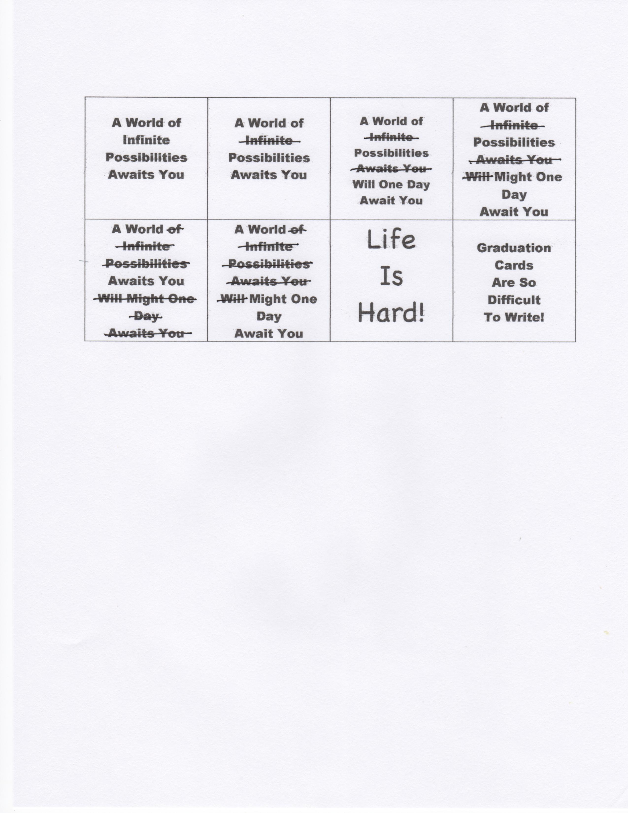

By Mr. Lyle (mrlyle1@gmail.com)

**Welcome and Prayer**

**Pomp and Circumstances Beyond Our Control**

**The Reading of the Sunday School Times**

**Address by Class Valasalutadictatorian**

**Magnanimous**

**Canunimous**

**Laudinum**

(a.k.a. Mr. Lyle)

(p.s. He plans to talk about cabbage)

**Presentation of Diplomas and Various Other Sundry Items**

**Closing Prayer**

**You’re Outa Here!**

**Good Bye**

See you later, alligator

After awhile, crocodile

In an hour, sunflower

Toodle-oo, kangaroo

Gotta go, buffalo

Adios, hippos

Chow chow, brown cow

See ya soon, baboon

Adieu, cockatoo

Better swish, jellyfish

Chop chop, lollipop

Bye Bye, butterfly

See ya mañana, iguana

Give a hug, ladybug

Can’t stay, blue jay

Farewell, gazelle

Take care, brown bear

Stay loose, bull moose

Good wishes, little fishes

Gonna hit the road, spotted toad

I’m outa here, white tailed deer

**I would just like to take a few moments to congratulate** **myself on sitting through your graduation ceremony.**