**July 22, 2018**

**Volume 6, Issue 37**

Sunday School Times

# Walter and His Dad, William

***Stuff For Today***

• Wait, Wait, Let Me Guess!

• Back to School Advice

* Walter and William

Published almost weekly, but more like…..whenever, so get used to it, OK?

**By Mr. Lyle (mrlyle1@gmail.com**

***Joshua 1:8-9***

***Keep this Book of the Law always on your lips; meditate on it day and night, so that you may be careful to do everything written in it. Then you will be prosperous and successful. 9 Have I not commanded you? Be strong and courageous. Do not be afraid; do not be discouraged, for the Lord your God will be with you wherever you go.***

Whether the story is actually historical, or merely a legend, no one knows for sure. Regardless of that fact, the tale of William Tell is an important part of Swiss national identity. Many times it is extremely difficult to separate fact from fiction when studying events that happened over 500 years ago. Fortunately for our purposes today, it matters little if the story is merely a story. It is apropos for our topic of Biblical study. The earliest versions of the legend were told as follows.

The area presently known as Switzerland was once under the dominating control of various Austrian families. They were harsh and many times cruel, and a constant reminder to the Swiss people that tyranny was to be despised.

An Austrian named Hermann Gessler was appointed to rule the area in question, and set his center of government in a village known as Altdorf. He was especially unsavory to the locals, and in a public display meant to bring the people into subjection, he ordered that a tall pole be erected in the town square. He would then “donate” a hat to be placed atop that pole, and every citizen would then be required to show submission by bowing to the hat and what it represented, each time they passed by.

On November 18, 1307, a local man and his son entered the little town. William Tell was a man’s man. A mountain climber, a renowned marksman with a cross bow, he was also incredibly strong. William found the Austrian influence in his village abhorrent, and in a display to his son Walter, as well as any authority watching his actions, he refused to bow to the acclaimed hat on the pole.

Gessler was furious, and arrested William Tell on the spot. When he realized whom he had in his possession, Gessler decided to make a huge public spectacle of this situation as a statement to the locals who still had animosity towards the Austrians. When he discovered that Tell was known for his abilities with a cross bow, he forced William Tell into a despicable situation. He must shoot an apple off of his son’s head.

As the story goes, Tell split the apple off of his son’s head. Gessler noticed that he had actually pulled two arrows from his quiver as he had prepared for the difficult shot. When questioned about the oddity, Tell informed him that, had he missed and killed his son, the second arrow was for Gessler himself. And of course, Gessler was furious, refused to allow him his freedom, and made plans for Tell to spend the rest of his life in a dungeon.

The trip to Gesslers castle was partly by ship. But severe stormy weather gave Tell a chance to jump overboard and escape. He ran cross country ahead of Gessler, ambushed him as he entered his castle and assassinated him there. News of the act traveled across the countryside. It became a rallying cry for the people, and Swiss independence from the Austrian oppression soon followed.

In class today we will reenact this moment in history. At first it may seem a dangerous task, but plans have been set in place to make it as safe as you can possibly imagine.

God cares about His children. He will protect them from undo harm. He loves us, and will not let anything come between Himself and His prize possessions.

**“Starting-a-New-School-Year-Soon” Advice**

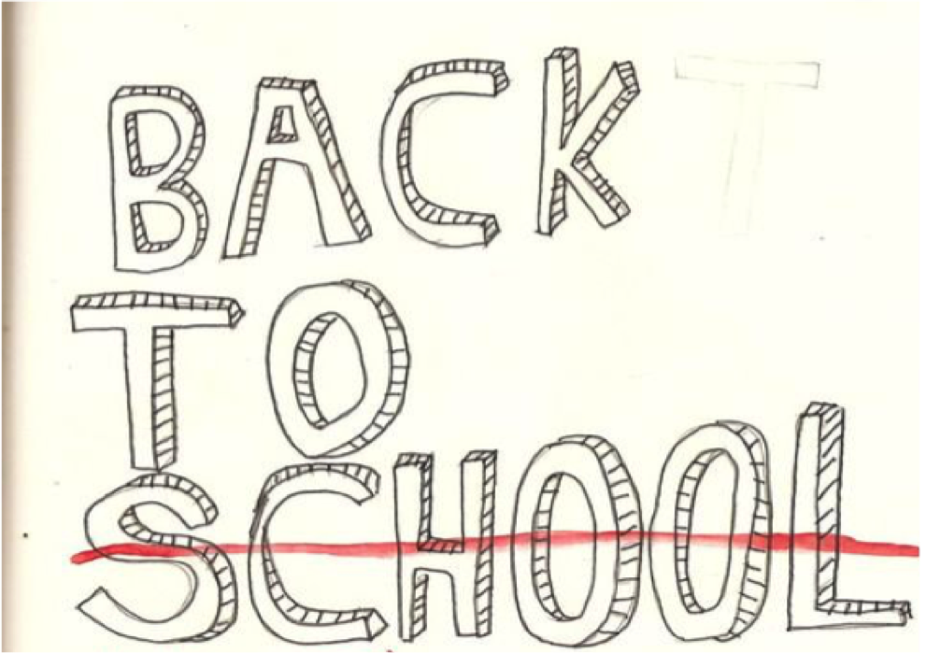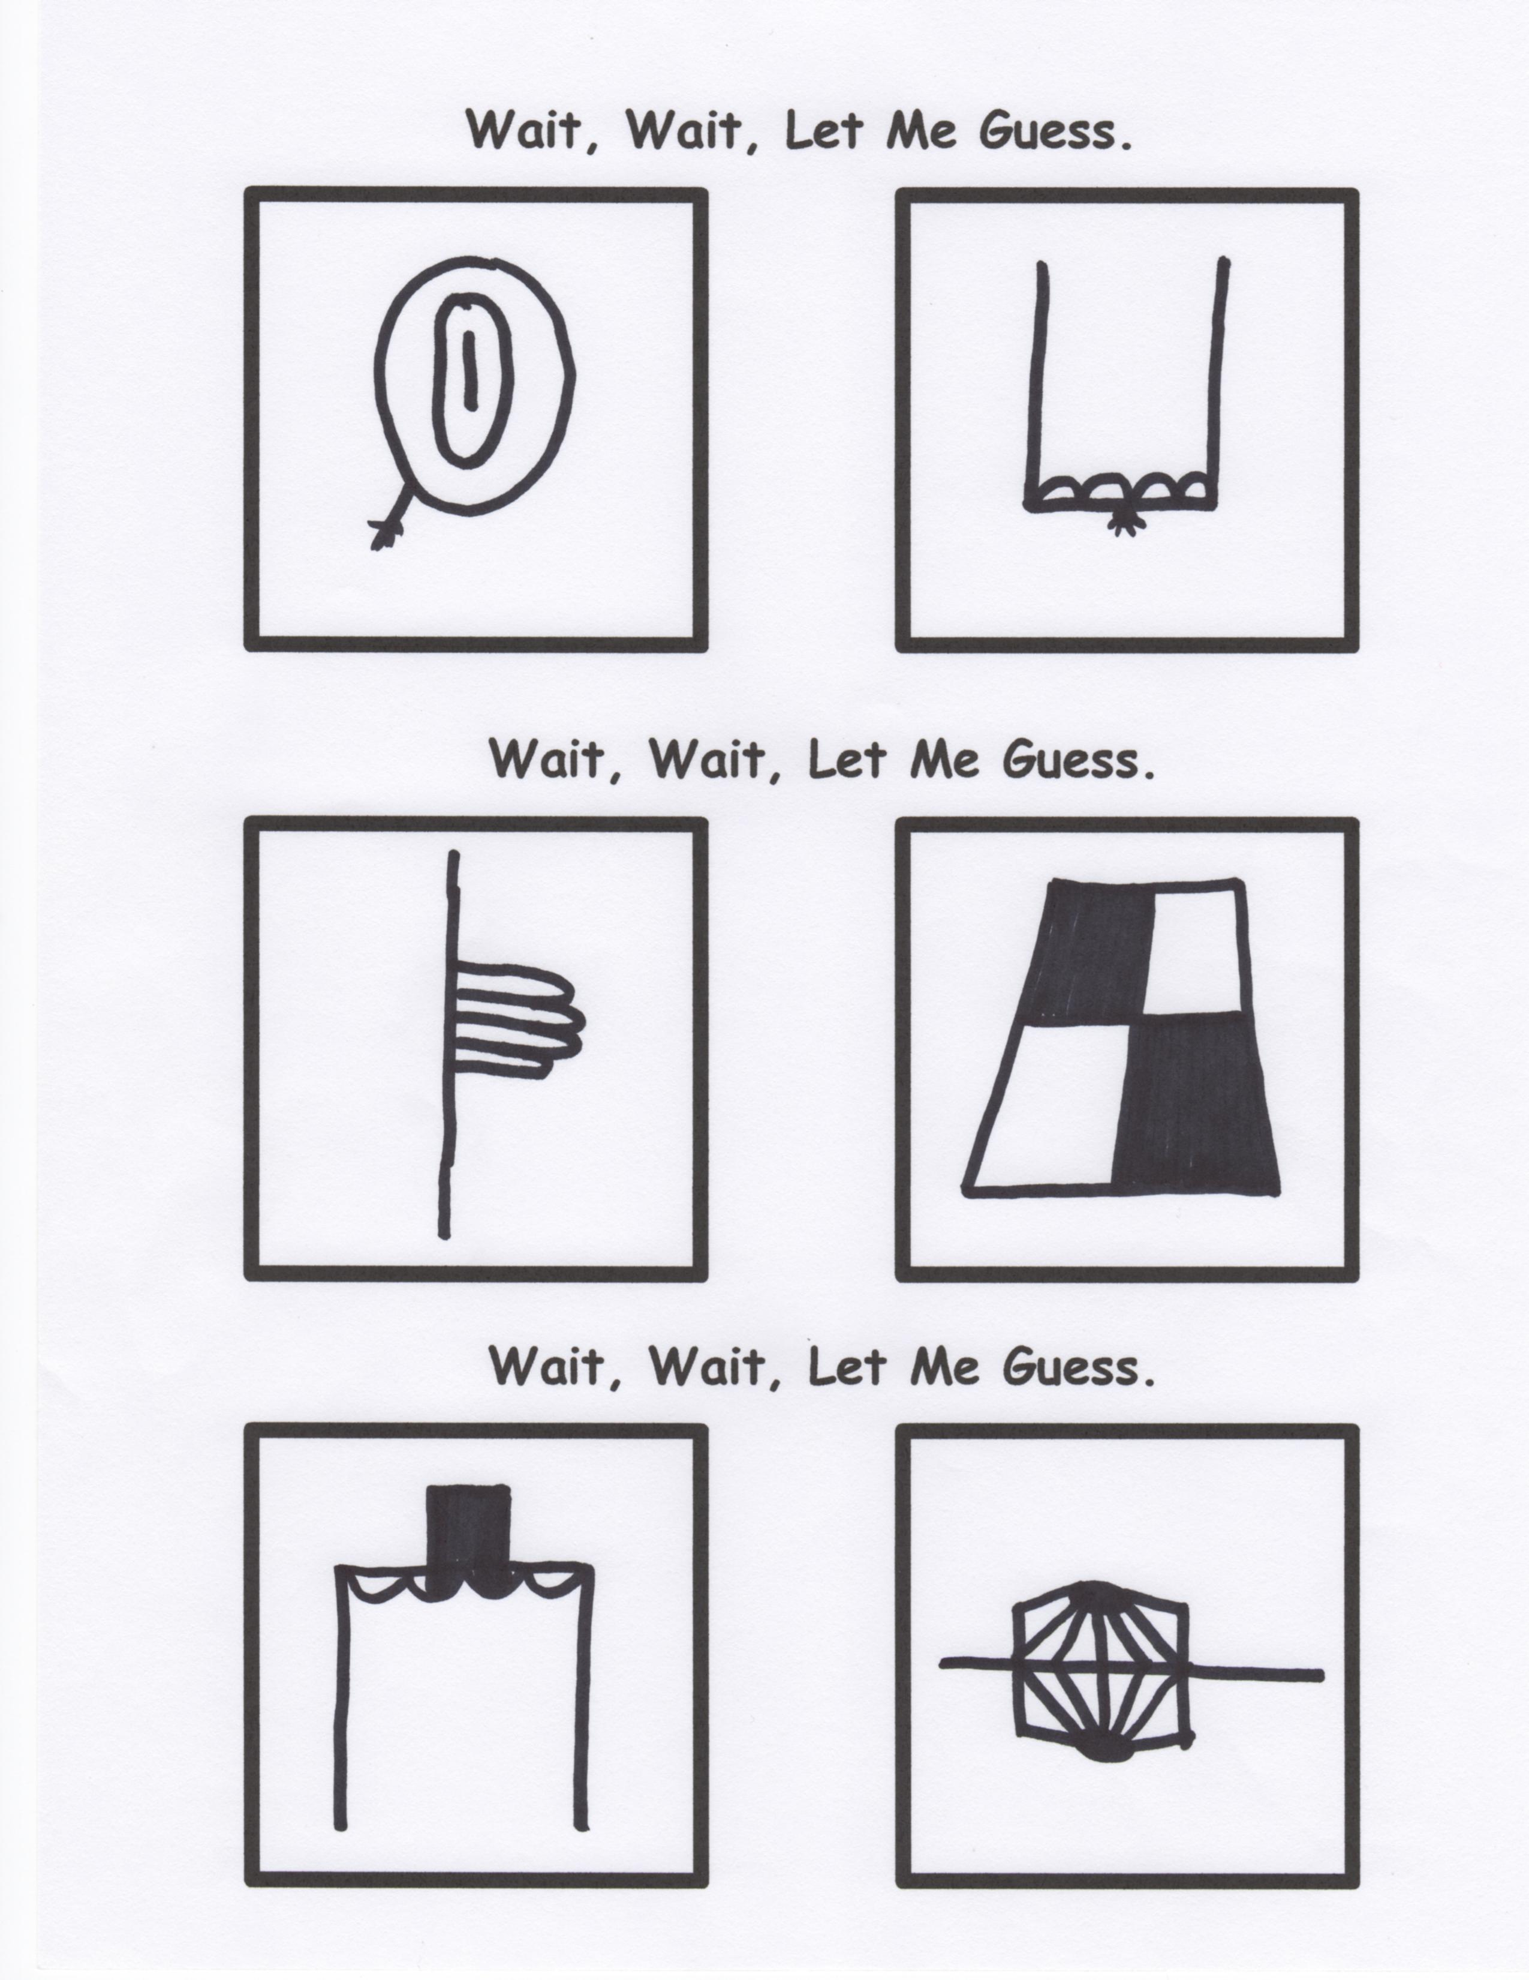

**Free Advice:**

Behave today as if this is the day for which you will always be remembered.

**Coming Soon…**

If you have to **sneak** to do it, **lie** to cover it up, or **delete** it to avoid it being seen…

then you probably shouldn’t be doing it!

By Mr. Lyle (mrlyle1@gmail.com)