**July 1, 2018**

**Volume 6, Issue 35**

Sunday School Times

***Stuff For Today***

• Wait, Wait, Let Me Guess!

• Written language

* Cuteness
* Moses makes a mistake

Published almost weekly, but more like…..whenever, so get used to it, OK?

# Mistakes Were Made!

**By Mr. Lyle (mrlyle1@gmail.com**

***Numbers 20;2-12***

***2 Now there was no water for the community, and the people gathered in opposition to Moses and Aaron. 3 They quarreled with Moses and said, “If only we had died when our brothers fell dead before the Lord! 4 Why did you bring the Lord’s community into this wilderness, that we and our livestock should die here? 5 Why did you bring us up out of Egypt to this terrible place? It has no grain or figs, grapevines or pomegranates. And there is no water to drink!” 6 Moses and Aaron went from the assembly to the entrance to the tent of meeting and fell facedown, and the glory of the Lord appeared to them. 7 The Lord said to Moses, 8 “Take the staff, and you and your brother Aaron gather the assembly together. Speak to that rock before their eyes and it will pour out its water. You will bring water out of the rock for the community so they and their livestock can drink.” 9 So Moses took the staff from the Lord’s presence, just as he commanded him. 10 He and Aaron gathered the assembly together in front of the rock and Moses said to them, “Listen, you rebels, must we bring you water out of this rock?” 11 Then Moses raised his arm and struck the rock twice with his staff. Water gushed out, and the community and their livestock drank. 12 But the Lord said to Moses and Aaron, “Because you did not trust in me enough to honor me as holy in the sight of the Israelites, you will not bring this community into the land I give them.”***

The Israelites had been moving about as an assembly at the direct command of God. The community lacked water and began to express their dissatisfaction. They congregated around a large rock, and at God’s explicit direction, Moses struck the rock and water came forth. They praised God for His provision and continued on their way. Interestingly, thirty-seven years later, they again found themselves at the very same location, experiencing an identical challenge. On this occasion, however, Moses was instructed to speak to the rock. In anger, he struck it in the same manner as he had previously. Water came forth, but Moses was severely reprimanded by God for his actions. This rock was a picture, a type of Jesus Christ, The Rock. Jesus was to be “struck” once by going to the cross. That was a one-time event, never to be performed again. Moses, in anger, had tarnished that picture. God felt so strongly about Moses’ behavior, that he was not allowed to enter the Promised Land expressly as a consequence of this action.

**CUTENESS**

By Mr. Lyle (mrlyle1@gmail.com)

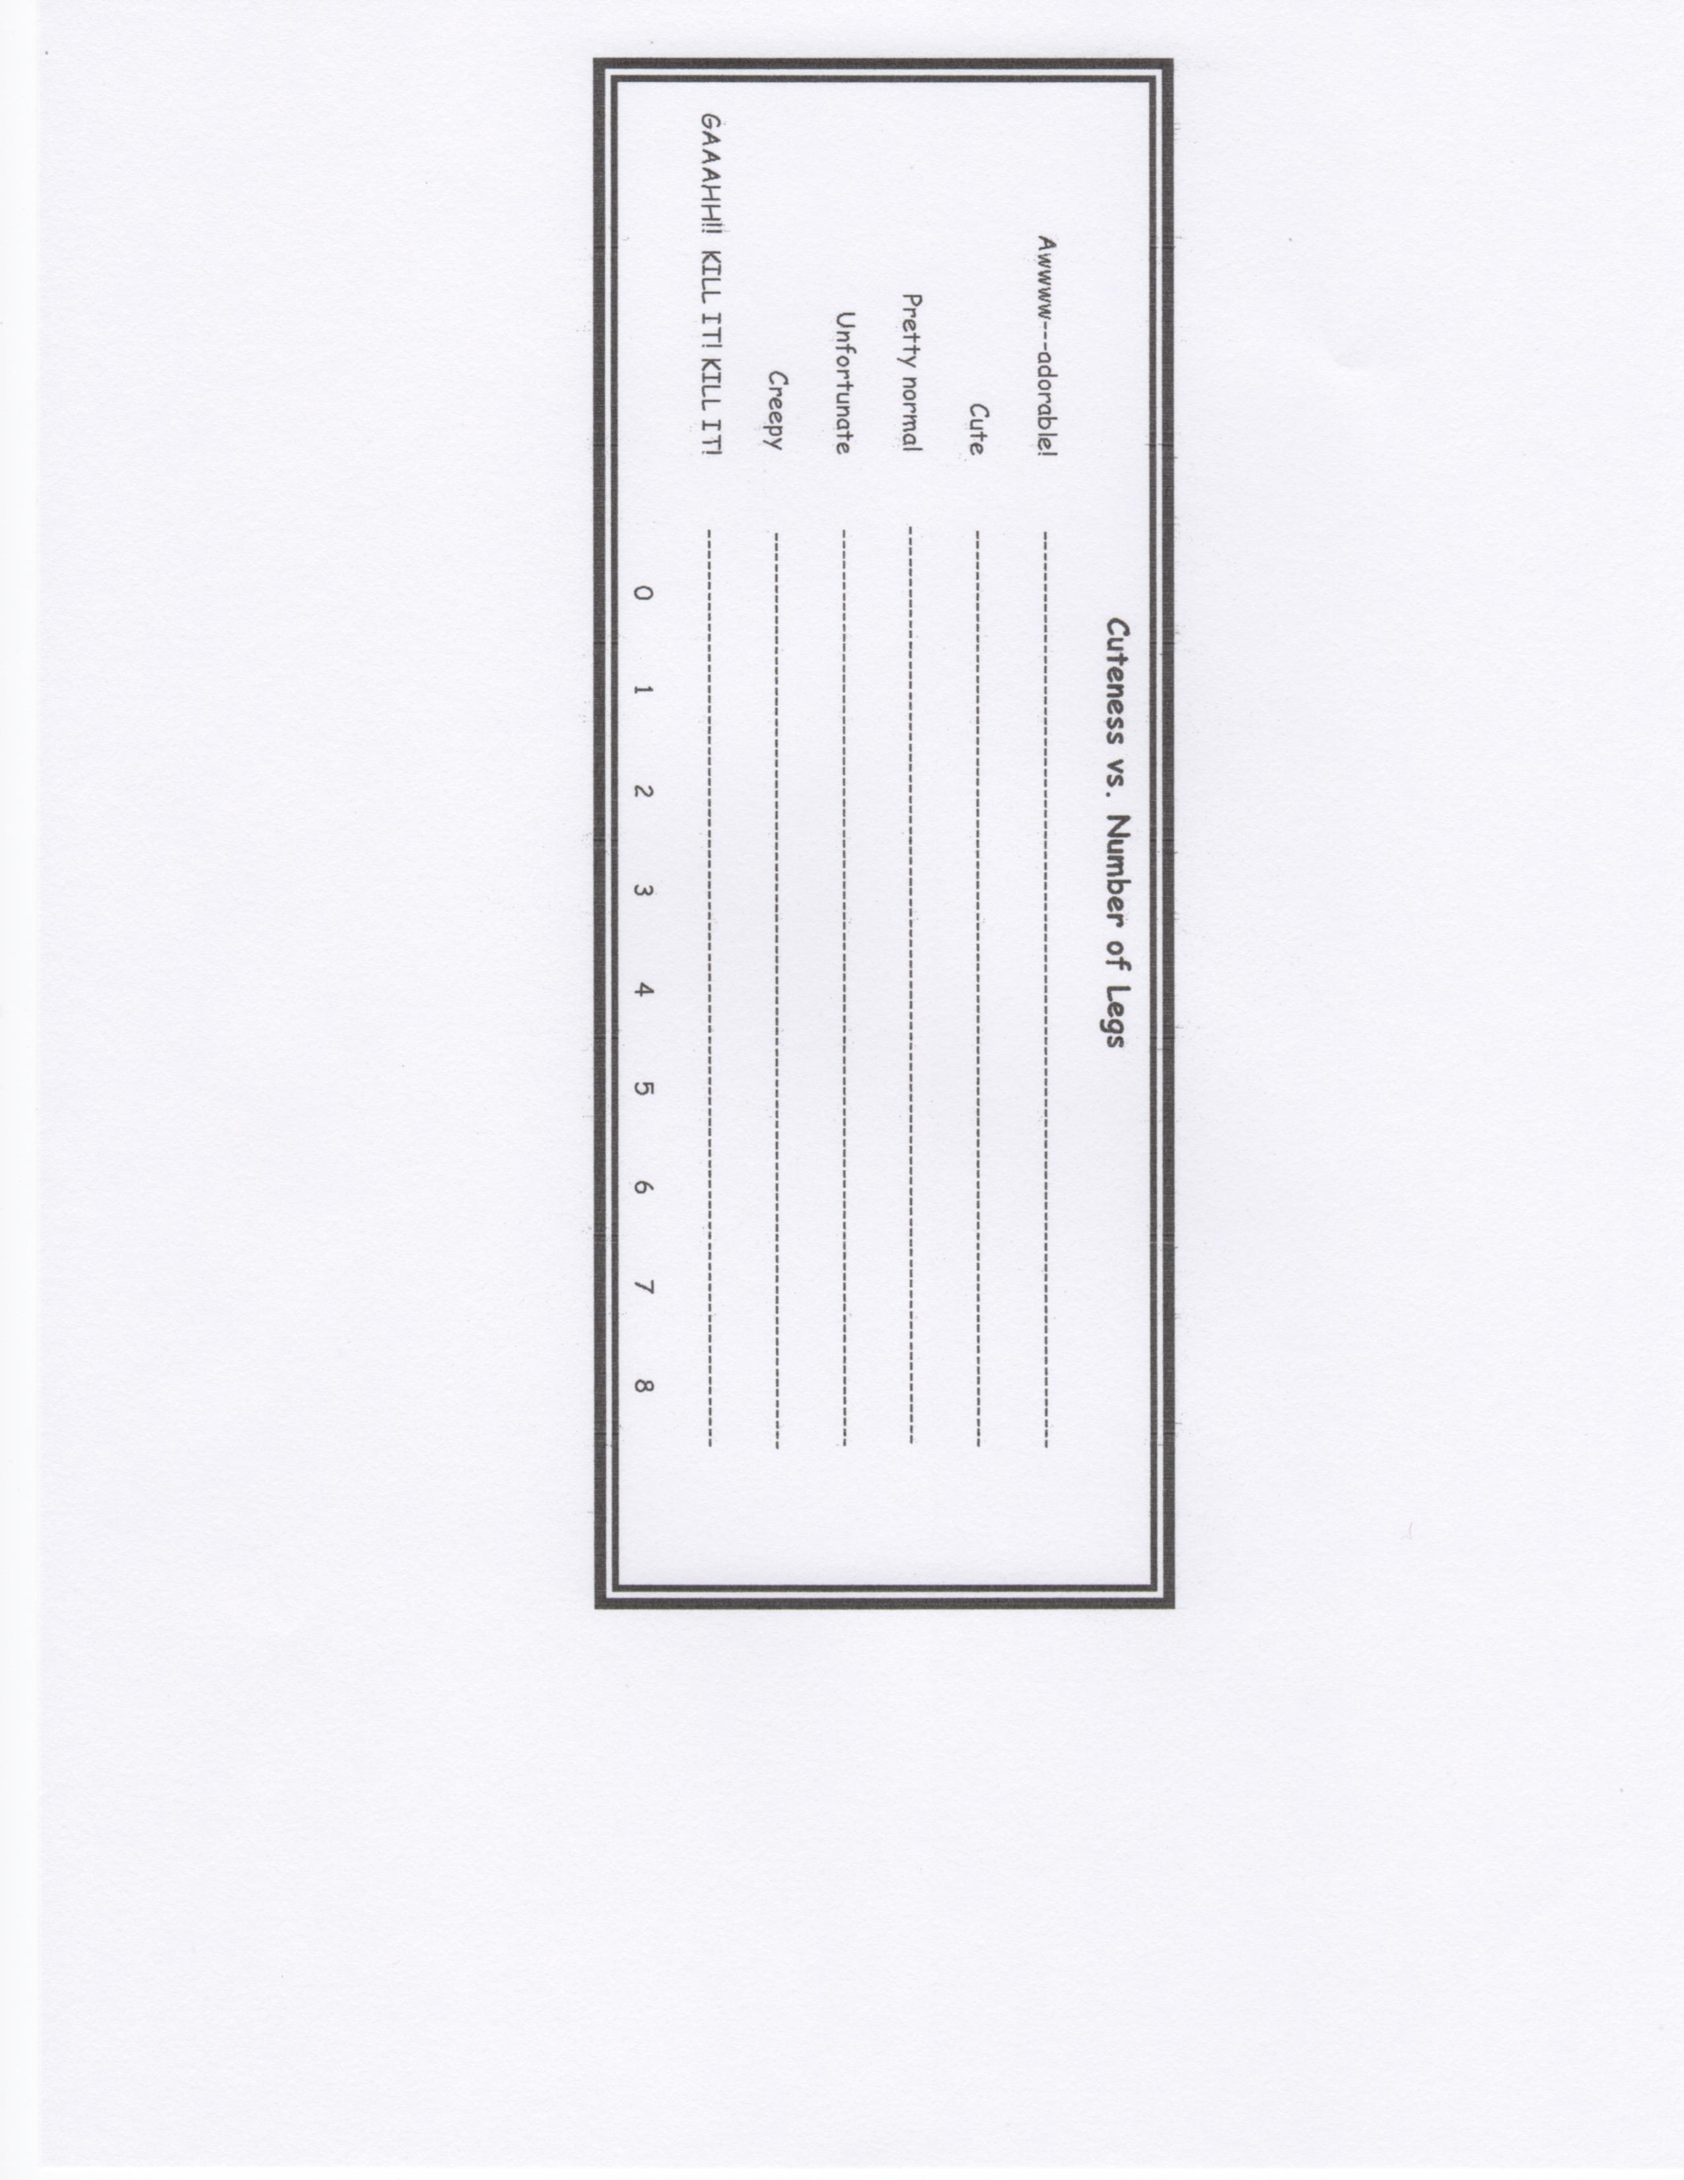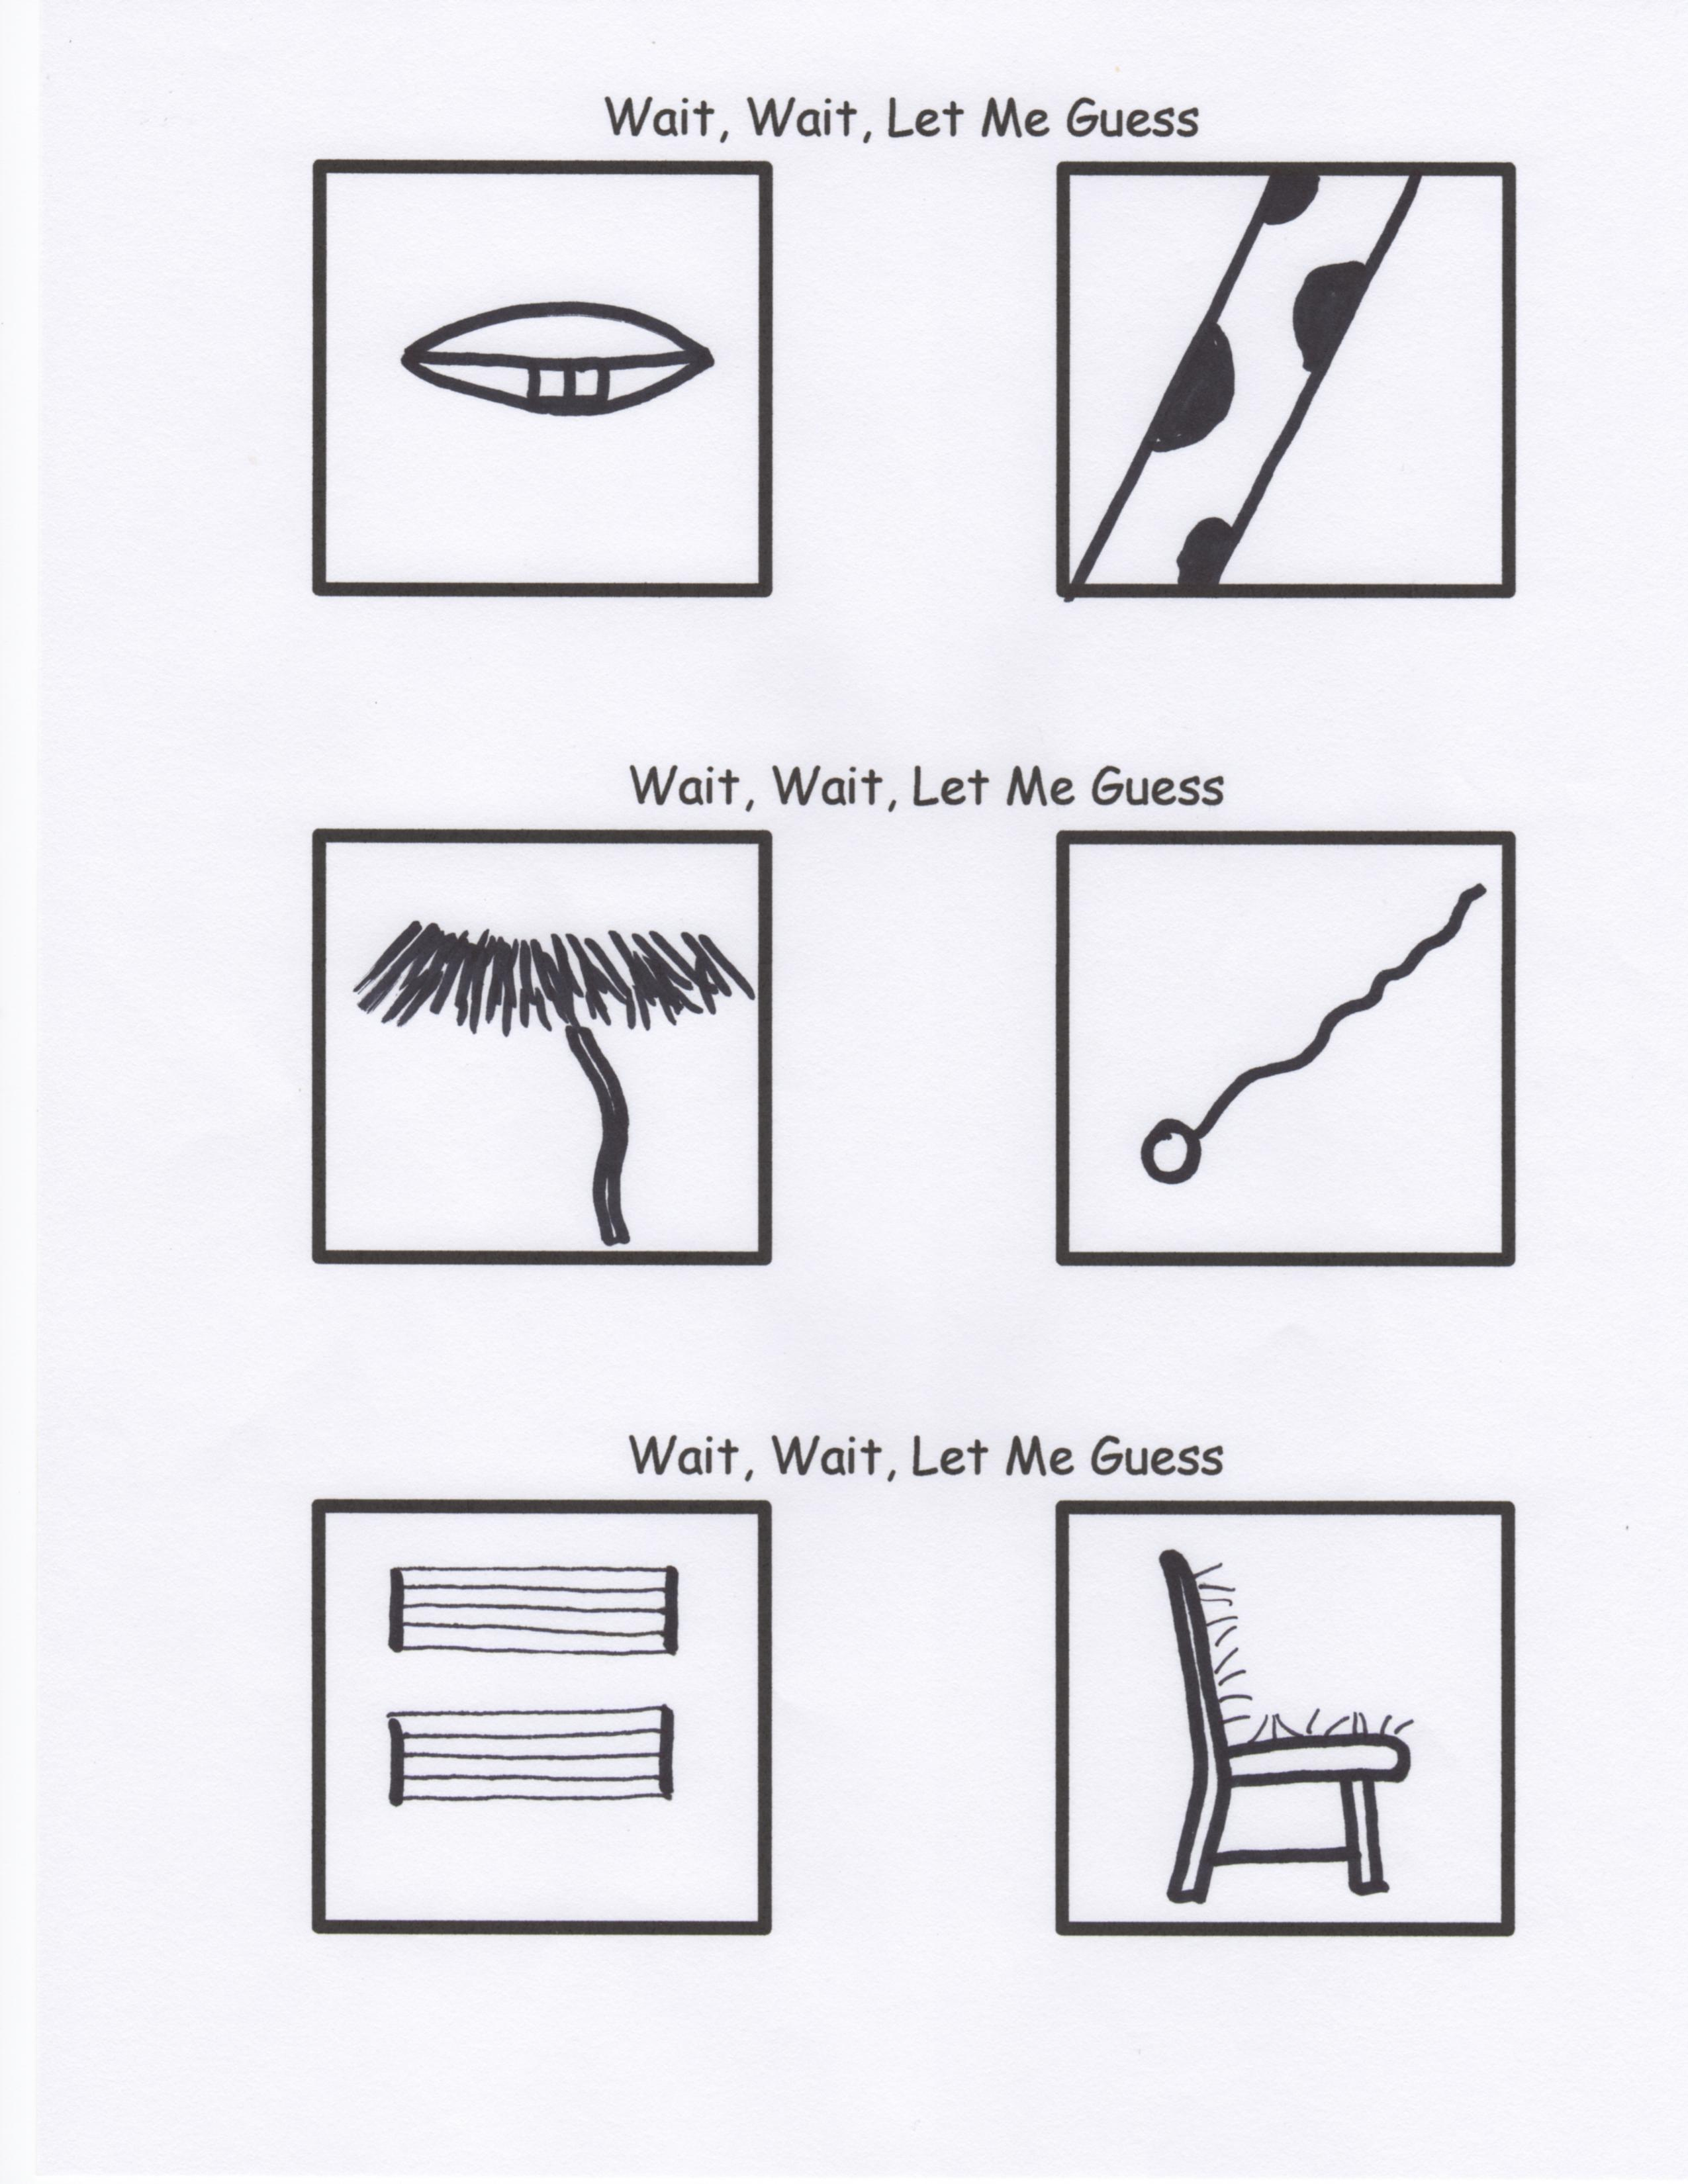

**For the True Scholars Among Us**

So…what did you think of the literary works of Martin Handford?