**June 10, 2018**

**Volume 6, Issue 32**

Sunday School Times

# The Last Word

***Stuff For Today***

• Wait, Wait, Let Me Guess!

• Thoughts

* The last word
* Questions and Answers

Published almost weekly, but more like…..whenever, so get used to it, OK?

**By Mr. Lyle (mrlyle1@gmail.com**

***Malachi 4:6***

***And he shall turn the heart of the fathers to the children, and the heart of the children to their fathers, lest I come and smite the earth with a curse.***

Malachi’s soliloquy is the concluding scene in the final act of the Old Testament. As the curtain begins to descend, the closing expression we hear, the last word spoken by God, is *curse.* The audience sits in reverent silence, unsure if applause is appropriate at this point. The lights go down; it is a somber ending to the story to be sure. Four hundred years of silence follow. God will say nothing more until His Son steps out onto center stage in Matthew.

The Old Testament would seem to be merely backdrop scenery, were it not for the New Testament. It is there that we realize what God was doing, and why. The panoramic background on the stage is filled with the colors and subtle hues and tints that point to the person of Jesus Christ. We began this exercise with a study of the first word in Genesis. It would be appropriate to consider the final word found in the Old Testament.

Verse four, of the fourth chapter of Malachi, is a reminder that the Law given to Moses was much more than just a piece of legislation. David reassures us in the Psalms that the decrees of God are wonderful and are to be studied and meditated upon, and that a close walk with the Lord is predicated on that truth. They are a *lamp unto my feet and a light unto my path.* The godly coordinate their lives by the commandments of the Lord. But as we have found, many of those laws also pre-figure the person of the Messiah, making them doubly delightful to contemplate and reflect upon.

God’s warning in the last verse is delivered with a cautionary portent. His exact words are, *lest I come and smite the earth with a curse.* That final word immediately takes us back to the Garden of Eden and the fall of man. When Adam and Eve sinned, a curse was pronounced by God upon mankind, as well as all of creation. Since that moment, the scourge of sin and the consequences of the judgment of God plague our daily existence. But our merciful God foreknew that, and planned a solution in eternity past. Salvation, and the eventual complete redemption of man from that curse, is the central theme of the Bible, from cover to cover.

In the original language, the word translated *curse* is quite interesting. It carries with it the subtle idea of a net or snare. Picture, if you will, a fisherman along the shore, working with a casting net. His polished technique is evident as the net unfurls in the toss and then drops into the water. Attached to his hand is a cord which he deftly begins gathering back towards himself. As the net descends around an unsuspecting fish, he has already drawn the bottom closed, sealing off any chance of escape for his prey. Likewise, if the hearts of God’s people are not focused upon Him, His judgment will be a shocking, sure, deadly surprise to the unprepared.

The common usage of this word also takes us into the realm of the camel driver. The more stubborn of these animals, at times, require a supplementary method of persuasion to submit to the master. The process of placing a large round guide ring through the soft cartilage between the nostrils is a bit unpleasant to imagine, and God is warning His people that He will administer the painful implantation of devices that will coerce obedience if necessary. God demands compliance with His Laws.

In addition to these nuanced definitions, the clear warning God communicated was a direct reference to Leviticus 27:29. In times past, as the Israelites were conquering and occupying the Promised Land, God had specific requirements assigned to individual battles for various reasons. In some instances, as in the case of the battle for Jericho, everything was to be *devoted* to the Lord. The identical Hebrew term translated as *curse* in Malachi, is translated differently in Leviticus. Everyone *devoted* to the Lord was to be killed. All that was flammable was to be burned. Nothing in the plunder could be ransomed, no one could be redeemed. Every living thing died, every combustible thing was destroyed, and anything that was left after those two ravages, was God’s. Consider the fact that those who were *cursed* or *devoted* to the Lord were not eligible for redemption. No price could be paid to bring them into a condition of relationship. Here we find the most significant concern of God. If His people were distracted and unconcerned with God and His love for them, they might miss the gift that was to come. He was planning to send a Savior, Jesus the Messiah, who would voluntarily go to a cross and shed His blood, and pay the necessary redemption price for all mankind who would accept the offer extended to them. Those not watching, those not attentive, would suffer the *curse* and miss the only possibility of redemption from sin.

The Old Testament begins with a subtle reference to the person of Jesus, and ends with a warning not to miss the Messiah and the redemption plan of God. Jesus Christ must be the focus of our lives. I trust that as you continue in your walk with God, your fascination with the Savior never ends, and that the reading and study of the Word of God become an ever increasing part of your life.

**Thoughts For Today**

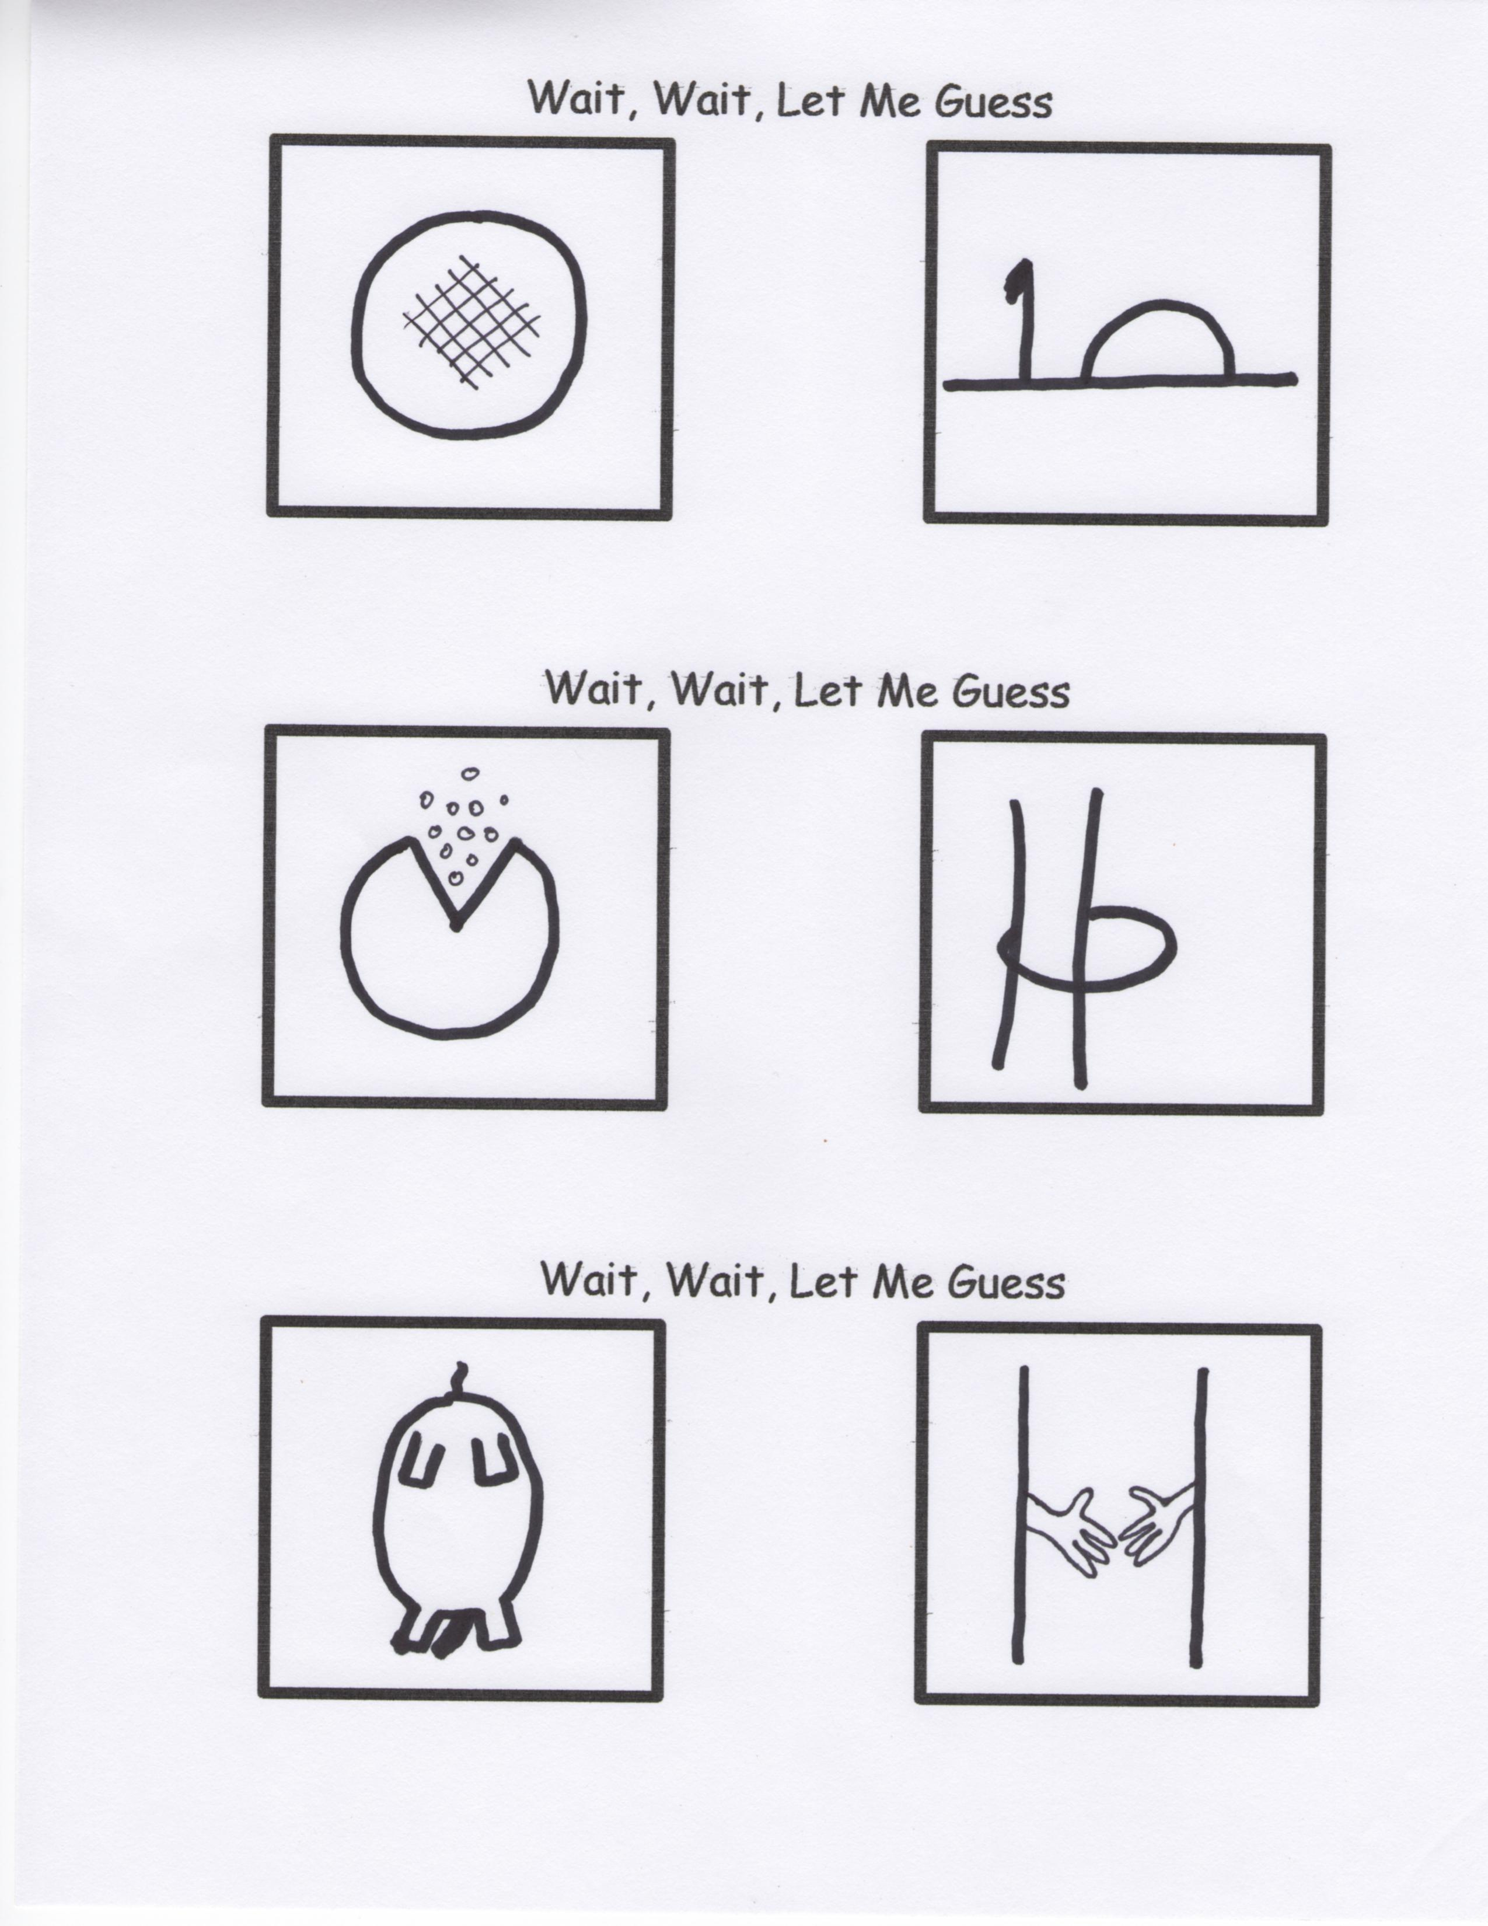

Why are little candy bars called “fun size?” It’s always more fun to eat a big one.

Do you realize that every time you clean something, you make something else dirty?

The word “swims” upside down is also “swims”.

You have to be odd to be number 1.

If your shirt isn’t tucked into your pants, then your pants are tucked into your shirt.

Is it rude for a deaf person to sign while holding a hamburger in their hand?

Mars is populated entirely by robots.

By Mr. Lyle (mrlyle1@gmail.com)

**A Few More Thoughts**

Your stomach thinks all potatoes are smashed.

Why is there no mouse flavored cat food?

Why is tuna sometimes called “tuna fish.” Chicken is never called “chicken bird.”