**February 11, 2018**

**Volume 6, Issue 19**

Sunday School Times

Published almost weekly, but more like…..whenever, so get used to it, OK?

# Bob and Darla’s Wedding

***Stuff For Today***

• Wait, Wait, Let Me Guess!

• A Valentine

* A Valentine ruined
* The Wedding

**By Mr. Lyle (mrlyle1@gmail.com**

***I Corinthians 13:4-6***

***4 Love is patient, love is kind. It does not envy, it does not boast, it is not proud. 5 It does not dishonor others, it is not self-seeking, it is not easily angered, it keeps no record of wrongs. 6 Love does not delight in evil but rejoices with the truth. 7 It always protects, always trusts, always hopes, always perseveres.***

Bob and Darla’s Wedding

The Bride----Darla

The Groom---Bob

The Maid of Honor---Ariel

The Best Man---Patrick

The Ring Bearer---Crush

The Officiant---Bruce

Narrator---Mr. Lyle

Guests---You

Today we will observe a wonderful time together in celebration of the sacred ceremony known as the wedding.

In little more than 8 years or so, many of you may be considering taking the plunge into the world of marriage. I will probably not be your teacher then anymore. Chances are that you will still find me here in the 6th and 7th grade classroom.

So I decided to approach the subject in a unique way. Valentines Day falls on a Sunday every 6 years or so. What better way to celebrate the day dedicated to love than with a wedding.

As a reminder, understand that Darla is a VERY high maintenance young lady! She is known to be quite exuberant and demanding. She shuns the idea that she is not the center of attention—always.

Bob on the other hand is…well…how shall I say it politely? Um…ok, Bob may be happy and fun loving, but he has some very annoying traits. And he is also a bit naïve, and cannot drive anything well.

Using the definition of love found in most of our world today, this couple’s chance of a successful marriage stand at slim to none. In the US today, 43% of all marriages fail for one reason or another. These failures cause untold heartbreak and misery for the men and women involved, and even more issues for any children that are caught in the turmoil.

When my grandparents were married, statistics show that less than 10% of all marriages ended in divorce. The year my parents were married, that percentage had risen to just over 20%. So what has happened?

The greatest factor stabilizing our country today is the concept of family. It is the core foundation of our society. Satan understands the principles involved and why God deemed marriage and the family good. And he has set out to undermine and pervert the definition of family in America today.

God’s definition of love, on the other hand, is one that can keep the marriage and family together. An unconditional, unwavering love, not a warm fuzzy feeling, is what God desires. He demonstrated true love for us when Jesus went to the cross and died for us “while we were yet sinners.”

If Bob and Darla are Christians, and are loving each other as God would have them to, even with all of their personal baggage that they are bringing into this marriage, even their marriage can be successful!

**Excuse Me, But Wednesday Is Valentine’s Day?**

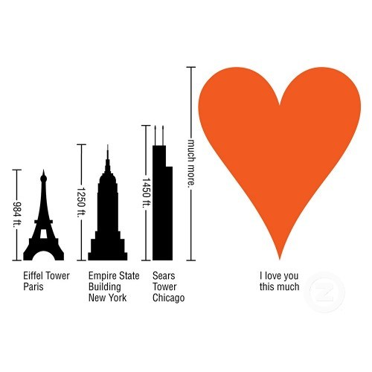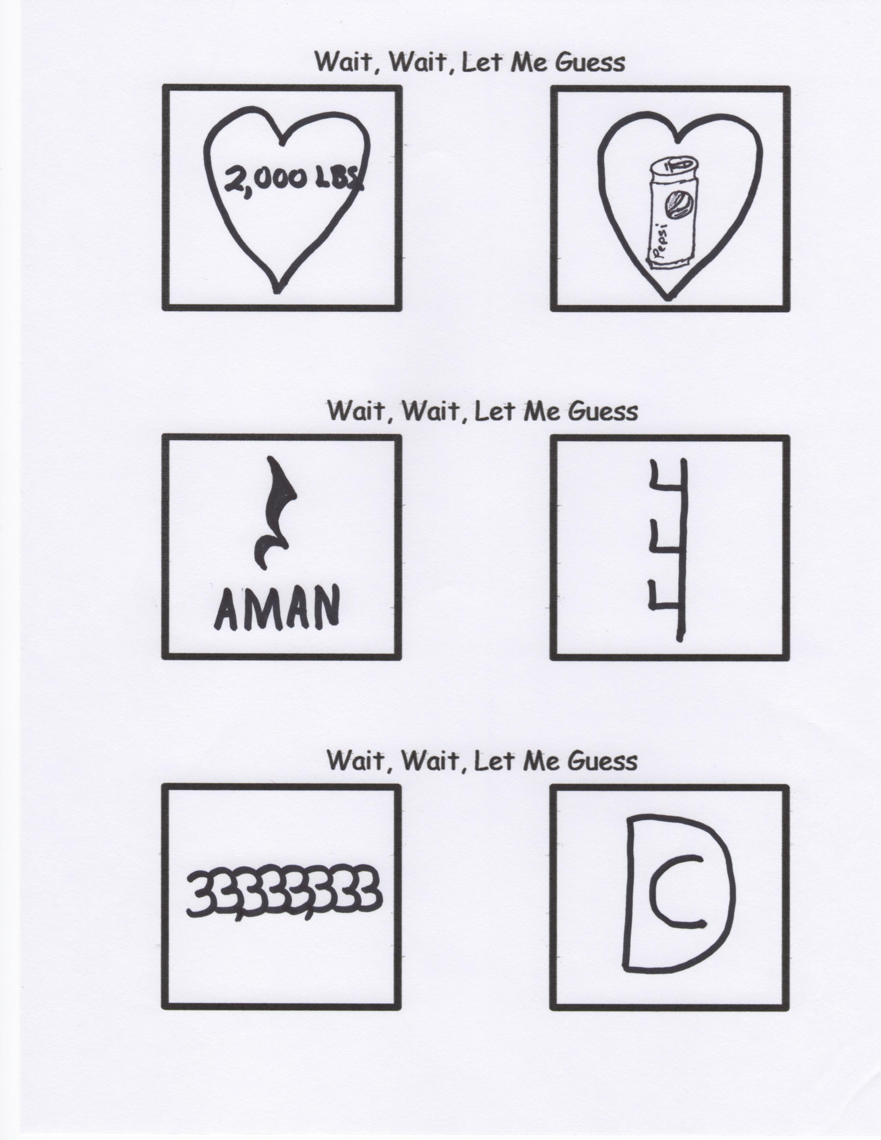

May I suggest a trip to Walmart to buy a very nice box of assorted chocolates. Be sure to get one with a “roadmap” of the flavors with their locations in the box. It may require you to spend a few extra dollars, but it is worth it.

Open the box, and take out the ones that you know your sweetheart doesn’t like. Save them for yourself. Next, take out some of the good ones for later—your sweetheart will never know the difference. (But be sure to keep the “roadmap”, or they will realize what you have done.)

And finally, duct tape the box closed. If they decide to throw the box at you in disgust, all that candy won’t go to waste.

Not a good idea you say?

If we are honest, there are times that we give to God but hold back for ourselves the choicest pieces of our lives. God wants the whole box of chocolates, not just part.

By Mr. Lyle (mrlyle1@gmail.com)

**For God so lo__ed the world**

**that He g__ve**

**His on__y**

**b__gotten**

**So__**

**__hat whosoever**

**bel__eveth in Him**

**should __ot perish**

**but have __verlasting life.**

**A Valentine for Mr. Lyle’s Wife**