**January 28, 2018**

**Volume 6, Issue 17**

Sunday School Times

***Stuff For Today***

• Wait, Wait

• There is no “i” in team?

* The Gospel

Published almost weekly, but more like…..whenever, so get used to it, OK?

# The Gospel In The Gates Of

# Jerusalem

***Nehemiah 3***

Nehemiah 3 reads much like a boring engineer’s report of an ongoing construction project. It is a comprehensive account of the rebuilding of the wall of Jerusalem. The captivity in Babylon was over and the Jewish people who had returned were struggling to bring their lives back to normal. With the leadership of Nehemiah, the plan was orchestrated to reconstruct the damaged walls surrounding Jerusalem. The Babylonians had left the walls in ruin seventy years previous. Restoring the walls was a matter of pride, identity, and security. The work was difficult and even dangerous. God approved and took note of all of it and recorded this footnote in history for us to see. With organization in place, the construction project began, and finished less than two months later.

A beautiful spiritual lesson can be found in the names of the gates of Jerusalem mentioned here. The plan of salvation and our ensuing Christian walk can be seen in detail as we take a tour of the walls of Jerusalem by way of a construction progress report.

*The Sheep Gate*. We begin at the Sheep Gate. The sacrificial animals were brought in through this gate into Jerusalem. Jesus was the Lamb of God. He was the Passover Lamb, the ultimate sacrifice offered once for all of time. There is a notation that the men of Jericho worked on the wall next to this gate. Jericho was a cursed city, a city of sin. Jesus carried our sin to the cross, bearing all of the sin of the world. This gate also reminds us that we are sheep, wandering our own way, lost. Jesus is the Great Shepherd, who came to search for and save those who are lost. It is fitting that our tour begins with the person of Jesus.

*The Fish Gate.* We would do well to recall the first command given by Jesus to new converts. He directed them to go and tell others what God had done for them. As Jesus called his disciples, He said that He would make them fishers of men. In fact, He stated that even He had come to seek and to save that which was lost. Spreading the good news about the salvation available to all is one of the most important aspects of being a Christian. Unfortunately, it is also the most neglected by many. The Fish Gate reminds us that we have an obligation to tell others about the love of God.

*The Jeshanah Gate.* Translated into English, the name would become the Old Gate. Our world that we live in today is one that accentuates and strives for that which is new. Many want the newest this or that, and it is human nature to look toward possessions or cultural practices from that view. But the Bible encourages us to look back to the old ways. God is the same yesterday, today, and forever. He never changes and the Bible remains ever true. The human heart has not changed over the years. We need to look to that which has proven to be correct and valid in the past. We are fallen creatures with a sin nature, susceptible to degrading moral standards and ever increasing sinfulness. As I look back at my few years upon this earth, I can see a decline in the values of the society that I live in. Many of the old ways were better, and we need to grasp hold of, and embrace, those things worth keeping.

*The Valley Gate.* This gate reminds us that there will undoubtedly be times in our life when we will suffer deeply. Life is not a cake walk, and we can expect difficulties. King David understood the valleys well as he mentioned in the 23rd Psalm. For the Christian, the walk through the valley is not a lonely one. God has promised to be with us during the dark times in life, and it is a comfort to know that is true. It is also during these challenging times that we have the potential to grow the most. Our joy is in the Lord, even in the valley.

*The Dung Gate.* In a world that used beasts of burden to accomplish many of the normal day to day aspects of life, there was a need to clean up after them. Refuse of that nature cannot remain in a city for long or health problems will arise. This gate was devoted to this very unglamorous but most necessary task. The honest individual will admit that we all have things in our lives that should not have residence there. We are called to live a righteous lifestyle as children of God. There will be times in our lives when some unmentionable things need to be cast out through the dung gate of our heart. Our spiritual health depends upon cleanliness.

*The Fountain Gate.* For the Christian, the joy associated with our salvation and walk with God is not to be bottled up within us. We are to share the love of God with the very dark world that we live in. Jesus said that the result of the Holy Spirit indwelling us is that He will be a fountain bubbling up through our lives. We should not be afraid to pour out our hearts into the lives of those around us.

*The Water Gate.* Note that no repairs were necessary on this gate. In the Bible, we see the analogy of Scripture with water. We are washed by the Word of God. We are cleansed by the Word. The Bible is not in need of repair, it does not need to be adjusted to become useful for our day. It is the one thing in life that we can be absolutely sure of. It is as relevant today as it was two thousand years ago, and will be in another two thousand years. Unchanging and applicable in every situation, the Bible, as is water, is not only necessary for cleanliness, but life cannot go on without it. We need the Word of God in our lives. We cannot live well without it.

*The Horse Gate.* In days of warfare, the army traditionally marched out through this gate, led by those on horseback and chariots. Paul emphasizes in the New Testament that we are involved in a spiritual battle every day. Our warfare is ongoing and very real, and we cannot let down our guard for even a moment, as the enemy will take advantage of any weakness found in our hearts.

*The East Gate.* Each morning, as the sun rose above the horizon and the new day began, the East Gate was the first to be opened. The uncertainty associated with the darkness dissipated, and the excitement of daybreak took root. We look forward to a time when our Lord will return. The dark night of sin will be ended and a glorious new day will dawn. Jesus will enter through the East Gate, and a new day that will never end, will begin.

*The Gate Miphkad.* Visitors to Jerusalem were to enter through this gate. It was the gate of inspection and review. Travel visas, or other documents, were checked at this gate before the traveller was allowed to proceed. This was also the gate through which a returning army entered back into the city. King David would meet his troops there, and the crowds were present to cheer them on in celebration of a job well done. We will one day stand before Jesus in review, at the judgment seat of Christ. For the Christian, all that we have done will be open for evaluation, and our rewards will be handed to us personally by our Savior. It is not a matter of salvation at this point. That issue was settled at the cross. This time of inspection is focused upon our actions as a child of God since the moment of our new birth.

*The Sheep Gate.* We end our tour at the Sheep Gate. Our lives should revolve around the person of Jesus Christ. It is because of Him that we live and have our being. He is the sum total of all that is important. He is the Alpha and Omega, the Beginning and the End.

Even a lowly engineer’s progress report of something as benign as the building of a rock wall, when inspired by the Holy Spirit and included in Scripture, need not be overlooked and ignored. God included it to give us a modicum of insight into what He expects of our walk with Him as His children

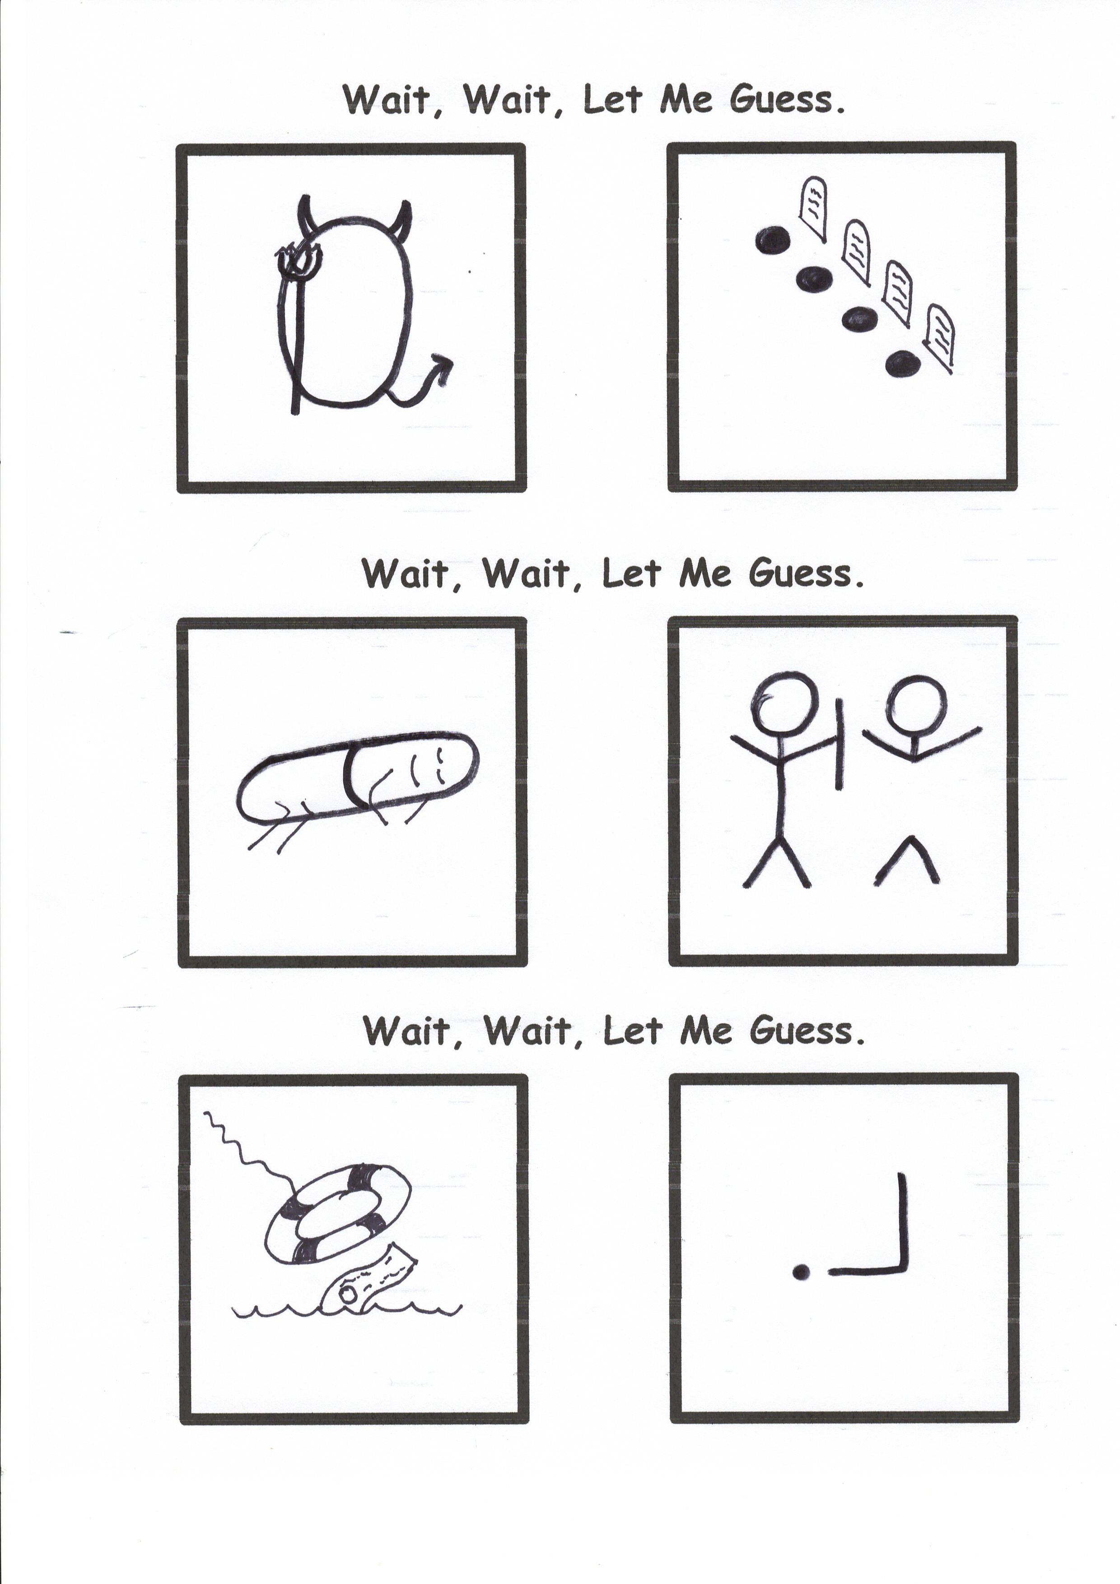

T E A M

There it is!