**January 7, 2017**

**Volume 6, Issue 14**

Sunday School Times

***Stuff For Today***

• Wait, Wait, Let Me Guess

• Girl Scout Cookies

* 12 Steps to Success
* Bears and You

Published almost weekly, but more like…..whenever, so get used to it, OK?

# The Great Bear Hunt Of 2018

**By Mr. Lyle (mrlyle1@gmail.com)**

***John 15:2-9,16***

***2 Every branch in me that beareth not fruit he taketh away: and every branch that beareth fruit, he purgeth it, that it may bring forth more fruit.***

***3 Now ye are clean through the word which I have spoken unto you.***

***4 Abide in me, and I in you. As the branch cannot bear fruit of itself, except it abide in the vine; no more can ye, except ye abide in me.***

***5 I am the vine, ye are the branches: He that abideth in me, and I in him, the same bringeth forth much fruit: for without me ye can do nothing.***

***6 If a man abide not in me, he is cast forth as a branch, and is withered; and men gather them, and cast them into the fire, and they are burned.***

***7 If ye abide in me, and my words abide in you, ye shall ask what ye will, and it shall be done unto you.***

***8 Herein is my Father glorified, that ye bear much fruit; so shall ye be my disciples.***

***9 As the Father hath loved me, so have I loved you: continue ye in my love.***

***16 Ye have not chosen me, but I have chosen you, and ordained you, that ye should go and bear fruit.***

The context of these verses is significant. The following day, Jesus would lay down his life on a cross. It is no accident that Jesus commanded us to bear fruit, and then gave us the most incredible demonstration ever. The only fruit that will last is that which grows out of the cross.

We are chosen by a God who’s choices bear the weight of eternity. That decision was with purpose in mind. We can confidently bury our fears and hesitations, knowing that God will not abandon us or leave us barehanded and barefoot. He can and will remove the barricades and obstacles. Robert E. Barron said *“No one is granted an experience with God without being subsequently sent.”* We can bear in mind that God is in control.

So, what exactly is fruit-bearing? And what fruit have we been called to bear? In a nutshell, it is loving others and leading them to Christ. All too often the horrors and reality of Hell are put out of our minds. We bear the responsibility of sharing the Gospel with a spiritually dead world that, without a relationship with God, will die one day and be buried and suffer unimaginably for eternity. That thought we should find unbearable.

So God, the ultimate vine dresser, prunes us and cultivates us, to bear fruit. We are left with the impression that it is completely unacceptable to not bear fruit. We are to make disciples. That requires us to love others.

There is one final key to success in this area. Bearing fruit is going to be impossible with out a close connection to the vine—Jesus. If we are barely connected, fruit bearing is going to be difficult, if nonexistent. And that connection is based in the Word of God. We must be continually absorbing the Word, letting it soak into us and cleanse us and give us an understanding and a desire to be close to Him.

Finally, and maybe most importantly, bearing fruit is ultimately for the glory of God. God is glorified when we bear fruit—good fruit. Being a fruit-bearing branch closely connected to the vine results in not just a barely bearable situation, but rather, our lives can be a joyful experience always—bearing fruit.

This White Space Has Been Set Aside for Notes of Today’s Lesson

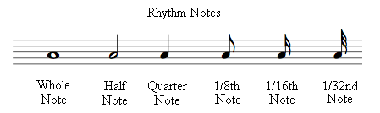

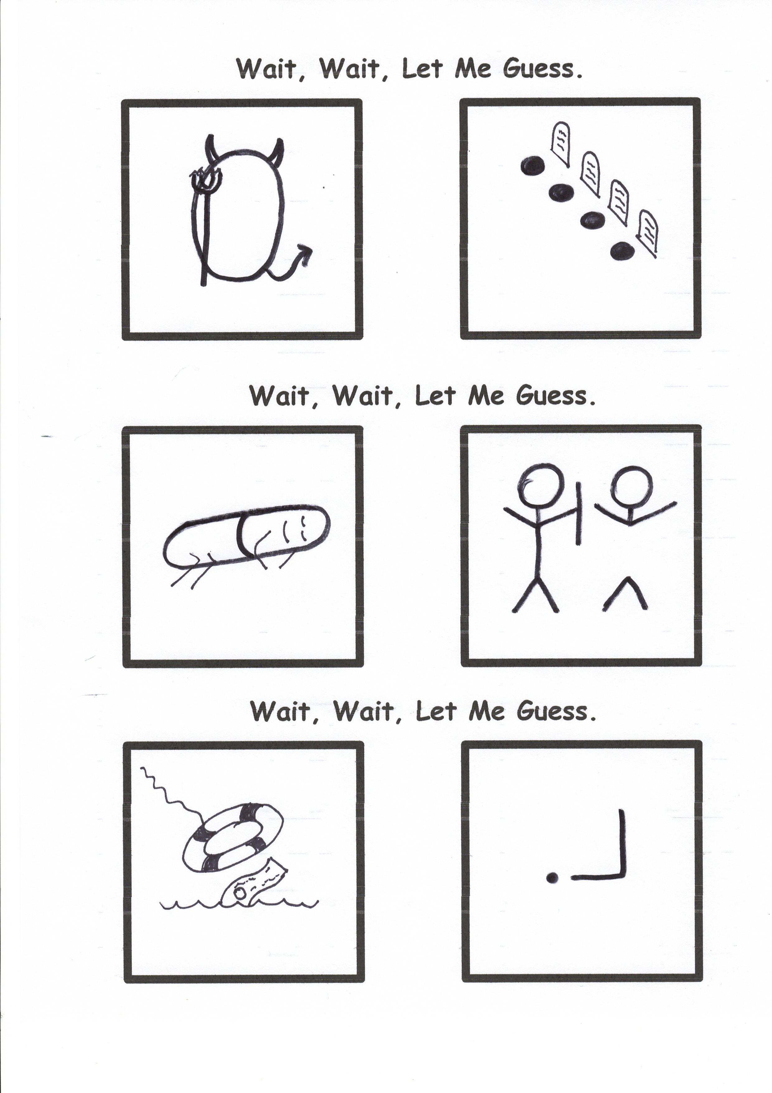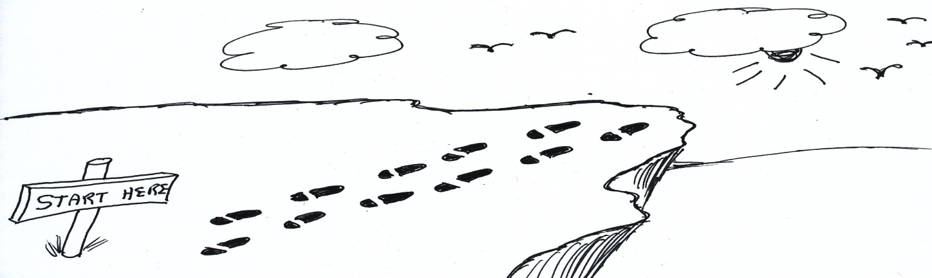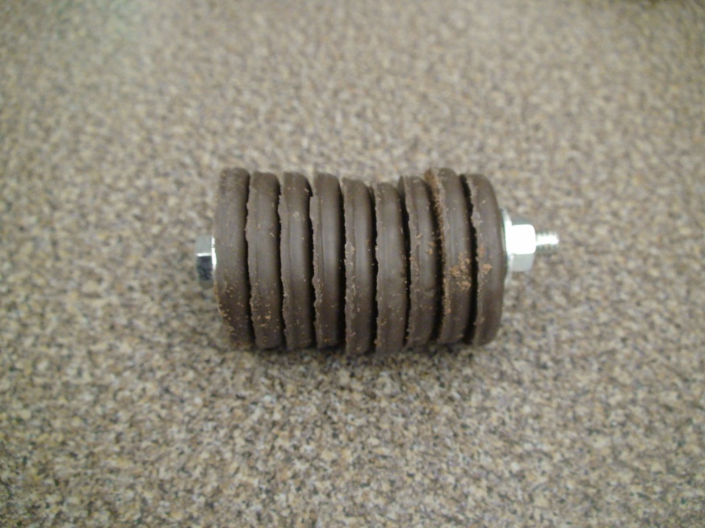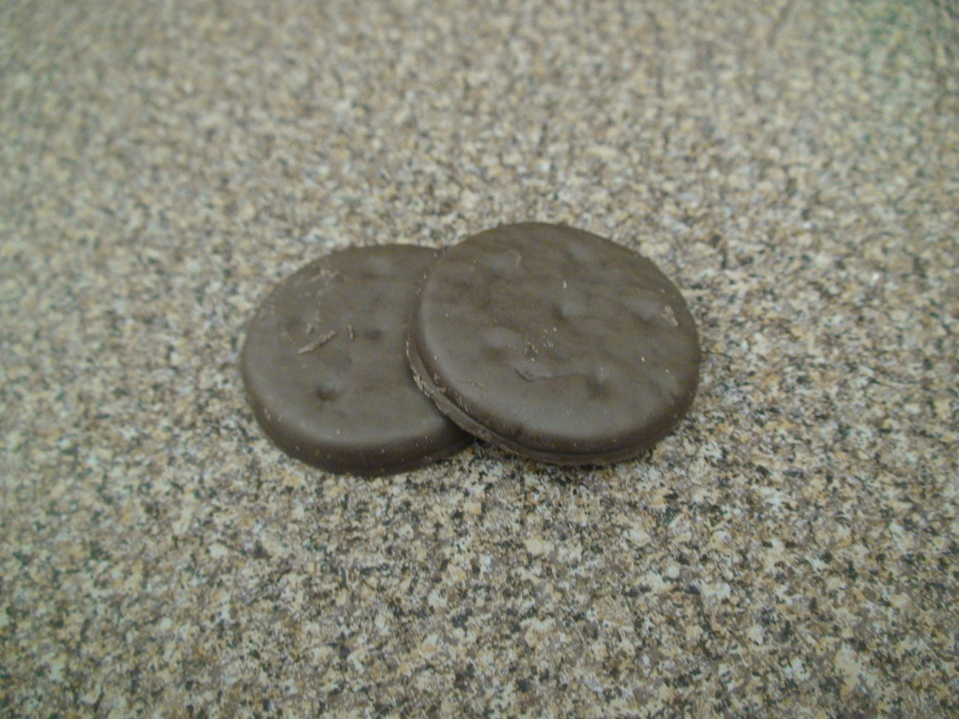

**Girl Scout Cookies Go On Sale**

**Thin Mints**

**Thick Mints**

**Wile E. Coyote’s 12 Steps To Personal Success**