**November 26, 2017**

**Volume 6, Issue 10**

Sunday School Times

Published almost weekly, but more like…..whenever, so get used to it, OK?

# The Prodigal Family

***Stuff For Today***

• Wait, Wait, Let Me Guess!

• Foreign Language

* Worship Signals
* A lady named “Glamorous”

**By Mr. Lyle (mrlyle1@gmail.com**

***The Book Of Ruth***

**Multiple Choice Outline For Today’s Lesson**

1. This lesson taught by

a.___Mr. Lyle

b.___Ol’-what’s-his-name

c.___His Majesty

2. Mr. Lyle’s family tree is

a.___really just a broken branch

b.___”funky”

c.___His Majesty thinks “a” is the right answer.

3. “Skittles” in Hebrew means:

a.___”Chocolate”

b.___”Unicorn Poo”

c.___His Majesty wishes it was “Kit Kat Bars”

4. Thou shalt not

a.___lick all of the color off of the Skittles and then put them back in the bag.

b.___put Skittles up our nose.

c.___quote or sing any part of “The Little Mermaid”

5. Home is where

a.___Mom buys me Skittles

b.___Dad buys me Skittles.

c.___the castle is

6. When life is hard

a.___I believe everyone should turn to Skittles for support

b.___I believe the more Skittles you eat, the better things get.

c.___I turn to Kit Kat Bars.

7. The best color of Skittles is

a.___Razorback Red (because of that crazy play in yesterday’s Razorback game)

b.___green (because it is so politically correct.)

c.___Dorian Gray (because they are Wildely delightful and last forever. Get the picture?)

8. This outline has got to be the stupidest outline ever, but…

a.___I tasted the rainbow!

b.___I will have a serious case of Skittles Pox

c.___His Majesty’s generosity will be fondly remembered by his subjects and they will live happily ever after. The End.

In the book of Ruth we find an unvarnished and uncensored account of a poverty stricken family making poor choices. Their condition goes from bad to worse as life throws them one curve after another. The decisions we make in life have consequences. Sometimes the choices we make haunt us for a lifetime.

God’s laws were clear regarding their options. Elimelech should not have taken his family away from the Promised Land. The hardships of famine should have been endured with others who believed and lived as God’s people. Instead, he chose to subject his family to the despicable lifestyle present in Moab.

When the little family’s spiritual leader died, the sons, as they came of age, decided to marry women from Moab. Marriage is a huge step in life, and these young men boldly stepped in exactly the wrong direction. God had warned His people over and over against intermarrying with the population of neighboring pagan nations.

When both young sons unexpectedly died, Naomi was left broken, hopeless, and alone.

There is one bright spot in this tale: a young lady named Ruth. Having grown up in the spiritual darkness of Moab, she caught a brief glimpse of the One True God in the lives of her new family. Not wanting to lose that, she boldly chose to follow her mother-in-law back to Israel.

Her willingness to leave everything she had ever known behind and embrace and identify with this new life she had found is just the beginning.

Most family histories in the Bible are centered on the men—father to son. As God gives us the family tree of the Messiah, we find Ruth proudly displayed in one of the branches. Who would have thought we would find a woman guilty of incest, a prostitute, an adulteress, and a woman from an unbelievably disdained, sinful background. God is able to forgive all sin and use the cleansed believer. We find an excellent example of this in the person of Ruth.

**Foreign Language 101**

By Mr. Lyle (mrlyle1@gmail.com)

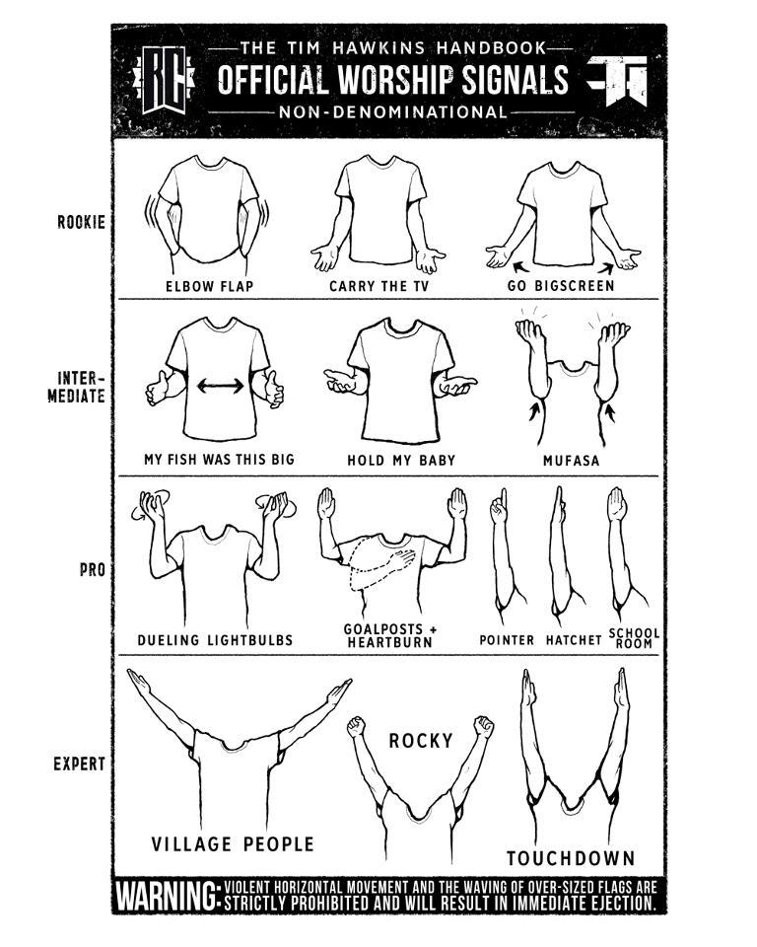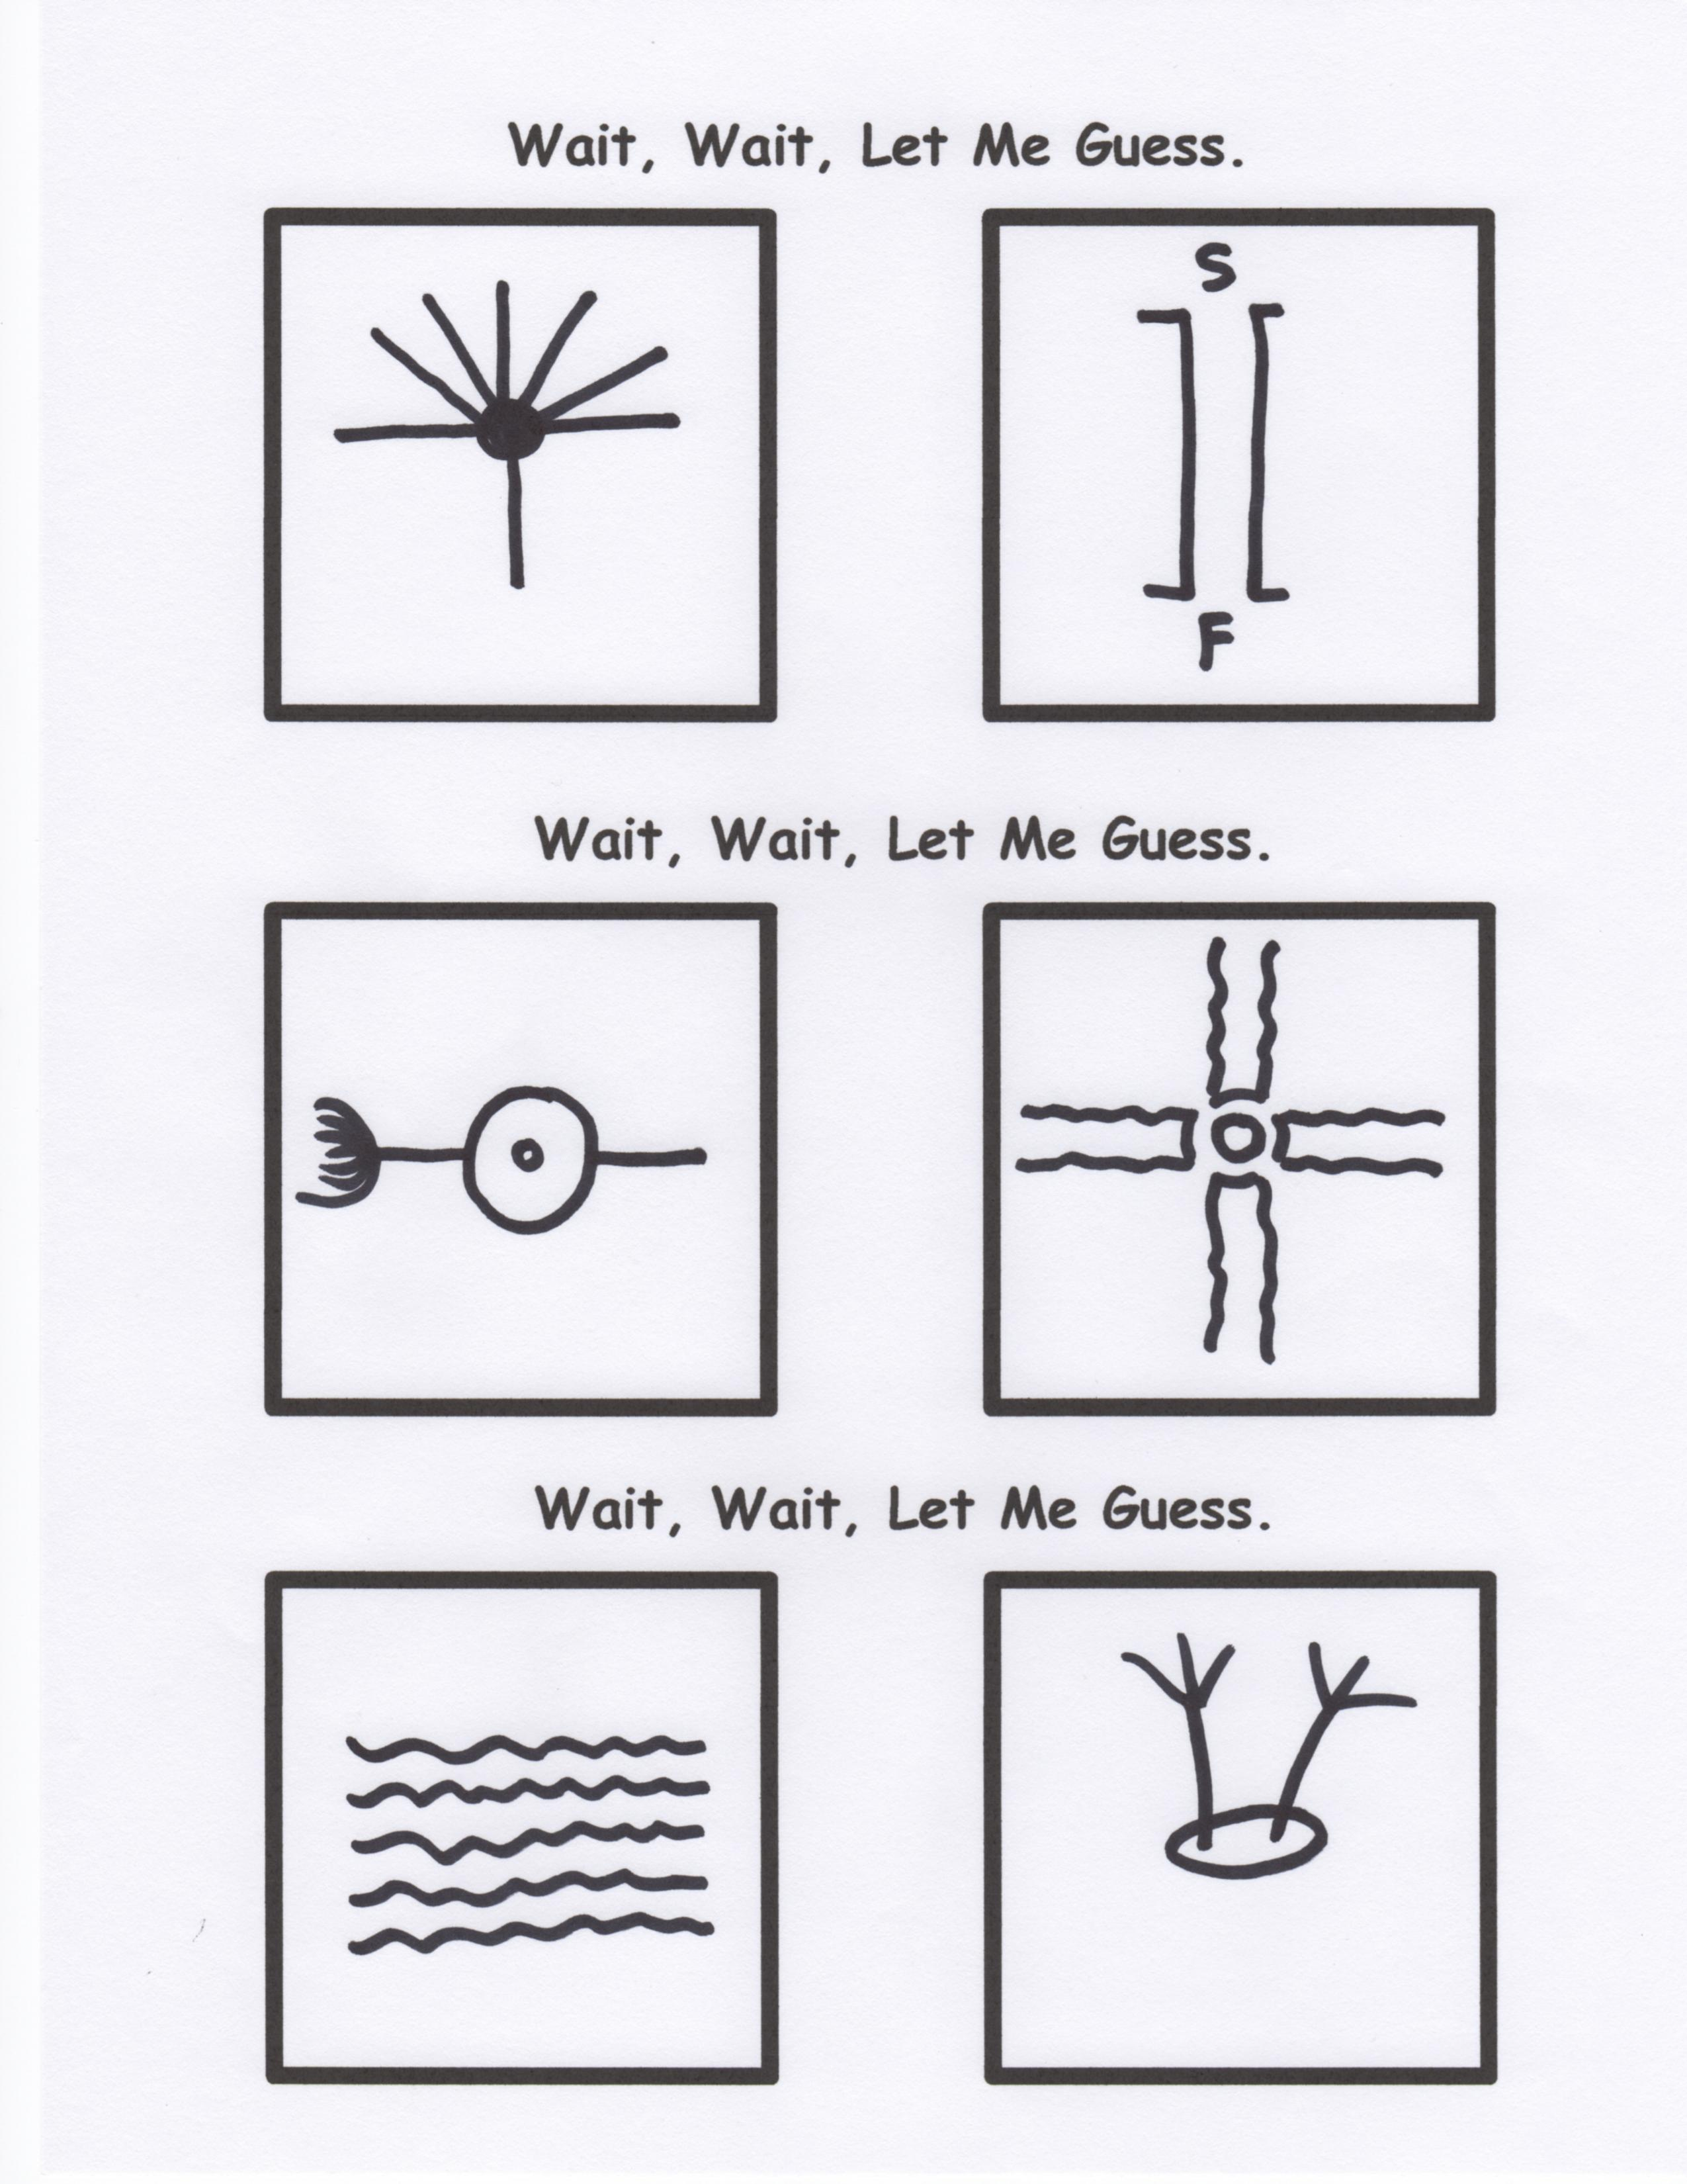

**Searching For A New Church Motto?**

1. Our Sundays are better than Dairy Queen’s.

2. Life stinks. We have a pew for you.

3. Honk if you love Jesus. Text while driving if you want to meet him.

**Official**

**Non-denominational Worship Signals**

Phrases every world traveller needs to know:

1. Wa Shing Ka

2. No Pah King

3. Tai Ni Po Ni

4. No Bai Dat Ting

5. Ai Bang Mai Ni

6. Wai Yu Mun Ching

7. Yu Stin Ki Pu

**Wait, Wait, Let Me Guess**