**July 9, 2017**

**Volume 5, Issue 36**

Sunday School Times

***Stuff For Today***

• Random thoughts to think about

• Bonus comic strip

• Of checker boards and the shadows cast upon them…see photo!

Published almost weekly, but more like…..whenever, so get used to it, OK?

# Truth or Consequences

**By Mr. Lyle (mrlyle1@gmail.com**

***James 1:14-15***

***14but each person is tempted when they are dragged away by their own evil desire and enticed.***

***15Then, after desire has conceived, it gives birth to sin; and sin, when it is full-grown, gives birth to death.***

Nearly fifty years ago daytime television featured a game show called *Truth or Consequences.*  Today’s lesson has nothing in common with this old TV program. I only mention it because the name is an appropriate title for our subject this morning.

***Sin***

Since the fall of Man in the Garden of Eden, we have all inherited a condition that the Bible refers to as a *sin nature.* If we are honest, we must admit that we do not need to be trained to do wrong—that comes naturally to all of us. Our true difficulty lies in recognizing the difference between right and wrong, and then doing what is right.

Enter: God’s Word—the Bible. The only reliable source of clearly defined right and wrong is Scripture. God shines His light of perfect love, revealing that which is godly and pure, and exposing the degradation of sin for all to see. A black and white checkerboard stands as an analogy of this effect, with it’s stark, contrasted, light and dark squares. The white denotes that which is pure and holy; the dark symbolizes that which is ungodly and loathsome.

In the photo below, the glass sitting in the middle represents us. The world we live in would influence us into believing that we as individuals can define what we want to call good and bad. Adam and Eve were deceived and entrapped in the very same snare. To rely on our own understanding of right and wrong is to cast a shadow of doubt upon what God has so clearly defined for us.

Actions and attitudes that, fifty years ago were considered sin by nearly all, have since become commonplace, finding a comfortable acceptance in today’s society. The *BIG* ones that first come to mind are abortion, homosexuality, loose morality, drugs and alcohol. There are others that may even be more devastating to our society today. Our world no longer defines marriage, or family, or honesty, or God from a Biblical perspective anymore. Right and wrong have been skewed severely.

In the photo, note the labeled squares. Believe it or not, *A* is exactly the same shade of dark as *B*! An optical illusion, to be sure, but the lesson here is, that, our shadow of doubt regarding God’s absolute standards distorts the real truth.

Sin is sin. Period. God has defined it, pointed to it and said ‘Stay away from it!” I just hope we recognize it in the correct light.

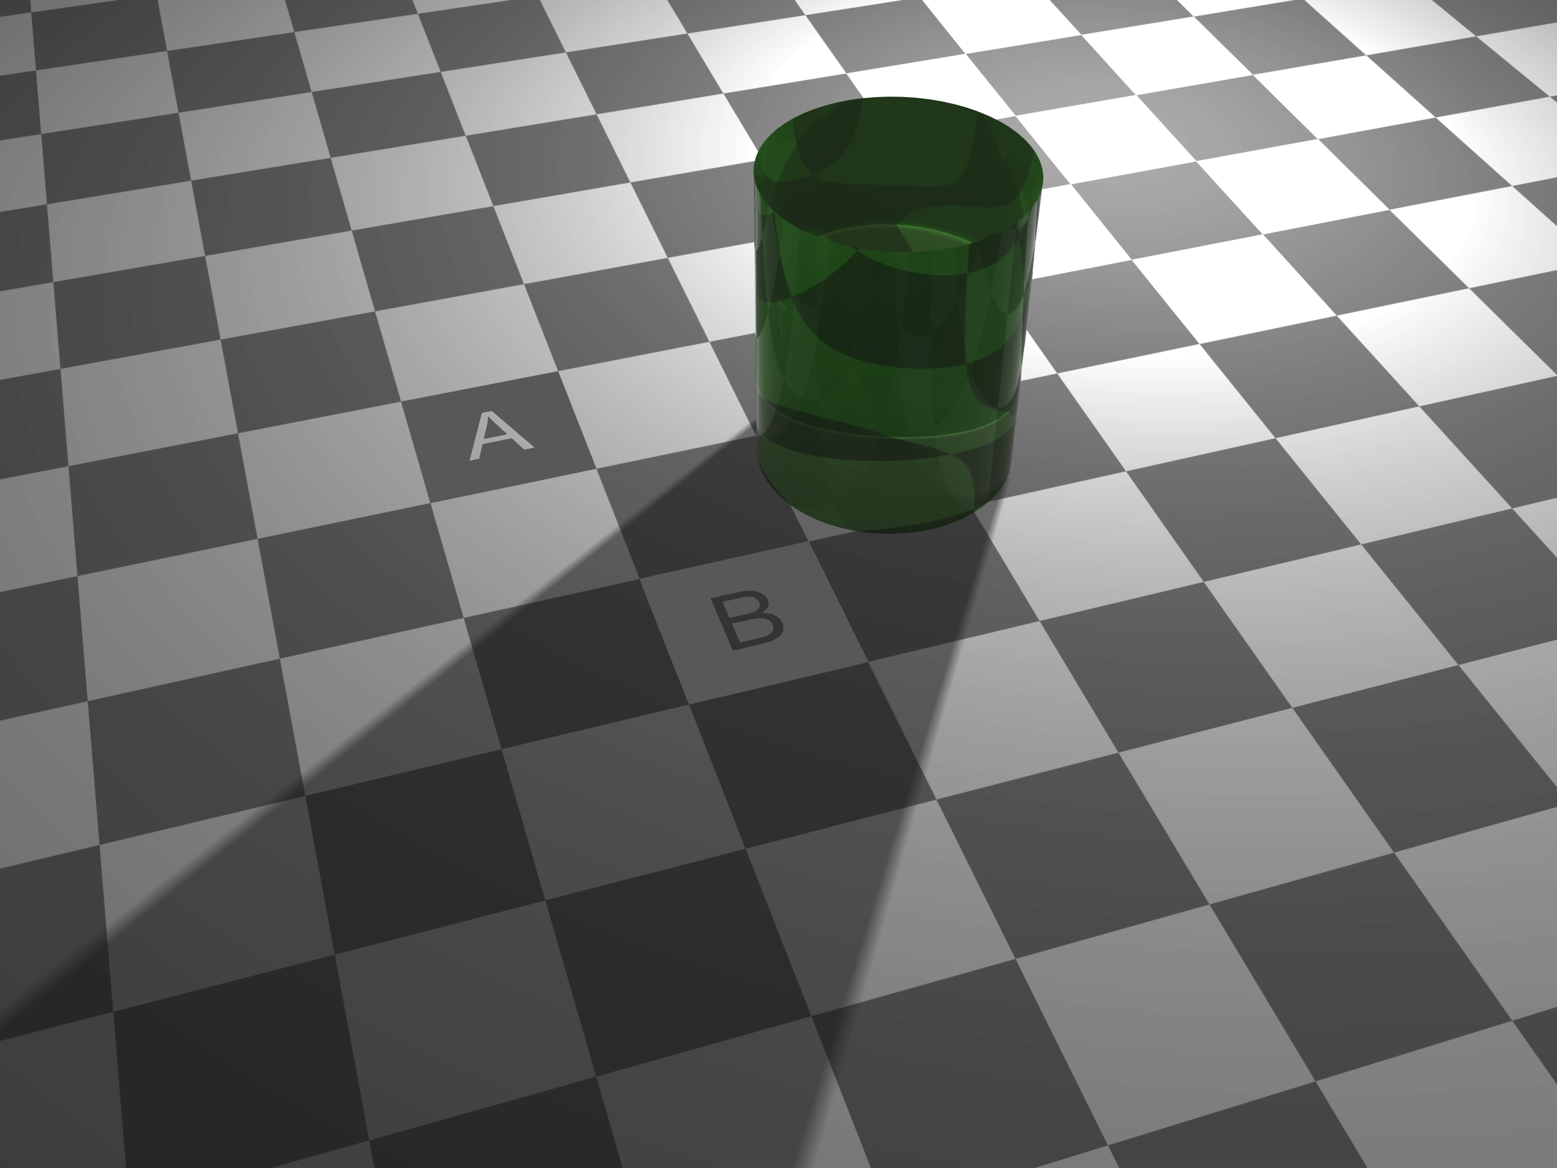

**Random Thoughts…**

**Worth Every Penny You They Cost You**

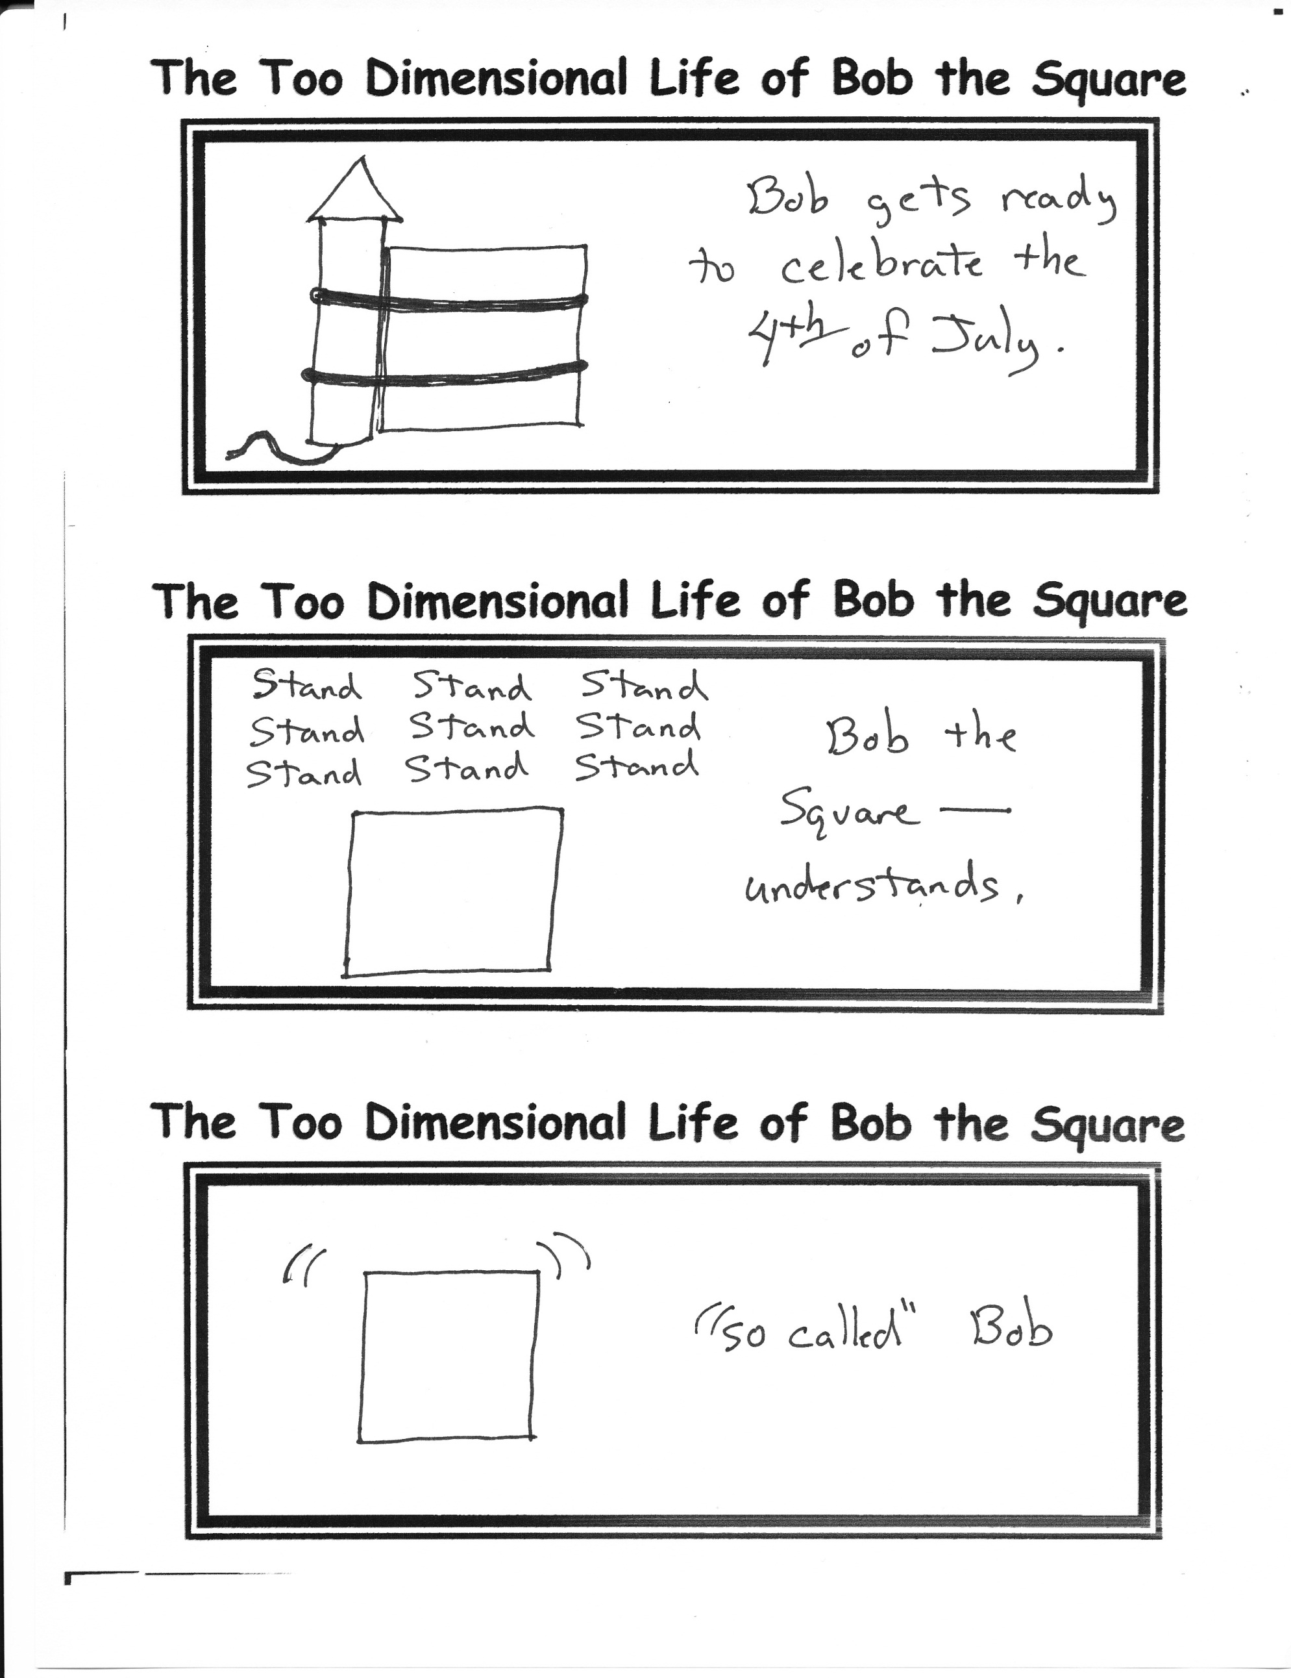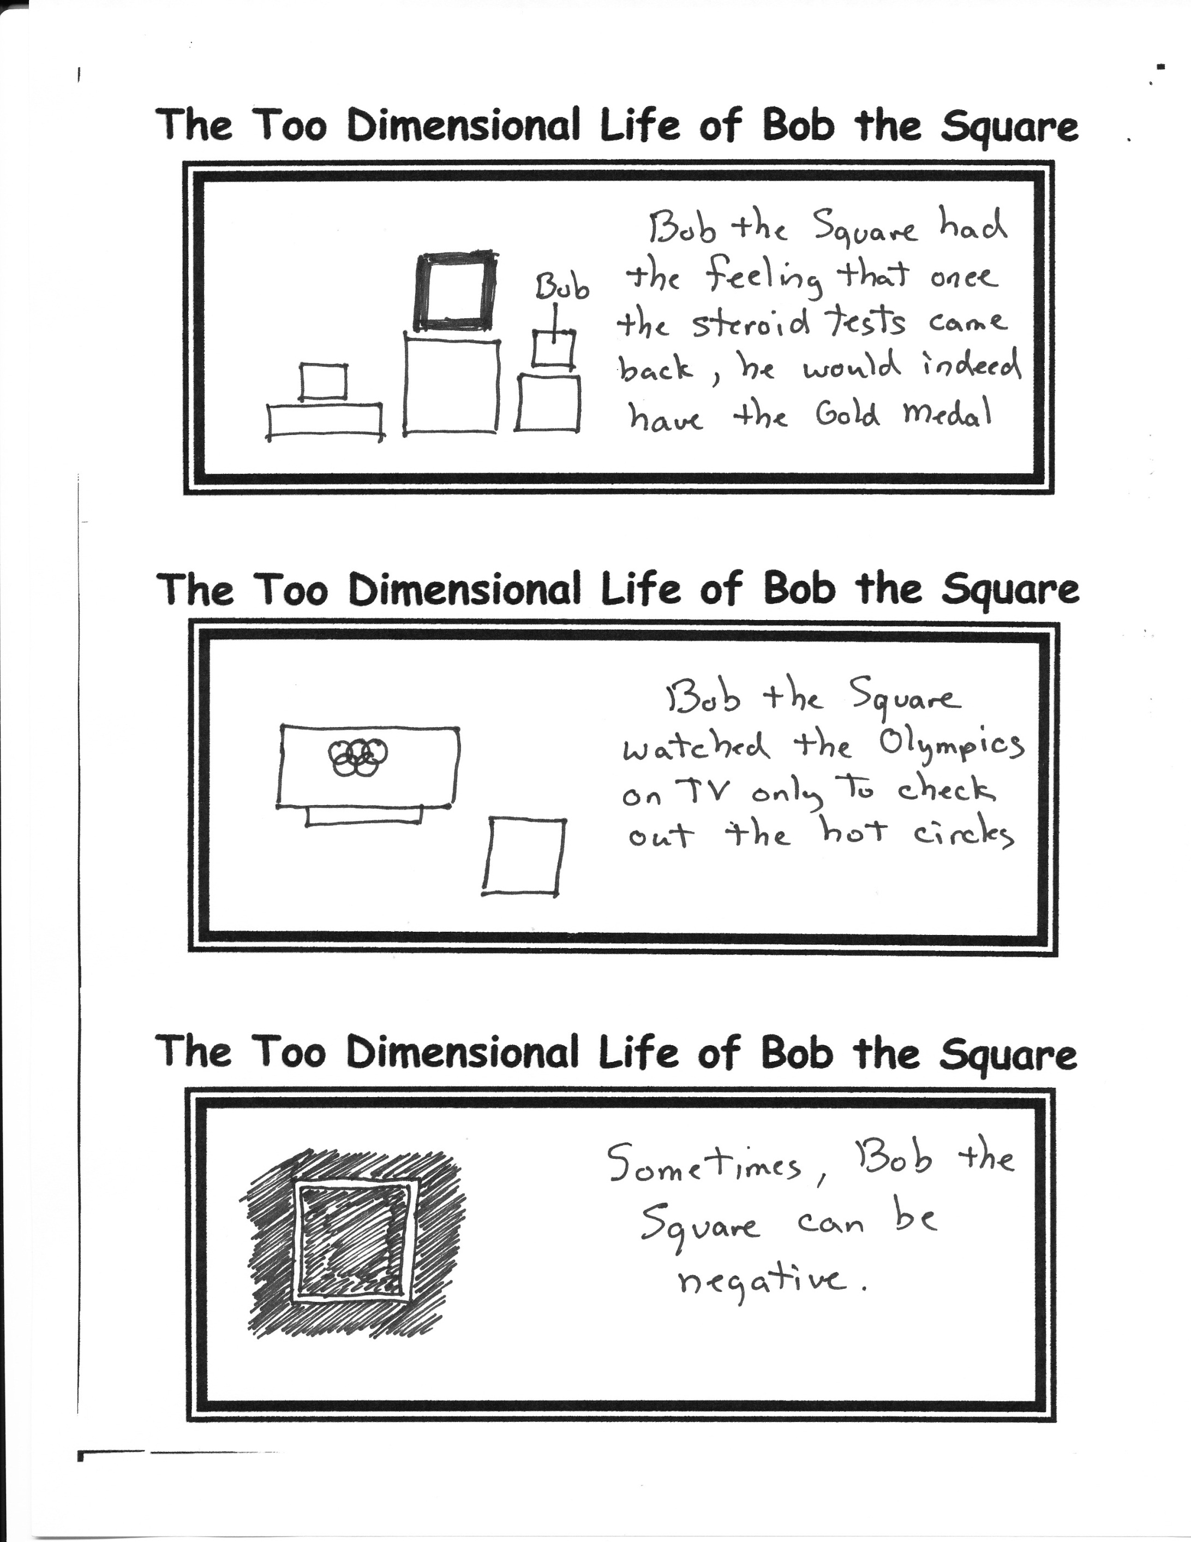

1. Am I the only person in the world who has never actually seen any one slip on a banana?

2. Choose very carefully and wisely today…you never know which donut may be your last!

3. Somehow I don’t think any of the Christian TV networks are going to produce a TV show called “Worship Idol”.

4. Sin wouldn’t be so attractive if the wages were paid immediately.

5. Don’t put a question mark where God put a period.

By Mr. Lyle (mrlyle1@gmail.com)