**April 16, 2017**

**Volume 5, Issue 26**

Sunday School Times

***Stuff For Today***

• Questions about Easter

• Random Idea #16

• Why the cross was so important

Published almost weekly, but more like…..whenever, so get used to it, OK?

# The Focal Point of All History

**By Mr. Lyle (mrlyle1@gmail.com**

***Romans 5:8***

***But God commendeth His love toward us, in that, while we were yet sinners, Christ died for us.***

The Bible tells us that in eternity past God had a plan. He foreknew that we would all have a problem called sin. And that sin would stand in the way of our having a relationship with God. His plan involved an amazing solution so incredible that I Peter 1:12 tells us that angels desire, or long, to look into it.

The angels witnessed creation and cheered each step of the process. They also watched as Satan became proud and arrogant and challenged God. Judgment was swift, final, and unimaginably painful, as God swept him and his followers from Heaven, and condemned each to one day burn in unquenchable fire for all of eternity.

Adam sinned also. But instead of a guaranteed Hell, he was given a chance to experience forgiveness from God. How remarkable the contrast!

The very idea of love, as God would define it, is a concept best understood by demonstration. Placing His plan into motion brought enthusiastic interest to all who were watching—especially the angels. They understood the magnificence of God, His unlimited abilities, His majesty! And they watched that very same God love in the most supreme way.

God willingly and lovingly stepped out of limitless eternity into our time and place, and exposed Himself to our condition to identify to us what true love is. That an infinitely powerful God would subject Himself to the degradation of the cross is without equal.

On the cross that day over 2,000 years ago, the entire universe watched as God demonstrated love—perfect, complete, and without equal. *Jesus loves me* the song says. He gave us dying proof!

**Easter**

**Questions**

By Mr. Lyle (mrlyle1@gmail.com)

Does anybody else find it odd that in this day and age of attempting to raise educated children, we insist on trying to convince them that bunny rabbits do indeed lay eggs?

Does anybody else find it odd that in this day and age of trying to raise children who are conscious of cleanliness, that we tell them it is OK to go around picking up stuff that obviously dropped out of a bunny rabbit, and then put some of that very stuff in their mouth?

Does anybody else find it odd that in this day and age of people suffering from malnutrition, that we do not explain to our children the nutritional benefits found in the consumption of Lepus steaks?

Does anybody else find it odd that in this day and age of trying to teach children about God, that we attach stories about egg laying bunny rabbits to the day set aside to remember the most important moment in world history?

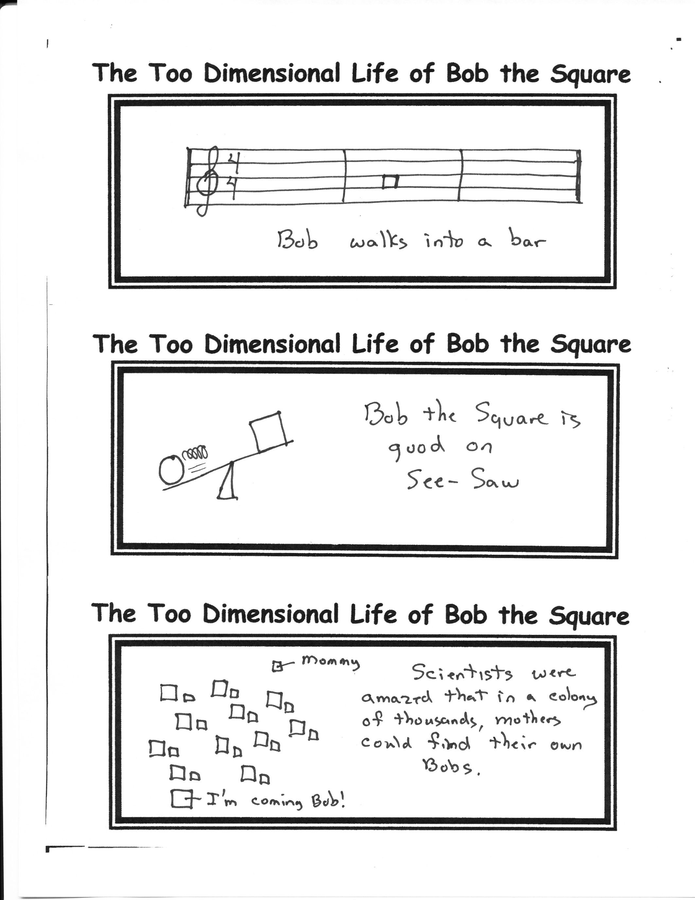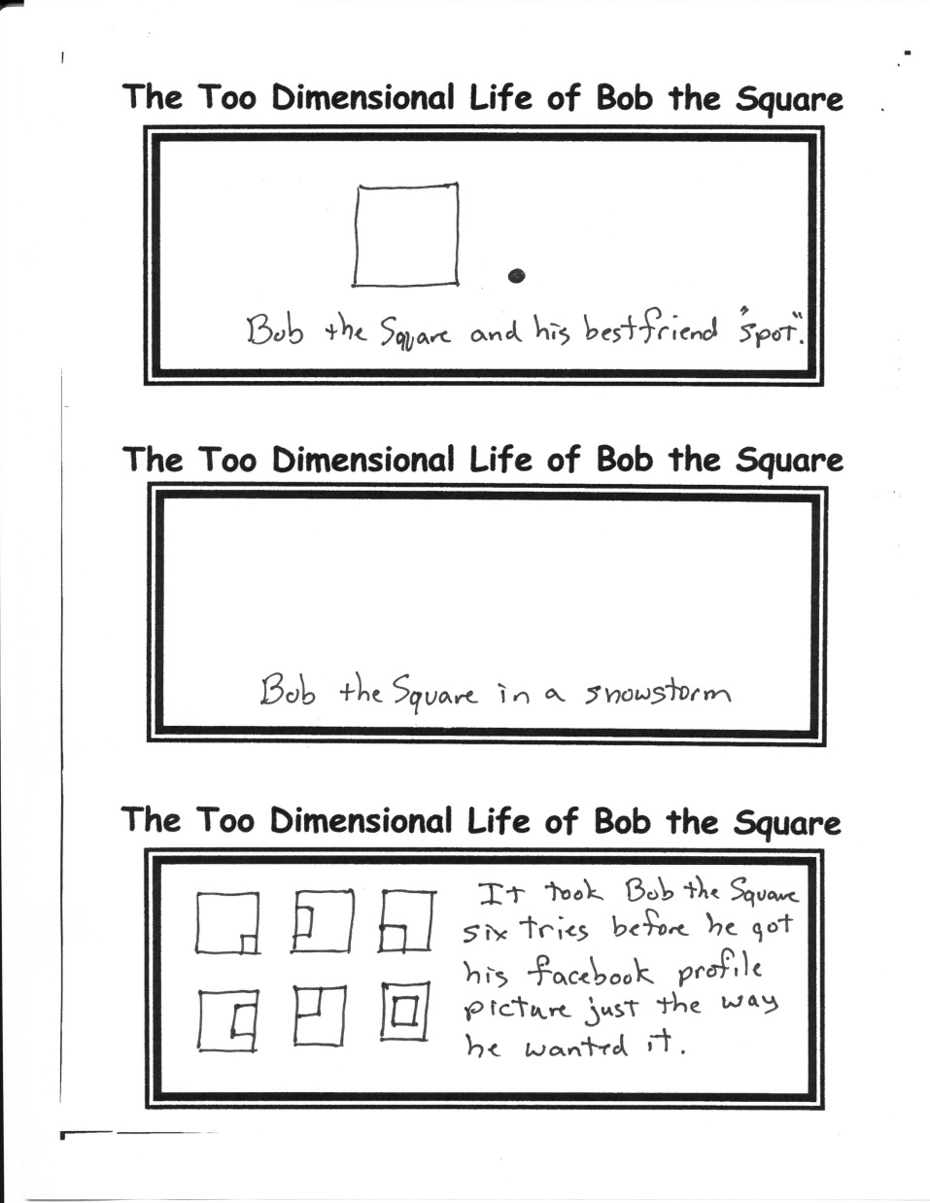

**Resurrection Day Math**

1 Cross

+ 3 Nails

4 Given

**Random Idea #16**

Place a slinky on an escalator and never be bored again!

**On What Day Is Easter Celebrated?**

The early church faced difficulty in placing a date on the calendar for Easter. You see, there was not a universally accepted calendar as we have now. Some used the Jewish calendar of approximately 360 days per year, some used the Roman calendar with 365 ¼ days per year.

A compromise was reached that, today, still baffles many people. The date is determined as:

***Easter Day is the first Sunday after the full moon which happens upon, or next after the 21st day of March; and if the full moon happens upon a Sunday, Easter Day is the Sunday after."***

***Using this method, Easter can only occur between March 22 and April 25.***

Spring Equinox 2017 fell on March 20. Full moon was next on April 11th. The Sunday following is today, April 16, 2017.