**May 15, 2016**

**Volume 4, Issue 26**

Sunday School Times

***Stuff For Today***

• Wait, Wait, Let Me Guess!

• The McDonald’s Curve

* How to balance pennies
* Dangerous toys

Published almost weekly, but more like…..whenever, so get used to it, OK?

# Nd

**By Mr. Lyle (mrlyle1@gmail.com**

***Romans 15:13***

*1****3Now the God of hope fill you with all joy and peace in believing, that ye may abound in hope, through the power of the Holy Ghost.***

Neodymium is the chemical element with the symbol Nd and atomic number of 60. It was discovered in 1885, but is actually quite common in the Earth’s crust. Most of the world’s neodymium is mined in China today. It has a variety of uses. Initially it was most often used as a dye in glass making. The reddish/purple colors are still popular today. My personal interest in neodymium is its use as an alloy in metal work. Combined with appropriate metals, heated to specific temperatures, and exposed to a strong magnetic field, neodymium becomes the strongest natural permanent magnet known today.

No one can see magnetism. But we can see its effects on the world around us and understand and believe in its existence. Magnetism is an integral part of nearly every facet of our lives today.

For those of us who are Christians, who have invited God to be a very genuine part of our lives, we have an amazing asset given to us by God. We understand that God indwells each believer. The Holy Spirit literally lives inside us! And God’s power is with Him. Remember this phrase:

*Power is the special*

*and peculiar prerogative*

*of God, and God alone.*

The majestic power of the Holy Spirit is displayed through the Bible, as well as in the world even today. Job 26:13 says that the Holy Spirit garnished the heavens—He put beautiful and amazing finishing touches on the universe. Genesis 2 says that He is responsible for human life.

I Peter 3: 18 tells us that the Holy Spirit raised Jesus from the dead.

And for each Christian, God has promised that the Holy Spirit is a compass pointing us in the right directions, He is our conscience convicting us of sin, and He is the power we need to resist sin and live a victorious life. He refines us daily if we will only allow Him to work in our hearts.

And in the future, we find Him involved in the return of Jesus to this earth. Romans 8:11 affirms that He will be directly responsible for millions of people rising from the grave someday!

We have that power living within us. What will we do with it?

**Balancing Act**

By Mr. Lyle (mrlyle1@gmail.com)

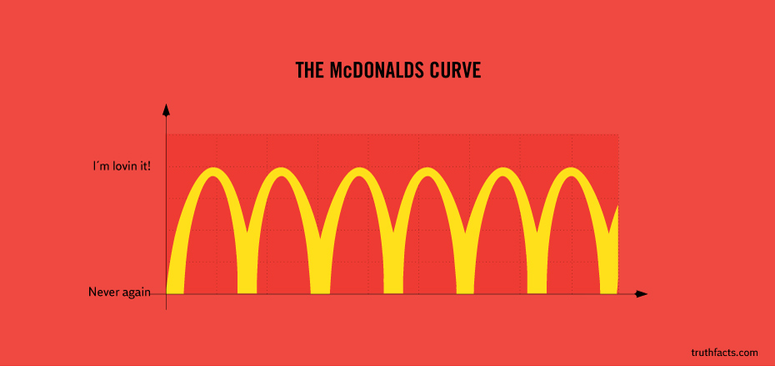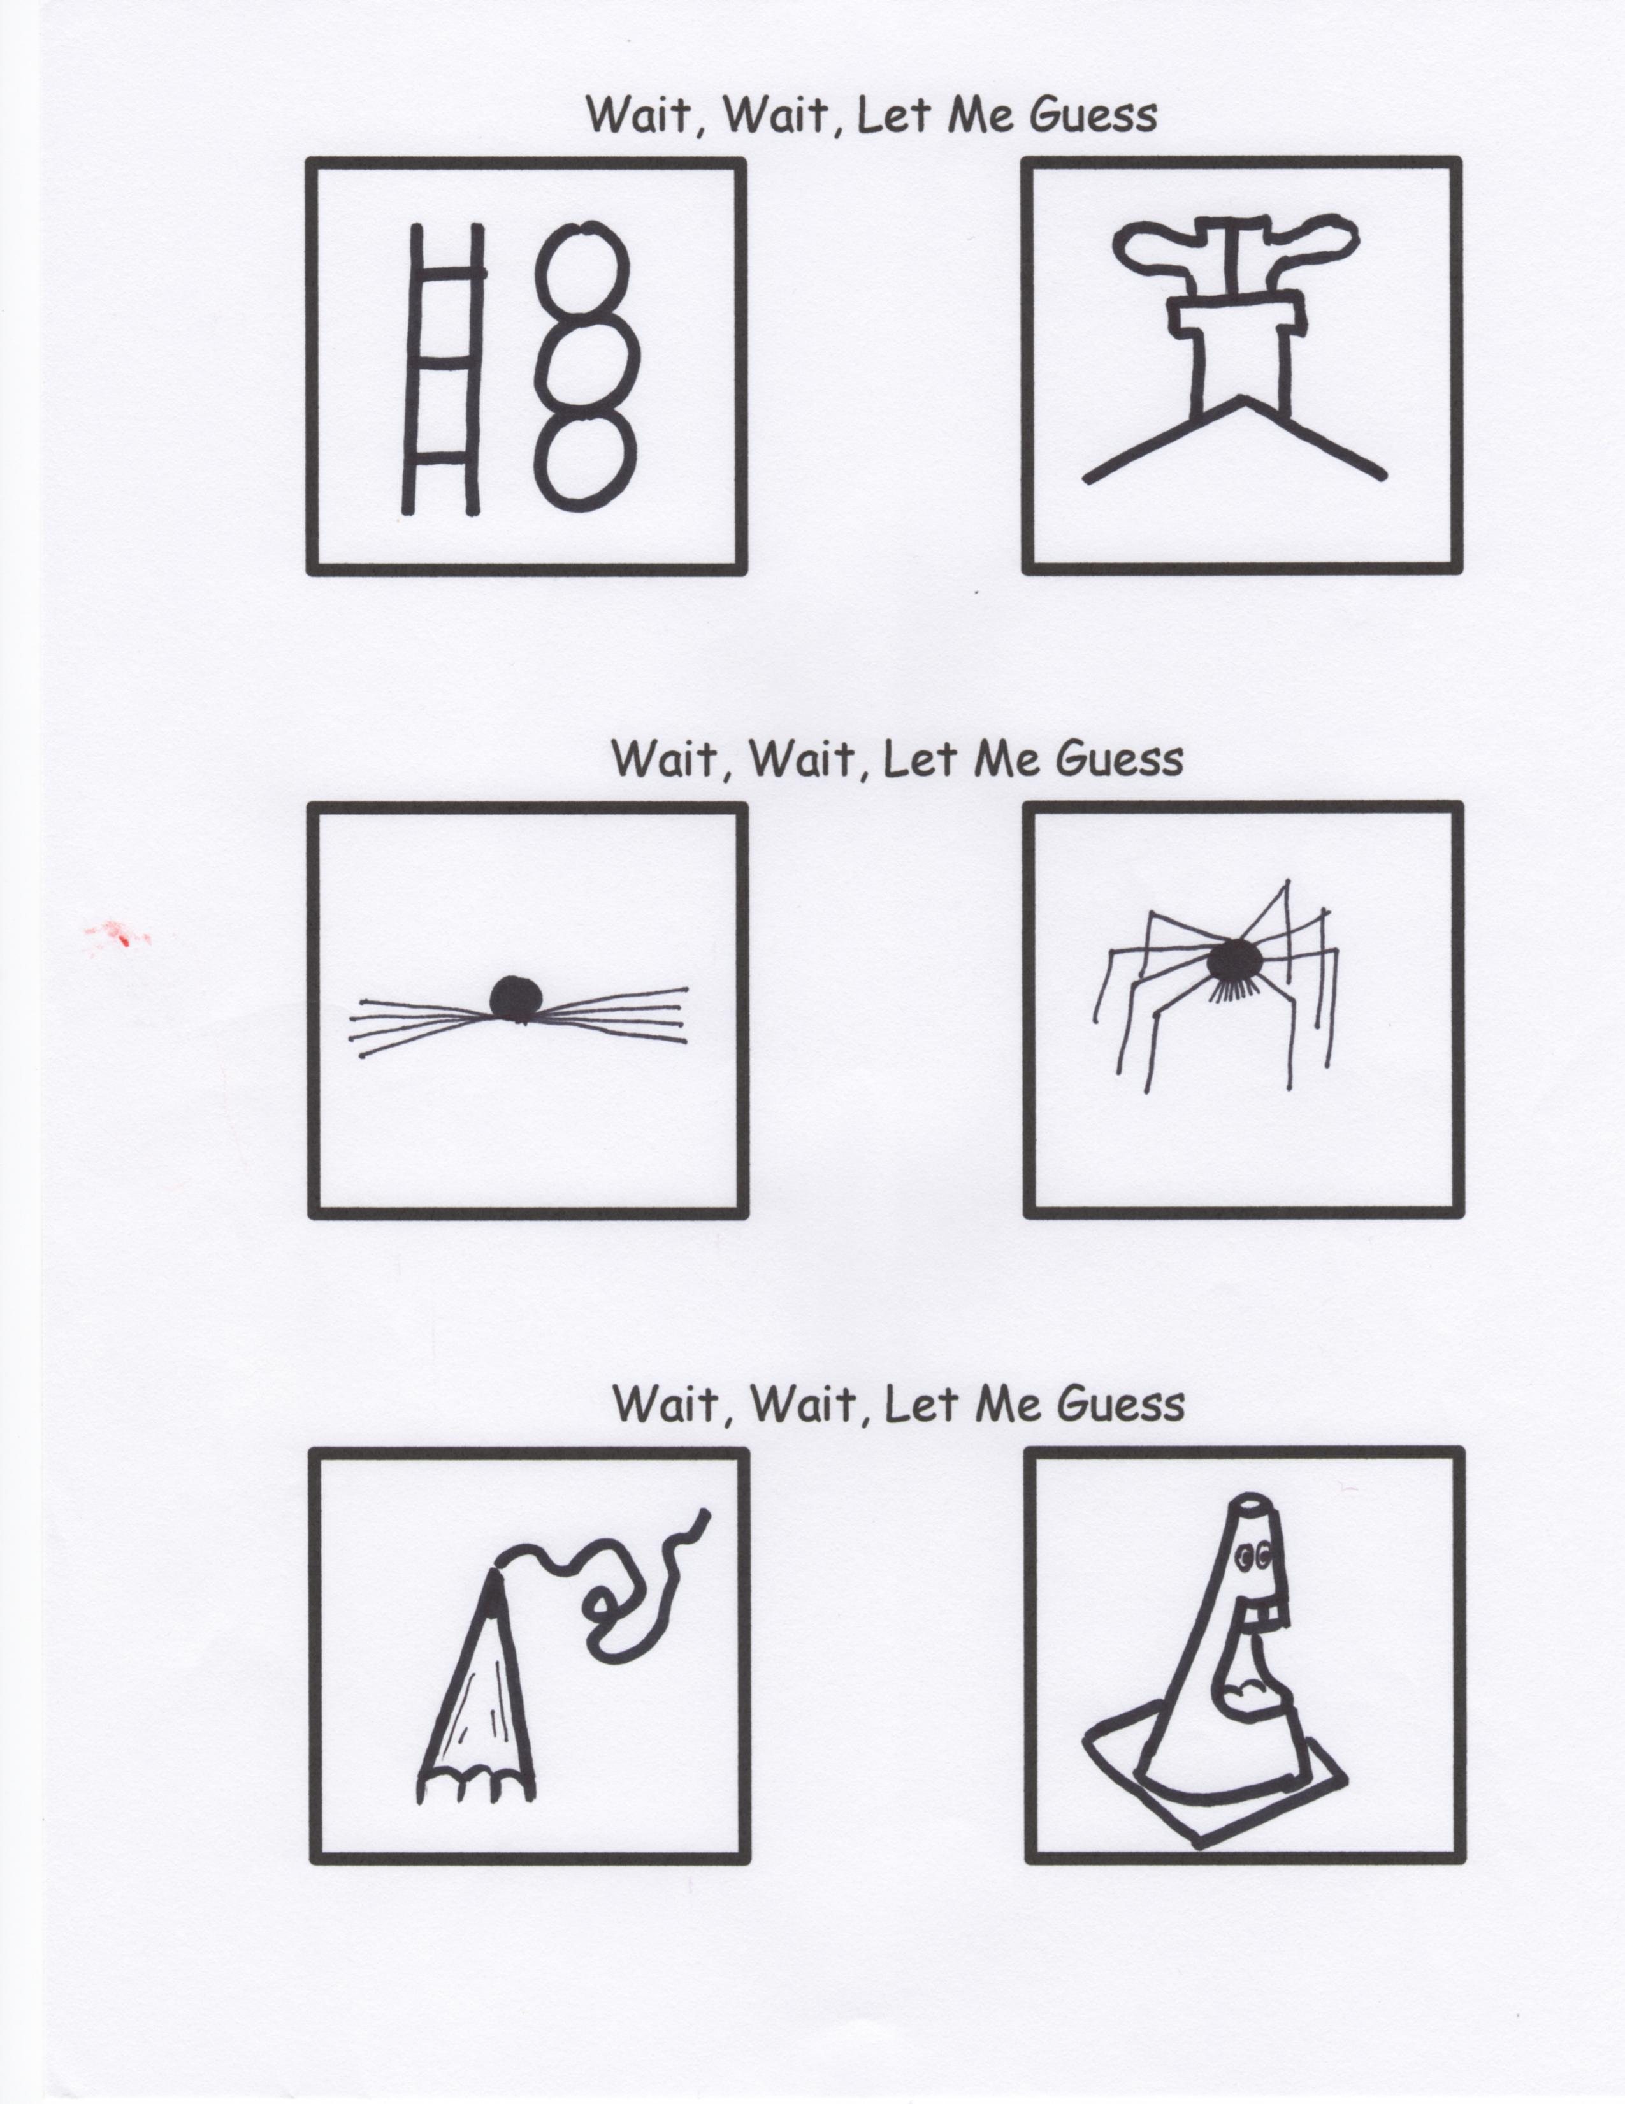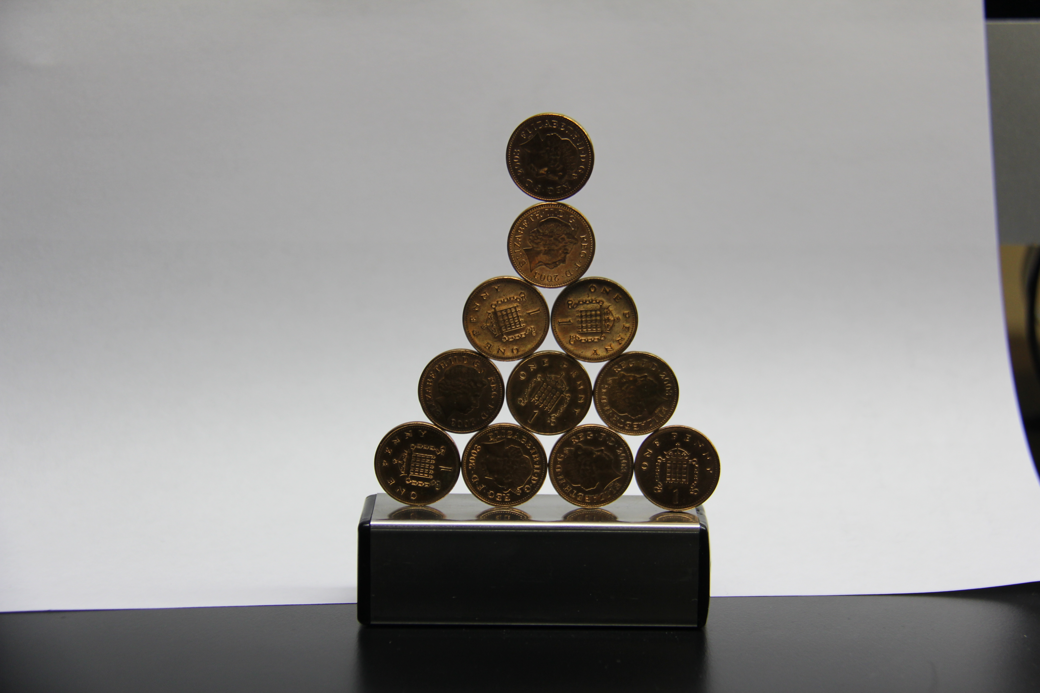

**The Most Dangerous “Toy” in Mr. Lyle’s Collection!**

Today, for those interested, I have brought the most dangerous “toy” I have. I really shouldn’t call it a toy! Children could be very badly hurt by this thing.

It is so dangerous, that my wife will usually leave the room when I bring it out to “play” with. (I had to sign a legal document just to purchase this amazing “toy”!)

Yes, I have even been hurt by it, so don’t think for a moment that I will allow any of you to handle this thing. Just watch.

For those wishing to learn how to balance pennies, the following tutorial should be helpful.

Balancing pennies on edge is a delicate art. First, care must be taken to ensure a solid, flat surface. I highly recommend laying a solid bar of steel horizontally to create a firm and level surface.

Next, carefully place individual pennies in a straight line to form a foundational row, carefully balancing each one on its edge

Building additional rows upon that foundation takes much practice, as the slightest movement can send the entire structure crashing to the ground.

Only a true professional would be expected to achieve the ultimate 5 row tall pyramid of coins. (See photo below of an actual 5-row achievement.)