**February 28, 2016**

**Volume 4, Issue 20**

Sunday School Times

***Stuff For Today***

• Wait, Wait, Let Me Guess!

• Written language

* Cuteness
* Moses makes a mistake

Published almost weekly, but more like…..whenever, so get used to it, OK?

# Kung Fu Ninja Moses and Aaron

**By Mr. Lyle (mrlyle1@gmail.com**

***Numbers 20;2-12***

***2 Now there was no water for the community, and the people gathered in opposition to Moses and Aaron. 3 They quarreled with Moses and said, “If only we had died when our brothers fell dead before the Lord! 4 Why did you bring the Lord’s community into this wilderness, that we and our livestock should die here? 5 Why did you bring us up out of Egypt to this terrible place? It has no grain or figs, grapevines or pomegranates. And there is no water to drink!” 6 Moses and Aaron went from the assembly to the entrance to the tent of meeting and fell facedown, and the glory of the Lord appeared to them. 7 The Lord said to Moses, 8 “Take the staff, and you and your brother Aaron gather the assembly together. Speak to that rock before their eyes and it will pour out its water. You will bring water out of the rock for the community so they and their livestock can drink.” 9 So Moses took the staff from the Lord’s presence, just as he commanded him. 10 He and Aaron gathered the assembly together in front of the rock and Moses said to them, “Listen, you rebels, must we bring you water out of this rock?” 11 Then Moses raised his arm and struck the rock twice with his staff. Water gushed out, and the community and their livestock drank. 12 But the Lord said to Moses and Aaron, “Because you did not trust in me enough to honor me as holy in the sight of the Israelites, you will not bring this community into the land I give them.”***

Kungfu Ninja Moses lived out in the desert perfecting his Kungfu Ninja moves. The Kungfu Ninja Master lit a great flaming torch. Kungfu Ninja Moses went over to it and tried to extinguish the flames with his Kungfu Ninja moves. Though he tried again and again, he could not put out the flaming torch. The Great Kungfu Ninja Master told Kungfu Ninja Moses, “Find your brother Aaron, perfect your Kungfu Ninja moves, and go to the Evil Jujitsu Lord Pharoah of Egypt. He has my Kungfu Ninjas and he must let them go!”

Kungfu Ninja Moses and Aaron showed the Evil Jujitsu Lord Pharoah of Egypt some of their best kungfu. The Evil Jujitsu Lord Pharoah of Egypt was not impressed until Moses and Aaron showed him their best, most awesome, Kungfu Ninja moves. The Evil Jujitsu Lord Pharoah of Egypt said that all of the Kungfu Ninjas could leave. Moses and Aaron kungfued for joy.

All of the Kungfu Ninjas went out into the desert. They were led by Moses and Aaron. They all practiced their Kungfu Ninja arts there in the desert. After an afternoon in the desert heat, all of the Kungfu Ninjas were thirsty. They complained to Moses and Aaron that there was no water there. Kungfu Ninja Moses and Aaron responded with a very interesting, never before seen, Kungfu Ninja move.

Kungfu Ninja Moses and Aaron took all of the Kungfu Ninjas to a large rock there in the desert. They kungfued them until all of the Kungfu Ninjas were quiet. Kungfu Ninja Moses then said “The Great Kungfu Ninja Master has great compassion. He will show us where we can get water to quench our thirst” Moses and Aaron kungfued like the great, skilled Ninja warriors they were, over to the rock.

Then Kungfu Ninja Moses said to the Kungfu Ninjas following him “Today, I will expertly hit this rock. I have been taught well by the Great Kungfu Ninja Master. My blows will be so powerful, that I shall break this rock in two, and water will gush out for everyone. It was an amazing sight to behold as Kungfu Ninja Moses and Aaron landed blow after blow on the huge rock.

Water came gushing out and all of the Kungfu Ninja warriors kungfued for joy!

**CUTENESS**

By Mr. Lyle (mrlyle1@gmail.com)

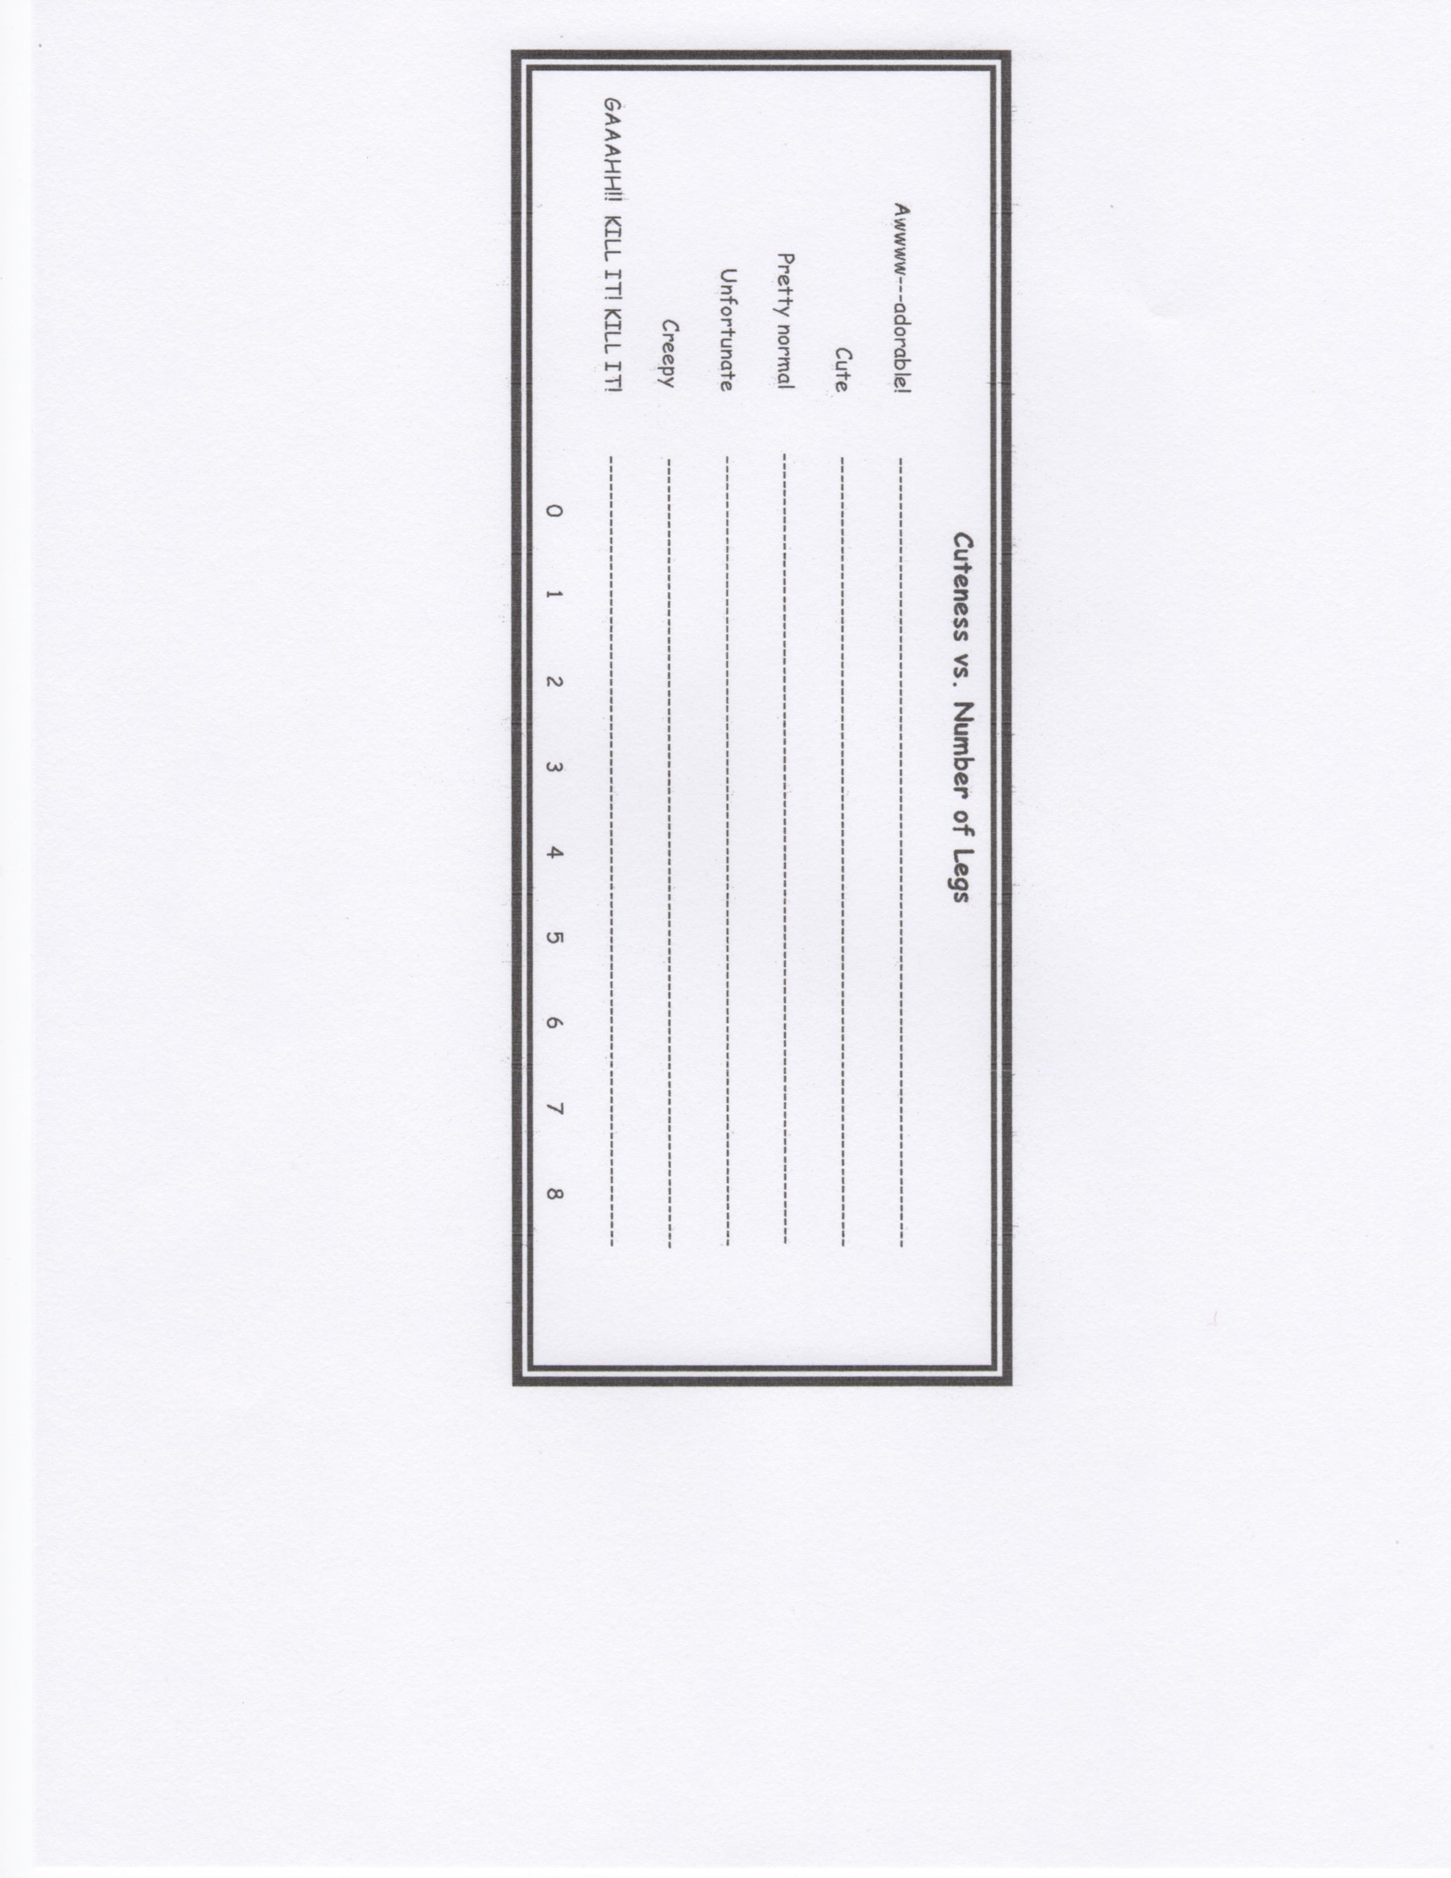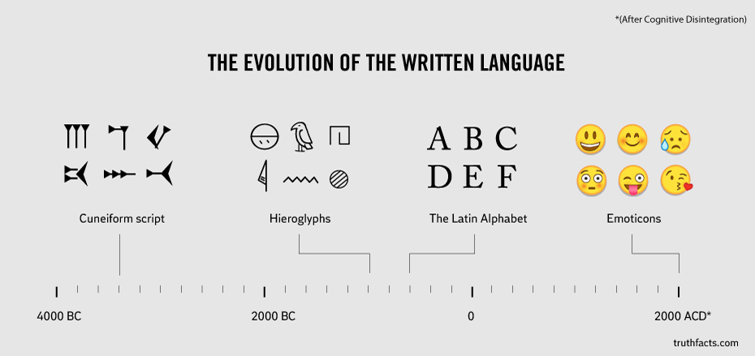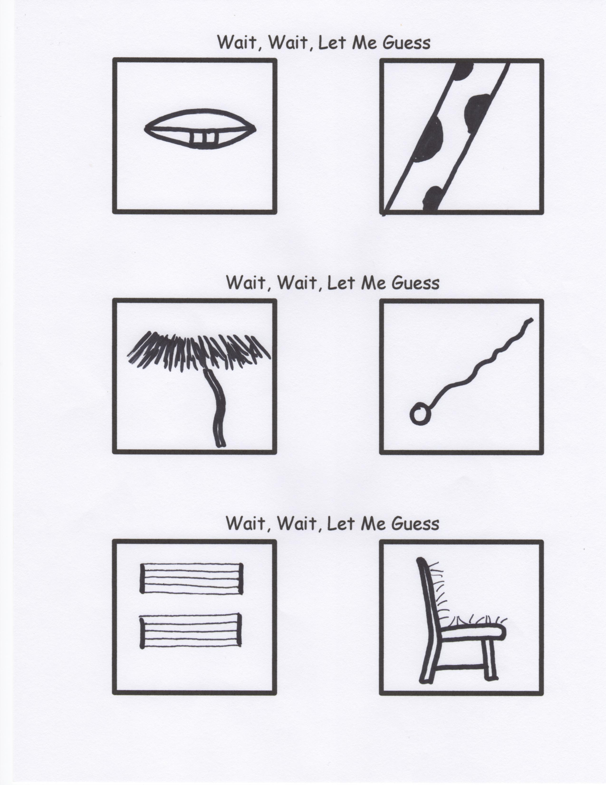

**For the True Scholars Among Us**

So…what did you think of the literary works of Martin Handford?