**November 13, 2015**

**Volume 4, Issue 12**

Sunday School Times

Published almost weekly, but more like…..whenever, so get used to it, OK?

# Welcome to eharmony.God

***Stuff For Today***

• Flying Insects

• Spider Anatomy

* eharmony.God

**By Mr. Lyle (mrlyle1@gmail.com**

***The Book Of Ruth Chapter 2***

God is sovereign. He can and will do what He wishes. How He accomplishes His will is beyond our grasp of understanding. Our God knows all, including the future, and is actively involved in the events of this world.

And He does have plans. Some see God as a sort of terrarium builder. They say He created the world and set everything into motion, then stood back to see what would happen. But the Bible tells us over and over that we serve a God who is intricately involved in the affairs of man.

He influences and moves the hearts and minds of all of us to accomplish His perfect design. In the book of Ruth we find God putting together a very unlikely, but tender love story. It was God’s blueprint that Boaz and Ruth meet, fall in love, marry, have children, and raise those children to fear God.

The story unfolds with incredible precision. Two lives from seemingly opposite backgrounds merge and God moves His plans another step further down the hallways of time.

Isaiah tells us that God is zealous—very zealous. Everything God does, He accomplishes with eagerness and excitement. He is sincerely fervent about all He has ever done. That is an amazing idea. Just think what that can mean. Not only was He intensely passionate and enthusiastic about the big moments, like creation. But He is also as ardently interested when dealing with individual people on a day by day, moment by moment basis.

We see an excellent example of this in the story of Ruth

**Spider Anatomy**

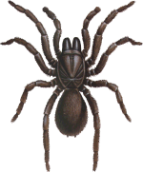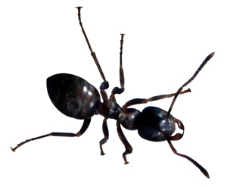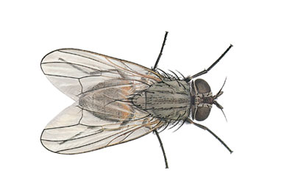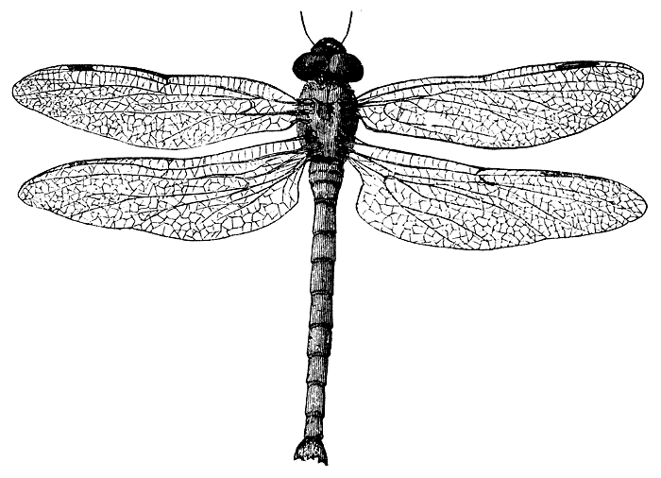

**Tnatropmi Swen**

Greetings, my name is Dlihc Fo Dog. I am from Ellivestop, Sasnakra. I am here to tell you about the book of Ekul in which I read that Sdog Nos voluntarily went to a Ssorc and allowed them to yficurc him. There he deid, and they put him in an evarg. But on Yadnus, he esora and the slegna showed everyone. The selpicsid did not eveileb at first, but when they saw mih, they dootsrednu.

1. Brain Ripper Outer

2. Blood Sucking Mandible

3. Leg Used To Explore Ears

4. Fangs—Huge Wet Fangs Still Dripping With Blood From It’s Last Victim

5. Teeth—Lots Of Teeth!

6. Zombies Eat This Part First

7. The Reason I Don’t Sleep

8. One Word—POISON

9. Filled With Ooey Gooey

10. Back Leg

11. Neck Artery Locator Leg

12. Eyeball Driller Leg

13. Filled With Vitamin C

**“Wait, Wait, Let Me Guess” Postponed One Week To Bring You A Very Special Edition Of “Identifying Flying Insects”**

By Mr. Lyle (mrlyle1@gmail.com)

Dragonfly Butterfly House Fly Won’t Fly Can’t Fly Better Never Be

Able To Fly!