**September 21, 2014**

**Volume 3, Issue 4**

Sunday School Times

Published almost weekly, but more like…..whenever, so get used to it, OK?

# La Isla De Dos Arboles

***Stuff For Today***

• Wait, Wait, Let Me Guess!

• Almost Biblical…but not

* Rocks and Candy
* La Isla De Dos Arboles

**By Mr. Lyle (mrlyle1@gmail.com**

***Psalm 103:7***

***He (God) made known His ways to Moses, His deeds to the people of Israel.***

One very large part of being spiritually mature is having the ability to understand things from a larger frame of reference. We need to have the wisdom to perceive that things are often interrelated and sometimes complicated, and still be able to determine and judge their comparative importance.

Seeing life from God’s point of view must be our goal. Unfortunately, it does not come naturally to us. The verse above explains it in a nutshell. The people of Israel, as they wandered through the desert for 40 years, got to see the amazing hand of God at work each day! Each day began with the miracle of manna on the ground for food, the cloud overhead for shade, and 2 million people out in the middle of nowhere with all the water they needed. The Bible also says that their shoes and other clothing did not wear out those many years and miles.

For most, though, it was just taken for granted. They saw the great works, they enjoyed the comforts, but they did not understand God’s ultimate plan. Not so with Moses. God made His big picture plans known to Moses. Moses got to see things from God’s view point, and understand why God was doing things the way He was.

The story of Jose is a parable centered on the idea that perspective is vitally important. As the story goes, Jose lived on a little island he called Dos Arboles-two trees. He would go down to the shore and float his canoe and play with the fish that swam nearby. It was a wonderful retirement plan. A cozy island, shade from the heat, and a pleasant life. The natives from nearby islands would come and check on him from time to time. You see, their legends said that a giant man eating monster lived on that island. They would call out to Jose and ask if he was still alive, and he would smile and wave. When they asked how he survived the monster, Jose would simply say “It’s all just a matter of perspective.”

Oh, the monster was very, very real! What was Jose’s secret to survival? Perspective! Jose saw his little island as La Isla De Dos Arboles, The Island of Two Trees. The natives saw La Isla De Pajaro Gigante, The Island of the Giant Bird. Perspective matters greatly!

When we have a proper perspective on life, when we see things from God’s point of view, life can make much sense. Many of the “why” questions in life are answered. God’s plan is that we not just endure life here on this earth, but that we have an “abundant life” filled with the good He has planned for us!

**Almost Biblical…**

**But Not**

By Mr. Lyle (mrlyle1@gmail.com)

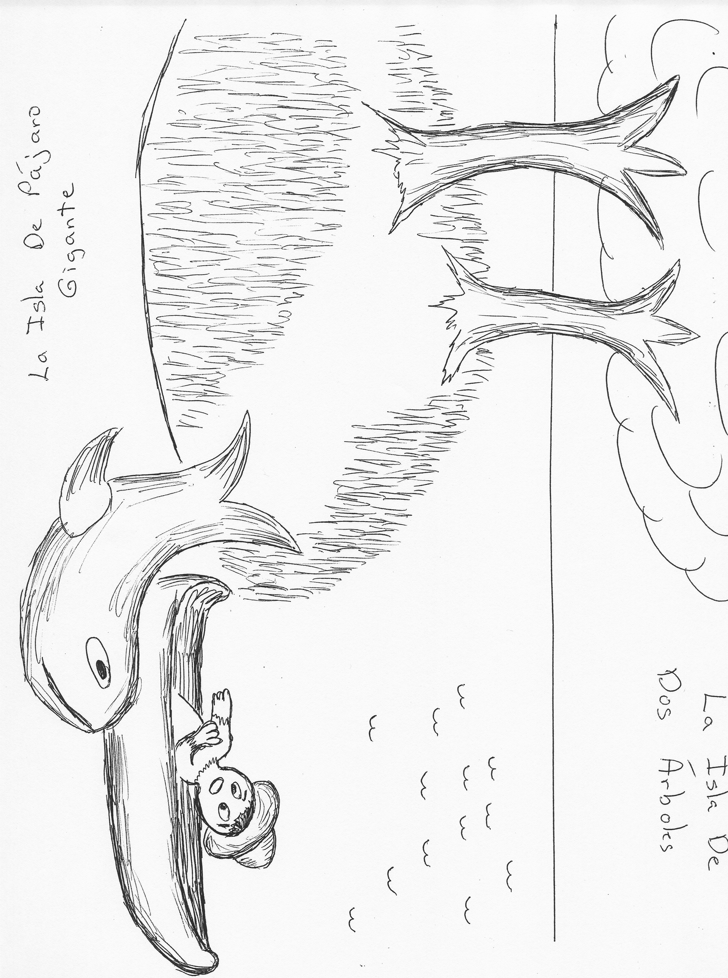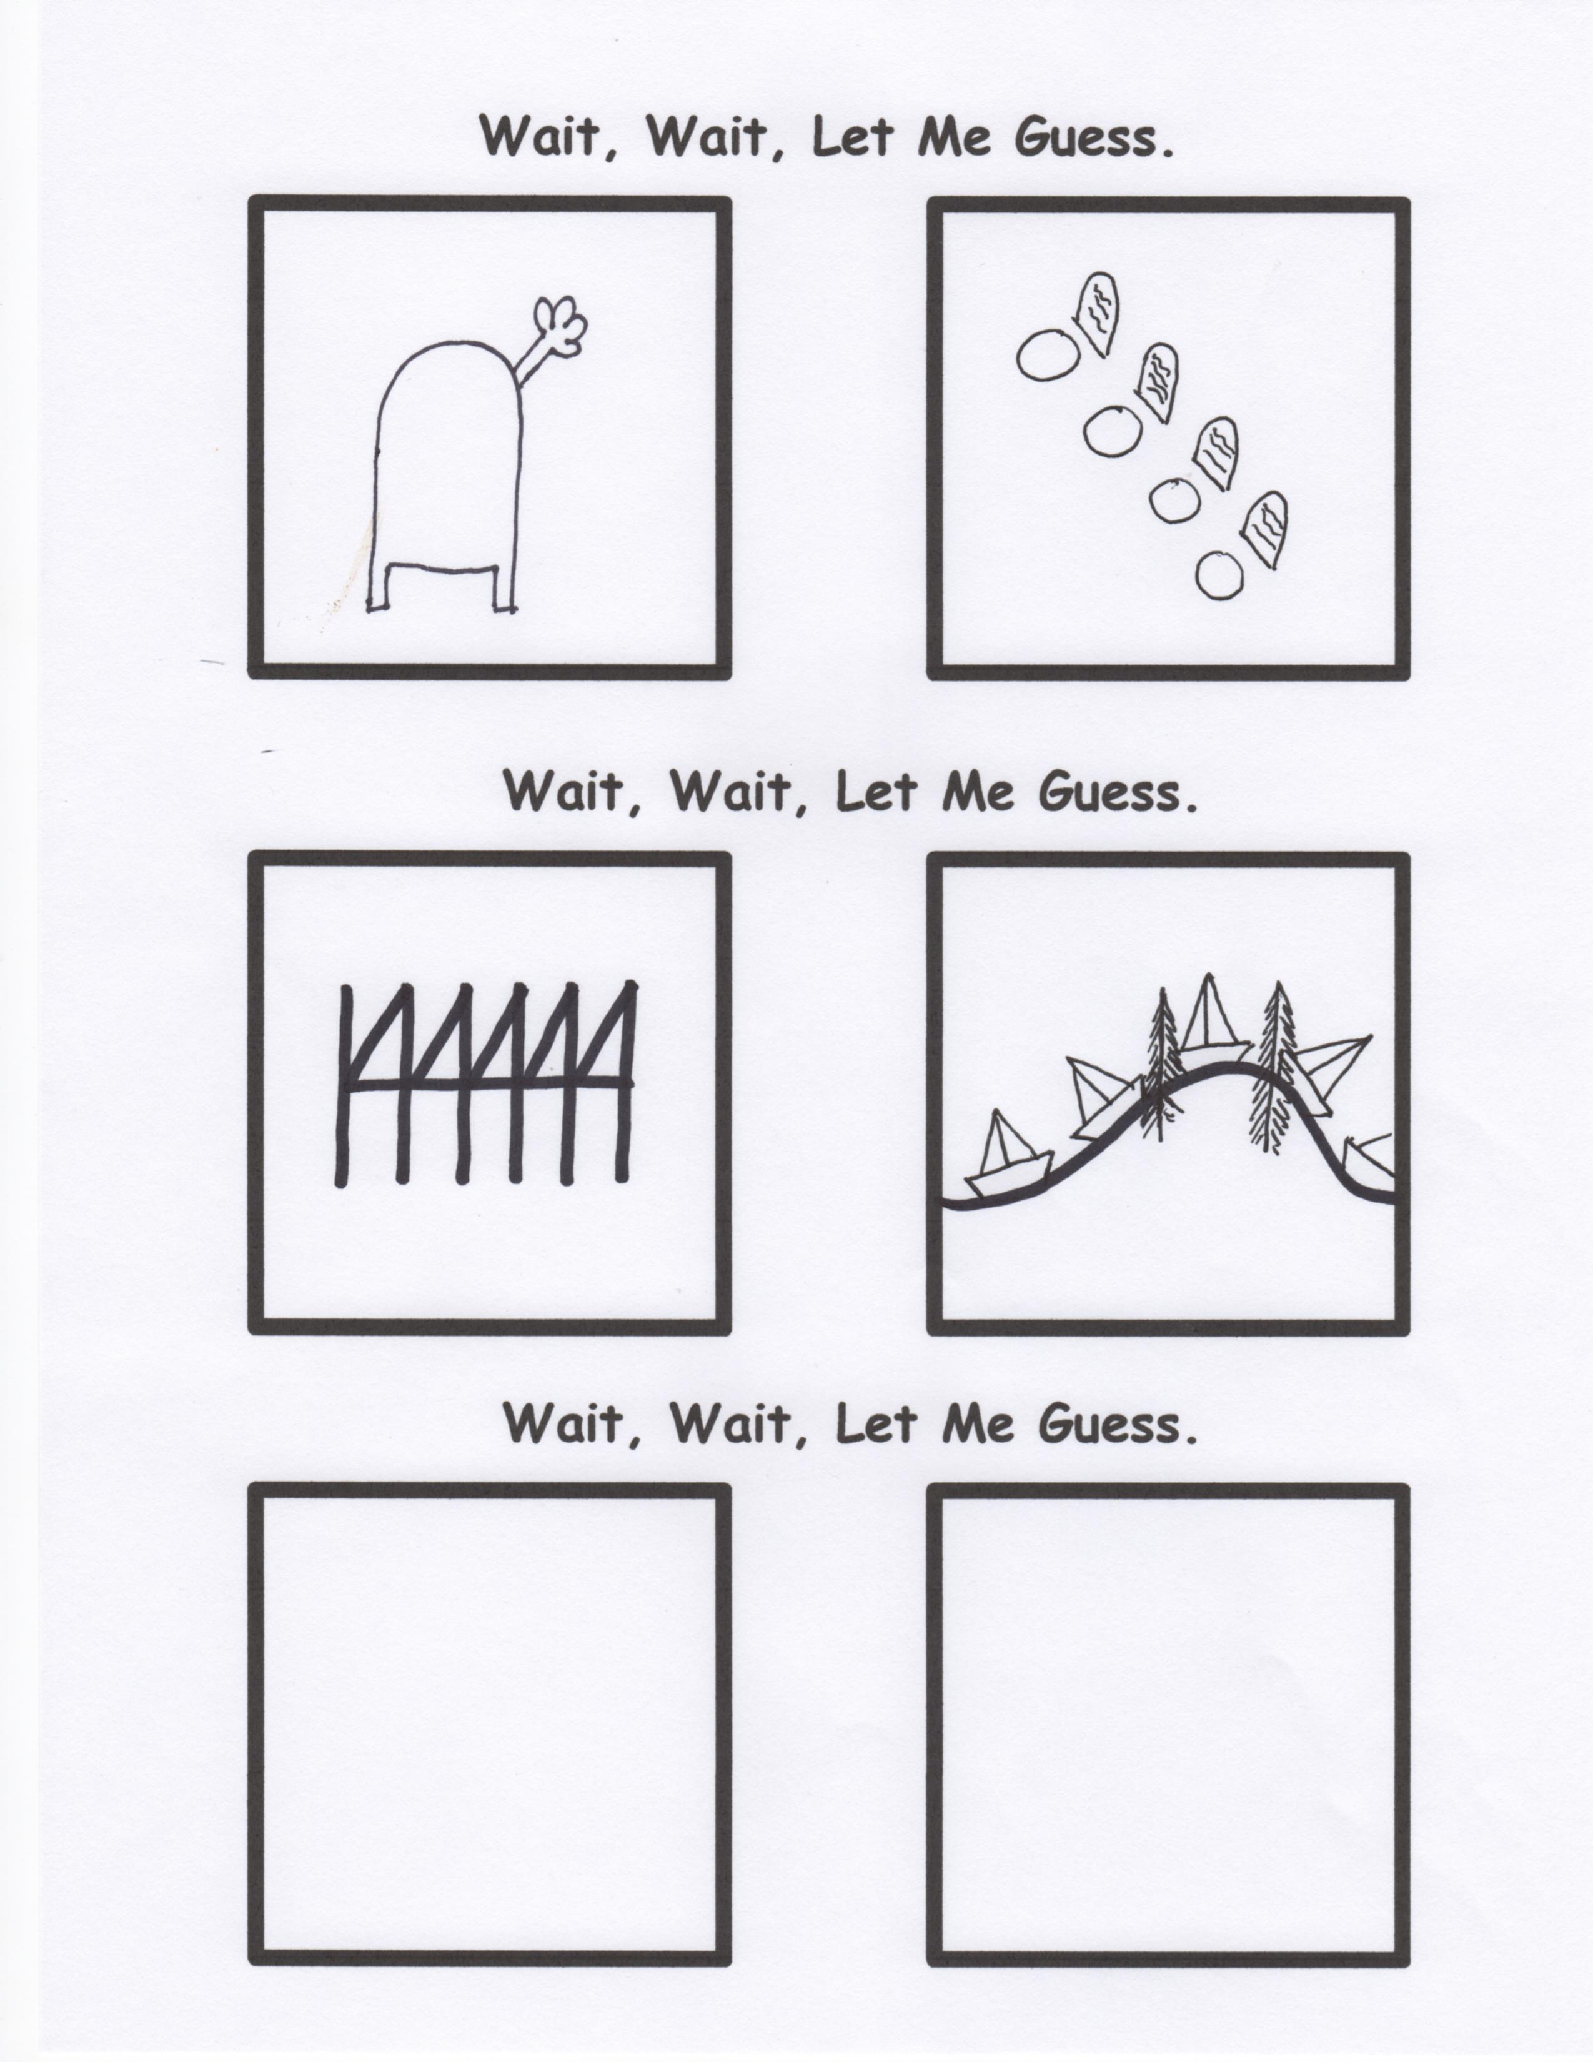

Isaiah 34:7 KJV

“And the unicorns shall come down with them, and the bullocks with the bulls, and their land shall be soaked with blood, and their dust made fat with fatness.

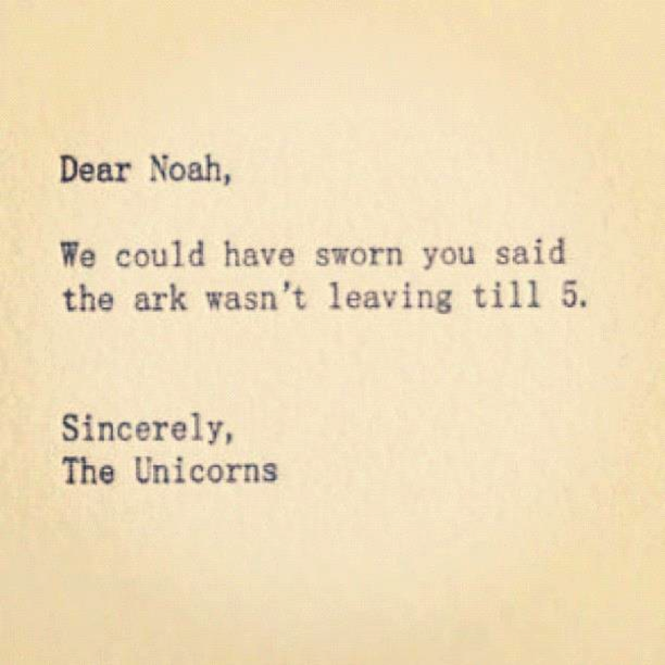

And on that day there shall be two walking in the field together. And they shall say one unto another, what is this thing that hath happened? For since the days of the prophets, this thing was foretold to us, but we did not understand. Verily, verily, I say unto you, there will be those who will be blinded to the truth. They will be ever seeing, but not understanding, until the one that hath been appointed from ages past shall appear. And he shall discover that it has indeed been written sideways, and then all things will be made known unto them.