**March 29, 2015**

**Volume 3, Issue 26**

Sunday School Times

***Stuff For Today***

• Marsh Mallows from ancient Egypt

• How to drive an ox

• Chocolate covered marshmallows: a rather unique Sunday School lesson

Published almost weekly, but more like…..whenever, so get used to it, OK?

# Chocolate Covered Marshmallows

**By Mr. Lyle (mrlyle1@gmail.com**

***Psalm 39:4-5***

***Lord, make me to know mine end, and the measure of my days, what it is: that I may know how frail I am.***

***5Behold, thou hast made my days as an handbreadth; and mine age is as nothing before thee: verily every man at his best state is altogether vanity. Selah.***

In this passage, David talks about how short life is—how fleeting. Note the last half of verse 5. Its structure is fascinating.

The word ***verily*** appears, followed by a short phrase, and then the word ***Selah****.* ***Verily*** is an expression that denotes earnestness, as if to say, “Take note of what is to follow”. ***Selah*** generally suggests that the reader stop and take heed, contemplate and consider what was just read.

Used together, it would seem appropriate to study carefully the phrase that falls between them.

In the original Hebrew, the sentence consists of three words. We will take a few minutes to look at each word in detail.

***Every Man***--Each person is personally responsible for their relationship with God.

***At his best state****—*This is a very specific term. A farmer of that day would recognize it immediately. An ox goad, a pointed shaft made of wood or iron, was used to steer oxen while working. When an iron goad’s point was broken, it was taken to a blacksmith for repair. This word was used to describe the needed repairs. Man is damaged, in need of repair—salvation.

***Is altogether vanity—***One word in Hebrew, it refers to a brief period of time, shortness. It is also a proper name. Because of the short span of his life, Abel’s name came to be synonymous with terms like fleeting or unfinished.

Translators did an amazing job bringing the Hebrew over into English. However, due to the limits imposed by cultural differences, not all words translate perfectly from one language to another.

We will look at this complete phrase in the light of Abel’s story.

**Marshmallows:**

**What Are They Really?**

By Mr. Lyle (mrlyle1@gmail.com)

Have you ever chomped down on a s’more and had ooey, gooey stuff run down your chin?

Have you ever made an attempt to crush the world record for stuffing as many little white fluffy cylinders into your mouth as possible? (And then started laughing, and had white drool stuff run out of the corners of your mouth?)

Have you ever gotten a yellow Peep at Easter and decapitated it like a ravenously hungry tiger, ripping it to shreds, and then gulping it down? (And had its internal organs stick to your teeth?)

Have you ever wondered to yourself “*Just what mysterious stuff is in a marshmallow anyway? And what makes it sticky on the inside, but not on the outside?”*

I have many questions that medication doesn’t solve.

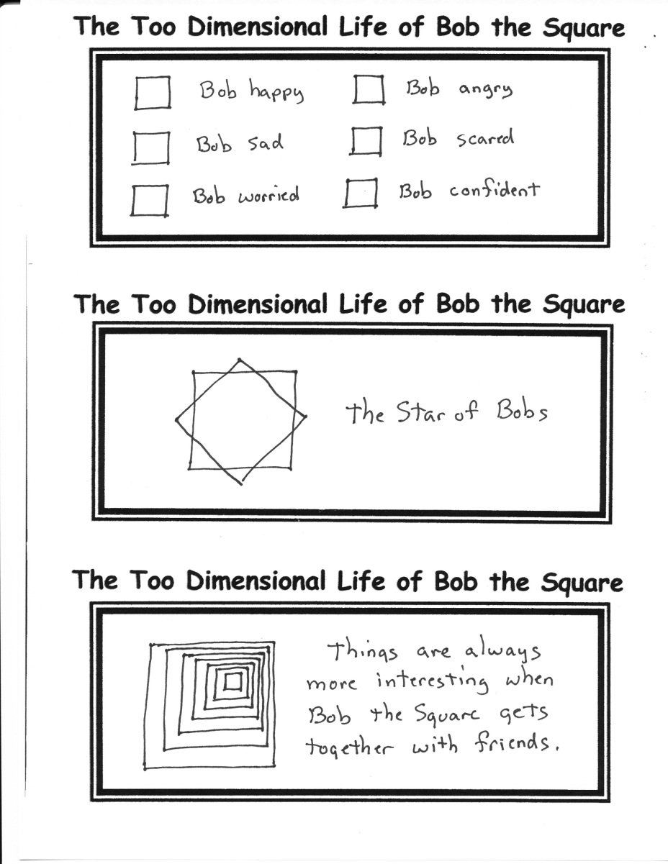 ck

**Why *Schadenfreude* is Such An Amazing Word**

No other language has a single word like this amazing German word that basically means “to find a sense of pleasure or joy while watching the misfortunes of others.”

**A.K.A. America’s Funniest Home Videos.**

**Just a Word of Advice: Don’t Teach Your Pets How to Text…**

***Althaea Officinalis***

Marsh Mallow is an herb that grows naturally in the East. Sap from its roots was used to make white fluffy candy thousands of years ago in ancient Egypt.