**February 15, 2015**

**Volume 3, Issue 22**

Sunday School Times

# Leprosy Cured?-One Week Yet To Go

***Stuff For Today***

• If you ever thought it would be cool to have an armadillo for a pet, let me explain why that is a horrible, horrible idea!

• Mr. Lyle has a magical paper cutter—and , like, dude, it does magical stuff.

• Why would anyone sit outside their house for a whole week?

Published almost weekly, but more like…..whenever, so get used to it, OK?

**By Mr. Lyle (mrlyle1@gmail.com**

***Leviticus 13:1-2***

***The Lord said to Moses and Aaron, 2“When anyone has a swelling or a rash or a bright spot on his skin that may become an infectious skin disease,[[a](http://www.biblegateway.com/passage/?search=lev%2013&version=NIV1984" \l "fen-NIV1984-3055a" \o "See footnote a)] he must be brought to Aaron the priest or to one of his sons[***[***b***](http://www.biblegateway.com/passage/?search=lev%2013&version=NIV1984#fen-NIV1984-3055b)***] who is a priest.***

***Leviticus 14:3***

***3And the priest shall go forth out of the camp; and the priest shall look, and, behold, if the plague of leprosy be healed in the leper.***

***Leviticus 14:8***

***8And he that is to be cleansed shall wash his clothes, and shave off all his hair, and wash himself in water, that he may be clean: and after that he shall come into the camp, and shall tarry abroad out of his tent seven days****.*

The health issues and concerns over leprosy are addressed in the Law given to Moses, and recorded for us in the book of Leviticus

As you read through this section of the Bible, do not miss the intricate picture God has painted for us regarding sin, and our defilement by it, and our need of a cure for it.

To depict the concept in a mathematical equation, it would simply be written as

***Leprosy=Sin***

The following list is certainly not exhaustive. Look through it and see if you can find any parallels between leprosy and sin.

1. It is not a respecter of persons. Everyone can have the problem.

2. It starts from within, and then soon shows its ugly head.

3. It begins small, but never stays that way.

4. It is loathsome and deadly.

5. We need to actively guard ourselves against it. Limit exposure and shun it.

6. It needs to be put away and avoided at all costs.

7. It progresses slowly, but surely. Do not let it fool you.

8. It is unclean and disgusting.

9. It is often not initially painful. The victim is desensitized to it.

10. It separates the victim from others.

11. The victim is lonely.

12. It can be contagious. There is no immunization known to man.

But there is a possibility of a cure, and an amazing process associated with it. In the rituals surrounding a confirmed cure, we see a clear picture of the work of Jesus upon the cross.

***The Cure=Jesus***

**Upcoming Dinner Theater**

Do not forget the meal that is planned for March 14th. Critics have hailed it…

*…more fun than 14 bagpipes playing Mozart 15th Symphony in D minor, while Sir Augustus Hamby reads passages from his memoirs in Latin. Lets face it. Anything would have to be better than that. So plan to go to the meal already!!!!*

**Armadillo**

**(Kinda Tastes Like Chicken?)**

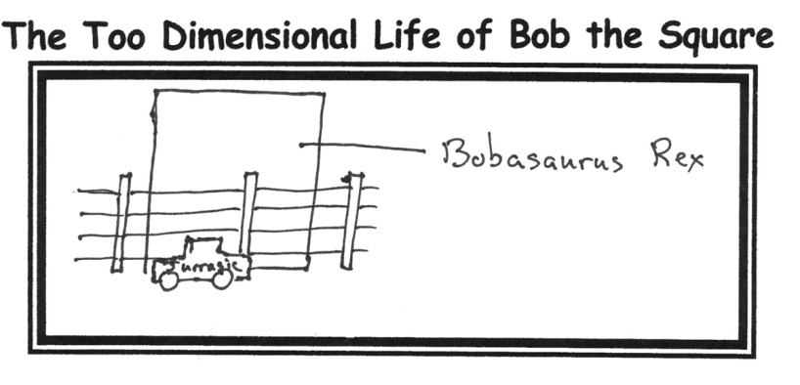

**The Illusion Explained**

Many people wonder how the paper cutter illusion is performed. In the past, I have been reluctant to give away my secrets. It has nothing to do with an illusionist’s code. I just have chosen to not reveal my methods.

But, I considered the idea for a while, and came to the conclusion that you might enjoy knowing the truth about it. It will require an in depth explanation. So, for the first time ever, I will reveal the deep dark secret of this wonderful trick.

The most important step in performing this trick is to obtain and prepare with special care the

We all know that this very recognizable shape does not even come close to looking like the real human heart, so, just where did this symbol come from?

Records of the first use of this symbol are found in ancient Babylon—shortly after the great flood of Noah’s day.

The Bible talks of a man named Nimrod (see Gen. 10:8-12). History tells us that he married a woman named Semaramis. Upon his untimely death, she did not want to give up her throne. So she invented a religious system that promoted her to be a god.

One of the symbols she used to make herself more familiar and memorable to her people was the ***Sacred Heart.*** Its shape has remained largely the same for thousands of years

Happy Valentine’s Day!

My Valentine to My Wife This Year



There is a reason that we don’t eat armadillo meat.

There is a reason that most of us do not keep them as house pets.

There is a reason that the medical community uses them as test subjects.

There is a reason that you don’t think of an armadillo as cute and cuddly.

There is a reason that armadillo is spelled the way it is.

There is a reason that you cannot catch an armadillo in a baited trap.

There is a reason that Mr. Lyle does not like armadillos hanging around his house.

There is a reason we will talk about armadillos today in class.

So there!

By Mr. Lyle (mrlyle1@gmail.com)