**February 8, 2015**

**Volume 3, Issue 21**

Sunday School Times

***Stuff For Today***

• Recall Notice

• In The Bleachers

• The single most amazing word in the English language!

Published almost weekly, but more like…..whenever, so get used to it, OK?

# The Most Incredible Word—EVER!

**By Mr. Lyle (mrlyle1@gmail.com**

***John 3:16***

***For God so loved the world that He gave His only begotten Son, that whosoever believeth in Him, should not perish, but have everlasting life.***

Heaven is an amazing place. It already exists—God abides there with myriads of myriads of Heavenly beings. We as Christians look forward to a day when we will experience it firsthand.

However, it is out of our reach. We cannot get there by anything that we can accomplish. Were it not for the grace and love of God, we would all burn in Hell forever.

The promise of God is clear; only those who are saved shall be allowed to enter that magnificent place. And only God can save us from our immense problem with sin. Try as we might, it is useless to think that we could solve the issue of sin by ourselves.

On our very, very, very best day, doing our very, very, very, best thing, compared to God, my goodness, your goodness, is nothing.

The good news is that all sin can be forgiven. There is nothing so heinous that God is not able to erase the penalty.

Because of what Jesus accomplished, salvation is available to all who believe. Creation was finger work—delicate and intricate. Salvation is described as the strong arm of the Lord at work—powerful and amazing.

Eternal life in Heaven is an incomprehensible idea. God has set eternity in the hearts of men, but we struggle to understand it.

The Christian has been bought and paid for. The penalty for our sin has been met. We have been redeemed. That word infers freedom.

So what is the incredible word? Class time today will include a detailed introduction of the word Hoosumaber!

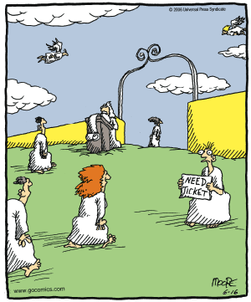

**Heaven**

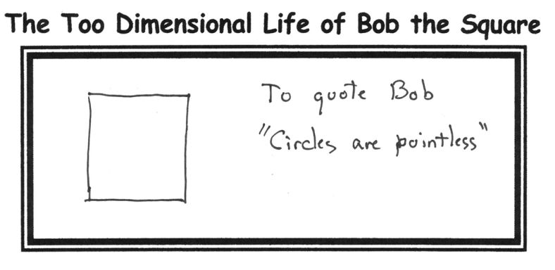

**SPACIAL MEEL**

**MERCH 14**

Peas be member da spacial meel dat wee half plant four duh Merch 14th.

Eat whale bee berry, berry munch fund, ant eye wood knot wont ewe too four gate a boot eat.

Uh meel ant uh moofy ant otter tinks wheel bee munch, munch fund.

Sew, be member two bee dare Merch 14th ate 6:00 ean duh Fail-o-sheep Hull hear @ duh charch.

## **Important Recall Notice**

By Mr. Lyle (mrlyle1@gmail.com)

The Maker of all human beings is recalling all units manufactured, regardless of make or year, due to a serious defect in the primary and central component of the heart. This is due to a malfunction in the original prototype units code named A.D.A.M. and E.V.E., resulting in the reproduction of the same defect in all subsequent units. This defect has been technically termed, “Sub-sequential Internal Non-morality”, or more commonly known as SIN as it is primarily expressed.

Some symptoms of this problem include: (a). Loss of direction, (b). Confusion of the mental component, (c). Amnesia of origin, (d). Foul vocal emissions, and ( e). Erratic, and self-destructive behaviors.

The Manufacturer, who is neither liable or at fault for this defect, is providing factory authorized repair service free of charge to correct this SIN defect. The Repair Technician, JESUS, has most generously offered to bear the entire burden of the staggering cost of these repairs.

There is no additional fee required. The number to call in all areas is P-R-A-Y-E-R. Once connected, please upload your burden of SIN through the REPENTANCE procedure. Next download ATONEMENT from the Repair Technician, JESUS, into the heart component.

Please see the operating manual. HOLY BIBLE, for further details on the use and implementation of these fixes. With the upgrade, the Manufacturer has made available to all repaired units a facility enabling direct monitoring and assistance from the resident Maintenance Technician, the Holy Spirit.

**Warning:** Continuing to operate the human being unit without corrections voids the Manufacturer’s warranty, exposing the unit to dangers and problems too numerous to list and will result in the human unit being permanently impounded.

For free service, dial J-E-S-U-S.

**DANGER:** The human being units not responding to this recall action will have to be scrapped and disposed of by burning. The SIN defect will not be permitted to enter Heaven so as to prevent contamination of that facility.

Thank you for your attention. Please assist where possible by notifying others of this important recall notice.