**November 30, 2014**

**Volume 3, Issue 14**

Sunday School Times

Published almost weekly, but more like…..whenever, so get used to it, OK?

# The End

***Stuff For Today***

• Bob and Envelopes

• Canard Lee Reed Book Club

• The End is just the beginning!

**By Mr. Lyle (mrlyle1@gmail.com**

***Genesis 49***

***And Jacob called unto his sons, and said, Gather yourselves together, that I may tell you that which shall befall you in the last days.***

***2 Gather yourselves together, and hear, ye sons of Jacob; and hearken unto Israel your father.***

***3 Reuben, thou art my firstborn, my might, and the beginning of my strength, the excellency of dignity, and the excellency of power:***

***4 Unstable as water, thou shalt not excel; because thou wentest up to thy father's bed; then defiledst thou it: he went up to my couch.***

***5 Simeon and Levi are brethren; instruments of cruelty are in their habitations.***

***6 O my soul, come not thou into their secret; unto their assembly, mine honour, be not thou united: for in their anger they slew a man, and in their selfwill they digged down a wall.***

***7 Cursed be their anger, for it was fierce; and their wrath, for it was cruel: I will divide them in Jacob, and scatter them in Israel.***

***8 Judah, thou art he whom thy brethren shall praise: thy hand shall be in the neck of thine enemies; thy father's children shall bow down before thee.***

***9 Judah is a lion's whelp: from the prey, my son, thou art gone up: he stooped down, he couched as a lion, and as an old lion; who shall rouse him up?***

***10 The sceptre shall not depart from Judah, nor a lawgiver from between his feet, until Shiloh come; and unto him shall the gathering of the people be.***

***11 Binding his foal unto the vine, and his ass's colt unto the choice vine; he washed his garments in wine, and his clothes in the blood of grapes:***

***12 His eyes shall be red with wine, and his teeth white with milk.***

***13 Zebulun shall dwell at the haven of the sea; and he shall be for an haven of ships; and his border shall be unto Zidon.***

***14 Issachar is a strong ass couching down between two burdens:***

***15 And he saw that rest was good, and the land that it was pleasant; and bowed his shoulder to bear, and became a servant unto tribute.***

***16 Dan shall judge his people, as one of the tribes of Israel.***

***17 Dan shall be a serpent by the way, an adder in the path, that biteth the horse heels, so that his rider shall fall backward.***

It is interesting to note that the very first mention of the end of time occurs very early in the Bible. Jacob prophesies about his sons—Israel, and what will happen to them in the end. Israel is God’s chosen nation and is “the apple of His eye”. So why is Israel a place of turmoil and trouble today? The Bible states that God has “looked away for but a moment”. But His attention will be brought back into focus upon them one day and the whole world will stand in awe as God pours out His wrath upon the earth, but saves His special, chosen people in very dramatic and noticeable ways.

We who are saved will watch these events from Heaven, spared from God’s judgment and wrath. Jesus Christ will come back and we will meet Him in the air and spend forever and ever with Him in Glory.

God is Judge, Jury, and Executioner. His perfect love demands that He judge sin and wrong. That characteristic is difficult for us to embrace, but it is seen through the pages of the Bible.

Let’s be ready for His return!



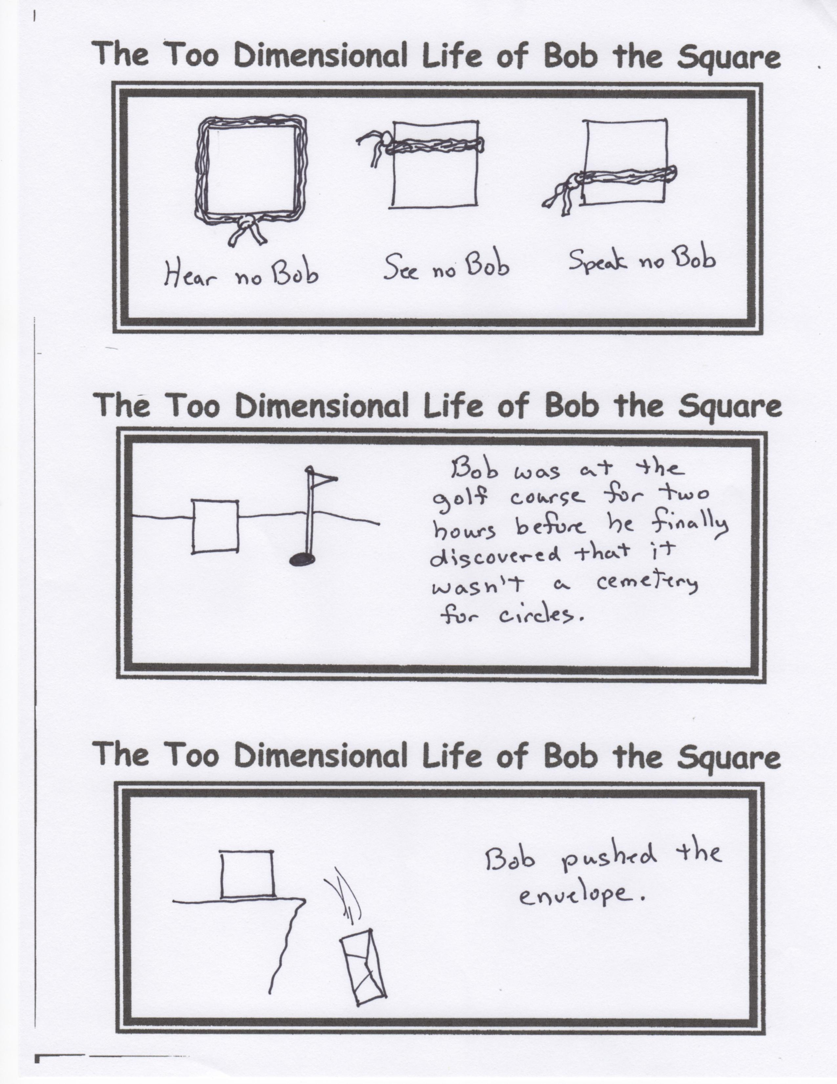

**BOOK OF THE MONTH CLUB**

Welcome to the Canard Lee Reed Book of the Month Club. As a member of this Sunday School class, you are automatically enrolled in the *Stupendous Fantasticus Incredibilious Bookworm Club.*

This month’s choices are absolutely some of the best books we have ever offered.

1. A Children’s Guide to Hitchhiking

2. Your First Picture Book—(Reading Is For Losers)

3. Mr. Fork Meets Mr. Electrical Outlet

4. The Little Engine That Thought He Could—But Failed Miserably

5. Some Kittens Really Can Fly—They Just Need Encouragement

6. Freeway Dodge Ball—Official Kindergarten Rules

7. Curious George and the High Voltage Fence