**November 16, 2014**

**Volume 3, Issue 12**

Sunday School Times

Published almost weekly, but more like…..whenever, so get used to it, OK?

# The Windsor Guildhall

***Stuff For Today***

• Bob the Square x 2

• A Movie Guide

* The Windsor Guildhall
* Questions and Answers

**By Mr. Lyle (mrlyle1@gmail.com**

In the sixteen hundreds (aproximately 1688) Christopher Wren, a well known architect, was commissioned by the Windsor town councillors to build the Windsor Guildhall - a picture of which is shown below.

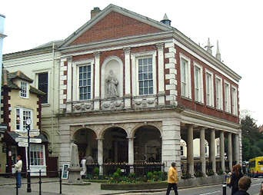

As you can see from the picture, the ground floor of this building is completely open, with the main part of the building being supported by 18 pillars around the edge. This open space was designed to be used as a public market.

When the town councillors saw what Wren intended to do, they (in their infinite architectural wisdom) protested to the great architect that his design would never work. Eighteen pillars would not be enough to support the weight of the building, and the whole thing would collapse.

Christopher Wren insisted that his design was solid and safe, and an argument ensued. The upshot of it all was, Christopher Wren agreed to add four more columns into his design. These four columns were interior columns, and can be seen in the picture below.

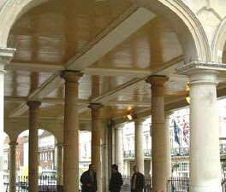

But Christopher Wren had the last laugh; when he designed the four inner pillars, he deliberately designed them to be two inches too short; the tops of the columns do not even touch the beams of the ceiling. They bear *no weight at all!*

Over the centuries, many people have had a good laugh at Christopher Wren's subtle jab at the town councillors (although today, if you visited the guildhall you would discover that at some point wooden shims have been placed above the pillars, so they really do bear weight.)

But Christopher Wren obviously knew what he was doing; for centuries this building stood strong and tall without those center columns supporting any weight.

The book of I Peter describes the church as a building...not made of stone, but of *living stone*. We, as Christians, make up the structure of the church.

**I Peter 2:4-5** says: *And coming to Him as to a living stone which has been rejected by men, but is choice and precious in the sight of God, you also, as living stones, are being built up as a spiritual house for a holy priesthood, to offer up spiritual sacrifices acceptable to God through Jesus Christ.*

Just as men rejected and disbelieved Christopher Wren's architectural plans, mankind has rejected the foundation (Jesus Christ) upon which God is building His church. But our foundation is a foundation which will never disappoint, and the structure built on that foundation will never collapse.

But God is not like Christopher Wren; unlike Wren, God has not put any "useless" columns in His church. The book of Ephesians tells us that we are *all* being fitted together. There are no useless or unimportant parts in God's building. We each have a part to play, a work to do, a section of the building to support. And when we choose not to do our part, the whole building suffers.

If we refuse to bear the weight given to us, the building will not collapse, but another - stronger - part of the building will have to carry the burdens we refuse to bear. In other words, our choice to not do our part in God's work is a choice to place a heavier burden on the back of another part of the church.

**A Movie Guide for Your Dad**

By Mr. Lyle (mrlyle1@gmail.com)

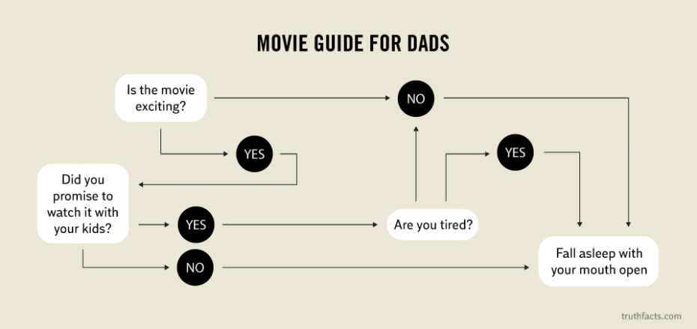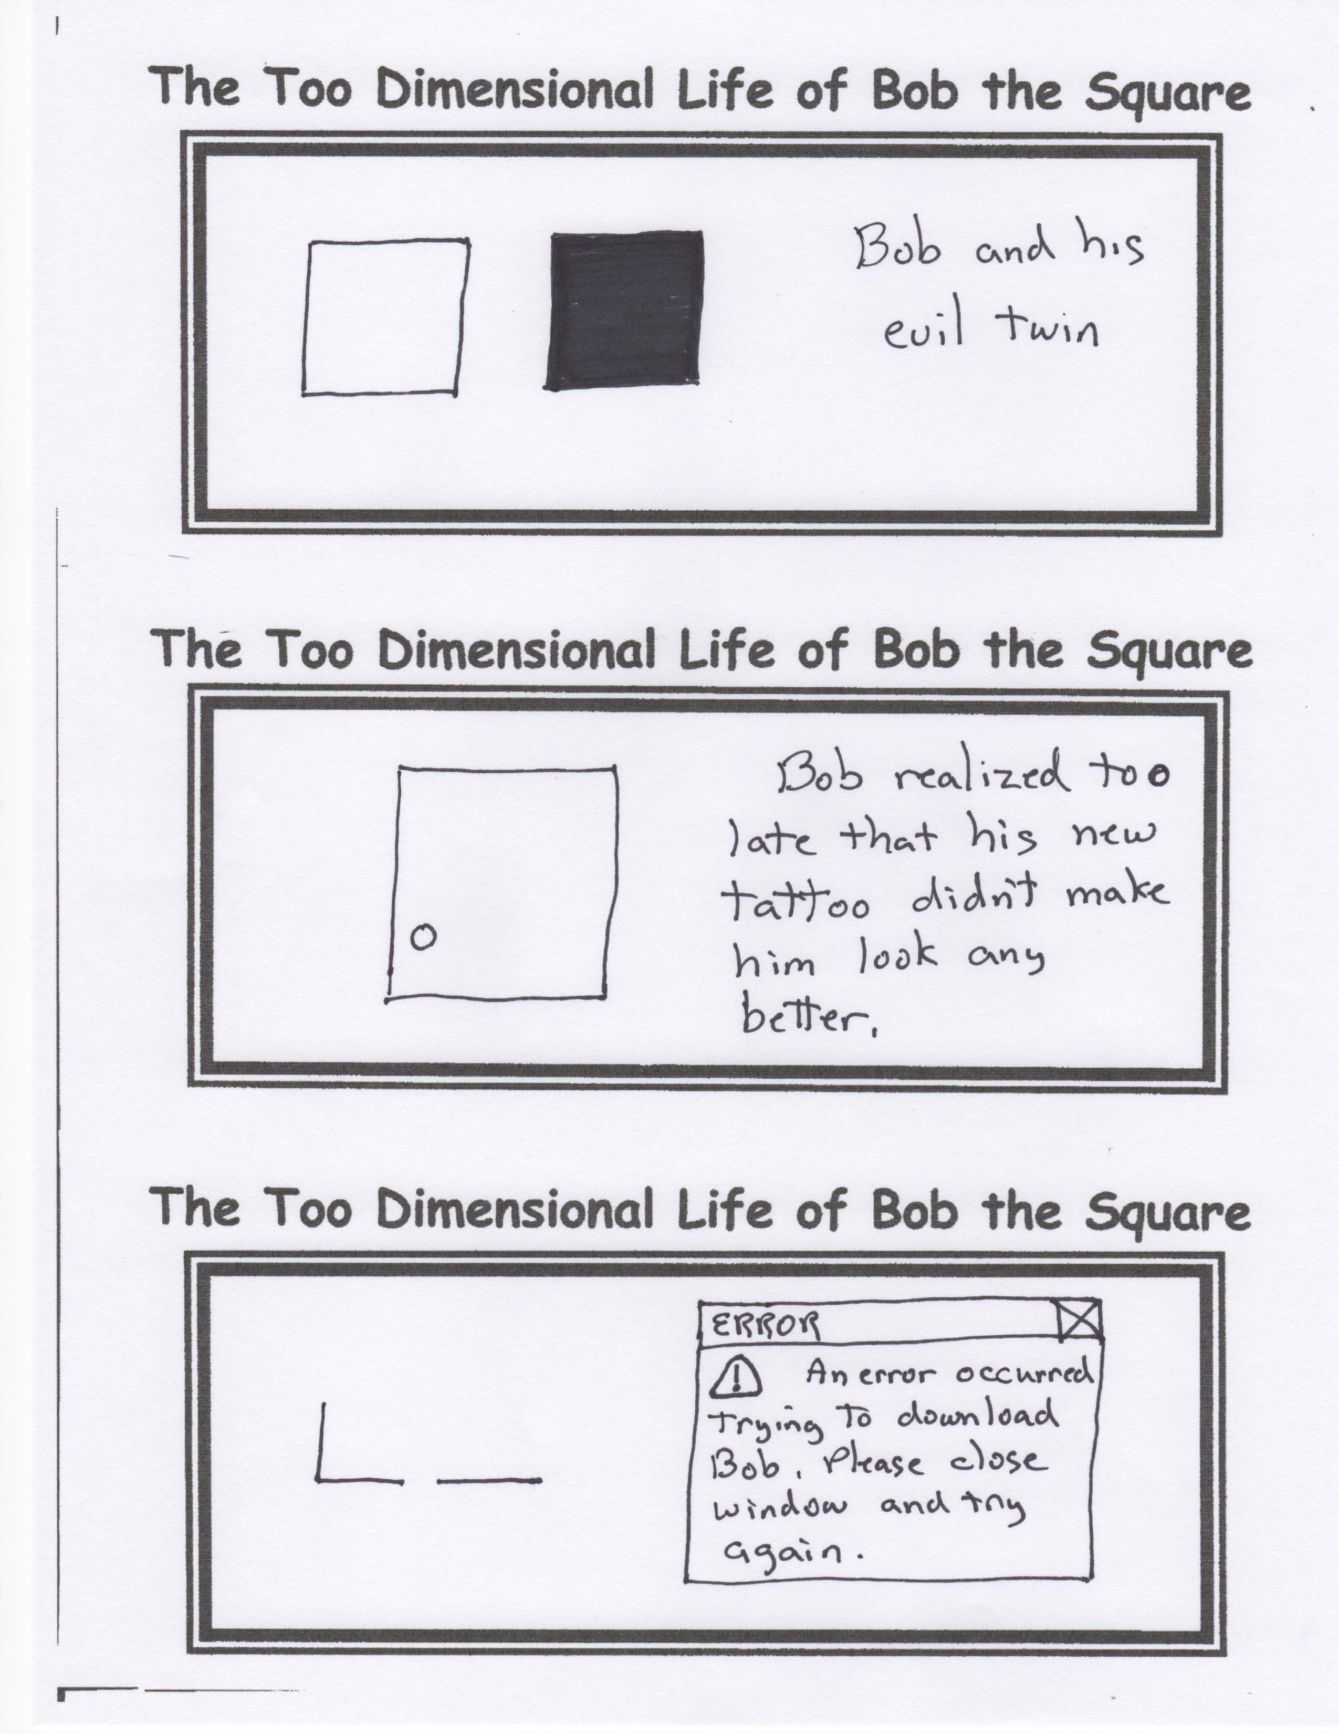

(An empty corner—how disappointing!)