**August 24, 2014**

**Volume 3, Issue 1**

Sunday School Times

Published almost weekly, but more like…..whenever, so get used to it, OK?

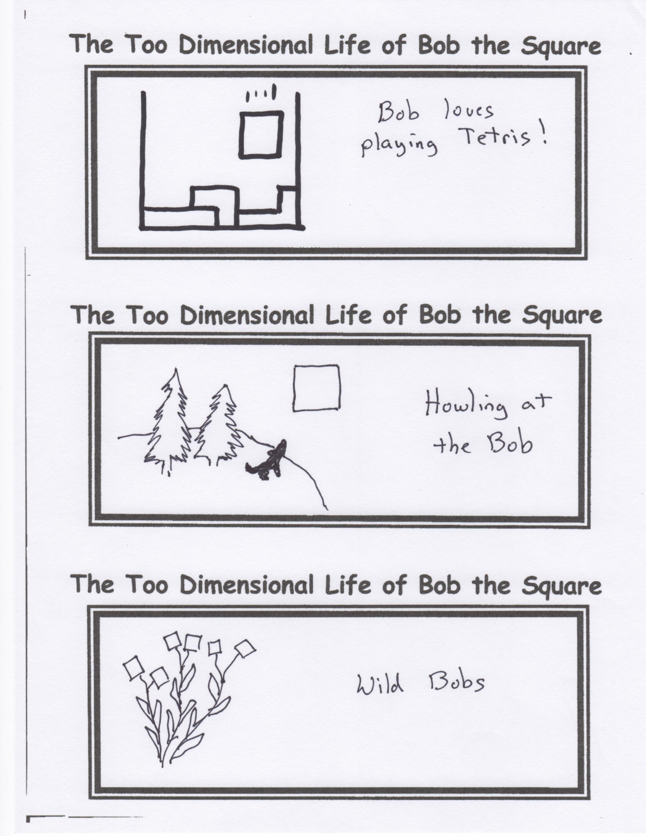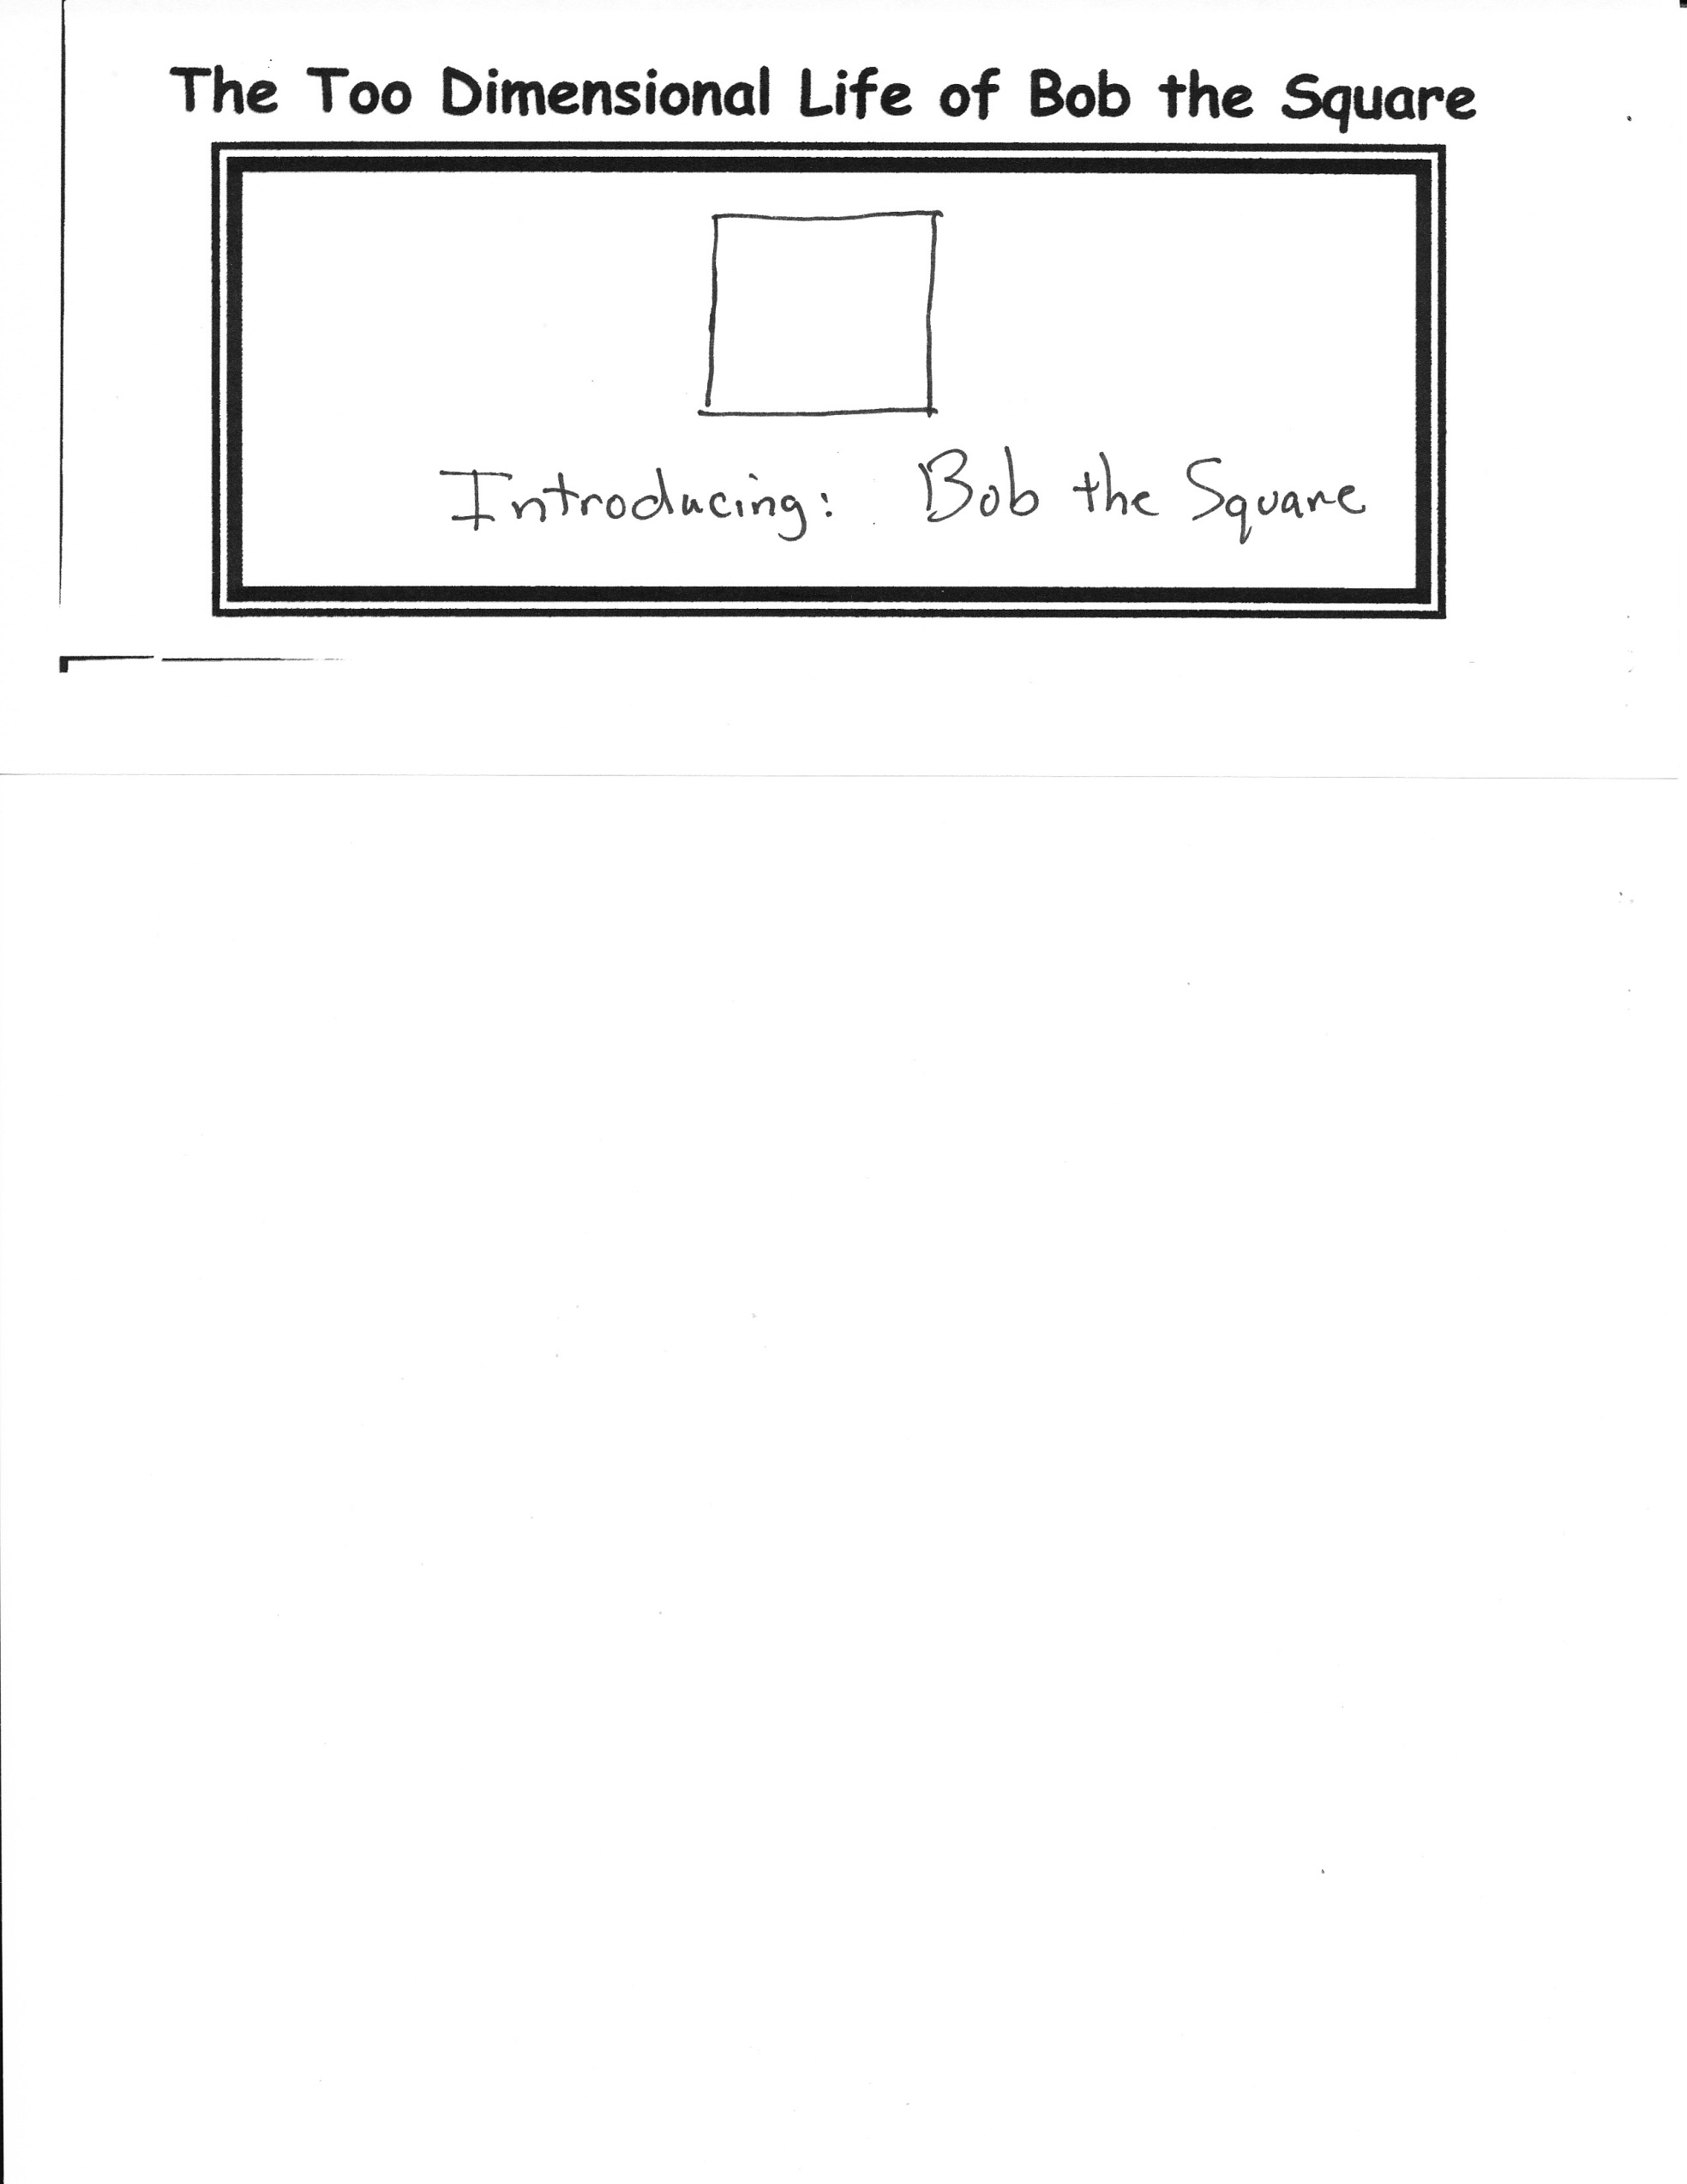

**Almost Biblical…**

**But Not**

Go to the ant, though sluggard, consider his ways. He rises early in the morning and goes about his tasks of gathering and storing. His back is strong for his work and he marches on with no commander, an army of one. He stores enough for the winter and his future is secure. At the end of the day, his labors have been fruitful. He rises to an high point at the setting of the sun and holds the weight for all to see. He is magnificent, excelling in wisdom, first among the creatures of the earth. But alas, he is still an ant, and I firmly step upon him with resolve and he is no more.



**Stuff**

Mr. Lyle’s e-mail:

[mrlyle1@gmail.com](mailto:Mrlyle1@gmail.com)

Mr. Lyle’s Facebook page:

Log onto facebook and look for Theother Lyle. You will be able to read all about my amazing adventures!

Welcome to the Sixth and Seventh Grade Sunday School. Today will be your chance to get to know your teacher for this coming year.

Mr. Lyle will begin this morning with the reading of the newspaper, which is always a special time for all of us. He will probably regale us with a few stories from his past. These are meant to help you to get to know him better. If I know him, he will start with the story about a humongous toad, the biggest anyone has ever seen! Then, I would expect him to tell you about how he got his Citizen Band Radio nickname. And for those who will be willing to stand up and take the official oath, there is the story about a psychopathic murderer who attempts to strangle someone he knew very well. That one is REALLY special. And finally, if you survive those stories, he has one about a little old lady named Mrs Larsen that he once knew.

And if all of that were not enough, there will be a short presentation by Mr. Lyle regarding his involvement many years ago in the Olympics. Few are familiar with his achievements during the 1972 Summer Olympics, and fortunately, (or unfortunately), for you, he has prepared a short documentary film regarding this amazing time in his life. This film is typical of his movie making prowess, so prepare yourselves accordingly for the rest of the year.

After the movie, when the applause has died down, he will share his personal testimony in picture format, explaining some of the episodes in his life that have brought him to this point in his walk with the Lord. He will probably give the picture away at the end of class to some poor, I mean, lucky individual! Hopefully, you will find his talk interesting. If not, well, there goes ten minutes of your life. ☺

***Stuff For Today***

• Introducing: Bob the Square!

• Almost Biblical

• Stories, a movie and a picture. How could it get any better than that?

**By Mr. Lyle (mrlyle1@gmail.com**

# So, Who Is Mr. Lyle, Really?

All good newspapers have comics, and so it is with this one. Each week look forward to a new and exciting look into the extraordinary life of Bob the Square, as seen through the slightly warped reality present in the mind of Mr. Lyle.

## The Too Dimensional Life of Bob the Square