**April 20, 2014**

**Volume 2, Issue 29**

Sunday School Times

# A Four-Letter Swear Word--_ _ _ _

***Stuff For Today***

• Wait, Wait, Let Me Guess!

• Stuff about chocolate Easter bunnies.

* The only swear word you will ever be taught in Sunday School!

Published almost weekly, but more like…..whenever, so get used to it, OK?

**By Mr. Lyle (mrlyle1@gmail.com**

***Deuteronomy 21***

***22 If someone guilty of a capital offense is put to death and their body is exposed on a tree, 23 you must not leave the body hanging on the tree overnight. Be sure to bury it that same day, because anyone who is hung on a tree is under God’s curse. You must not desecrate the land the Lord your God is giving you as an inheritance.***

Capital punishment in the Old Testament was far from the manner adopted in our culture today. The Mosaic Law permitted three methods, all of which we would find extremely repulsive today.

First, God allowed justice to be served with a sword. A quick, but brutal method of execution, it was used many times.

Secondly, there was a place in the Law for death by fire. This method would require preparation and planning. Implementation of this sentence would have been much more difficult and probably more public.

Lastly, the third option was stoning. This was a community event. Everyone was to throw stones at the accused until they were dead. The average individual participating in the execution would have forever, a lasting memory of a human being slowly dying right before their eyes.

But oddly, Deuteronomy 21 does not deal with these allowable techniques of execution. It instead deals with crucifixion. Somewhat common in the pagan world, its torture and degradation were not to be introduced by Israel into its criminal justice system. God says it is a “cursed” way to die.

God knew the future. He knew that His Son would come to this earth and die at the hands of the Roman government. He knew that their most heinous form of punishment was death by the cross.

The extreme agony suffered by a convicted criminal was difficult to watch. The Romans could execute swiftly and cleanly if they desired. But the cross was a public spectacle of torture, reserved for the most despicable humans, and deigned to keep them alive for as long as they wished their public torture to continue.

In our culture and language, we have swear words. These are words that are used in times of extreme emotion or anger. Generally they refer to something nasty or disgusting or horrible. For the Romans, watching a crucifixion was one of the most disgusting, horrid things any human could experience. And a curse, or swear word, developed from it

In Latin it has four letters, making it oddly similar to many of our curse words. The word—CRUX. In Latin, it is the very word for “cross”.

God despises sin so intensely that He sent His Son to die a horrible death as an innocent, yet convicted, man.

And God loves us so intensely that He sent His Son to die a horrible death as an innocent, yet convicted, man.

This Easter, may we remember these facts and allow them to sink into our hearts and consider the great gift that as given to us that day over 2000 years ago. God loves us! And showed us, and the entire universe, just how much He cares about us.

**Chocolate Easter Bunny Technical Consumption Regulations.**

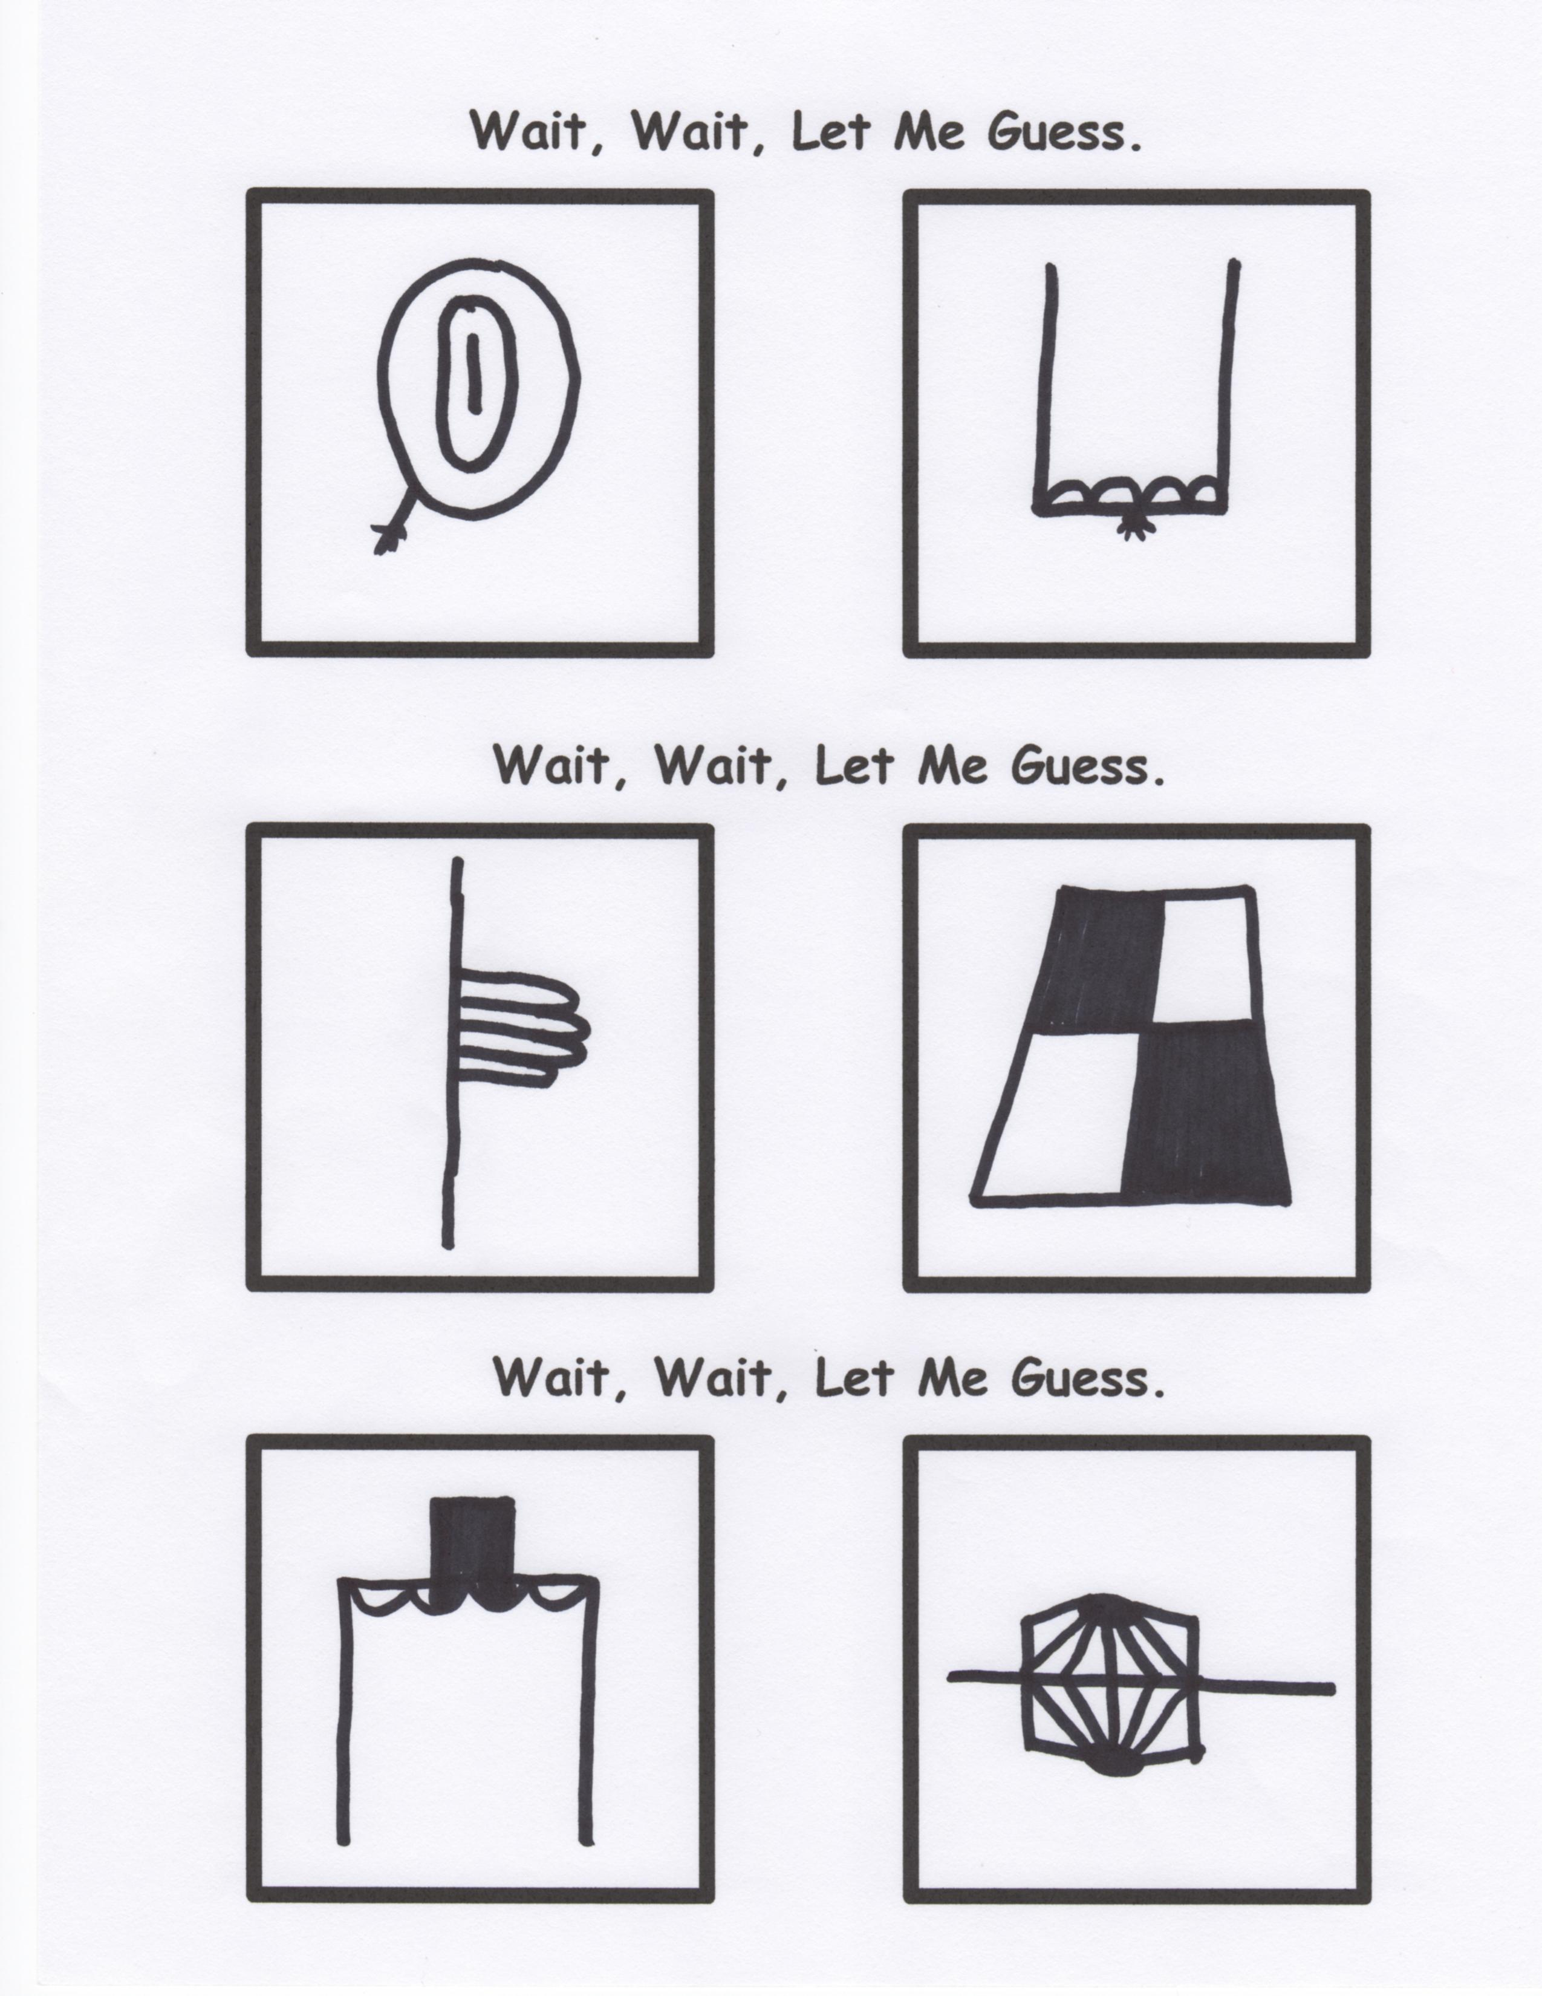

Mr. Lyle is now on Facebook!

Anyone who wishes to be his “friend” can send a friend request to Theother Lyle. Check it out. It will make you smile—guaranteed.

We have included the following technical data. Also, please note that all facts quoted herein are conjectural and any and all reasonable conclusions should be considered fortuitous.

Always, always, always eat the ears first. Easter bunnies have an unmatched, highly acute sense of hearing. The slightest sound can set off their natural flight instinct, and you may never see them again. Eating the ears first makes them totally deaf, leaving them much more docile and easy to eat.

Secondly, eat the eyes and nose. Bunnies have incredible eyesight, and blinding them will make them easier to keep track of, should you lay one down for any reason. Their inherited defense mechanism is to remain completely motionless, hoping to not be detected by predators such as you.

And by eating the nose and mouth relatively early in the consumption process ensures that they cannot scream out in pain as you devour their frail little bodies.

Lastly, you want to be known as a generous person, so carefully eat around the tail portion, being careful to not get too close to it. When it has been sufficiently trimmed off, offer it to your little brother or sister. They’ll never know the difference! And you’re a hero!

By Mr. Lyle (mrlyle1@gmail.com)