**April 6, 2014**

**Volume 2, Issue 27**

Sunday School Times

# The Hatfields and McCoys

***Stuff For Today***

• Wait, Wait, Let Me Guess!

• Can God use you?

* What if?
* Hatfields and McCoys

Published almost weekly, but more like…..whenever, so get used to it, OK?

**By Mr. Lyle (mrlyle1@gmail.com**

***Matthew 18:15-17***

***15 “If your brother or sister sins, go and point out their fault, just between the two of you. If they listen to you, you have won them over. 16 But if they will not listen, take one or two others along, so that ‘every matter may be established by the testimony of two or three witnesses.’ 17 If they still refuse to listen, tell it to the church; and if they refuse to listen even to the church, treat them as you would a pagan or a tax collector.***

**Recipe**

Ingredients:

1. One hog.

2. Asa, a young man from the South who decided to fight for the Union.

3. A river called “Tug Fork”.

4. A romance between Roseanna and Johnse.

5. Assorted guns.

6. Stupidity.

Beginning in 1880 and continuing through 1891, mix the Tug Fork, Asa, the “Union defector”, one whole hog, and Roseanna and Johnse together. Add plenty of guns and a very generous portion of stupidity. Stir well, and allow things to go on unchecked.

This recipe makes:

1. Twelve people dead

2. Ten maimed or badly hurt.

3. The Governor of West Virginia threaten to invade Kentucky

4. Seven people jailed for life

5. One man hanged for his crimes

6. And the US Supreme Court hand down a decision, before its all over.

The names Hatfield and McCoy hold a special place in US history. The story of seemingly unbridled hatred and revenge in the hills of eastern Kentucky is without equal.

And to think that it all started with a dispute over who owned a particular pig! In terms of that day, it was worth about 24 dollars. Translate that number to today’s economy for comparison—the death and destruction originates over a mere two hundred dollars!

We find ourselves in disbelief that anyone could be so callous and harsh over something so small. But if we are honest, we must confess that we also find ourselves at times in heated contests with those around us, over things even more trivial than a pig.

Interpersonal relationships inside the church can be challenging. We are fallen human beings, and even though we have a relationship with Christ, our sin nature bubbles to the surface all too often. At heart we are selfish creatures, wanting our own way. And in our minds, those that infer themselves into our plans and spoil them are to be treated harshly.

Jesus taught a different way, however. And He was clear in His directions—very clear!

On Christmas Day, 1957, Dr. Martin Luther King delivered a sermon that he had written while in prison a few months earlier. It dealt with this subject, and I would like to summarize his three points, because they are worthy of note.

First, we must be willing to forgive. That does not mean that we ignore the wrong that may have been committed, but rather, we embrace a true spirit to forgive.

Second, we need to understand that the wrong that we may have suffered is not the other person’s total identity. We need to acknowledge that we are all sinful creatures, with good and bad points in each of us. The victory goes to the persons capable of focusing upon the good character traits in both parties involved.

And, thirdly, to carry an attitude that says that we must defeat or humiliate our opponent is misguided. We would do well to remember that God’s love is unconditional towards us, and therefore, we can risk allowing ourselves to seek understanding and even friendship with others.

So are you a Hatfield or a McCoy? Rather, be a loving example of Christ to those that you rub shoulders with each day.

**What If?**

By Mr. Lyle (mrlyle1@gmail.com)

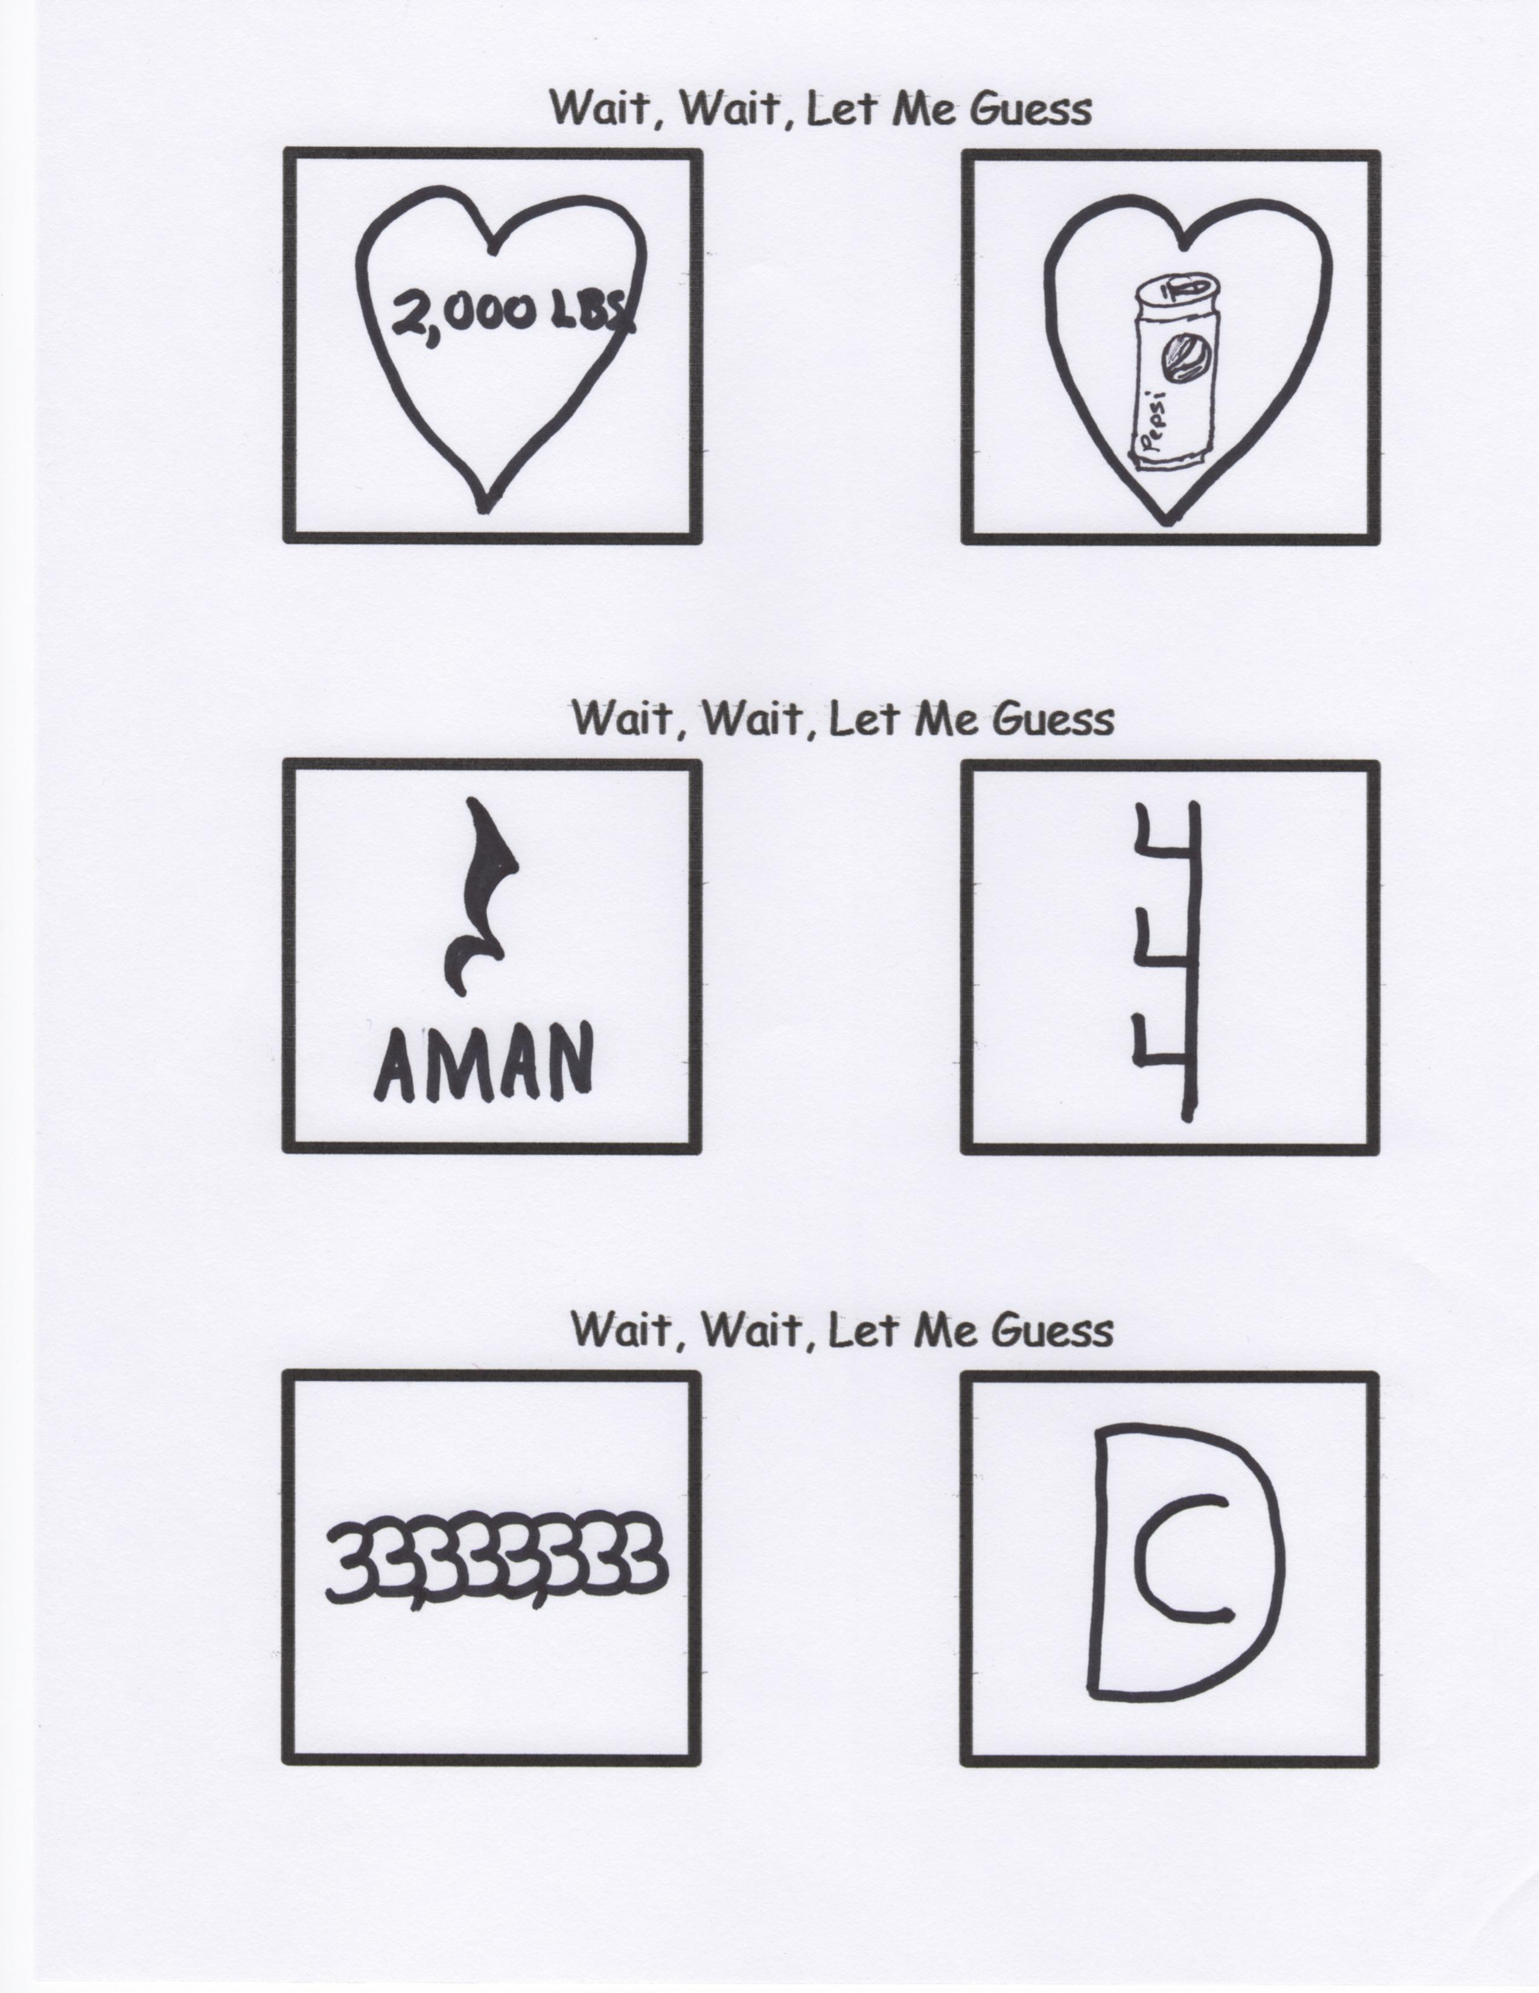

**Can God Use You? Well, Let’s See…**

1. Jacob was a cheater

2. Peter had a temper

3. David had an affair.

4. Noah got drunk.

5. Paul was a murderer.

6. Gideon was a doubter.

7. Miriam was a gossiper.

8. Martha was a worrier.

9. Thomas was a doubter.

10. Sarah was impatient.

11. Elijah was depressed.

12. Moses stuttered.

13. Zaccheus was short.

14. Abraham was old.

15. Rahab was a prostitute.

16. Jonah ran from God.

17. Oh, and Lazarus was

DEAD!!!

So…what do you think?

So…

I was sitting at home, contemplating the universe and its amazing complexity. The enormously vast reaches of space, and how God created our planet and put us there to enjoy it. I thought about how incredible the idea of life is, and how fortunate I am to be alive. I began to recall all of the tiny things God has included in this world for us to enjoy. Even in the smallest of details we can see the hand of our God. And then I see the crowning achievement of creation—people--with their incredible variations of character, and their ability to comprehend and think. I remembered how fortunate I was to have friends, and I began to think about them. I went down the list, glad that I am alive to enjoy their company. And I eventually got to you. I remembered, YOU STILL OWE ME TWENTY BUCKS!!!!

What If we treated our Bibles like we do our cell phones?

What if…

We carried it everywhere we went?

What if…

We turned back to get it if we forgot it?

What if…

We checked it for messages throughout the day?

What if…

We used it in case of emergency?

What if…

We spent about an hour or more using it every day?

We pay for the privilege to use a cell phone. You get free “unlimited minutes” with your Bible.