**November 24, 2013**

**Volume 2, Issue 12**

Sunday School Times

***Stuff For Today***

• Wait, Wait, Let Me Guess

• Girl Scout Cookies

* Lost Dawg
* Questions and Answers

Published almost weekly, but more like…..whenever, so get used to it, OK?

# After God’s Own Heart

**By Mr. Lyle (mrlyle1@gmail.com)**

***II Samuel 22:36***

The Bible records the faults as well as the failures of men and women. It is easy to focus upon those blemishes. On a large white canvas, a black smudge is easily seen and gathers attention. That dark spot becomes the focus of consideration instead of the vast white areas that are unscathed by discoloration. David made an enormous mistake with Bathsheba. He compounded that sin by murdering her husband—a man whom David had known and considered a friend for many years. Nathan, the prophet, confronted David openly. Nathan put his life on the line when he challenged David. The king could have had him executed right then and there. Instead, David immediately admitted his guilt and asked for forgiveness from God. In Psalms we are given a first-hand look into the private thoughts of this man as he dealt with this issue. His instant humility and heart condition are traits God desires in all. He was *a man after God’s own heart.*

To understand the heart of David is difficult from our vantage point. We see a boy with his sheep, a young man challenging giants, and a man with huge mistakes as well as huge successes in his life. Remember it was David who brought the nation together, who planned and financed Solomon’s temple, and who wrote many of the Psalms that today still touch many hearts. One Psalm, written by David, places our attention appropriately upon the secret of his success as a man of God. It is also found in the Book of Psalms. It is a song he wrote as he neared the end of his life and is now recorded in II Samuel 22. Verse 36 places everything into perfect perspective. *Thou hast given me the shield of thy salvation: and thy gentleness has made me great.* Our relationship with our Lord is based upon his gift of salvation. It is the foundation block that everything else stands upon. David also understood that nothing in his own self was of any lasting value. The gentleness of God, His bending down towards man in love, His tender care for us, His compassion delicately touching our lives—that is what makes anyone great. The understanding of that truth may allow any of us to develop into men and women *after God’s own heart.*

**A Suggestion:**

As farm animals go, turkeys are not very bright. In fact they are downright stupid. So, this Thursday, as you are eating your turkey meal, feel confident that you have probably done that animal a favor by removing it from it’s pitiful existence on a farm.

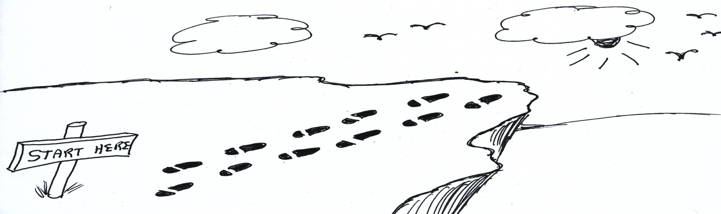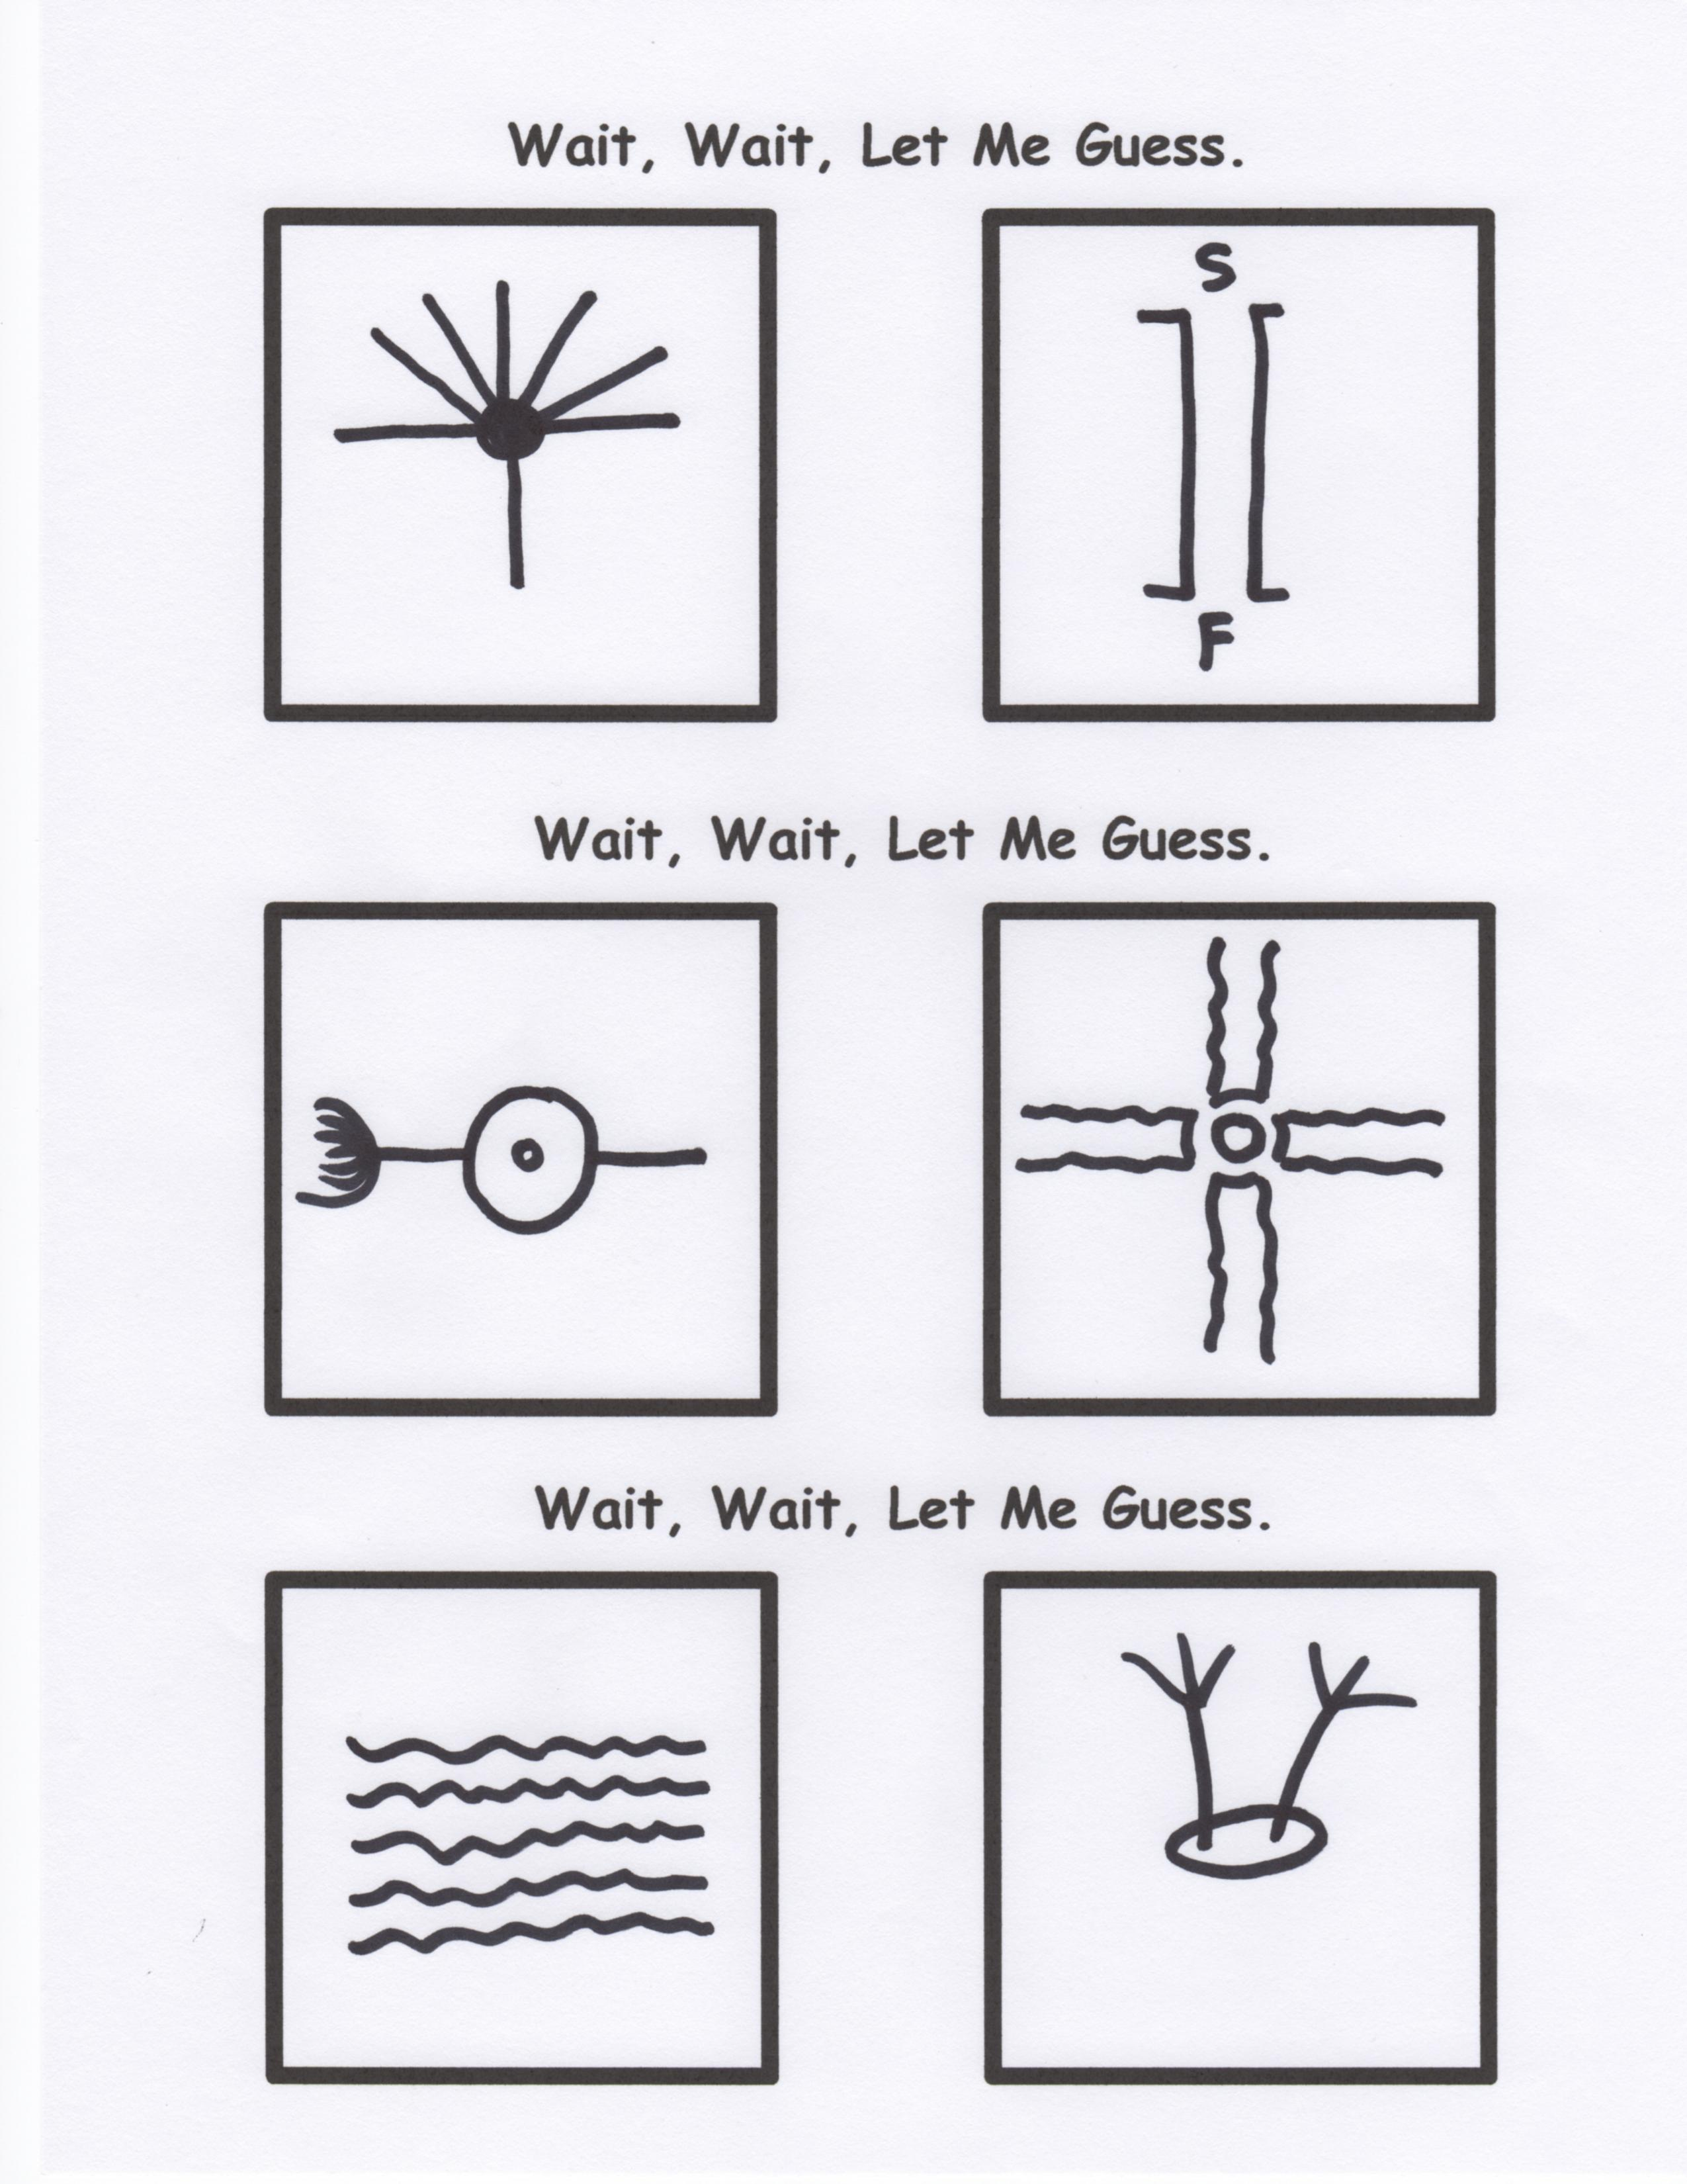

**Wile E. Coyote’s 12 Steps To Personal Success**

**Lost Dawg**

(A Paid Advertisement)

I lost my dawg while walking up 42nd street. He went off to play with other dawgs, and I haven’t seen him since. He answers to “dawg”, “JaQuan”, or just plain “sup yo”. If you see him, tell him to hit me up. I be missin’ my brotha.

**Girl Scout Cookies Go On Sale**

**Thin Mints**

**Thick Mints**