**November 17, 2013**

**Volume 2, Issue 11**

Sunday School Times

***Stuff For Today***

• Wait, Wait, Let Me Guess

• Evolutionary Theory

* Questions and Answers
* The Redeemer says “yes”

Published almost weekly, but more like…..whenever, so get used to it, OK?

# Ruth Chooses A Redeemer

**By Mr. Lyle (mrlyle1@gmail.com)**

***The Book Of Ruth Chapter 3 and 4***

To a Hebrew, the New Testament term of redeemer would be more accurately defined as kinsman-redeemer. The Old Testament law of the kinsman-redeemer provides some interesting insights into the concept of calling Jesus our Redeemer. The Biblical narrative says that Ruth washed (we are washed, born again, forgiven), anointed herself (we have the anointing of the Holy Spirit), dressed in her best clothes (we are clothed in the righteousness of Christ), and she claimed her redeemer (we, too, must accept our Redeemer). Staking that claim was her only requirement. Everything else became the responsibility of Boaz. (God performs all the work in our salvation.)

There is also mention of a redeemer who was of closer relationship who refused to do his duty, and thus Boaz could fulfill the request. That nameless kinsman represents the Law. It cannot save, because no one is able to keep it. The kinsman-redeemer was also responsible for justice. If we claim Jesus to be our Redeemer, He is our Kinsman-Redeemer, and we have no need to seek personal revenge for wrong done to us, he will ensure that justice is applied.

The romance of redemption is a beautiful thing to behold.

Marketing Failure #347

Purina Dog Chow

(Homework Flavor)

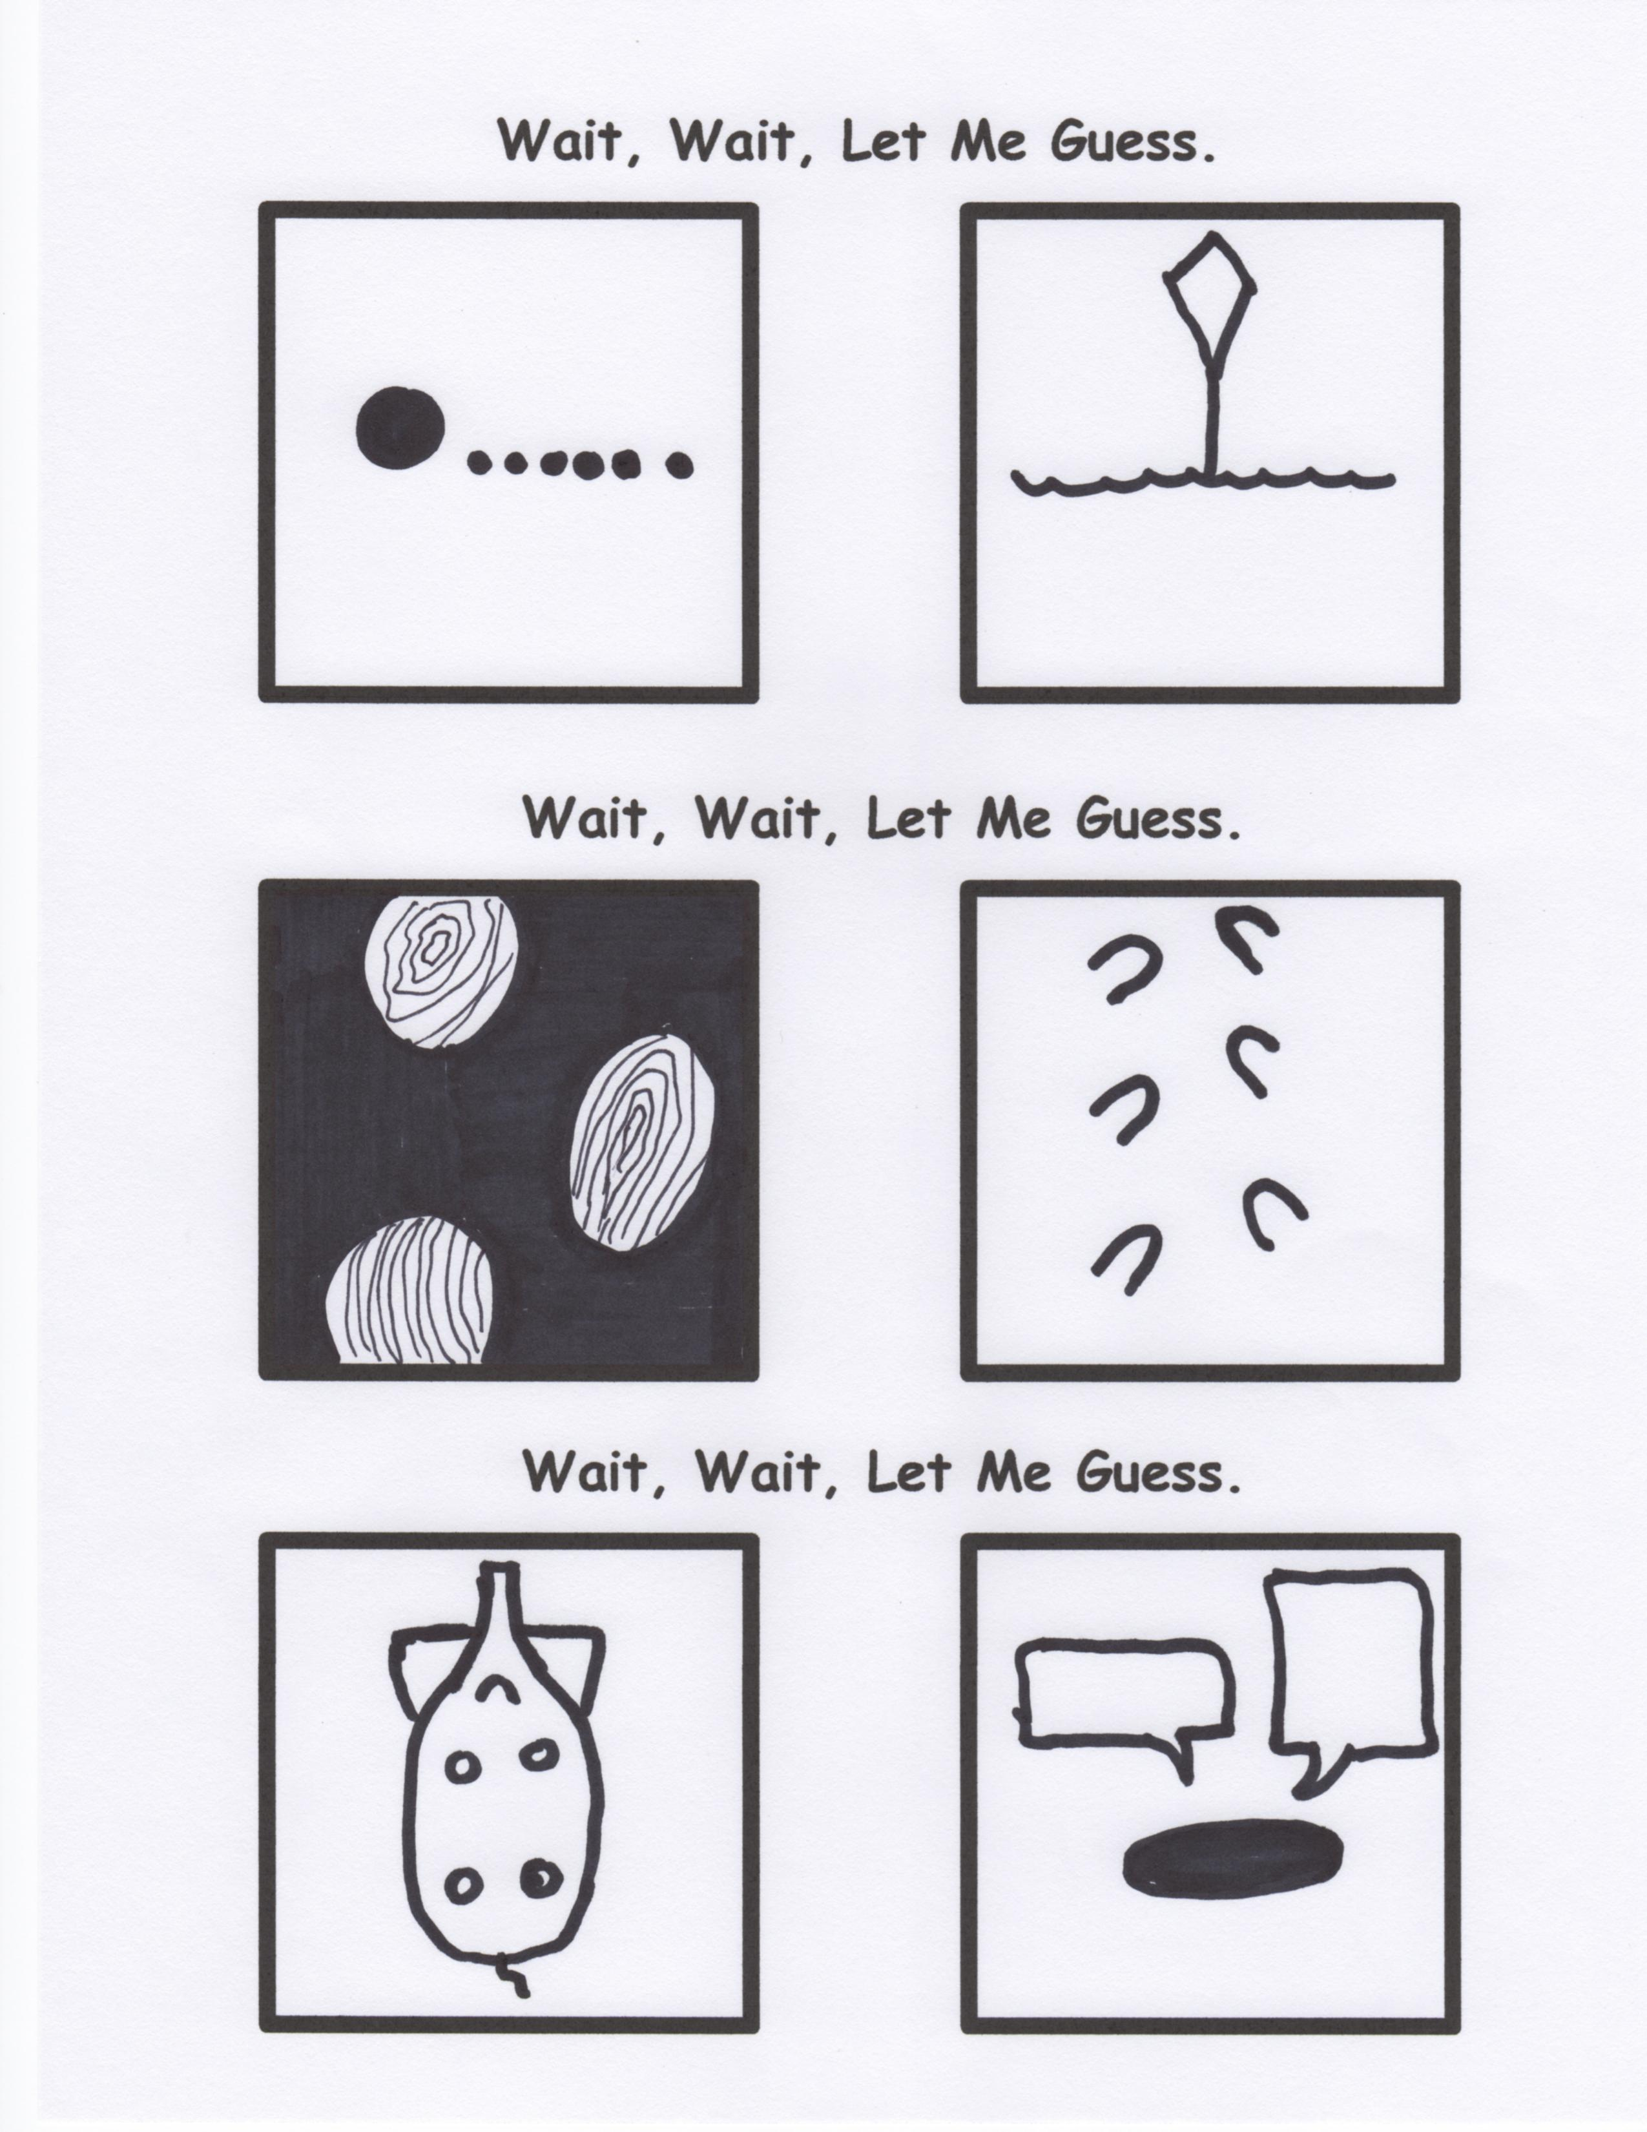

**A Question:**

Once per semester Mr Lyle takes questions from you about the Bible, God, church, other religions, etc. He will then attempt to answer them in class. So, if there is something that you always wondered about or would just simply like to have an answer to, next week will be your chance. You will be given a piece of paper to write your question on—you will NOT sign it—and hand it in and we will go through each one until all have been answered. No question is “off the table”. You can ask anything you like. This is ALWAYS interesting!

**Mr. Lyle Explains Evolutionary Theory**

By Mr. Lyle (mrlyle1@gmail.com)

120 million years ago this boulder looked remarkably like a 1983 Nissan Sentra. Isn’t evolution amazing?!

The lives of countless tens of people were brutally and tragically counted as failure this weekend as the Middle School Cookout was cancelled. The loss will be felt for many, many years to come. Counselors will be available for those needing help dealing with the tragic turn of events. Those still struggling with their hurt can rest assured that it will be rescheduled soon.