**August 25, 2013**

**Volume 2, Issue 1**

Sunday School Times

***Stuff For Today***

• Wait, Wait, Let Me Guess!

• Paper clip anatomy

* The Elusive Loopy
* Anatomy of a “shell” game

Published almost weekly, but more like…..whenever, so get used to it, OK?

# How To Not Destroy A Watch

**By Mr. Lyle (mrlyle1@gmail.com**

***Luke 10: 38-42***

***38 As Jesus and his disciples were on their way, he came to a village where a woman named Martha opened her home to him. 39 She had a sister called Mary, who sat at the Lord’s feet listening to what he said. 40 But Martha was distracted by all the preparations that had to be made. She came to him and asked, “Lord, don’t you care that my sister has left me to do the work by myself? Tell her to help me!” 41 “Martha, Martha,” the Lord answered, “you are worried and upset about many things, 42 but only one thing is needed. Mary has chosen what is better, and it will not be taken away from her.”***

The passage above provides a glimpse of an everyday moment in Jesus’ life. We find the Lord giving instruction to Martha concerning her decision-making processes. He gently reminds her of her dislocated priorities.

As Christians, we often face identical challenges. The world that we live in is quick to drag our focus away from God. How we make choices every day is crucial. Fortunately, the Bible gives us a few hints to guide us in making positive, Godly, choices.

**1. Pray**. Talking to God results in a closer walk with Him. That can never be a bad thing.

**2. Read the Bible**. There is a wealth of information to be found in the Word.

**3. Apply what you find in the Bible**. That sounds easy, but often it is not.

**4. Accept God’s leading**. Don’t doubt or argue with Him. He’s REALLY, REALLY smart!

**5. Seek Godly council**. Many times there are people in our paths that God has conveniently placed there for us to lean on.

**6. Stretch your faith**. There are times when we must be prepared to throw caution aside and follow God blindly—and never, never give up.

**7. Check the desires of your heart**. When we walk with God, His “wants” become our “wants”.

Life hands us opportunities. How we use those moments can affect our lives tremendously. It may be cliché, but what would Jesus do (or say)?

And what about that watch? Well, that is part of the lesson today.

**The World’s Easiest Knot To Tie—But Also The Most Difficult**

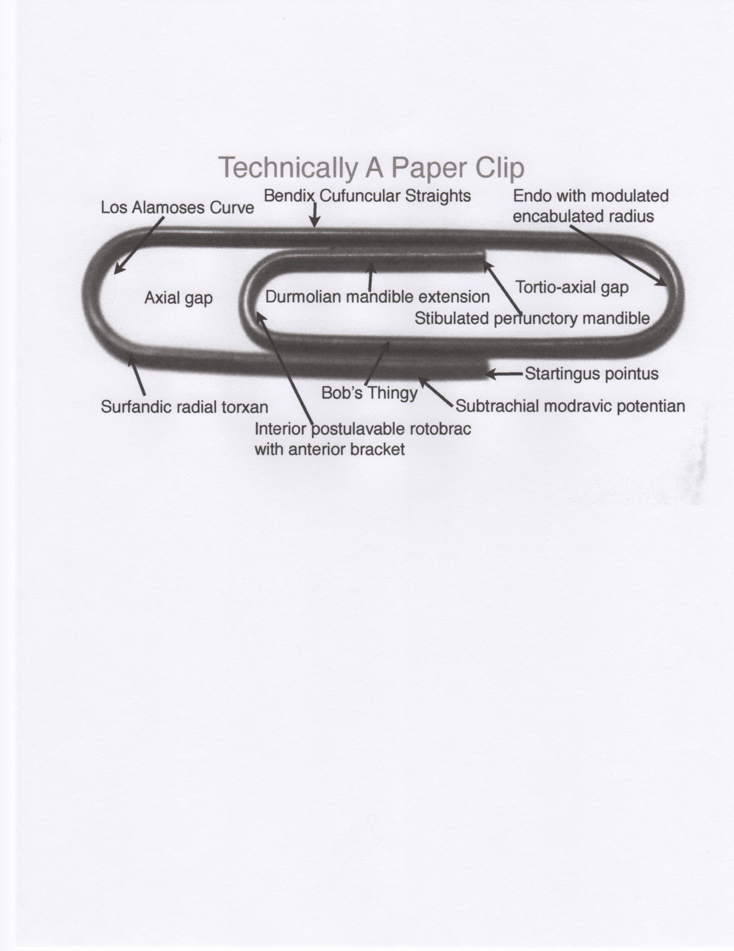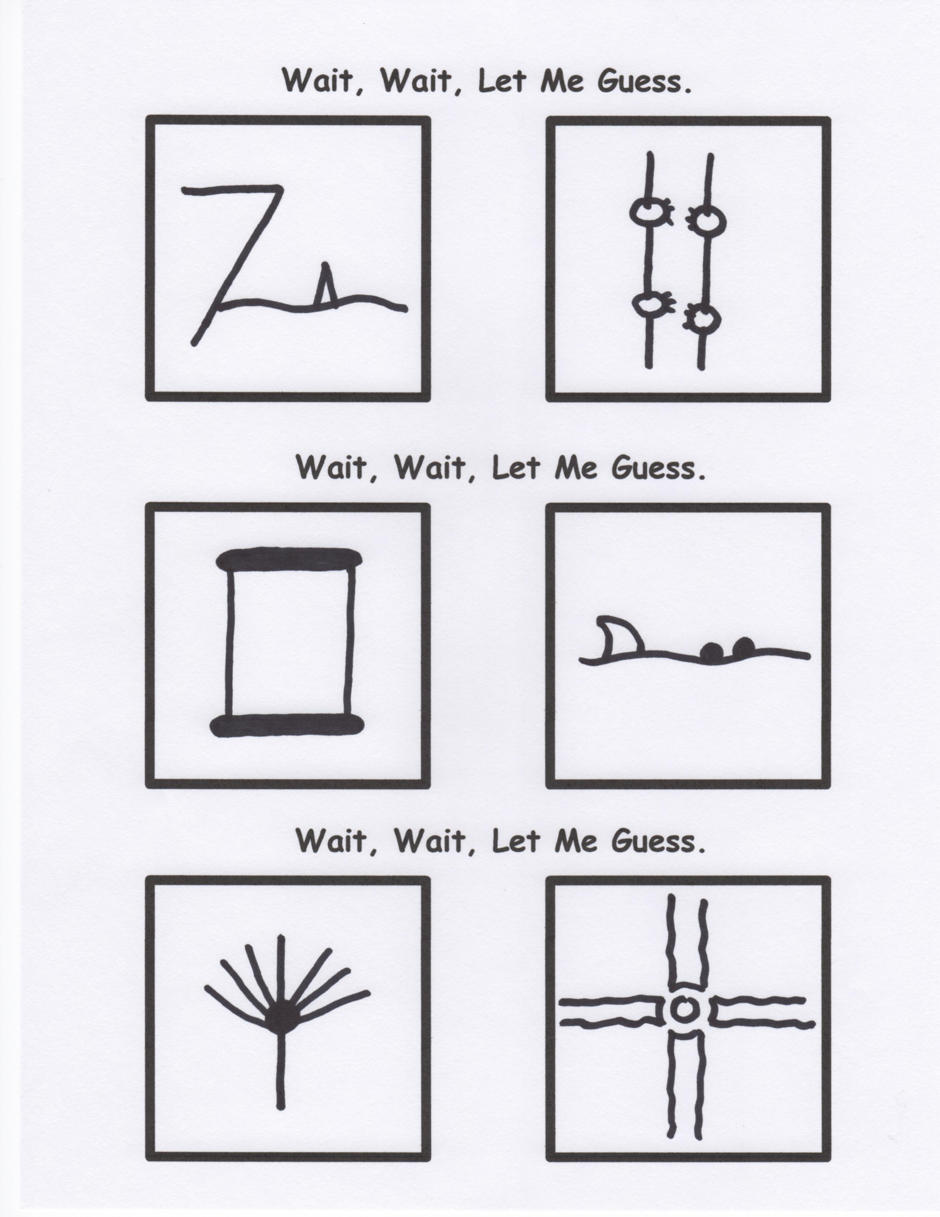

Growing up in a small town in central Kansas in the 1960’s was not as boring as it might seem to someone looking at the scene from our day and time. One could describe it all with a few basic words:

Flat: Imagine a square mile with no more than a 5 foot high “hill” out in the middle of it.

Hot: In the summer, I recall 20 consecutive days of 120 plus degree temps. (The warmest—128**°)**

Cold: One winter, 20-30 degrees below zero for weeks with even water towers freezing solid!

Windy: Always windy! On a clear day—gusts up to 80 mph were possible.

And for me, there was Boy Scouts. I learned a lot in that program. To this day, I can still tie every knot that I learned as a 10 year-old boy.

By Mr. Lyle (mrlyle1@gmail.com)

**Today’s Special**

Buy one Sunday School Times for the price of two, and receive the second one absolutely FREE!