**July 7, 2013**

**Volume 1, Issue 39**

Sunday School Times

***Stuff For Today***

• Teacher Quotes

• Green

* The 11th Commandment

Published almost weekly, but more like…..whenever, so get used to it, OK?

# The 11th Commandment

**By Mr. Lyle (mrlyle1@gmail.com**

***Exodus 21:2-6***

***2 “If you buy a Hebrew servant, he is to serve you for six years. But in the seventh year, he shall go free, without paying anything. 3 If he comes alone, he is to go free alone; but if he has a wife when he comes, she is to go with him. 4 If his master gives him a wife and she bears him sons or daughters, the woman and her children shall belong to her master, and only the man shall go free. 5 “But if the servant declares, ‘I love my master and my wife and children and do not want to go free,’ 6 then his master must take him before the judges.[a] He shall take him to the door or the doorpost and pierce his ear with an awl. Then he will be his servant for life.***

Israel had bid farewell to the oppression of Egypt and was traveling through the desert. God was leading them day by day, by way of a cloud. A group of probably millions, with no government or laws to order their new society by, relied upon God absolutely. With Moses as their leader, challenged by a multi-faceted social structure with many types of personalities, success would be a miracle. Remember, most of these people were Israelites, but few had been followers of God until witnessing the judgment of the mighty hand of God upon Egypt. At Mt. Sinai, they received from God a complete set of laws to live by, simply known to them as “The Law”. This set of laws governed every aspect of their normal lives, and especially, their worship of God. Through the Law, they would learn right from wrong, good from bad, and live accordingly.

Jesus said in the New Testament that He had come to fulfill the Law, not do away with it. That statement reinforces the idea that much of the Law pointed to, or foreshadowed, the coming Messiah. Most people have a familiarity with the Ten Commandments. Few realize what the “eleventh” was. Immediately following the first ten are the remaining laws. At first glance, it may appear peculiar, but the eleventh law addressed slavery. An acceptable practice in those days, it should be described as being culturally similar to an employer and employee relationship. The technical points in this particular law allowed a servant voluntarily to become a permanent slave of his owner. Due to the way slavery was to be structured and practiced among the Israelites, this was not necessarily a repugnant idea, and so it was a very real possibility. It required the piercing of an earlobe, and the slave was to repeat these words specifically—I love my master, I love my wife, I love my children. Let’s move now to a New Testament thought. Jesus was voluntarily pierced for us. Jesus loves the Father, His master, He loves His wife, Israel, and He loves His children, the Church. Jesus came to fulfill the Law, not to destroy it.

**My Favorite Quotes From Teachers**

By Mr. Lyle (mrlyle1@gmail.com)

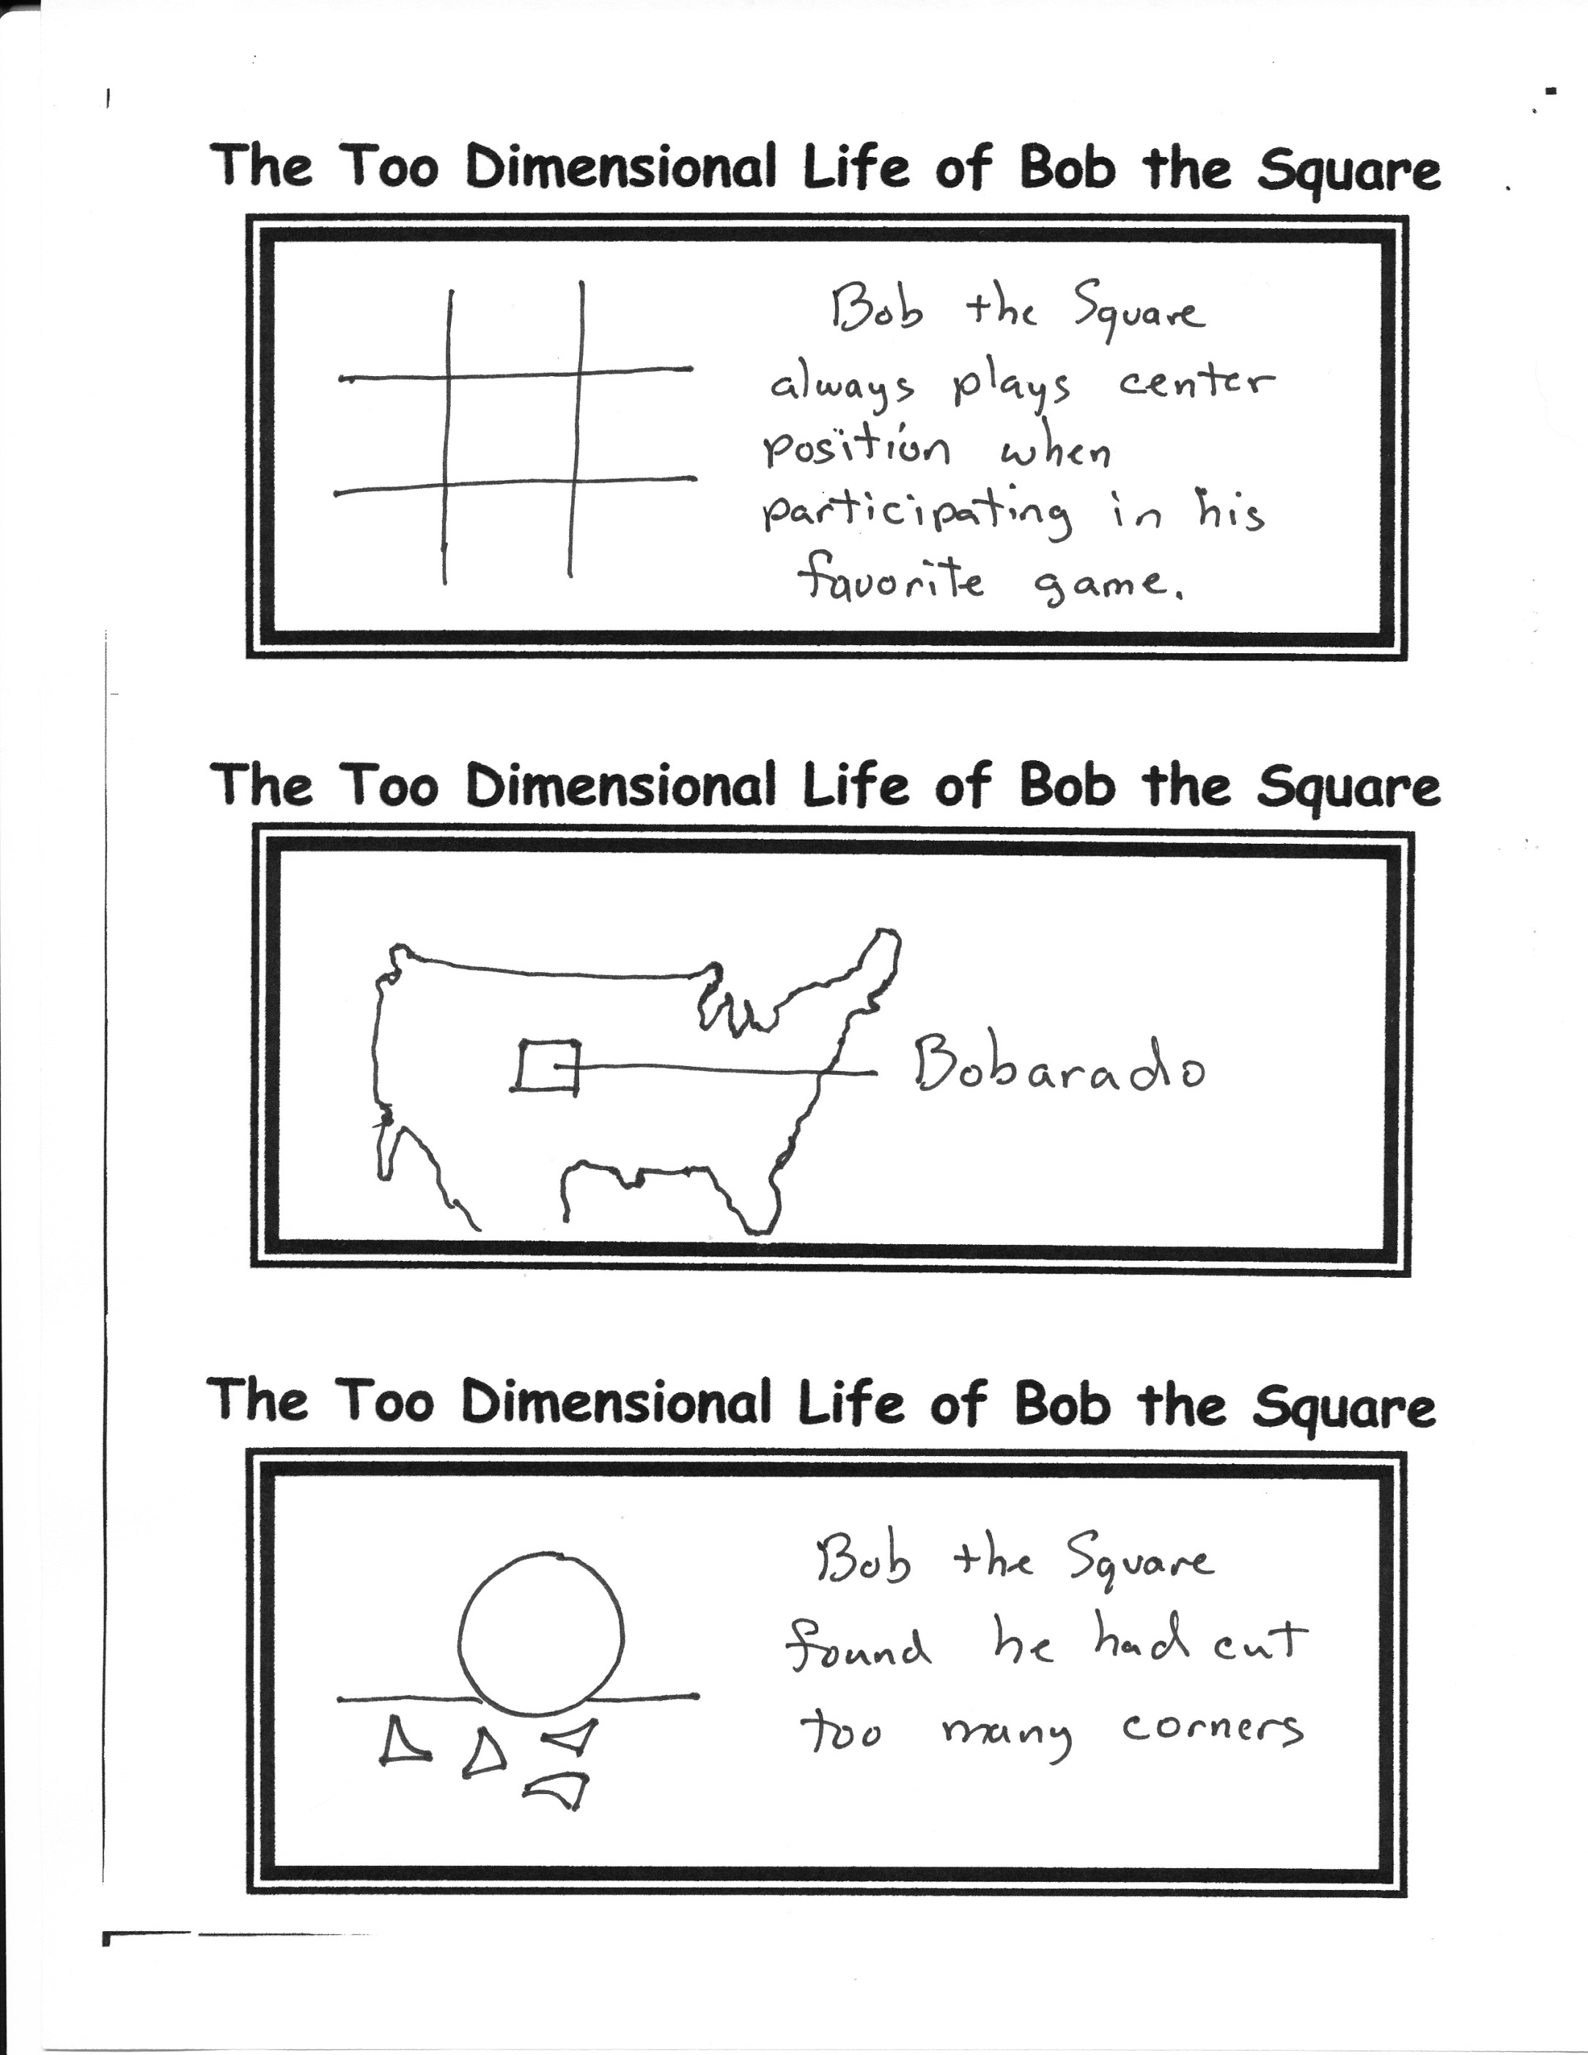

**I Have Never…**

…Skydived. But I have zoomed in really fast on Google maps!

…

***I Am Green***

**N**early all living plants need carbon dioxide to live. Humans exhale carbon dioxide. Therefore I will breathe deeply and incredibly fast. I want to feed as many plants as possible because ***I am green.***

**T**he Earth is warming and sunshine is obviously adding to the problem. My old truck disperses a tremendous cloud of smoke going down the road. That shade will help to cool the planet. Therefore I will drive as much as I possibly can because ***I am green.***

**C**attle expel noxious methane into the atmosphere. This is unacceptable. Therefore I will, during my lifetime, eat as many cattle as possible because ***I am green.***

1. My desk is not a rummage sale. One day, you will have office supplies of your very own, and then you will understand.  Until then, please refrain from manhandling the items on my desk.

2. Leave the plants on my desk alone. There are days unknown to you when the well-being of my plants outranks the well-being of my students. Don’t make me pick; you might not win.

3. Can you still turn this in? Sweetie, there is no such thing as a grade lower than zero, so you don’t have much to lose. Hand it in and let’s see what happens.

4. In a ceremony that has lasted thousands of years, I have been bestowed with magical powers that tell me when you want to go to the bathroom just because you are bored.

5. What do you mean “what’s on the test?” I’ve just spent the last three weeks telling you what’s on the test.

6. Sometimes I’m tempted to take you down to the 4th grade so that you can meet the other kids in your graduating class.

7. I cannot believe you wore that to school today.

8. Yes, dear, we did do something in class yesterday. We saw that you were absent and somehow gathered the courage to move on without you. Here’s your homework assignment. It’s due tomorrow.