**June 23, 2013**

**Volume 1, Issue 37**

Sunday School Times

***Stuff For Today***

• Wacky cake—a very special dessert

• Is the name “Ed” really found in the Bible?

Published almost weekly, but more like…..whenever, so get used to it, OK?

# Ed

**By Mr. Lyle (mrlyle1@gmail.com**

***Joshua 22***

Conquering and possessing the Promised Land had been a long, arduous task. With many mistakes along the way, the Israelites were no longer as dedicated to the cause as they once were. Joshua aged, and the intensity and commitment of the people waned. They decided to call a halt to the conquest for a while, and the sad truth is that they never concluded what they started. God had clearly delineated for them the exact geographical boundaries for each of the twelve tribes to inhabit. He had promised them unequivocal success if they would but obey Him. All they had to do was walk in and claim the land—flowing with milk and honey, with houses they didn’t have to build, trees they didn’t have to plant, and crops already in the ground—absolutely free. They grew tired and complacent, not willing to trust God entirely.

The tribes of Reuben, Gad, and the half tribe of Manasseh, had requested that they be allowed to reside on the East side of the Jordan River. God permitted it, but do not think for a minute that it is what God would have preferred. He simply allowed them to live there, knowing full well that problems would lie ahead of them if they refused His perfect inheritance in the Promised Land. The two and one half tribes had committed themselves to cross over the Jordan with the rest of the nation and assist the other tribes as they conquered the land. Much time passed. Having kept their word, tired and worn, they wanted to go home. Joshua warned them explicitly to keep the commands of God, and never forget Him.

With permission to leave granted to them by Joshua, they headed for their inheritance. Upon reaching the Jordan River, they decided to build a very large, imposing altar to God. All of Israel heard of it and misinterpreted their actions. Thinking that the two and one half tribes had turned their backs on God, they prepared to go to war with their own brothers. Tempers flared until it was learned that the tribes that they had assumed to be rebellious weren’t wayward after all. The explanation given for their questionable behavior was this—they had fear and concern that someday, they would no longer be considered part of Israel because they lived on the East side of the Jordan. The dramatic altar was to be a witness to future generations that there was indeed a link between the two groups of people. The clarification calmed emotions, and everyone went their separate ways.

Gad, Reuben, and Manasseh called their altar “Ed”, which means “a witness”. On the surface, the building of this monument seems like an appropriate gesture. A more in-depth look at the altar named Ed exposes a few complications. First, the nation of Israel was to have one and only one altar, and God had mandated that it be located in front of the Tabernacle in Israel. Sacrifices were to be offered only there. Ed was a bloodless altar, and represents the theology of today that ignores the blood sacrifice of Jesus. The church today is a divided entity. There are those that hold to the fundamental truths of the Word, and others who define the Word down so far as to try to make it say what “their itching ears want to hear”. The actions of these errant Israelites were indicative of their true hearts. Many hundreds of years later, Jesus crossed the Sea of Galilee and visited the Gadarenes. That visit was memorable. They were pig farmers, a ceremonially unclean animal under the Law. They had a problem with demonic possession, and upon seeing Jesus work miracles, they told Him, in no uncertain terms, to leave their land.

**Father’s Day? No--Wacky Cake Day!**

By Mr. Lyle (mrlyle1@gmail.com)

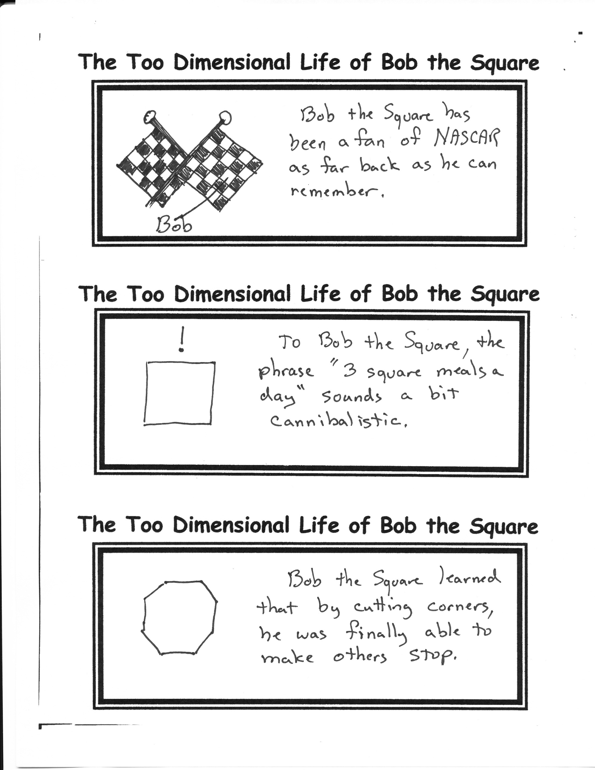

**Wacky Cake**

* 1 1/2 cups unbleached all-purpose flour
* 1 cup sugar
* 3 tablespoons unsweetened cocoa
* 1 teaspoon baking soda
* 1/2 teaspoon salt
* 1 teaspoon vanilla
* 1 teaspoon vinegar
* 5 tablespoons vegetable oil
* 1 cup cold water

In a large mixing bowl, mix flour, sugar, cocoa, soda and salt. Make three wells in the flour mixture. In one put vanilla; in another the vinegar, and in the third the oil. Pour the cold water over the mixture and stir until moistened. Pour into 8 x 8-inch pan. Bake at 350°F. oven for 25 to 30 minutes, or until it springs back when touched lightly.

My calendar has two very special days that are known to me as Wacky Cake days. I happen to celebrate the anniversary of my 29th birthday, and what most people call Father’s Day.

On those two days I am treated to wacky cake. This special delight has eluded my culinary skills my whole life. I CANNOT BAKE A WACKY CAKE! I have tried many times and failed as many times—complete, total failures—inedible failures!

My favorite dessert of all time is just out of my reach. My family takes pity on me twice a year and treats me to something VERY special—wacky cake. I enjoyed one last Sunday—yes I ate the whole thing.

**Fun Fact of the Week**

On July 11, 2011, Neptune completed it’s first complete orbit around the sun since it was discovered in 1846! ☺