**April 28, 2013**

**Volume 1, Issue 31**

Sunday School Times

***Stuff For Today***

• Everything you ever wanted to know about Kung-Fu

• This week Q and A

• Kung-Fu Ninjas Moses and Aaron

Published almost weekly, but more like…..whenever, so get used to it, OK?

# Kung-Fu Ninjas Moses and Aaron

**By Mr. Lyle (mrlyle1@gmail.com**

***A story loosely based on the first 17 chapters of Exodus***

Kung-Fu Ninja Moses lived out in the desert perfecting his Kung-Fu Ninja moves.

The Great Kung-Fu Ninja Master lit a great flaming torch. Kung-Fu Ninja Moses went over to it and tried to extinguish the flames with his Kung-Fu Ninja moves.

. Though he tried again and again, he could not put out the flaming torch.

The Great Kung-Fu Ninja Master told Kung-Fu Ninja Moses ”Find your brother Aaron. He is also a Kung-Fu Ninja. Perfect your Kung-Fu Ninja moves, and go to the Evil Jujitsu Lord Pharaoh of Egypt. He has my Kung-Fu Ninjas and he must let them go!“

Kung-Fu Ninjas Moses and Aaron went to Egypt and showed the Evil Jujitsu Lord Pharaoh some of their best Kung-Fu.

The Evil Jujitsu Lord Pharaoh of Egypt was not impressed until Kung-Fu Ninja Moses showed him some of his very best Kung-Fu Ninja moves.

Finally, the Evil Jujitsu Lord Pharaoh of Egypt said that all of the Kung-Fu Ninjas could leave his country. Kung-Fu Ninjas Moses and Aaron Kung-Fued for joy!

All of the Kung-Fu Ninjas then left Egypt and all of its Evil Jujitsu ways, and went out into the desert, led by Kung-Fu Ninjas Moses and Aaron. They all practiced their Kung-Fu Ninja arts out there in the desert.

After an afternoon of Kung-Fu Ninja practice in the desert heat, all of the Kung-Fu Ninjas were thirsty. They complained to Kung-Fu Ninjas Moses and Aaron that there was no water there.

Kung-Fu Ninja Moses responded with a, never before seen, Super Kung-Fu Ninja move.

Kung-Fu Ninjas Moses and Aaron led all of the Kung-Fu Ninjas to a large rock there in the desert. They Kung-Fued them there until all of the Kung-Fu Ninjas were quiet.

Kung-Fu Ninjas Moses and Aaron then did an Extra Super Kung-Fu Ninja move—in super slow motion!

They told the Kung-Fu Ninjas ”The Great Kung-Fu Ninja Master has great compassion. He will Kung-Fu to us and show us how we are to quench our Kung-Fu thirst.

Kung-Fu Ninjas Moses and Aaron Kung-Fued like the greatly skilled Kung-Fu Ninja warriors they were, approaching the rock as they Kung-Fued in front of the thirsty Kung-Fu Ninjas.

Then Kung-Fu Ninja Moses said to all of the Kung-Fu Ninjas watching his Kung-Fu moves, “Today I will expertly strike this rock. I have been taught well by the Great Kung-Fu Master. My blows will be so powerful, that I will break this rock in two, and water will gush out for everyone.”

It was an amazing sight to behold—Kung-Fu Ninja Moses used Super Slow Motion Kung-Fu moves, landing blow after blow, in super slow motion, until the rock broke in two, also in super slow motion!

Water came gushing out and all of the thirsty Kung-Fu Ninjas Kung-Fued for joy.

**So, How Was Your Week?**

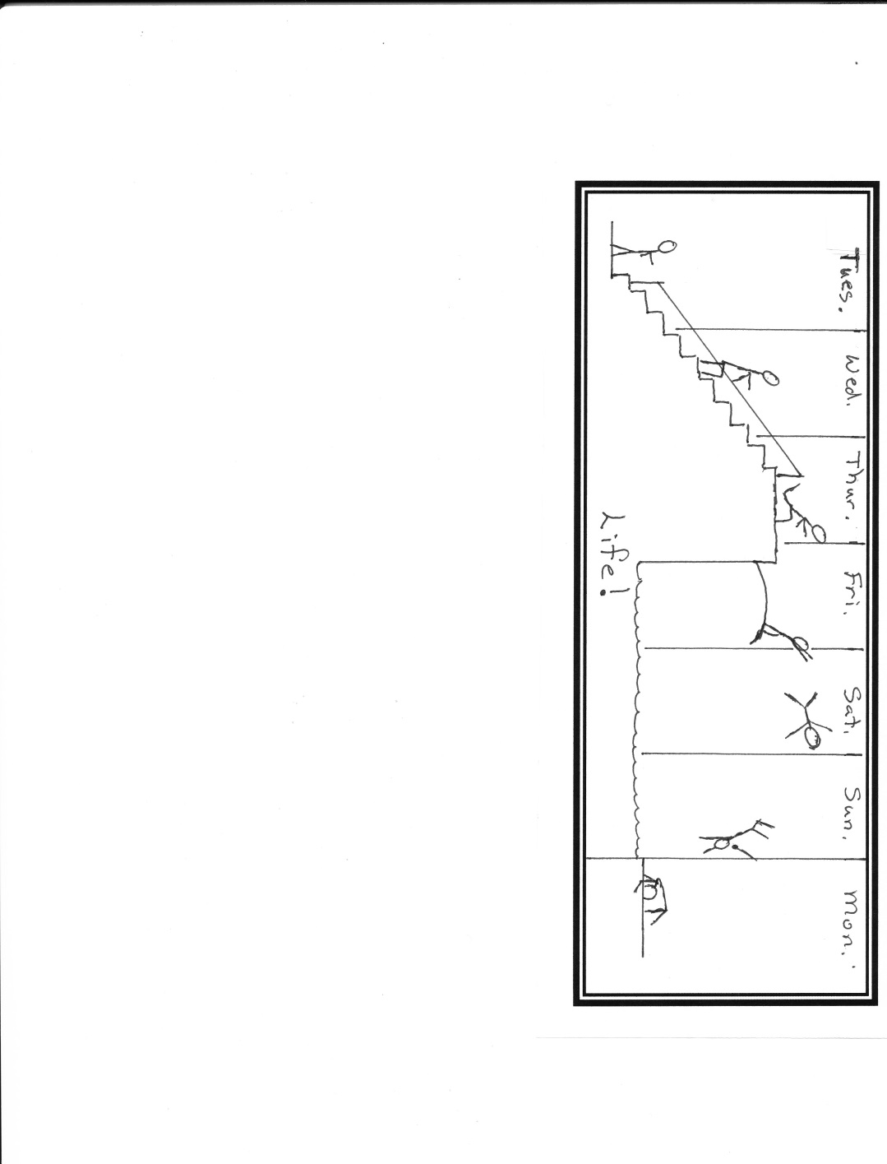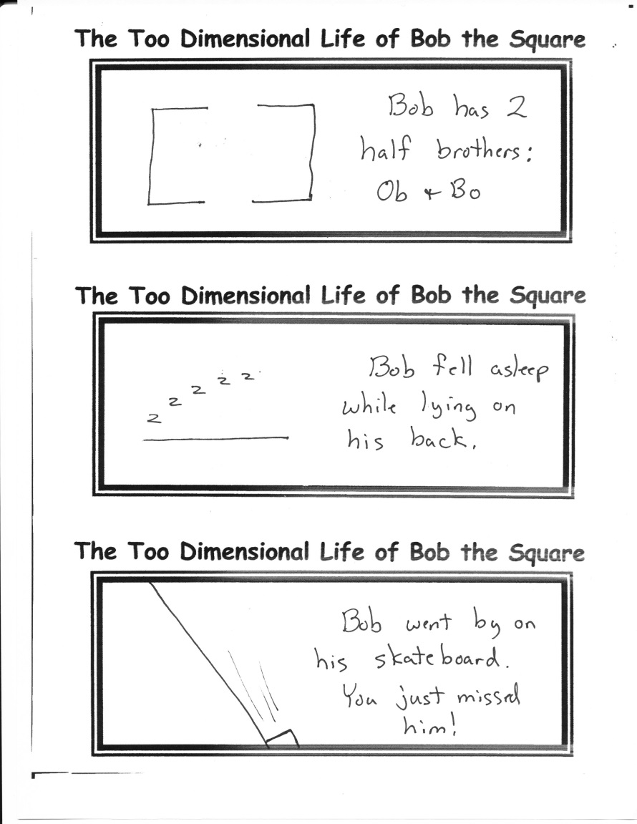

By Mr. Lyle (mrlyle1@gmail.com)