**April 21, 2013**

**Volume 1, Issue 30**

Sunday School Times

Published almost weekly, but more like…..whenever, so get used to it, OK?

# Two Dollars Worth of God

***Stuff For Today***

• How to pray

• Biblical archeology

• More questions and answers today

I would like to buy two dollars worth of God please.

Not too much, and not too little.

Oh, I can afford plenty more, but

Not too much. I want to spend so little.

What will I do with just two dollars worth?

Not too much. Is that too little?

Sure, His greatness is beyond me. I understand

Not too much. I am so little.

And yet He loved me so, He considers what he gave me

Not too much and not too little.

I should give Him all that I am. I know that is

Not too much, but it is seems like too little

So, I guess I would like to buy all that I can have of God, that’s

Not too much. Why should I spend too little?

**Archeologists X-ray Skull of the Disciple Thomas**

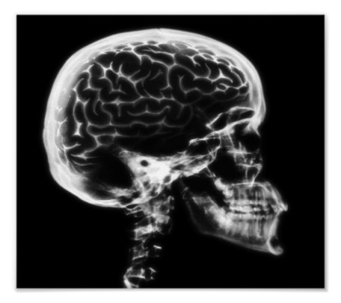



**The Proper Way to Pray**

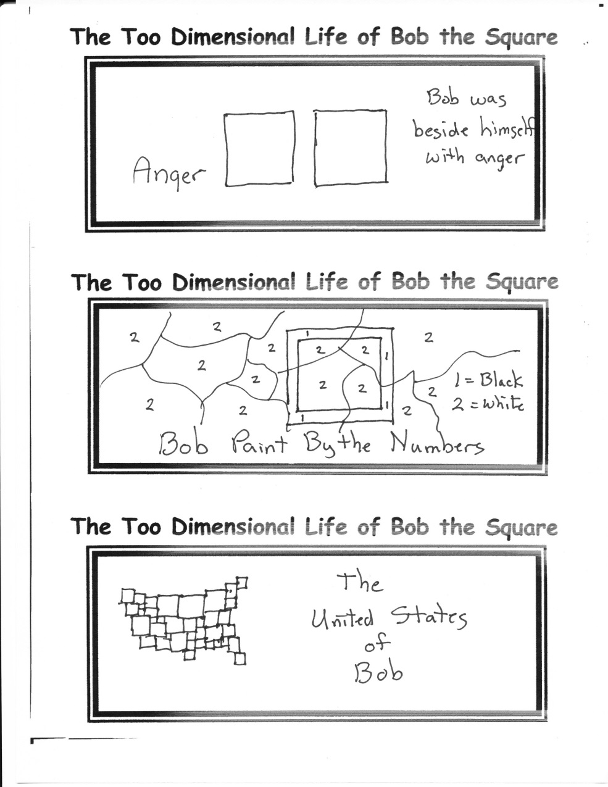

**Q and A Today!**

**You got questions, and I got answers.**

(at least I hope so, or this is destined to be a VERY boring Sunday School class time.)

My extremely fervid inventiveness has led to the announcement of this illusory discovery. For centuries, readers of the Bible have wondered at the doubt displayed in the actions of Thomas the disciple. As the x-ray clearly shows there is an abnormality in his brain tissue. Now, we have no doubt regarding his medical condition—he was just like the rest of us!

By Mr. Lyle (mrlyle1@gmail.com)

The proper way for a man to pray,

Says Deacon Lemuel Keys,

And the only proper attitude

Is down upon his knees.

No, I should say the way to pray,

Says Reverend Doctor Wise

Is standing straight with outstretched arms

And rapt and upturned eyes.

Oh, no, no, no, said Elmer Slow.

Such posture is too proud.

A man should pray with eyes fast closed

And head contritely bowed.

It seems to me his hands should be

Austerely clasped in front.

Both hands pointing toward the ground,

Said Reverend Doctor Blunt.

Last year I fell in Hitchkins’ well,

Head first, said Cyrus Brown.

And both my heels were stickin’ up,

And my head was pointing down.

And I made a prayer right then and there,

The best prayer I ever said.

The prayin’est prayer I ever prayed

Was standin’ on my head.