**March 10, 2013**

**Volume 1, Issue 25**

Sunday School Times

***Stuff For Today***

• Recap of Friday Meal

• Life Truth #6

• How many times can you tell a story before people begin to take notice and wonder why you are telling it over and over?

Published almost weekly, but more like…..whenever, so get used to it, OK?

# A Story x Three = ?

**By Mr. Lyle (mrlyle1@gmail.com**

***II Kings 18-20***

***II Chronicles 29-32***

***Isaiah 36-39***

History from a textbook consists of names, dates and events of interest. The Biblical record, divine history, is not merely a chronicle of past occurrences. There are spiritual truths cast, and many times hidden, in the narrative. Scripture details past experiences rarely more than twice. God saw fit to pass down to us a few facets of Hezekiah’s reign over Judah. He did so with three distinctive authors, three varying viewpoints, and placed the information in three different locations in the Bible. That act flags this small portion of the historical record as noteworthy, even though the events are relatively insignificant and minor compared to the rest of the world of that day.

Of the twenty-one kings who ruled over Judah following the reign of David, none are equal to Hezekiah. If David was number one in God’s eyes, Hezekiah was number two. His reign is one of transforming the struggling southern kingdom back into what it was meant to be, a nation the entire world would look upon with respect because of their relationship to Jehovah God. His father, Ahaz, had boarded up the temple and urged the nation to worship pagan gods. Hezekiah took his position as the leader of Judah upon the death of his father, when he was but twenty-five years of age. One has to admire his conviction and drive. He opened the doors of the temple again, and cleaned it. He, having discovered the truth of the Law, for the book had been lost and forgotten, reintroduced the practices once again. Temple worship had been restored after a very long time of neglect. Return to the Word of God always results in great things.

**BUT**

Because of the kindness of God upon his life, Hezekiah became proud, Pride is a dangerous commodity, and Hezekiah owned much of it. A man who started so well, ended quite poorly. Today we will take a closer look at this man and his successes and failures. There is much we can learn from his story—repeated three times—and recorded in the Bible for us to see.

**Important Updates From Friday Meal**

By Mr. Lyle (mrlyle1@gmail.com)

The Most Memorable Masterfully Measured and Made Major Mouth Moving Main Meal Moment in March happened this last Friday night. For those who could not attend, a few highlights follow.

1. We had a visit from the World’s Ugliest Man! A man so incredibly ugly that his face had to remain hidden under a towel so as not to frighten those around him.

2. We watched a polar bear go through some incredibly difficult circumstances. And yes, we did laugh at him.

3. We learned from the story of Rindercella that if you want a prandsome hince to lell in fuv with you, be sure to slop your dripper.

4. We ate Puppy Critters, Fraidy Cat, Screamin Mimi, Sponge and Sludge, Pota, Angel Pillows, and of course, who could forget the Zoldello Kabitozer-purula!

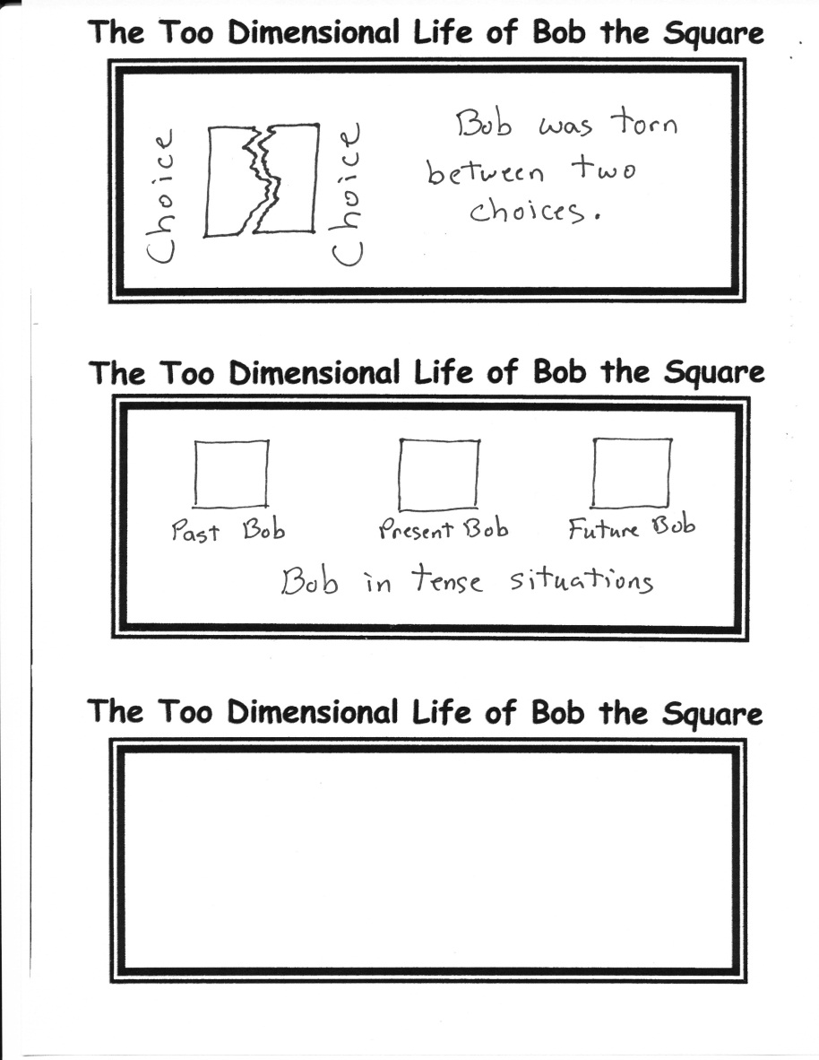

**For your own safety, please do not stop here and read, there is nothing to see. Go on to another article. Thank you.**

**Punctuation**

You, need to learn: punctuation—for. Later! “In Life” (You may be) wondering why. You have! To study about, things of: this nature? Believe –me when I (say it) is very ”important“

**Life Truth #6**

Daddys are right 97% of the time.

Nobody cares about the other 4%.