**December 16, 2012**

**Volume 1, Issue 14**

Sunday School Times

Published almost weekly, but more like…..whenever, so get used to it, OK?

# It’s A Kroger Christmas!

**By Mr. Lyle (mrlyle1@gmail.com**

***Stuff For Today***

• Everything you ever wanted to know about Barney Kroger

• The newest character in A Kroger Christmas reprises again this year

• How well do you really know the Christmas story?

**How Well Do You Know Christmas?**

**(True or False)**

1._____There are 32 “la”s in the first verse of “Deck the Halls”.

2._____”Jingle Bells” never mentions Christmas.

3._____”Silent Night” was originally written for guitar.

4._____”Joy to the World” was not written as a Christmas song.

5._____Snowflakes have 6 sides.

6._____Animal cracker boxes have strings on them so they can be used as Christmas tree decorations.

7._____Pointsettias, mistletoe, and holly are all poisonous.

8._____Snowmen fall from the sky unassembled.

9._____Santa did not live at the North Pole until 1882.

10.____Santa’s North Pole has an official Canadian Zip Code.

11.____Mistletoe means “bird poo on a twig”.

12.____Both male and female reindeer have antlers.

13.____Rudolph’s real name is Rollo. He was also known as Reginald.

14.____All Santa’s reindeer are males.

***Luke 2***

*And it came to pass in those days, that there went out a decree from Caesar Augustus that all the world should be taxed.*

***2****(And this taxing was first made when Cyrenius was governor of Syria.)*

***3****And all went to be taxed, every one into his own city.*

***4****And Joseph also went up from Galilee, out of the city of Nazareth, into Judaea, unto the city of David, which is called Bethlehem; (because he was of the house and lineage of David:)*

***5****To be taxed with Mary his espoused wife, being great with child.*

***6****And so it was, that, while they were there, the days were accomplished that she should be delivered.*

***7****And she brought forth her firstborn son, and wrapped him in swaddling clothes, and laid him in a manger; because there was no room for them in the inn.*

***8****And there were in the same country shepherds abiding in the field, keeping watch over their flock by night.*

***9****And, lo, the angel of the Lord came upon them, and the glory of the Lord shone round about them: and they were sore afraid.*

***10****And the angel said unto them, Fear not: for, behold, I bring you good tidings of great joy, which shall be to all people.*

***11****For unto you is born this day in the city of David a Saviour, which is Christ the Lord.*

***12****And this shall be a sign unto you; Ye shall find the babe wrapped in swaddling clothes, lying in a manger.*

***13****And suddenly there was with the angel a multitude of the heavenly host praising God, and saying,*

***14****Glory to God in the highest, and on earth peace, good will toward men.*

***15****And it came to pass, as the angels were gone away from them into heaven, the shepherds said one to another, Let us now go even unto Bethlehem, and see this thing which is come to pass, which the Lord hath made known unto us.*

***16****And they came with haste, and found Mary, and Joseph, and the babe lying in a manger.*

***17****And when they had seen it, they made known abroad the saying which was told them concerning this child.*

***18****And all they that heard it wondered at those things which were told them by the shepherds.*

***19****But Mary kept all these things, and pondered them in her heart.*

***20****And the shepherds returned, glorifying and praising God for all the things that they had heard and seen, as it was told unto them.*

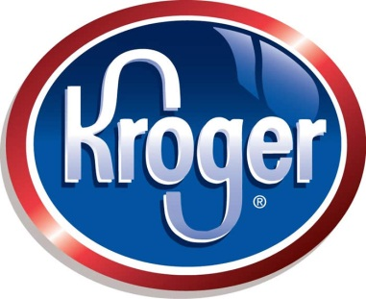

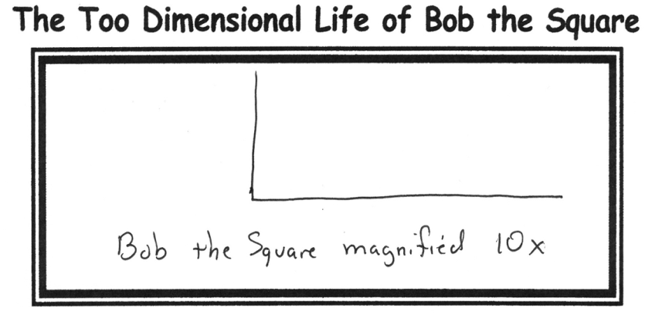

**Tradition**

One lesson appears every year in this Sunday School class. It has become a long standing tradition. The first Kroger Christmas appeared nearly 10 years ago. You will never look at a brown paper bag the same.

1. In 1883, Barney Kroger invested his life savings of $372 to open a grocery store at 66 Pearl Street in downtown Cincinnati.

2. Gross sales now top $70 billion per year.

3. Kroger was the first grocery to include a bakery and fresh meat department in their stores.

4. Along with its 2500 grocery stores, Kroger owns nearly 400 fine jewelry stores.

## **Fun Facts About Kroger**

By Mr. Lyle (mrlyle1@gmail.com)