**December 9, 2012**

**Volume 1, Issue 13**

Sunday School Times

Published almost weekly, but more like…..whenever, so get used to it, OK?

# Real Estate Basics 101

**By Mr. Lyle (mrlyle1@gmail.com**

***Stuff For Today***

• Announcement of March Meal

• What is Gold Lace Juniper, and what is it doing in the middle of the classroom?

• How to know for sure that you can trust God and all of His promises

***II Corinthians 1: 18-22***

***18****But as surely as God is faithful, our message to you is not “Yes” and “No.”****19****For the Son of God, Jesus Christ, who was preached among you by me and Silas****[***[***b***](http://www.biblegateway.com/passage/?search=2%20Corinthians%201&version=NIV1984#fen-NIV1984-28804b)***]****and Timothy, was not “Yes” and “No,” but in him it has always been “Yes.”****20****For no matter how many promises God has made, they are “Yes” in Christ. And so through him the “Amen” is spoken by us to the glory of God.****21****Now it is God who makes both us and you stand firm in Christ. He anointed us,****22****set his seal of ownership on us, and put his Spirit in our hearts as a deposit, guaranteeing what is to come.*

God is faithful ALWAYS! He can ALWAYS be trusted, and His Word will ALWAYS be true. It is that simple.

But God understands that we are but humans with faults—and sometimes we doubt Him. Even heroes in the Bible struggled with uncertainty. It is interesting to note that God, at times, went to great lengths to dispel their disbelief, and confirm to them the reality of His existence and love for them.

God gave us an absolute guarantee to assure us of His promises--the Holy Spirit.

I am not going to pretend that I even remotely understand the concept of a triune God. The Bible has clearly stated that God is One, and yet God is also three—God the Father, God the Son, who we also know as Jesus, and God the Holy Spirit. Three distinct, unique Persons existing and working so perfectly together that They can be called One.

When an individual puts their faith and trust in God, and accepts Jesus as their personal Savior, (also known as becoming a Christian), one of the many amazing things that God does is to place the Holy Spirit in them. One of the three Persons of the Trinity literally comes to live inside of us.

The Bible uses words like regeneration, or made spiritually alive to help us understand this incredible idea. We as Christians have the intimate presence of the Holy Spirit in our lives, a guide, a comforter, a reminder, a teacher…we could go on and on!

II Corinthians 1:22 explains to us that the Holy Spirit is a *deposit*. We will spend our class time today looking at what that simple word actually implies, and how much we can learn about trusting God, because He chose to use this word and not another.

We will look for a moment at the world of buying and selling houses and land, and the financial dealings in practice today. Specifically, we will analyze the practice of attaching something called earnest money, with an offer to buy a piece of real estate.



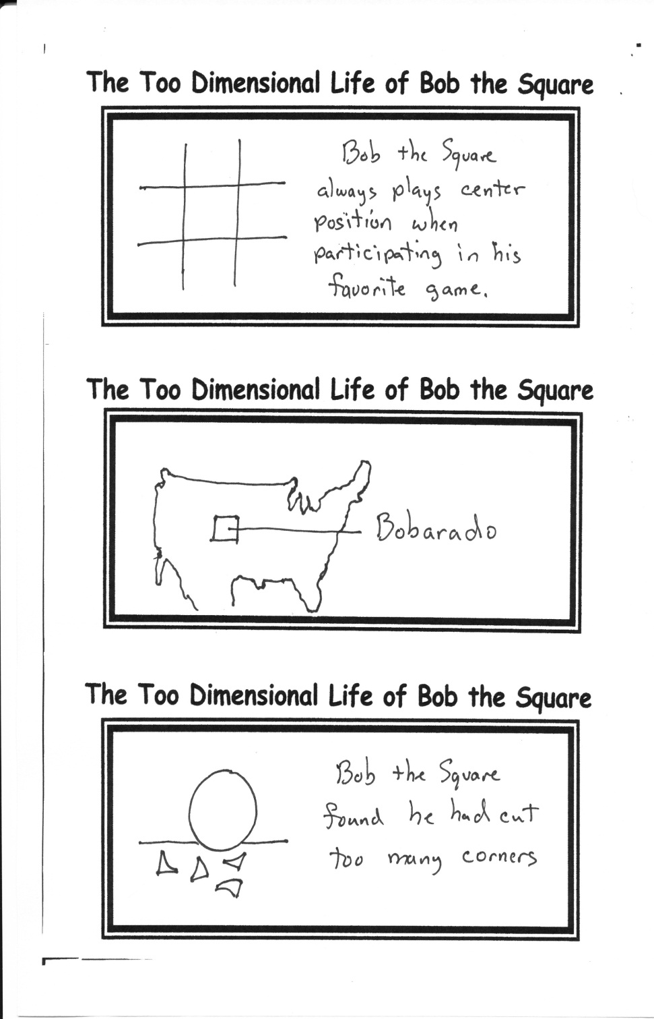

Only once during the two years you are a member of this Sunday School class, will you have the opportunity to experience the most amazing meal EVER! We call it

THE MOST MASTERFULLY MEASURED AND MADE MAJOR MOUTH MOVING MAIN MEAL MOMENT IN MARCH

Details will be coming! Do not miss this!

By Mr. Lyle (mrlyle1@gmail.com)

## **Dinner Theater Coming In March**

**The Real Estate Deal (a critique)**

“A good return on investment!”

“Incredible assets!”

“A Tony Award dividend!”

“We need an extension”

“A special affects insolvency”

“The movie had less liabilities!”