**November 25, 2012**

**Volume 1, Issue 11**

Sunday School Times

Published almost weekly, but more like…..whenever, so get used to it, OK?

# Are You A Moose?

**By Mr. Lyle (mrlyle1@gmail.com**

***Stuff For Today***

• Is the plural of moose really mooses?

• A brief history of Pepsico

• Why you will always remember the story of a stray yellow Labrador.

Probably a question very few have been asked, but one with a wonderful story and a lesson behind it. We will spend our class time this morning exploring this oddity.

The public school system in our country today has many positive attributes. But as any large organization, it has some unfortunate short falls. Textbooks tend to focus on measurable things. Subjects like math, and science or geography can be taught methodically, and the results tested and quantified.

But there are topics of equal or even greater importance that are characteristically bypassed because of the difficulty in measuring results. Personal character traits are extremely important for success in life. What kind of personality you possess—honesty, ingenuity, industriousness, to name a few—will take you much farther in life than will your simple understanding of physics or geometry.

That is where the Bible becomes the most excellent textbook. The many stories are filled with spiritual answers to be sure. Included between the lines, to a student willing to study and work for it, are real life examples of real life people displaying their character, or lack of it, to the whole world for all time.

God has recorded many examples of success and failure for us to consider. His Word is an outstanding study of positive character traits. Many years ago, in the early days of our country, educators recognized this attribute, and made the Bible the main textbook in the public school system of that day.

When our country pushed the Bible out of the schools, it lost a tremendous educational resource.

I have had the opportunity to work for some very influential and wealthy people in my personal business. Over the years, from conversations with many of those people, a common list of character qualities emerged.

I expected to see a common attribute of hard work—very hard work. I also expected to see the common attribute of stability, also known as stick-to-it-iveness. And I expected to see common attribute of intelligence, or knowledge.

One character trait, common to all, was VERY evident, and was a complete surprise! We will discuss this trait in detail, and it begins with the question: are you a moose?

## **Record Moose Taken In Hunt In Alaska**

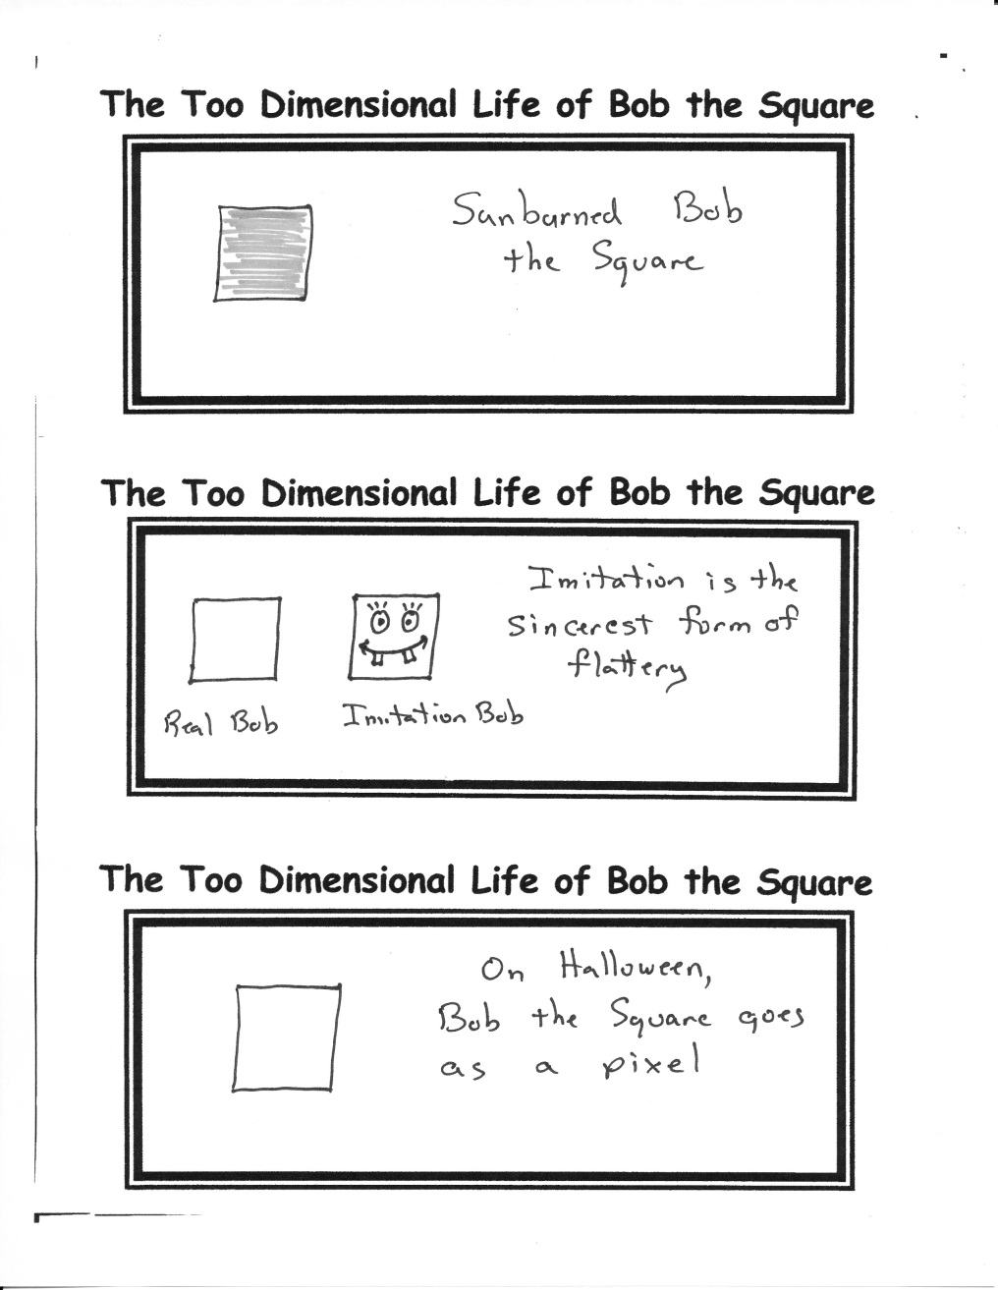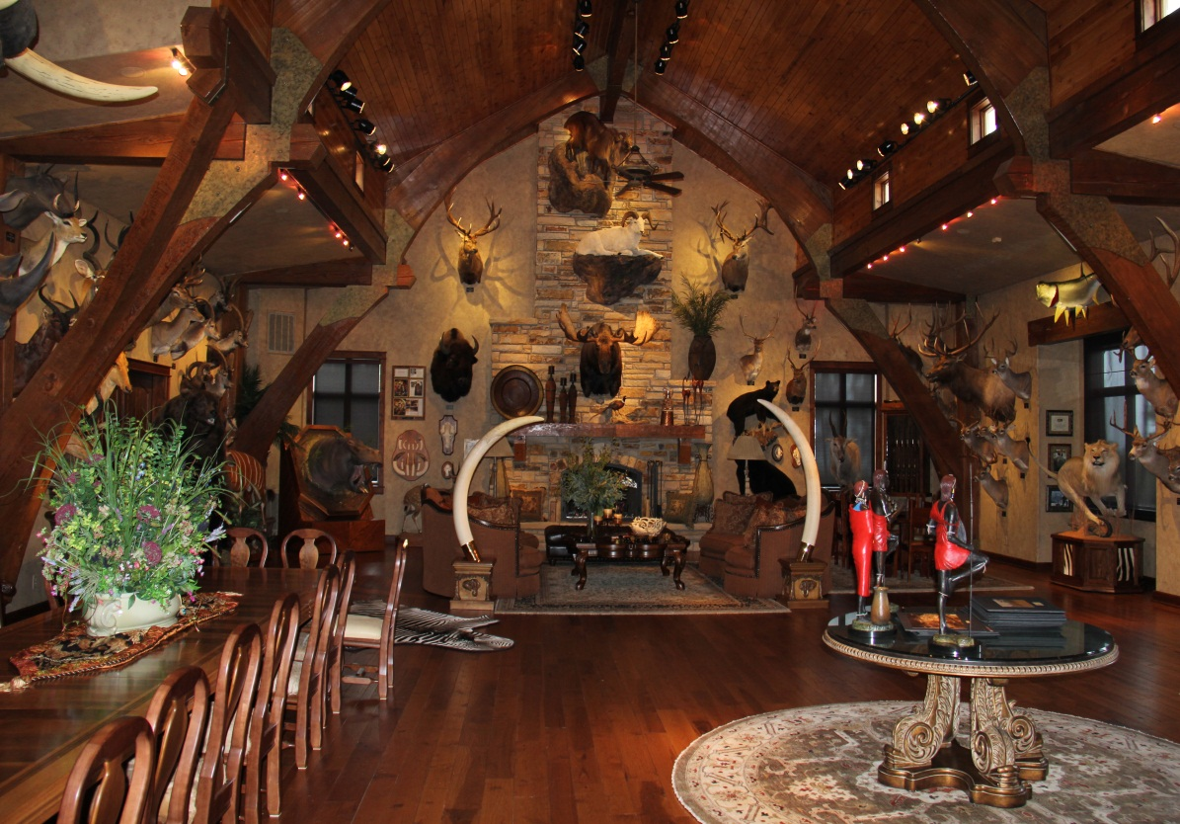

Corporations spend millions in advertising for your business. A select few have successfully achieved recognition without even saying a word (or a name). And these three have something else in common. Can you guess what it is?

Pictured above is the fireplace of a local individual who is a big game hunter. You will notice a trophy moose in the very center of the photo. During his many hunting expeditions, his travels took him to Alaska. He was fortunate enough to bag the largest moose taken in that state that year. From tip of antler to tip of antler is 62 inches. (That is over 5 feet across!) I have personally seen this animal, and it is indeed HUGE!

By Mr. Lyle (mrlyle1@gmail.com)