**August 26, 2012**

**Volume 1, Issue 1**

Sunday School Times

An instrument of Sixth and Seventh Grade Sunday School—First Baptist Church, Russellville AR

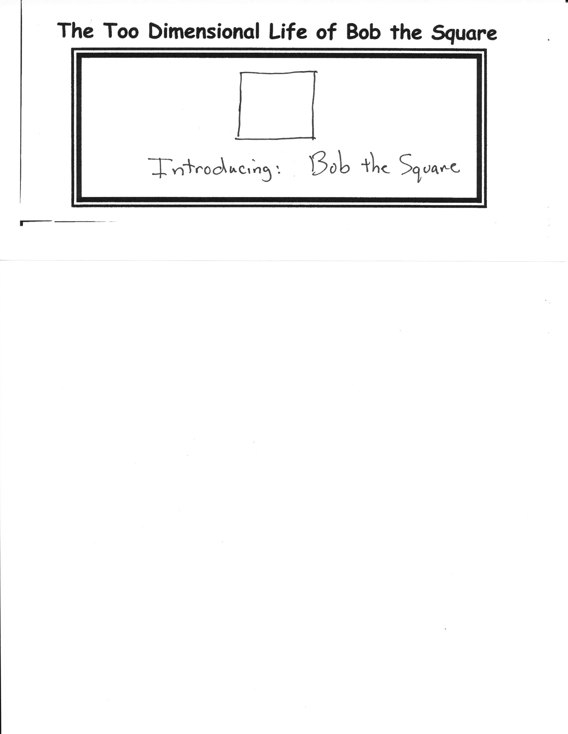

**By Mr. Lyle (mrlyle1@gmail.com**

# So, Who Is Mr. Lyle, Really?

All good newspapers have comics, and so it is with this one. Each week look forward to a new and exciting look into the extraordinary life of Bob the Square, as seen through the slightly warped reality present in the mind of Mr. Lyle.

## The Too Dimensional Life of Bob the Square

Welcome to the Sixth and Seventh Grade Sunday School. Today will be your chance to get to know your teacher for this coming year. There will be a short presentation by Mr. Lyle regarding his involvement many years ago in the Olympics. Few are familiar with his achievements during the 1972 Summer Olympics, and fortunately, (or unfortunately), for you, he has prepared a short documentary film regarding this amazing time in his life. This film is typical of his movie making prowess, so prepare yourselves accordingly for the rest of the year.

After the movie, when the applause has died down, he will share his personal testimony in picture format, explaining some of the episodes in his life that have brought him to this point in his walk with the Lord. He will probably give the picture away at the end of class to some poor, I mean, lucky individual! Hopefully, you will find his talk interesting. If not, well, there goes ten minutes of your life. ☺

Following this, there will be a short question and answer time for you to ask any questions you might like to ask him about himself, or his wife, or his family, or McDonalds McRib sandwiches, or does he like pickles or onions better, or his favorite type of dog, or cat or monkey, or what he does for a living in real life, or what his favorite soft drink is, or what does he think of world market oil prices, or is that his real hair color, or does he dye it that way, or…well, you get the idea., Lucky for you he has prepared a short video to help answer some of these questions.

***Stuff For Today***

• Meet a very special participant in the 1972 Summer Olympics

• Mug shots today!

• Q and A with Mr. Lyle including a special video presentation