(Continued from page 1)

There are a number of reasons that we should attend and be a part of a local church. First and foremost, God said so. That stands alone as reason enough. End of discussion. Let’s get in the car and go home.

If you need more than that, you may have a spiritual problem that needs to be addressed. But there are advantages for the Christian who does attend church and does not just sit as a spectator, but gets involved. The key here is involvement. At the moment of our conversion, God gives each of us a spiritual gift. That gift is given with a goal in mind. We are to use that gift in the church, in cooperation with other people who also have their individual gifts, and work together to accomplish great things for God. He uses the picture in the New Testament of a human body. Many parts working together to move and breath and live. The church likewise is many parts, each unique, but necessary for proper function.

Consider the concept of playing baseball. It’s difficult to swing a bat with only one arm. With only one eye, depth perception fails and it becomes impossible to judge the distance and speed of the pitch. Only one leg makes the running of the bases a huge challenge. We need all of our parts to play a good game. The church needs all of her parts as well, and God has strategically placed people in the church for specific purposes. We need to learn what our specific gift is, develop it, and then use it for His kingdom.

The local church fills other needs in our lives as well. We were created as social beings. We need relationships to function well. Sitting in a fishing boat on Sunday morning and watching the sunrise may make us feel close to God for a moment, but there is little to no social interaction there, and whether we want to admit it or not, God created us with a need that only the presence of other people can fill in our lives. We have all seen, or at least heard, of examples of the odd behaviors established by those who completely withdraw from society and social interaction. I recall, as a young man, hearing and reading about the richest man in the world at the time, Howard Hughes. A man with everything at his fingertips, and an amazing intellect, withdrew from everyone and lived as a very wealthy recluse. And died a very miserable, lonely man. He finished his life poorly. We need others—Christian others—who can challenge us and correct us if necessary.

We need a reminder from time to time who God is and our place in His plan. The world we live in is going to try to get our attention away from things spiritual and fill that void with anything that it can. We can easily get caught up in the lights and glitter of the excitement of the world. Satan is the greatest showman who ever lived and can quite easily distract us from what is really important in life. We need to focus on God and what He has to offer. When our children were young, we enrolled them in team sports in the community. Specifically, soccer. Our oldest, our son, played from the time he was 4 or 5 years old through high school. If you have ever been around a community league team, as the age bracket rises, so does the possibility of having to travel to neighboring towns to play games. When he started playing years ago, it was unthinkable for a league team to play a game on a Sunday afternoon. But very gradually, something changed. First, it was a “make-up game” that was scheduled “just once” on a Sunday afternoon. A year or two later, a game or two was scheduled for a Sunday afternoon. I vividly remember the weekend we found ourselves at a tournament that scheduled the final game for the top two teams for Sunday morning at 11:00. Our son chose to not play in that game and risked losing his place on the team, rather than compromise his convictions. Today, I teach a 6th-7th grade Sunday School class, and it is not uncommon during the sports seasons, to have half of the class out due to scheduled tournament games. God has described Himself as a still, small voice, a whisper. In the noise of today, that whisper is sometimes difficult to hear. Church gives us an organized, purposed time to reflect on God and his goodness. We need that structure.

Growth for the Christian occurs in many ways. Daily devotions are a wonderful thing. Listening to a sermon is a wonderful thing. But what I have noticed in my own life is that I tend to ignore my shortcomings. It is convenient for me to overlook things in my life that need to be addressed. I don’t know that I don’t know what I don’t know. In the church, we will have the opportunity to meet those who may be much farther along in their walk with the Lord, and there will be things we can learn from them, simply by rubbing shoulders with them in the context of the church relationship.

A healthy church is a place filled with a family like atmosphere. Yes, there are moments of friction and disagreement, but those are fleeting and give way to laughter and joy and belonging. I grew up in a healthy family environment. I know first hand what that looks like. And I assure you, there is nothing quite like it. Being a part of a church gives us the opportunity to experience that joy. I had a friend in grade school who had spent his early years in an orphanage in Korea. He and his sister were adopted into a loving family that lived across the street from me when I was young. Do not ever underestimate the value of a family relationship. He clung to the concept of family. He had seen both sides, and much preferred a mother and a father and a family. We need each other. We spur each other on to maturity. And we actually are family—we are all God’s children.

Nothing that we can do can possibly impress God, and cause Him to say that we have earned our spot in Heaven. Our very best is nothing to an infinite God. Our access to Heaven is based solely on the person of Jesus and what He did for us when He went to the cross and paid the price for our sins. However, God does expect us to show our faith through good works. The good we do should be a natural outgrowth of a close walk with Him. It should never be seen as a requirement for admission into eternal home. We love others because He first loved us. It is as simple as that.

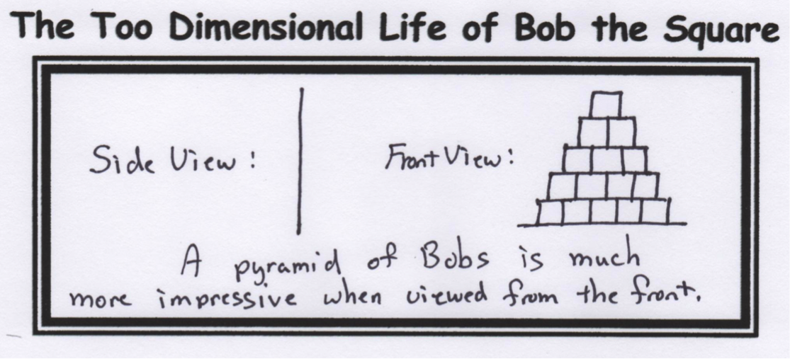

Turboencabulator Technical Industrial Specifications may be obtained from:

Torricelli Barometer Works, Ltd.

Toroidal Turboencabulator Dept. (TTD-3)

London, W.C. 1. England

Torboencabulateurs

Canadian-Francais. Ltee.

468 Jean de Quen, Quebec 10, P.Q.

Encabulators R Us

1523 Industrial Way

Pomona Beach, TX 65356