(Continued from page 1)

free until Christ comes into our lives and sets us free from the penalty and bondage of our sin. And never forget that indulging in sinful things is indeed slavery to those things. We will never control the sin. The sin controls us. Our only hope is God’s power working in our lives.

***Romans 6:23 For wage of sin is death, but the free gift of God is eternal life through Christ Jesus our Lord.***

And Salvation is absolutely free. There is no cost to us; it is a free gift. Shop in any store in the country and if you find a “100% Off” label, you can be assured that the items on that sales table will be gone in moments. Why would anyone turn down an absolutely free gift? Free to us, but it cost God everything to provide the gift to us. Too often we forget the awful price that had to be paid and we take it all for granted.

***John 3:16 For God so loved the world, that He gave His only begotten Son, that whosoever believeth in Him, should not perish, but have everlasting life.***

If you had the cure for cancer, would you keep it quiet? Would you not share your amazing discovery with everyone you met? We have the cure for the malignancy of the soul. And should be freely announcing to the world our discovery.

***John 15:8 This is to my Father’s glory, that you bear much fruit, showing yourselves to be my disciples.***

Early in our US history, we experienced what is commonly referred to as the “Boston Tea Party.” The early settlers of our country wanted free trade, not tariffs and duties attached to their goods. They wanted the choice to be able to market their goods as they saw fit. We also are free to choose to market, or share our faith. We serve out of love by choice. God never forces anyone to share, but He reminds us on many occasions in the Word, that the natural outflow of our salvation should be the desire to tell others of our great gift

***Romans 8:1-2 Therefore, there is now no condemnation for those who are in Christ Jesus, because through Christ Jesus the law of the Spirit sho gives life has set you free from the law of sin and death.***

In the TV cartoon world, from time to time, I remember seeing a character with a large wooden vice on his head wincing in pain as the screws were tightened. As Christians, we have the distinct privilege of being free from the pain of guilt and shame and can be content. Jesus has paid for our sins and has forgiven us. We are free of such issues.

***Deuteronomy 30:19 This day I call the heavens and the earth as witnesses against you that I have set before you life and death, blessings and curses. Now choose life, so that you and your children may live.***

And finally, God has given us free choice to choose Heaven or Hell. Free will is an amazing thing. I hope we all choose correctly.

What freedom!

**Fred’s Story**

Fred lived in an ordinary neighborhood, doing ordinary things, living a very ordinary life. His family tree was filled with ordinary relatives also doing ordinary things. He expected his life would go on quite ordinarily. He supposed that few would even notice that he existed and would go on about their ordinary lives as well.

It is the way life in the Om household had always been—very ordinary. Grandpa Om, Grandma Om, Cousin Om…as far back as the records could be traced, the Om family name was synonymous with ordinary.

Until that fateful day when a stranger came into town and offered Fred a gift. He was handed an “e” and told to place that treasure deep within himself. “Place this ‘e’ in the center of your heart and keep it there. It will change your life forever,” he said.

Fred accepted that stranger’s gift and took his sage advice to heart. No longer would he be known as Fred Om. From that point on, with an “e” in the middle of his heart, he was known to all as Freed Om.

Even to this day, Freed Om is no longer ordinary, but highly sought after by all. A treasure to know and to live with that is so valuable that many have given their lives for Freed Om.

The moral to the story? What a difference an “e” makes!

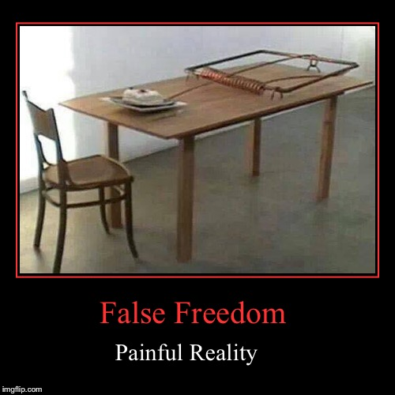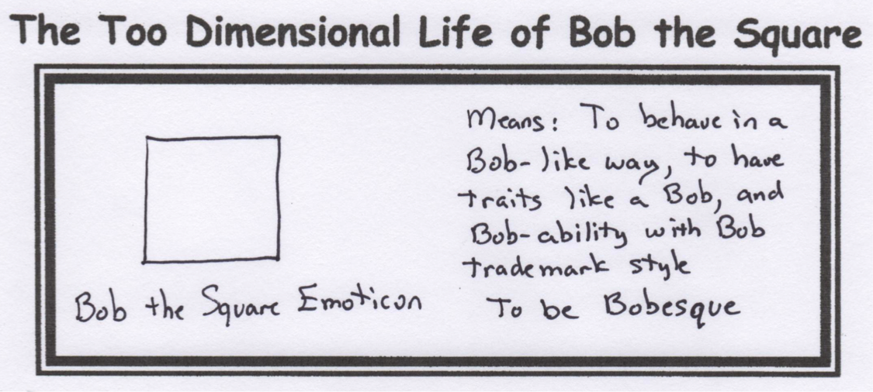

Feel Free to Have an Extra Piece of Cake.