**April 14, 2019**

**Volume 7, Issue 29**

Sunday School Times

***Stuff For Today***

• Short history lesson regarding the nursery rhyme ***Mary Had A Little Lamb***

• A Crossword Puzzle

• What Donkey? And why in the world should I care what color he is?!!!

Published almost weekly, but more like…..whenever, so get used to it, OK?

# So, What Color Was The Donkey?

**By Mr. Lyle (mrlyle1@gmail.com**

***John 12***

***That’s right! The entire chapter!***

The Gospel of John recounts events in the life of Jesus from a unique perspective. His attention to detail often includes mention of geographical location. Many times, he gives insight by placing things accurately on a timeline. John 12 is a beautiful example of this.

These verses take us back to one week before the Jesus’ death on the cross. Between the four Gospels, much is

recorded about His last week. Many prophecies of Scripture were being fulfilled during this time. A lot was going on.

I Corinthians 5:7 tells us that Jesus is our Passover Lamb. That takes us back into the Old Testament. The Passover was an extremely important event in the lives of the people of Israel. The laws regarding how it was to be celebrated and observed were quite detailed and explicit. They were to pick a lamb without any flaws or blemishes, observe it for four days, and then, on the evening of the Passover, they were to kill it and eat it in a solemn meal.

Many things in the Old Testament point to the person of Jesus, His character, His actions, His attributes. This Passover lamb is one of the most striking and touching pictures of Jesus to be found in the Law.

A flawless lamb was chosen (Jesus was without sin), and was to be observed for four days. I have seen lambs before, and they are absolutely adorable! I can imagine the attachment that might develop when an animal like that was brought near the family for a few days? And then, at sunset Passover evening, it was slaughtered and roasted

and eaten. The sense of personal loss would have been evident, I am sure.

Mary did indeed have a little Lamb--our Passover Lamb—Jesus Christ.

So, what color was the donkey? A fair question. For that answer, we must consider the Jewish culture.

The king of Israel was an honored position. One that demanded respect. It was the feeling of the people that God called a king to be humble. He places great emphasis upon the humility of His people—especially the leadership.

So, to promote that idea, instead of riding upon a horse, the kings of Israel rode upon donkeys. It was a gentle reminder of how their heart attitude should be.

And to set them apart from the common man, they rode upon white donkeys. Though probably somewhat rare, a king could afford to find one and own one.

The horse was an animal of war. The donkey, an animal of peace.

Many classic paintings depict Jesus riding into Jerusalem that Palm Sunday morning. A few painters researched their subject and knew this fact, and painted their donkey white.

(Continued Page 2)

**“A”**

**Crossword**

**Puzzle**

By Mr. Lyle (mrlyle1@gmail.com)

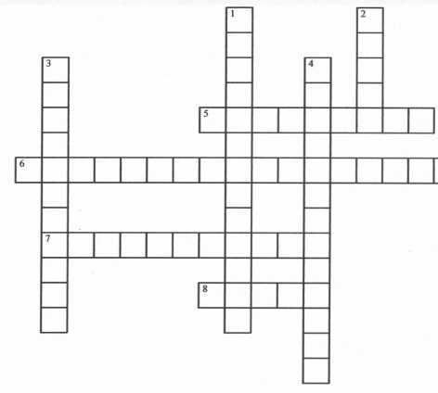

**A Short History**

The words of the American  nursery rhyme *Mary Had a Little Lamb* were inspired by an actual story. Young Mary Sawyer decided to take her little lamb to school one day at the suggestion of her brother. Visiting Mary's school that day was a young man that was very taken by the presence of the lamb. The next day he returned to the little red school house and handed Mary a piece of paper with the three original stanzas written on it.

The Redstone School built in 1798, believed to be the school house mentioned in the rhyme, is now located in Sudbury, Massachusetts. In the town center of Mary's home in Sterling, Massachusetts stands a statue of Mary's lamb.

In the first recording of the human voice in 1877, Thomas Edison recited *Mary Had a Little Lamb.* He re-recorded it again in 1927 for posterity

**Across**

5. Roller Coaster Scream

6. Ghost Sighting Exclamation

7. Sigh of Relaxation

8. Repeated Alphabet Beginning

**Down**

1. Perfect Heavy Course Load Report Card
2. Starting Letter of First 5 words in the Dictionary
3. Carried Away Initially Writing Aardvark

4. Tongue Depressor Vocalization