(Continued from Page 1)

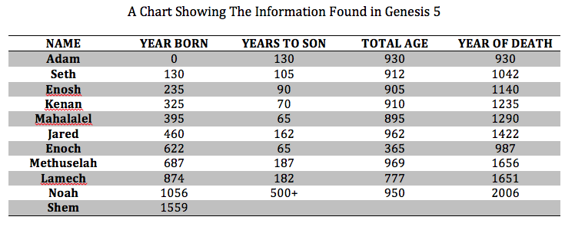

Take note of the year that Adam died. Notice that Noah was born shortly after Adam passed away. But Lamech could have known Adam personally and talked with him.

Enoch was taken at a relatively “young” age. The Bible tells us here that he walked with God. That is said of no one else in scripture. What a remarkable man he must have been. Other passages tell us that he was a preacher of the message of God. One would imagine him to have been a wonderful example of a godly man in every respect. His son would have witnessed the life of his father first hand, and no doubt, respected it. Remind yourself at this point of the commandment to “Honor your father and mother”, and note that it came with a promise of an extended lifespan. Methuselah is on record as the man to have lived the longest. Is that just coincidence?

The great flood came in the year 1656. It is the belief of this writer that God took his people home and spared them His wrath and destruction. Only Noah and his immediate family survived God’s judgment as the flood came upon the earth. They were miraculously and wonderfully saved.

Tremendous lifespans in those days allowed for overlapping of many generations. Imagine the experience and knowledge that could be passed down through the family. That could also work negatively, in that a poor example of a father would continue to influence many generations of impressionable minds.

This generational account also pins down time for us in an interesting way. The earth is not as old as the world says it is. It was created with the look of age, and to say otherwise, is to disregard Genesis 5.

**Three Things About Johann**

First, Johann was an officer in the German army, and as a new Christian, was searching for a church to attend. The Mennonite church he approached was not ready to accept him with open arms, so He moved to Sweden where he found a bit more liberal Mennonite church to become a part of and served there for a number of years. After some time had passed, he returned to Germany where he once again approached the church there about becoming a part of their fellowship. Noting his acceptance in Sweden, there was little they could do but allow him to join. But, because of the uniqueness of his background and his remarkable conversion, they wrote it all down in church records for future reference, should there ever be a need of this somewhat odd information.

Second, he is the first Ratzlaff recorded in any church documents.

And thirdly…….well…….let’s let Mr Lyle tell you the rest of the story.

