**October 8, 2017**

**Volume 6, Issue 5**

Sunday School Times

Published almost weekly, but more like…..whenever, so get used to it, OK?

# An Island Paradise Called Hu Waru

***Stuff For Today***

• Wait, Wait, Let Me Guess!

• Little Known Conjecture

* Amerigo Vespucci
* Hu Waru

**By Mr. Lyle (mrlyle1@gmail.com**

***Luke 6: 27-31***

***27 ‘But to you who are listening I say: love your enemies, do good to those who hate you, 28 bless those who curse you, pray for those who ill-treat you. 29 If someone slaps you on one cheek, turn to them the other also. If someone takes your coat, do not withhold your shirt from them. 30 Give to everyone who asks you, and if anyone takes what belongs to you, do not demand it back. 31 Do to others as you would have them do to you.***

Even on a good day, it is difficult for us to genuinely love those who mistreat us.

The story of Hu Waru embraces this topic. The mythical island chain is composed of three islands. The first island, Watts, is named after Sir Ampsund Watts. The middle and much larger island is Yoore, named of course after the Viking Crusader Yoore Seally. And to the far west we find Nayme, discovered and mapped by the famous Dutch explorer Gwatno Nayme. The islanders traditional greeting of “Hu Waru, Hu Waru.”, lends itself to the common name of the island chain.

As the story goes, The islanders embarked upon a campaign to build a National Monstrosity, and division among its citizens soon followed. The engineers responsible for the project, commonly known by the acronym NME (The National Monstrosity Engineers) became arrogant and disrespectful. They chided the less educated with their constant flaunting of mathematical formulas used during the construction process. The division among the population was shocking.

Probably the darkest hour for these islands was the day that the NME’s took control of a key supply of raw materials. A mine on the island of Watts was taken by force and declared to be under new ownership—the island of Yoore! The headline in the newspaper the next day said it all. Watts Mine Is Yoore’s!

Luckily, there was a level head among the indigenous population, Mr. P. Smayker. His attention to detail and thoughtful consideration resulted is an excellent campaign to reunite the torn nation. He called it an LUV program. Let’s Understand Volume was a well-received effort to teach the less educated the formulas that the engineers were flaunting upon the people.

T-shirts were printed and a nationwide emphasis begun. Billboards everywhere proclaimed:

**Luv**

**Yoore**

**NME”s**

It worked! In no time at all the nation was reconciled. This little paradise of the South Pacific was once again a wonderful place to live and work.

Jesus was adamant that his disciples know that there would be those that would not tolerate them and would genuinely hate them simply because they were Christ like—Christians. We would do well to heed his advice and learn how to deal with those that may not like us much (or at all).

Elisha dealt with an enemy army in 2 Kings chapter 6. In one of the most striking “battles” in the Old Testament, Elisha asked God to blind the entire army. He then promptly led them into the capital city, where he presented them to the king and told him to feed them and send them home in kindness. With their blindness healed, and food in their stomach, and a story unlike any other, they returned home and allowed Israel to continue in peace.

Love your enemies? Hmmm, it does work. How about that!

**Little Known Conjecture About Me**

By Mr. Lyle (mrlyle1@gmail.com)

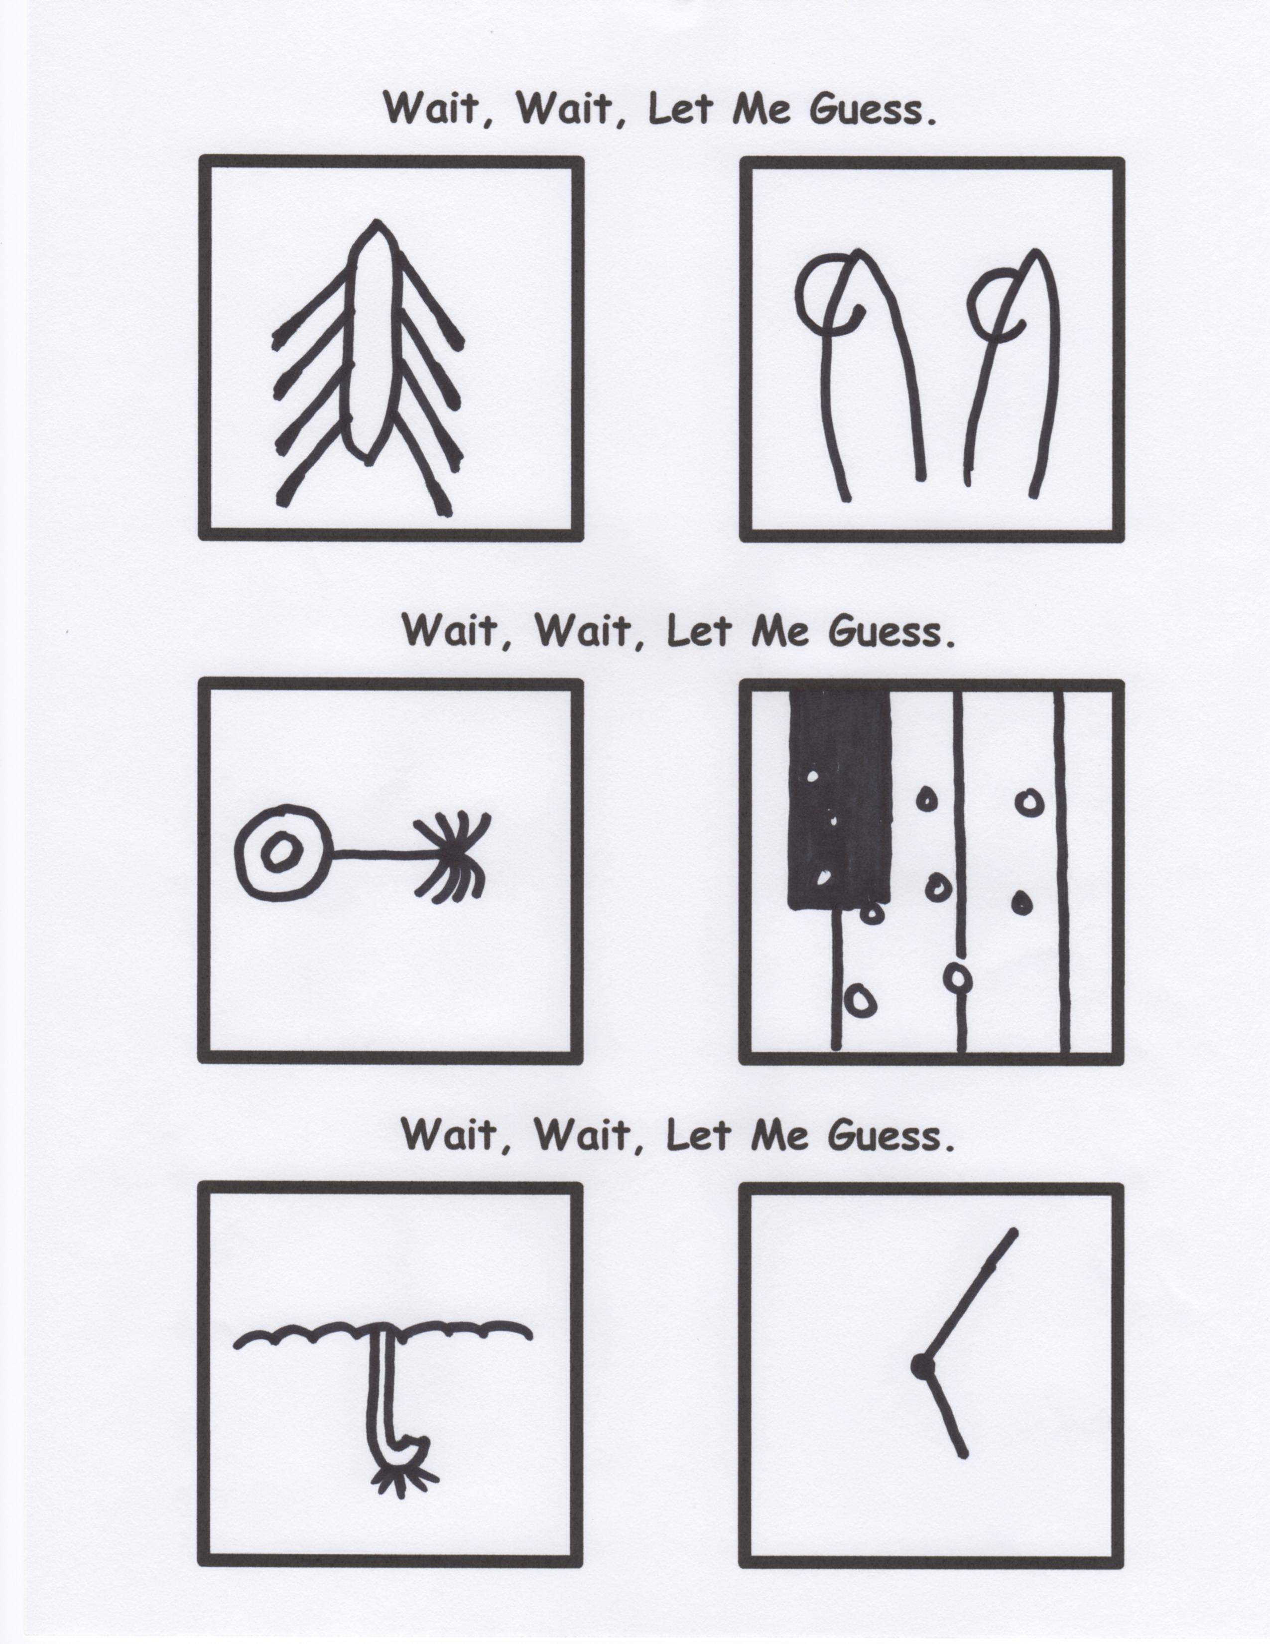

**Remember to Give 100% Each Week!!**

Monday—12%

Tuesday—17%

Wednesday—23%

Thursday—19%

Friday—4%

Saturday—16%

Sunday—9%

Back in the early 80’s I lived in Southern Florida where I worked at Joes Gator Ranch as head alligator wrestler.

As a kid I never played with dolls. I played with ACTION FIGURES! But I never did find a nice camouflage outfit for Malibu Barbie.

I really enjoyed my three years as a power forward for the Detroit Pistons!

When I put on my shoes, once I get one shoe on, I almost always know where the other one goes.

On my first day of school, my parents dropped me off at the wrong nursery. There I was, surrounded by all those trees, shrubs, and bushes.

One of the goals in my life is to put a whole bag of M&M’s in alphabetical order!

I asked my Mom if I was a gifted child. Well, she said they certainly would not have paid for me!

…and then Satan said,

”Let’s put the alphabet in Math.”

**Just a thought:**

If they had used his last name instead of his first, we might all be living in ***The United States of Vespucci.***

Like I said, it is just a thought.