**November 6, 2016**

**Volume 5, Issue 9**

Sunday School Times

Published almost weekly, but more like…..whenever, so get used to it, OK?

# How to Use Your Tools Well

**By Mr. Lyle (mrlyle1@gmail.com**

***Stuff For Today***

• Tools : the Bigger, the Better!

• There is no such thing as a stupid question. Stupid answers? Now that is another story!

• What would you like to have written on your gravestone?

What would you like to have written on your gravestone? I have considered this at times, and I believe the following phrase would suffice for me.

**Here Lies a Disciple of Jesus Christ, Cleverly Disguised as a Woodworker. He Used His Tools Well.**

I just hope that I can live up to it. Let me explain what I mean.

We as Christians are called to be disciples. That title requires more than just a desire to follow along behind a leader. We are to become like Jesus in word and deed. Everything else that we do pales in comparison to that task.

Life absorbs much of our time and assets. It is very easy to get lost in the everyday grind and its demands. But our focus must be where our citizenship really lies—in Heaven. All that we have in our lives is a gift from God. Gifts are given with reason and purpose. We are to use what we have to work for Him. Our tools, as it were.

Our tool chests consist of far more than just money. Included in the drawers and trays of that tool chest are our talents and abilities, health, reputations, and time.

As a woodworker by trade, I am quite familiar with the importance of tools. Without them, work does not progress very quickly or very well. Tools are specific to task, and size is sometimes critical.

Too often we judge success or failure in this life by the balance in our bank account. God judges by other criteria. He has given us a task, as well as the necessary equipment to adequately accomplish His plan.

Giving our money to His work is of value, to be sure, but our other assets must not be overlooked. We talk of giving a tithe of our money, but has anyone considered what a tithe of time, or a tithe of talent might look like?

[***Luke10:2***](http://www.biblegateway.com/passage/?search=Luke+10:2&version=NIV1984) *He told them, “The harvest is plentiful, but the workers are few. Ask the Lord of the harvest, therefore, to send out workers into the field.*

It is interesting to note there is no mention of a financial plan, or many of our other usual concerns. Rather, the focus is upon the time and effort of individuals willing to perform the necessary task. You see, money is no object to a God who owns everything. But our time—now that is a commodity of immense value to God.

May we use our gifts-**our tools-**wisely!

## **Questions, But Sadly, No Answers**

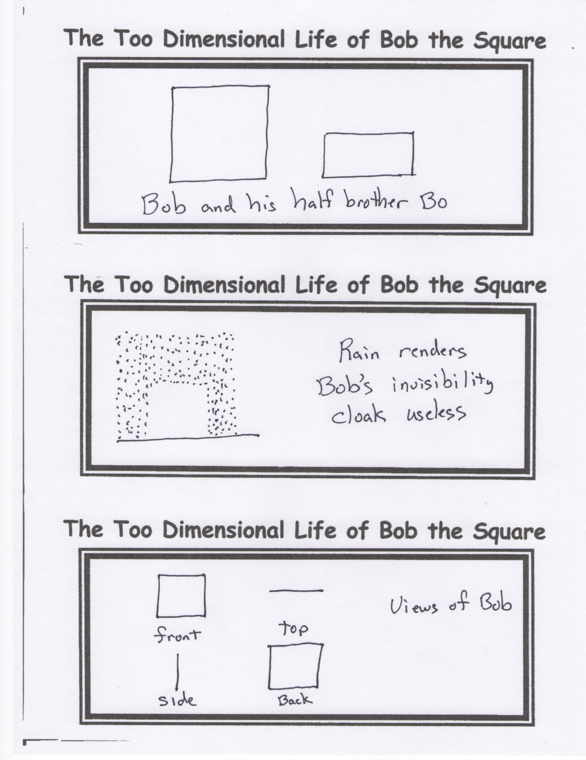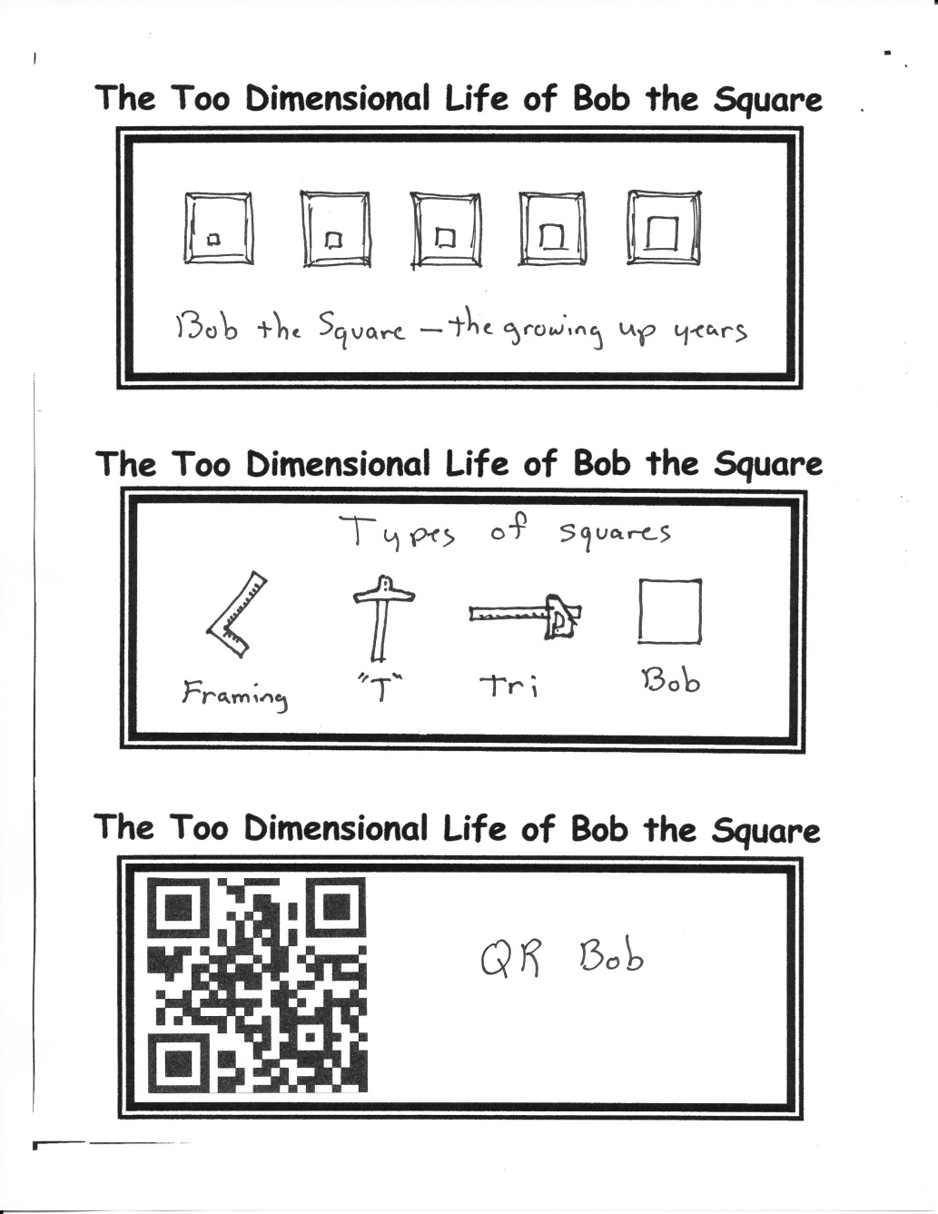

By Mr. Lyle (mrlyle1@gmail.com)

1. If I *Save the Whales*, can I collect the whole set?

2. Can a fool be so sufficiently talented that nothing can be considered fool-proof?

3. Are fast reflexes an acceptable substitute for good manners?

4. Is it legal to fill out my taxes in Roman Numerals?

5. If a recipe calls for eggs to be beaten, consider this first—what did they do?

6. What disease did cured ham actually have?

7. Why do all toasters have a setting that burns toast to such a horrible black crisp that no human being could possibly eat?