**June 18, 2017**

**Volume 5, Issue 33**

Sunday School Times

***Stuff For Today***

• Books I would like to write

• Welcome to the Canard Lee Reed Book of the Month Club

• What ”The Last Hurrah“ and Mr. Lyle’s Bucket List have in common

Published almost weekly, but more like…..whenever, so get used to it, OK?

# A Book Report On A Bucket List

**By Mr. Lyle (mrlyle1@gmail.com**

***2 Timothy 2:15***

***Study to show thyself approved unto God, a workman that needeth not to be ashamed, rightly dividing the Word of Truth.***

Allow me to take you back in time to 1972. Also, let me introduce to you a 16 year old kid sitting in his American Literature class. His teacher, a brilliant man by the name of C. Nevin Miller has assigned a book report—three pages—typed.

The young man promptly goes to the school library in search of a suitable novel. Unfortunately, his mind is not set on actually reading that novel. He searches through the paperback books found at the east end of the shelving, knowing full well that, included on the back cover, would be a short synopsis of the entire story.

Finding a book with a fairly detailed rendition of the general story line, he chooses a rather famous novel by Edwin O’Conner titled ***The Last Hurrah***.

Quickly scanning through the chapters, he locates and reads two or three pages, noting a few of the minor details found in the story line.

In less than 15 minutes of this pathetic, hurried note taking, he attempts to create the illusion of actually having read the story. The final result—three pages—typed.

This *brilliant* plan was fraught with errors. *The Last Hurrah* was a very well known book in its day, having spent much time on the *New York Times* best seller list at number one! It had, in 1958, been adapted into a movie, with characters performed by top Hollywood box office celebrities.

Seldom seen in this world are graded and returned book reports with so much red ink on them that they tend to glow with an eerie reddish hue.

Mr. C. Nevin Miller assessed my book report as barely worthy of a *D-minus.* The lowest grade I ever received from a teacher. I had never read the book, and my report clearly showed my bluff.

So here is my question for you. Do you read the Bible? Do you study it? As a Christian, God has assigned you and I the responsibility of putting together a *book report* telling and showing the world what God has for all. And the world can tell if you have read *The Book!*

Before I die, I plan to read *The Last Hurrah.* It is on my *bucket list—a m*iserable failure I would like to correct as best I can over 40 years late.

**Books I Would Like To Write**

Top 6 Things Your Dad Will NEVER Say!

6. No son of mine is going to live under this roof without an earring. Now quit your belly-aching and let’s go to the mall.

5. You know Pumpkin, now that you’re thirteen, you’ll be ready for un-chaperoned car dates. Won’t that be fun?

4. Well, I don’t know what’s wrong with the car. Probably one of those doo-hickey thingies—ya know—that makes it run or something. Let’s just have it towed to a mechanic and pay whatever he asks.

3. What do you mean you wanna play football? Figure skating is not good enough for you, son?

2. Here’s a credit card and the keys to my new car. Have fun!!!

1. Well, how ‘bout that? I’m lost! Looks like we’ll have to stop and ask for directions.

By Mr. Lyle (mrlyle1@gmail.com)

Over these many years, I have had occasion to consider a writing career. Processing many ideas through my fertile imagination, I have come up with some exceptional ideas for books targeted toward small children

1. A Childrens Guide to Hitchhiking.

2. Your First Picture Book (Reading Is For Losers)

3. Connect The Dots (No Matter How Well You Follow The Numbers, They Still Don’t Make A Picture)

4. Why Can’t Mr. Fork And Mr. Electrical Socket Be Friends?

5. Some Kittens Really Can Fly!

6. Freeway Dodgeball—Official Kindergarten Rules

7. The Little Engine Who Thought He Could—But Failed Miserably

8. Curious George and the High Voltage Electric Fence

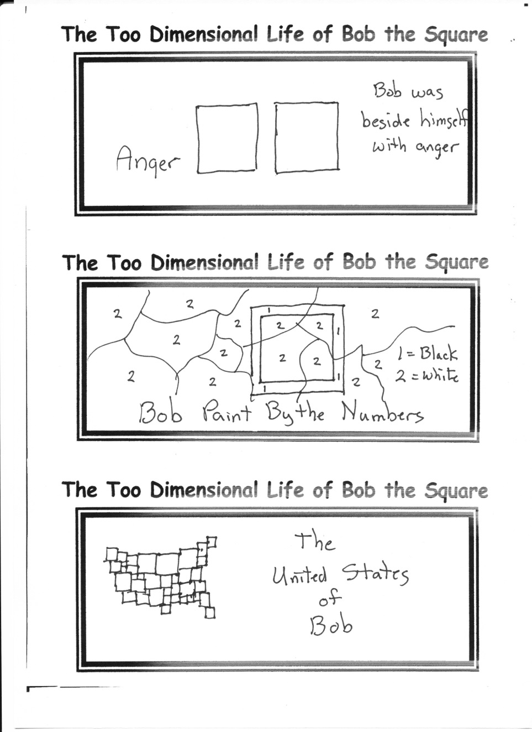

**The *Canard Lee Reed* Book Of The Month Club**

Welcome to the most amazing book club you could ever belong to. Sign up today, and be on your way to enjoying titles such as

1. *How to Write Large Books* by Warren Peece

2. *The Lion Attacked* by Claude Yarmoff

3. *Archery for Dummies* by Beau N. Arow

4. *Irish Heart Surgery* by Angie O’Plasty

5. *Desert Crossing* by Rhoda Kamel

6. *School Truancy* by Marcus Abscent

7. *I Lost My Balance* by Eileen Dover and Phil Down

8. *Shhh!*  By Danielle Solloud

9. *The Philippine Post Office* by Imelda Lettur

10. *Great Party Games* by Bob Frapples

11. *Stop Arguing* by Xavier Breth

12. *The Complete Guide to Raising Pet Mosquitoes*  by Iam Reelie Eetchy