**April 9, 2017**

**Volume 5, Issue 25**

Sunday School Times

***Stuff For Today***

• Short history lesson regarding the nursery rhyme ***Mary Had A Little Lamb***

• A Crossword Puzzzle

• What Donkey? And why in the world should I care what color he is?!!!

Published almost weekly, but more like…..whenever, so get used to it, OK?

# So, What Color Was The Donkey?

**By Mr. Lyle (mrlyle1@gmail.com**

***John 12***

The Gospel of John recounts events in the life of Jesus from a unique perspective. His attention to detail often includes mention of geographical location. Many times, he gives insight by placing things accurately on a timeline. John 12 is a beautiful example of this.

These verses take us back to one week before the Jesus’ death on the cross. Between the four Gospels, much is recorded about His last week. Many prophecies of Scripture were being fulfilled during this time. A lot was going on.

I Corinthians 5:7 tells us that Jesus is our Passover Lamb. That takes us back into the Old Testament. The Passover was an extremely important event in the lives of the people of Israel. The laws regarding how it was to be celebrated and observed were quite detailed and explicit. They were to pick a lamb without any flaws or blemishes, observe it for four days, and then, on the evening of the Passover, they were to kill it and eat it in a solemn meal.

Many things in the Old Testament point to the person of Jesus, His character, His actions, His attributes. This Passover lamb is one of the most striking and touching pictures of Jesus to be found in the Law.

A flawless lamb was chosen (Jesus was without sin), and was to be observed for four days. I have seen lambs before, and they are absolutely adorable! I can imagine the attachment that might develop when an animal like that was brought near the family for a few days? And then, at sunset Passover evening, it was slaughtered and roasted and eaten. The sense of personal loss would have been evident, I am sure.

Mary did indeed have a little Lamb--our Passover Lamb—Jesus Christ.

**“A”**

**Crossword**

**Puzzle**

By Mr. Lyle (mrlyle1@gmail.com)

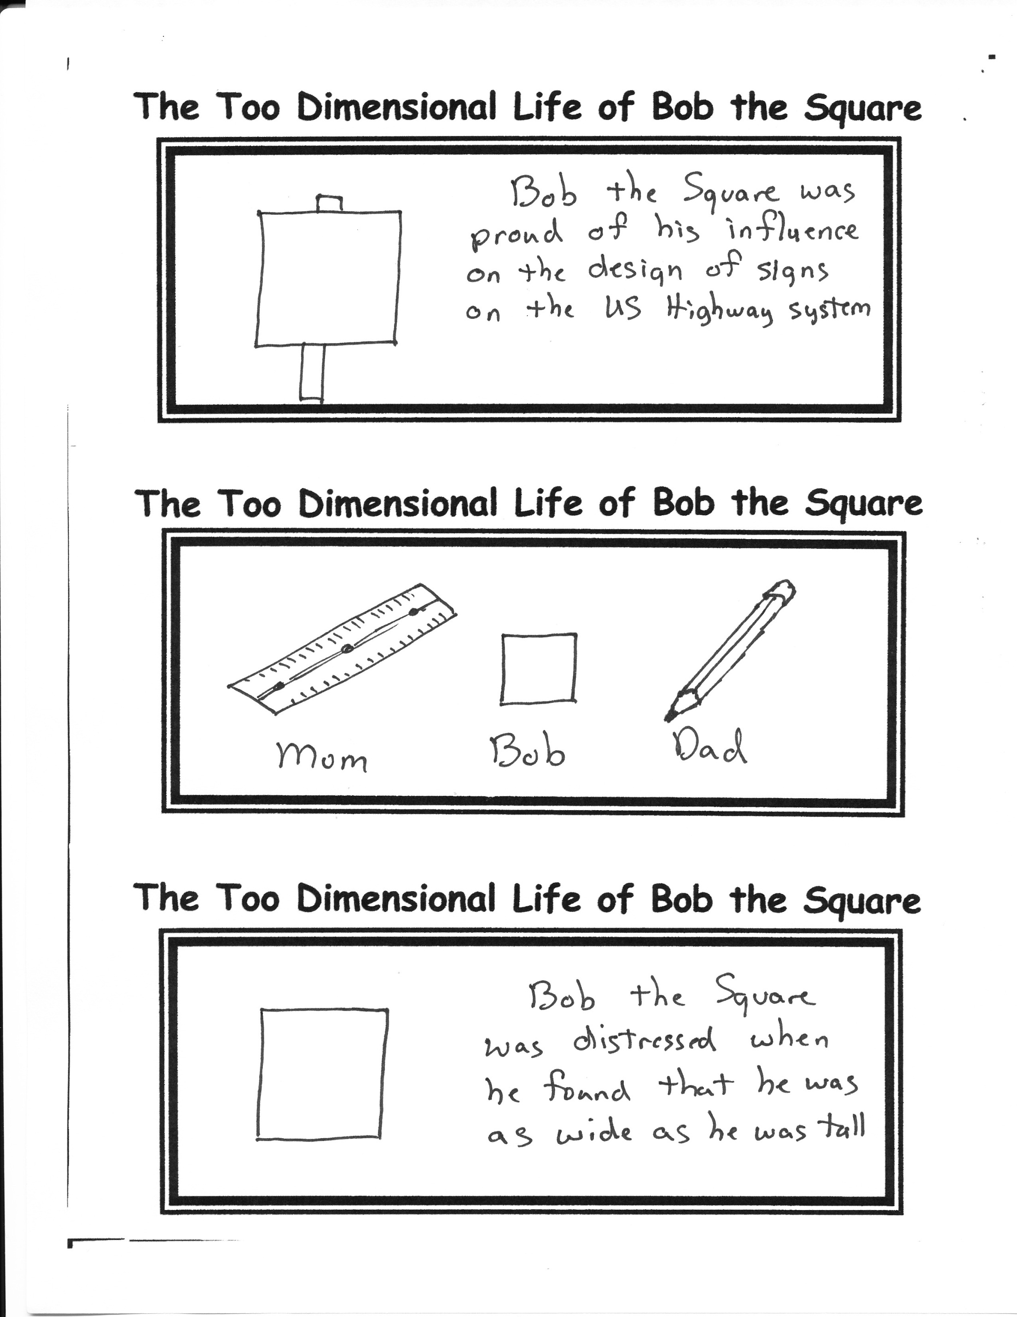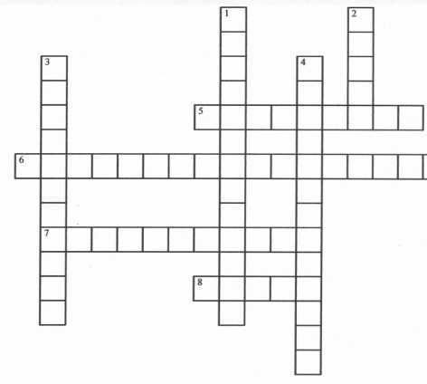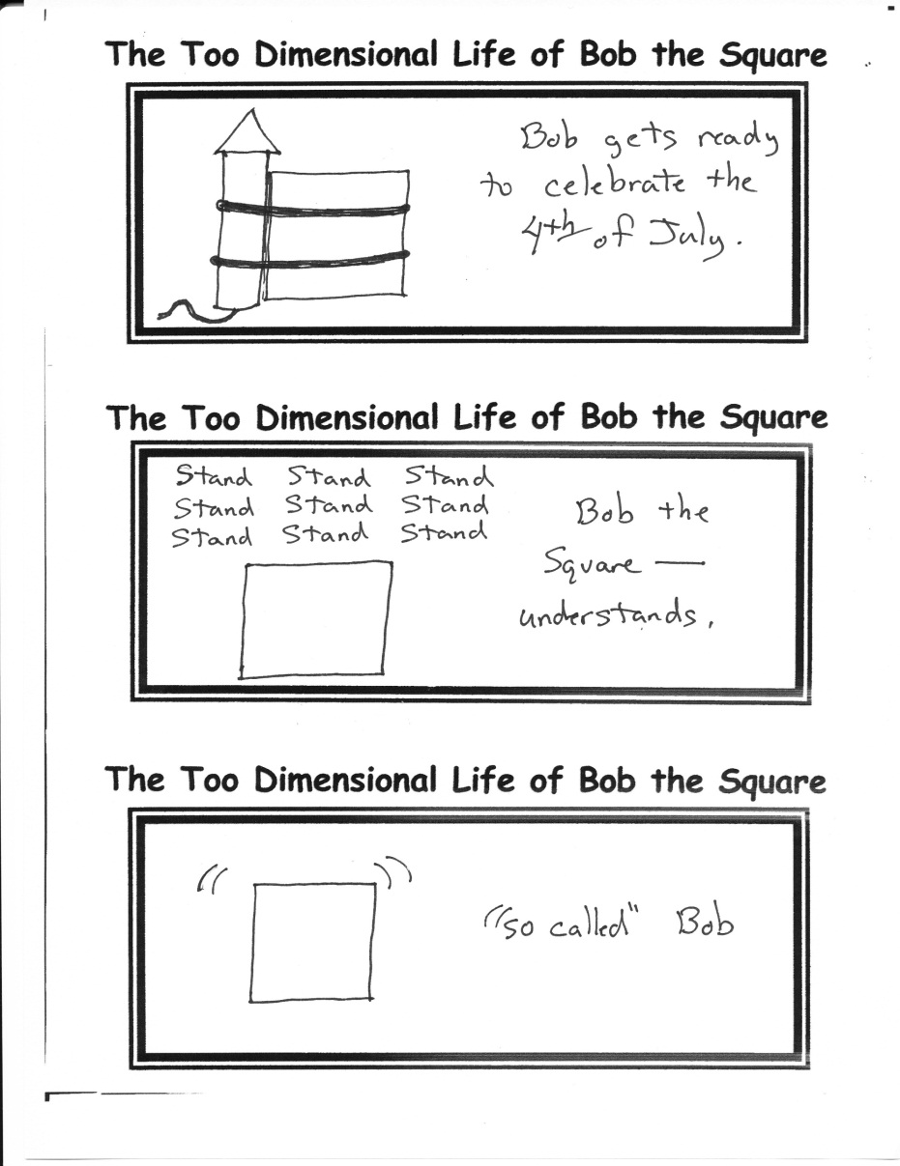

**Across**

5. Roller Coaster Scream

6. Ghost Sighting Exclamation

7. Sigh of Relaxation

8. Repeated Alphabet Beginning

**Down**

1. Perfect Heavy Course Load Report Card
2. Starting Letter of First 5 words in the Dictionary
3. Carried Away Initially Writing Aardvark

4. Tongue Depressor Vocalization

**A Short History**

The words of the American  nursery rhyme *Mary Had a Little Lamb* were inspired by an actual story. Young Mary Sawyer decided to take her little lamb to school one day at the suggestion of her brother. Visiting Mary's school that day was a young man that was very taken by the presence of the lamb. The next day he returned to the little red school house and handed Mary a piece of paper with the three original stanzas written on it.

The Redstone School built in 1798, believed to be the school house mentioned in the rhyme, is now located in Sudbury, Massachusetts. In the town center of Mary's home in Sterling, Massachusetts stands a statue of Mary's lamb.

In the first recording of the human voice in 1877, Thomas Edison recited *Mary Had a Little Lamb.* He re-recorded it again in 1927 for posterity