**February 5, 2017**

**Volume 5, Issue 19**

Sunday School Times

# Mr. Lyle Bowl XVII--2017

***Stuff For Today***

• March Dinner Theater

• Welcome to Febrooaree

• Mr Lyle Bowl XVII

Published almost weekly, but more like…..whenever, so get used to it, OK?

**By Mr. Lyle (mrlyle1@gmail.com**

***II Peter 1:5-7***

***5 For this very reason, make every effort to add to your faith goodness; and to goodness, knowledge; 6 and to knowledge, self-control; and to self-control, perseverance; and to perseverance, godliness; 7 and to godliness, mutual affection; and to mutual affection, love.***

I watched Superbowl I. The Green Bay Packers and the Kansas City Chiefs met in the Los Angeles Coliseum on January 15, 1967. As an eleven year old who did not follow the game much, it left little impression on me.

It was not called *Superbowl I* until retro-actively given the name in 1970. It was simply known as the *AFL-NFL World Championship Game.*

Broadcast on both NBC and CBS, it was the only Superbowl game to date that was not completely sold out. For those who care, the Packers beat the Chiefs 35-10.

Seventeen years ago, an idea was born that has consistently appeared in Sunday School every first Sunday in February. It is called the *Mr. Lyle Bowl*, and it returns again today..

The playing field looks somewhat like a regulation football field, and we use a football, and there is a referee, but that is where any similarity ends.

This game is an analogy of the life of a Christian. With an impossible set of rules, and a ref that knows them all too well, winning is all but impossible—on your own.

You see, for a Christian living in the world, playing the game of life is difficult at best. God has an incredible standard that we are to maintain—perfection. On our own, that is an impossible goal.

The good news is that God never intended for us to tackle this game on our own. He has provided a Way in the person of Jesus Christ.

The key to winning in this life is to maintain a relationship with Him. We need to allow Him to lead, and then be brave enough to follow.

2,000 years ago, Jesus took the field as a human being just like us, and won, by living a perfect life. He showed us how, wrote it all down in a Book called the Bible, and gave us an internal referee, the Holy Spirit, to call the plays for us.

Play the game of life according to God’s plan—and win!

**The Field For Today**

**The Most Incorrectly Pronounced Word in the English Language**

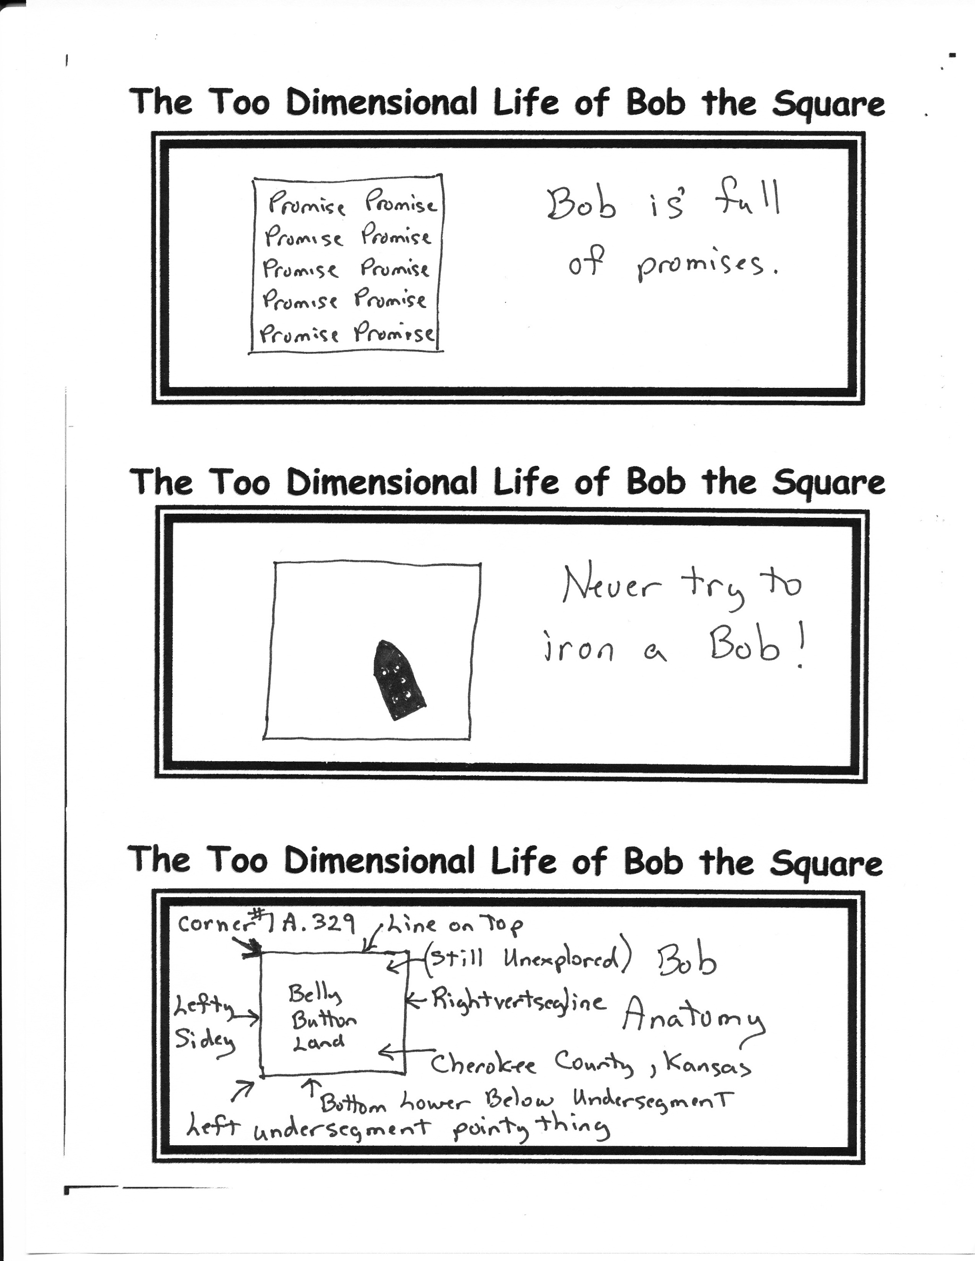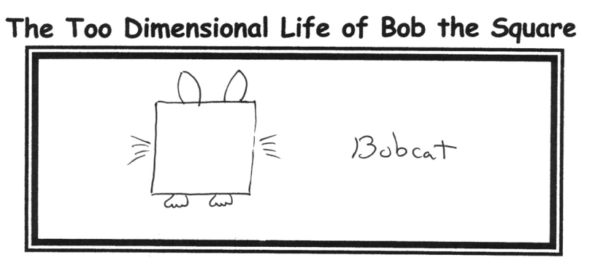

**Upcoming Dinner Theater**

**The *Most Masterfully Measured and Made Major Mouth Moving Main Meal Moment in March*** will be held March 11th.

We had ***An Awesome April Appetite Alternative—An Almost Above Average Attraction to Attend*** just in case we had to do this in April.

Check and mark, and draw on, and post-it-note, and push-pin, and circle, and highlight in yellow your calendars.

BE THERE!

10yd_____________

20yd_____________

30yd_____________

40yd_____________

50yd_____________

60yd_____________

70yd_____________

By Mr. Lyle (mrlyle1@gmail.com)