**September 27, 2015**

**Volume 4, Issue 5**

Sunday School Times

***Stuff For Today***

• Wait, Wait, Let Me Guess

• Rscheearch

* Man’s survival
* 10%

Published almost weekly, but more like…..whenever, so get used to it, OK?

# A Place Not Found On Google Maps

**By Mr. Lyle (mrlyle1@gmail.com)**

***10%=Tithe***

So, how do you figure out how much to give God?

**Money**—that one is easy,. Divide the total by ten. But does a God who owns everything really need our money? Or does He want us to be less absorbed by it? What about our…

**Time**—with a limited amount of time at our disposal, it may well be the most valuable thing that God gives us. With 24 hours a day, ten percent would be 2.4 hours? Imagine what God could do with our willingness to give Him our time. And then there is…

**Talent**—that’s even harder to figure! God has given every Christian at least one spiritual gift. He wishes for us to learn to use our gift for His purposes. Also, don’t forget all of the …

**Many things beside money that God gives us.** Through our life, we receive many gifts from a very generous God. Can we ever calculate a true tithe?

***Isaiah 7:3***

***Then said the Lord unto Isaiah, Go forth now to meet Ahaz, thou, and Shearjashub thy son, at the end of the conduit of the upper pool in the highway of the fuller's field.***

Christmas season and the accompanying celebrations help us to remember the passage in Isaiah 7:14. As remarkable as is the content of these verses, so is the physical location they were first quoted. God wanted a face to face meeting between the king of Judah, Ahaz, and His prophet, Isaiah, at a very specific location. Few places in Scripture are as exacting in description as this one. That fact spurs some interest and inquiry. Isaiah 7:3 presents these geographical notes. The meeting was to take place at the *end of the conduit.* God had promised David that his family line would always sit upon the throne of Israel. That family tree was the conduit through which Jesus claims rightful ownership of the throne. He is at the end of that line, the final King who will rule and reign forever. The conduit empties into *the upper pool.* In Israel, water is precious and a blessing. A body of water, a pool, is literally the word for blessing in the Hebrew. And the word *upper* elsewhere in Scripture is translated Most High when referring to God Himself. Jesus, the Most High God is indeed a blessing to all. The remaining phrase, *in the highway of the fuller’s field*, is an allusion to an elevated roadbed, one that keeps the traveler out of the mud and muck through which the road extends. As we look to Christ in our everyday walk, we need holiness. It is essential to keep our lives out of the dirt and filth that the rest of the world so easily entangles itself in. *The fuller’s field* is a laundry of that day. The only way that we can be truly sanctified in our daily walk, is to be cleansed of our sin and that can come by no one but the Savior Himself. It is no accident that God chose to articulate one of the promises of His coming Son at this very allegorical location.

**Rscheearch**

Aoccdrnig to a rscheearch at Cmabrigde Uinervtisy, it deosn’t mttaer in waht oredr the ltteers in a wrod are, the olny iprmoetnt tinhg is taht the frist and lsat ltteer be at the rghit pclae. The rset can be a taotl mses and you can siltl raed it wouthit a porbelm. Tihs is bcuseae the hamun mnid deos not raed ervey lteter by istlef, but the wrod as a wlohe. Amzanig, huh?

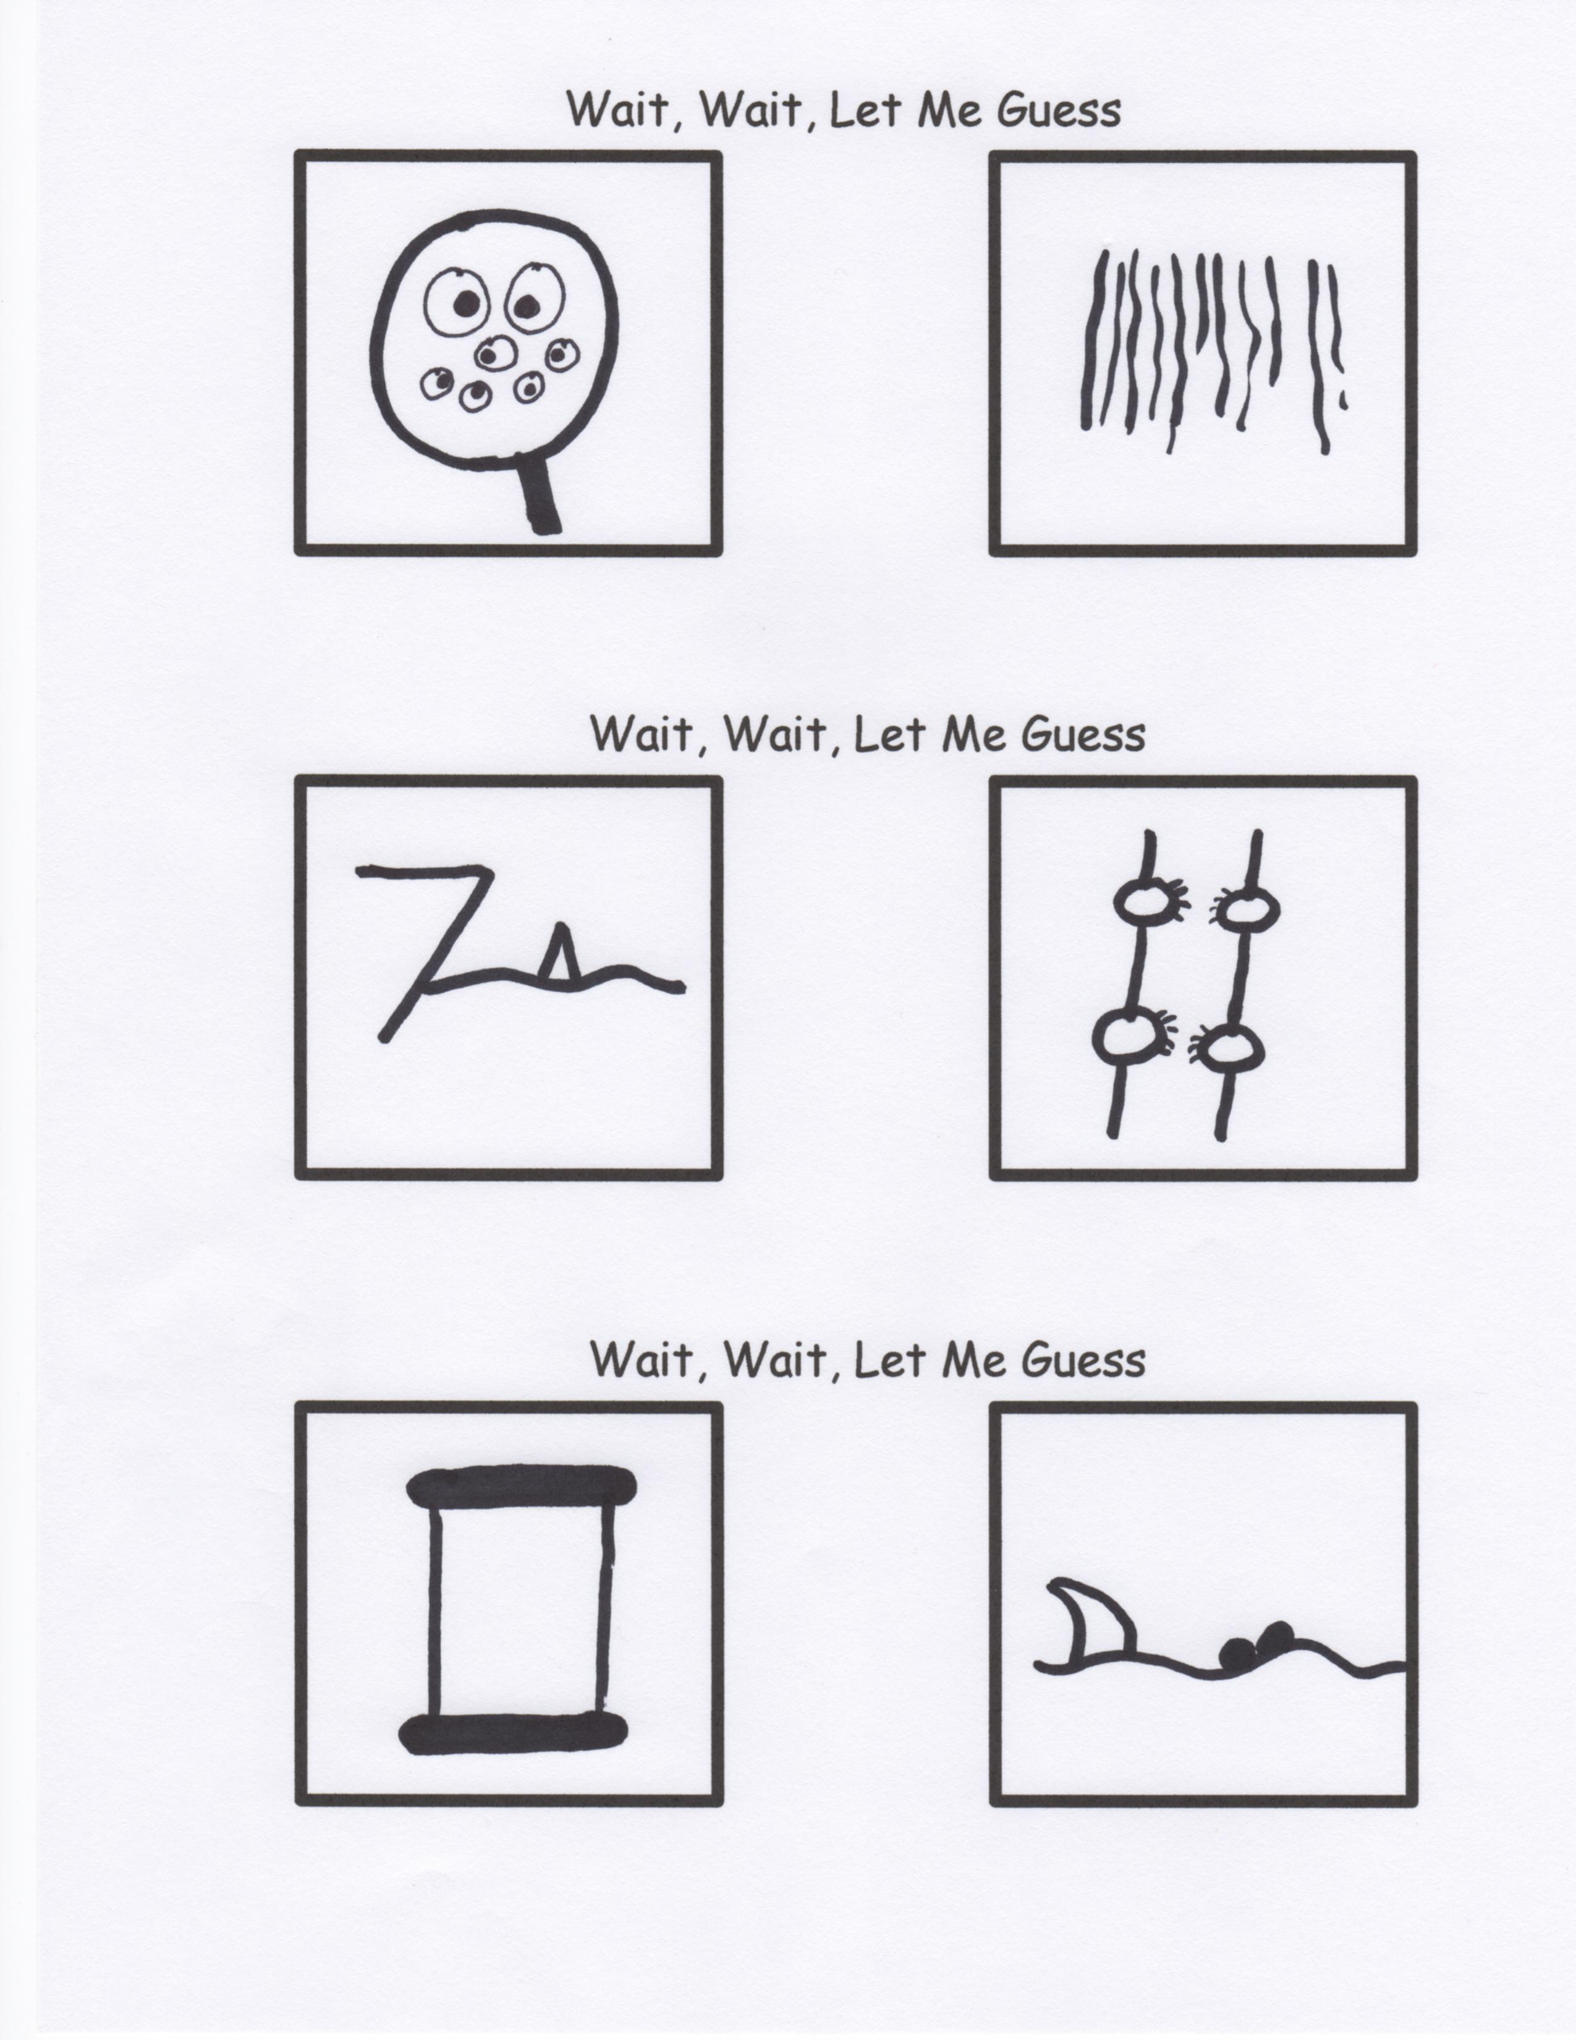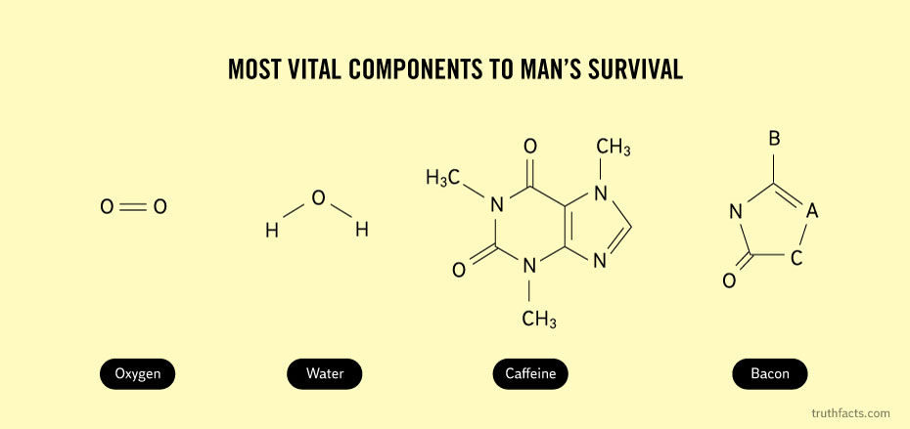

BACON

Oxygen

**Jesus is coming back someday.**

**RUE ?**

**Your Greatest Treasure**

Remember, friendship is the greatest treasure of all…that is, of course, unless you have a magic pony! Then, by all means, it is the magic pony.

Caffeine

Water