**September 20, 2015**

**Volume 4, Issue 4**

Sunday School Times

Published almost weekly, but more like…..whenever, so get used to it, OK?

# Reveal Another Terrific Zero

***Stuff For Today***

• Wait, Wait, Let Me Guess!

• A Love Story

* A little lost dog
* RATZ

**By Mr. Lyle (mrlyle1@gmail.com**

***Matthew 7:24-27***

*24 “Therefore everyone who hears these words of mine and puts them into practice is like a wise man who built his house on the rock. 25 The rain came down, the streams rose, and the winds blew and beat against that house; yet it did not fall, because it had its foundation on the rock. 26 But everyone who hears these words of mine and does not put them into practice is like a foolish man who built his house on sand. 27 The rain came down, the streams rose, and the winds blew and beat against that house, and it fell with a great crash.”*

Television game shows have always been a large part of network programming. RATZ is patterned after a game show I grew up with called “Let’s Make A Deal”. The premise of the game was that the host of the show would present a chosen individual a gift of some sort, and then would offer to trade that gift for another—always of unknown quality or quantity. The winners of the game would be the ones who chose wisely.

The world that we live in is dominated by the pursuit of money. Jesus talked often about our desires for, and our accumulation of, things. Is it wrong to be financially successful? In a word—no. Many of God’s men were wealthy. The key to handling great wealth is our attitude towards it.

Chasing material things is of little value from God’s perspective. We would do well to see money simply as a tool to use. There are times when a craftsman might use a small tool to accomplish what he needs to do. Other times, a large, massive piece of machinery is better suited for the task. You see, it is the task at hand that is of importance, not the tool used to accomplish the work.

There is a well-known saying “Money can’t buy happiness.” And yet so often people live their lives as if it can. Good examples for our discussion here today are lottery winners. Those who have won millions and lived the “good life”, later often tell a sad tale of financial ruin. After the money is spent, and their families destroyed, many are quoted as saying “I wish I had never won that money!”

God must have first place in our hearts. Nothing else can fill that position adequately. And when God is number one, the other things in our lives can fall into place, and it can be a wonderful experience. Without Him, life has little or no meaning at all. He is the reason for all that we are, all that we do, and all that we hope to be.

Welcome to our Sunday School Bible lesson!

**Zydefex**

From Lyle Pharmaceuticals comes the miracle drug of the 21st Century – Zydefex.

For years, our researchers have looked for the cure for the common cold, high cholesterol, diabetes, heart disease, Alzheimer’s, and of course, cancer. That cure is now available in an over-the-counter version we call Zydefex. Zydefex is truly the wonder drug of all drugs. We have found it to cure everything! Yes, everything! From aches to acne, from dandruff to dangling participles, Zydefex is YOUR cure! And is available today in a handy 40,000mg capsule form.

Disclaimer:

Zydefex has been shown to cause epilepsy, kidney stones, and cancer in all laboratory rats. Once a regimen is begun, Zydefex must be taken continually for at least 20 years, or death will result. Zydefex has also been shown to be the cause of heart failure, diabetic shock, the sudden growth of additional fingers or toes. Those using Zydefex as a hair re-growth regimen should be aware that each hair shaft that re-grows will be at least ¼ inch thick at the base. Zydefex has also been shown to be a key cause of incontinence, drooling, and slurred speech. Most users of Zydefex soon learn to ignore the limp that occurs as the left leg muscles atrophy to ½ their normal size.

**Lost Dog Found**

By Mr. Lyle (mrlyle1@gmail.com)

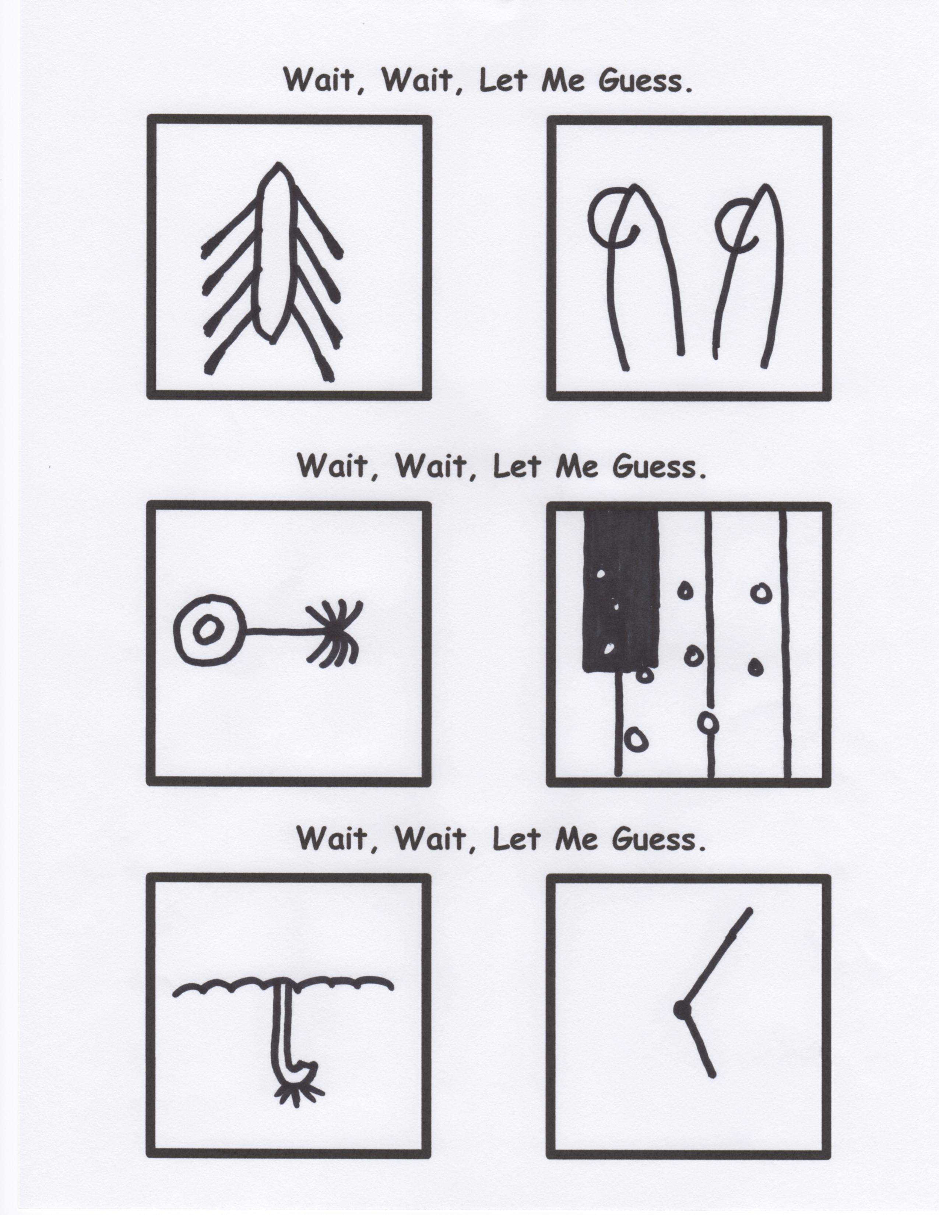

A male beagle was found around 11:30 AM on September 19th on the corner of 14th and Pine. Approximately six months old and mostly brown with cute patches of white on his nose and feet. A slightly crooked tail, and a blue collar but no tags. Very friendly, and loves kids. Tasted a lot like chicken………………………………..He licked me first, so I licked him back. What, did you think I ate him?!!!

**A Love Story**

*He knew it would never work between them.*

*The girl had been born into a wealthy family.*

*He was just a third person singular masculine subject pronoun*