**August 30, 2015**

**Volume 4, Issue 2**

Sunday School Times

Published almost weekly, but more like…..whenever, so get used to it, OK?

# Kimberton Stage Robbed at Gunpoint!

***Stuff For Today***

• Wait, Wait, Let Me Guess!

• Presidential Trivia

* Classic literature
* Court Case 32 U.S. 7 Pet. 150 (1833)

**By Mr. Lyle (mrlyle1@gmail.com**

***Nehemiah 9:17***

***And refused to obey, neither were mindful of thy wonders that thou didst among them; but hardened their necks, and in their rebellion appointed a captain to return to their bondage: but thou art a God ready to pardon, gracious and merciful, slow to anger, and of great kindness, and forsookest them not.***

In the passage above, note the phrase “thou art a God ready to pardon.”

On November 26, 1829, the stagecoach from Philadelphia to Reading was robbed at gunpoint at a bend in the road known as Kimberton. Eleven days later, the same gunmen held up the stage again—at the same location—this time hurting the driver in the process. This event took place early in our country’s development, and the US Mail was held in great regard. The leaders of our nation felt a strong obligation to instill absolute trust in this newly established communication network. Thieves targeting the US Mail could expect VERY heavy penalties!

And so the case of the Kimberton stage robbery was no small spectacle. An enormous manhunt ensued, and the capture of the offenders inevitable.

James Porter, George Wilson, and John Poteet were arrested and charged with 6 counts each. John Poteet, a young man, still wet behind the ears, turned State’s Evidence and was let off with little punishment. With John’s testimony against them, James Porter and George Wilson were found guilty on all counts and scheduled for sentencing three weeks later. At sentencing, George Wilson was given a chance to speak, and in surprise to everyone, changed his original plea of innocence to a plea of guilty on all but one count. The court was not moved, and sentenced both men to hang by the neck until dead on July 2, 1830.

The story now takes a bizarre twist, as news of this odd behavior by George Wilson struck at the heart of some very influential people who were following this case. Using their position and prominence, they successfully obtained an audience with none other than the President of the United States, Andrew Jackson! Pleading for George Wilson’s life, they requested that the President exercise his constitutionally granted power to issue an official Presidential Pardon. Two weeks later, Jackson granted their request.

The story now takes an even bizarrer (I know it’s not really a word, but it sounds funny) twist! When presented with the officially signed document of Presidential Pardon, George Wilson refused it, choosing rather to die than live! This was unprecedented in US history. Never before had a pardon been turned down. Eventually, this case came before the US Supreme Court.

In a decision that has stood the test of time, the Supreme Court sided with George Wilson. A pardon could not be forced upon anyone. Acceptance by the accused is a crucial factor. The story ends with the needless death of George Wilson.

We serve a God ready to pardon. God has granted all of us relief from our death sentence—the result of sin. Some in this world choose to accept His forgiveness and pardon. Others refuse it. And God will not force His gift on anyone. We are all given freedom of choice.

Each of our stories have two possible endings, and only two. Ending number one is to accept God’s pardon and enjoy eternity with Him forever one day. The alternative is to reject His offer and die needlessly forever in Hell.

Don’t be a George Wilson!

**Stuff You Probably Didn’t Know About Past Presidents**

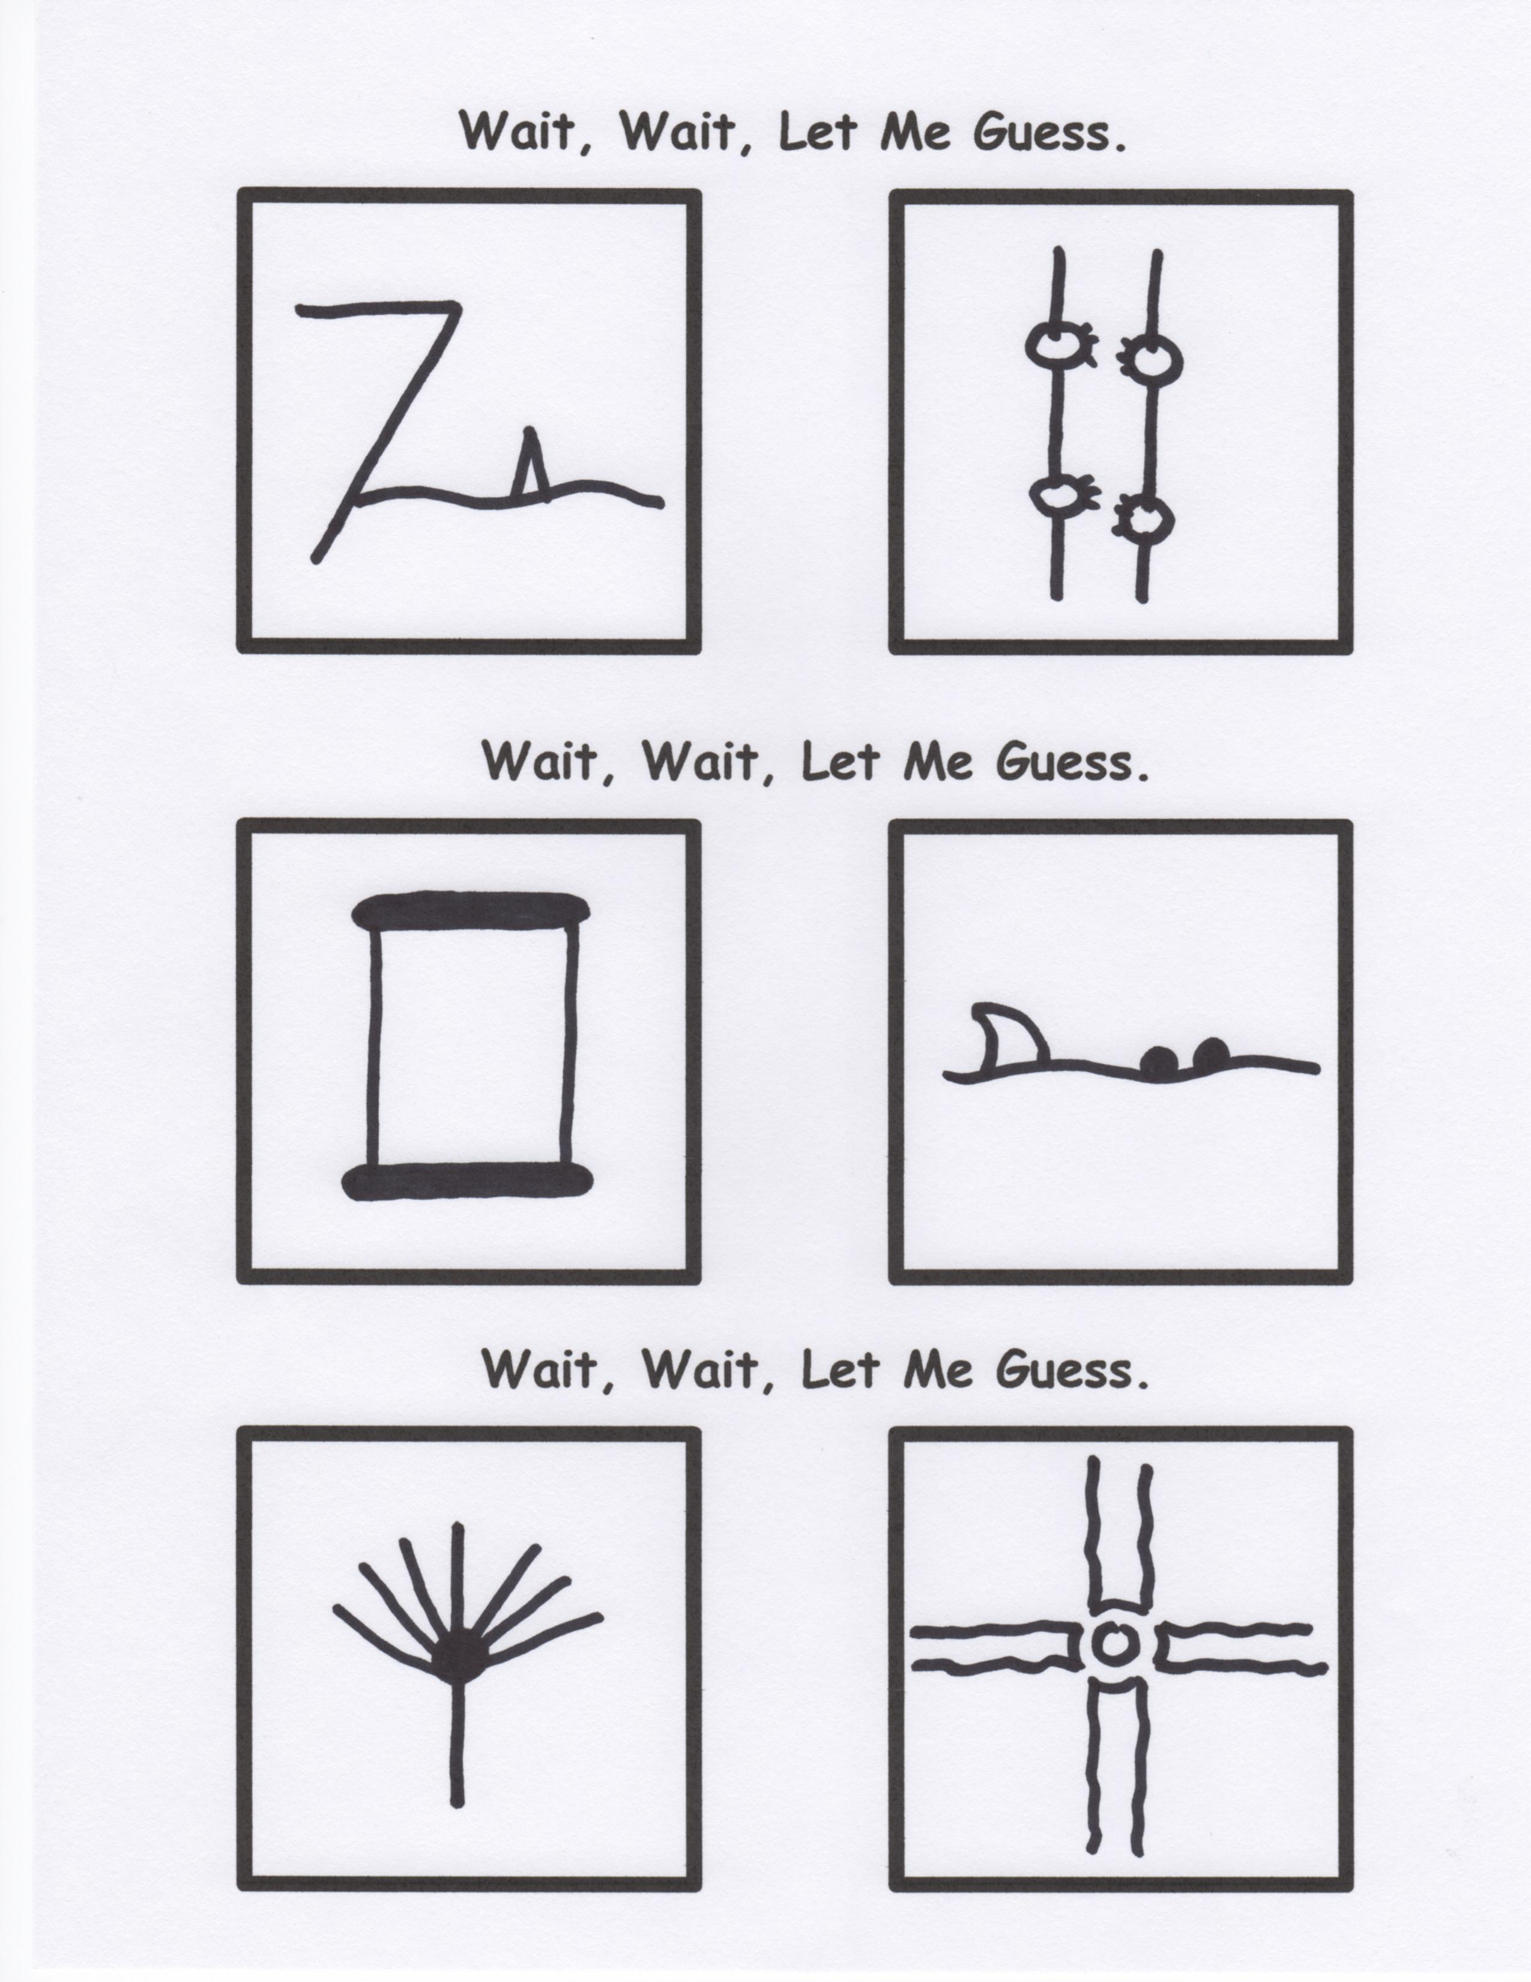

By Mr. Lyle (mrlyle1@gmail.com)

1. John Quincy Adams was known to regularly go swimming in the Potomac—always in the nude.

2. James Garfield was ambidextrous. It is recorded that he could simultaneously write a sentence in Latin with one hand and in Greek with the other.

3. Ulysses S. Grant got a speeding ticket for riding his horse too fast down a Washington street.

4. Lewis and Clark sent two bears back to Thomas Jefferson who kept them as pets on the White House lawn.

5. Herbert Hoover spoke Mandarin Chinese fluently and often spoke it around the White House for privacy.

**Mr. Lyle Explains Classic Works of Literature**

***The Wizard of Oz*** is the poignant story of two women trying to kill each other over a pair of shoes.